- HTML Form
Besides the planetarium application itself which will be the main centerpiece of Polaris, we will also offer a tool in the website that will allow users to calculate times, locations, and other information about a certain celestial event/phenomenon through inputting parameters, providing an output of a certain time, location, etc. that the user can then save through creating/logging in into an account, entailing another page for the login. They can collate a list of events, or observations as we call them, which would enable astronomers to easily get a list or schedule of celestial events that they are interested in, arranged from chronological order (most upcoming to farthest upcoming).
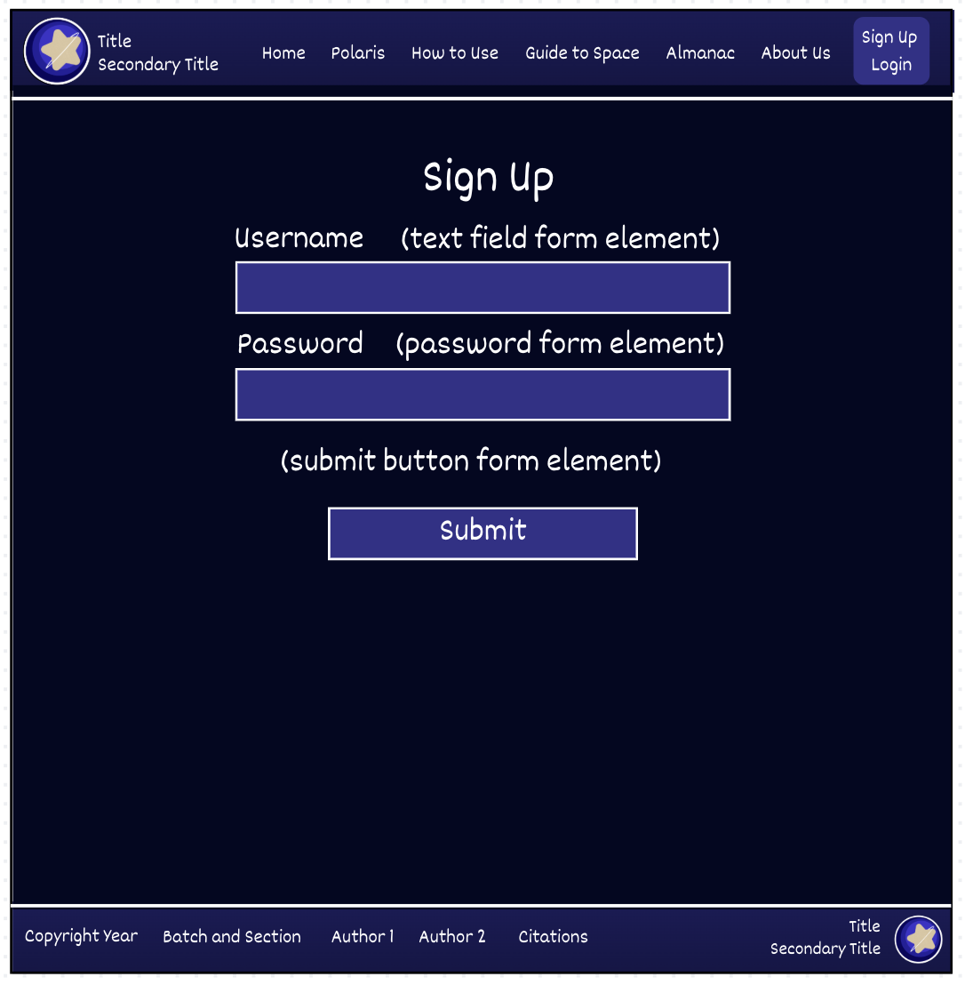
- Webpages Design + Explanations for Content
  - Sign-up form
    - As stated, there will be two main forms, one for signing up, and another for logging in. From our research, it would be more efficient to use popups for the login form, but an actual webpage for the signup form.

The figure on the right shows the Sign Up page, accessible on the button located on the top right of the header.

  - Almanac
    - This webpage, which can only be accessed once the user logs in, consisting of other subpages, will allow for computation for certain celestial phenomena. For example, upon clicking the “Phases of the Moon” page, the user, after being redirected to a separate subpage, will be able to find the specific moon phase given the date and time they input. Examples of some phenomena we will provide include:
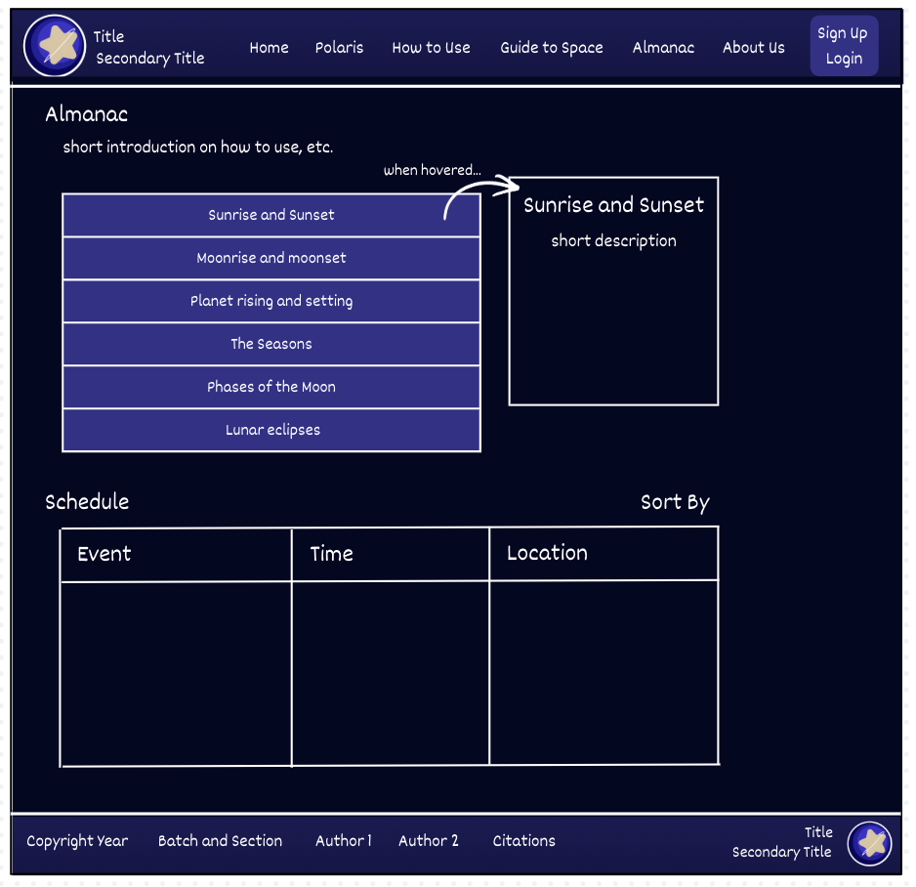
Sunrise and Sunset
Moonrise and moonset
Planet rising and setting
The Seasons
Phases of the Moon
Lunar eclipses

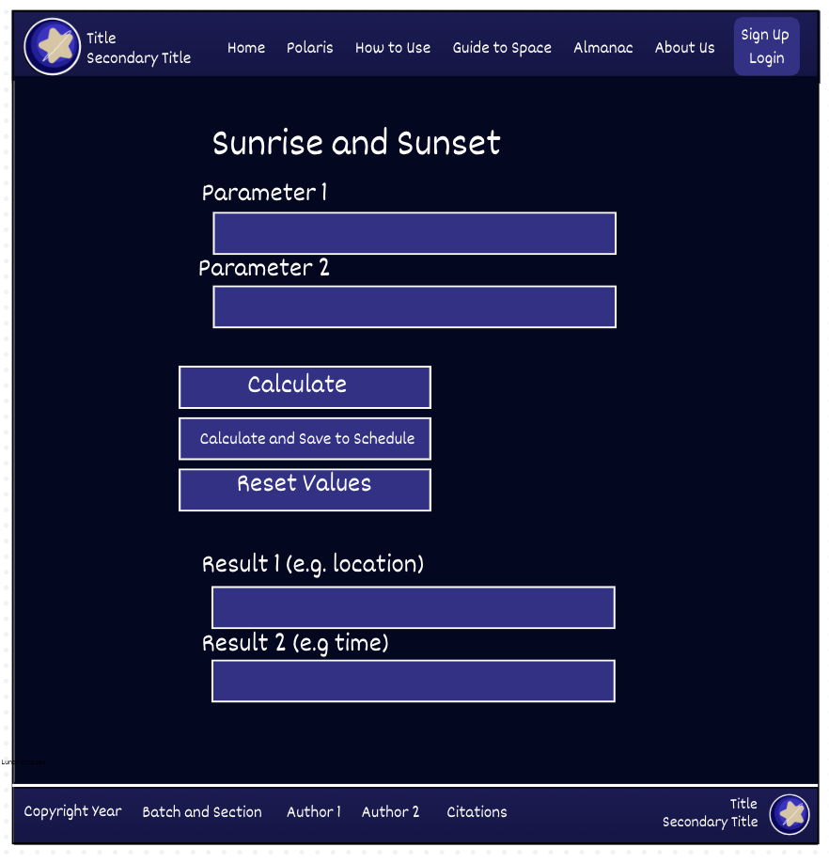
    - The results, after being computed, may also be submitted to the server and be saved into a list that can be accessed in the main almanac page. This serves as a schedule for astronomers as to when and where they can observe their computed phenomena.

On the right shows the webpage of the content settings page. Here, the parameters may be inserted, as well as the calculate, save, and reset buttons.

- Wireframes
  - Almanac
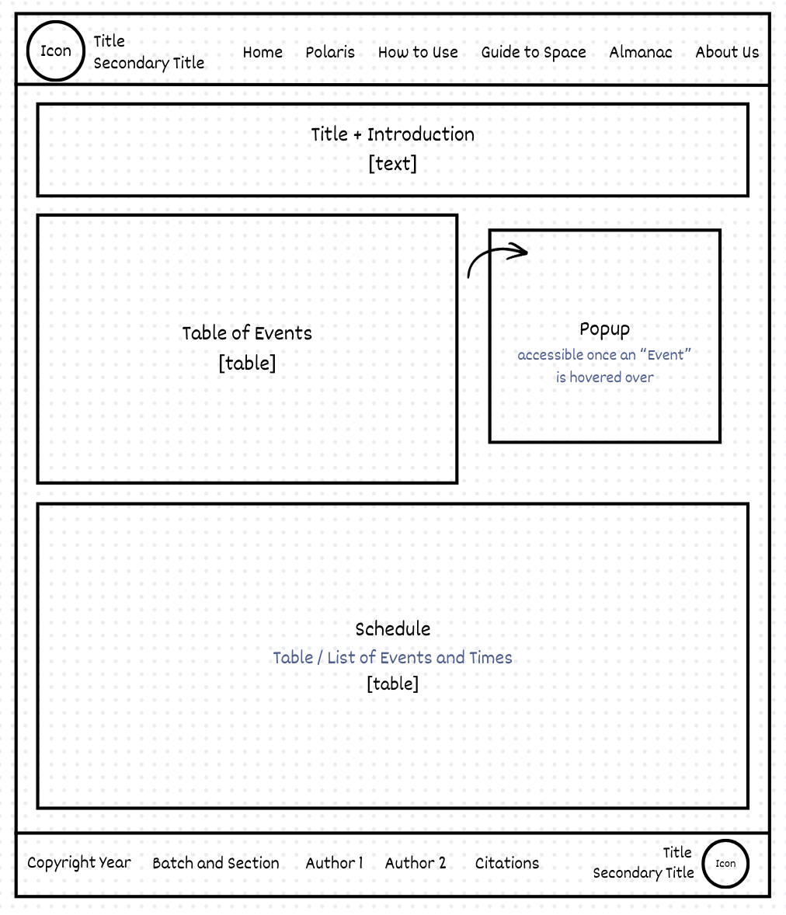
  - Events
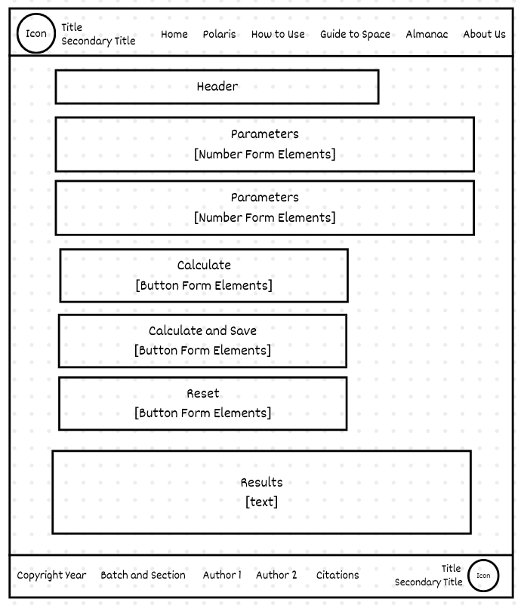
  - Signup
