barblot

## R Markdown

This is an R Markdown document. Markdown is a simple formatting syntax for authoring HTML, PDF, and MS Word documents. For more details on using R Markdown see <http://rmarkdown.rstudio.com>.

When you click the **Knit** button a document will be generated that includes both content as well as the output of any embedded R code chunks within the document. You can embed an R code chunk like this:

#6-3排序后均值的条形图  
states<-data.frame(state.region,state.x77)  
means<-aggregate(states$Illiteracy,by=list(state.region),FUN=mean)  
means

## Group.1 x  
## 1 Northeast 1.000000  
## 2 South 1.737500  
## 3 North Central 0.700000  
## 4 West 1.023077

means<-means[order(means$x),]  
means

## Group.1 x  
## 3 North Central 0.700000  
## 1 Northeast 1.000000  
## 4 West 1.023077  
## 2 South 1.737500

barplot(means$x,names.arg=means$Group.1)  
title("Mean Illiteracy Rate")

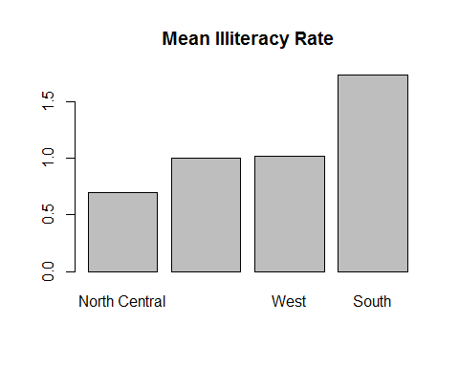

summary(cars)

## speed dist   
## Min. : 4.0 Min. : 2.00   
## 1st Qu.:12.0 1st Qu.: 26.00   
## Median :15.0 Median : 36.00   
## Mean :15.4 Mean : 42.98   
## 3rd Qu.:19.0 3rd Qu.: 56.00   
## Max. :25.0 Max. :120.00

## Including Plots

You can also embed plots, for example:



Note that the echo = FALSE parameter was added to the code chunk to prevent printing of the R code that generated the plot.