Storefront DaaS
Solution Design Document
Authentication via CIDP, dWeb reverse proxy, catalogue discovery and data exploration
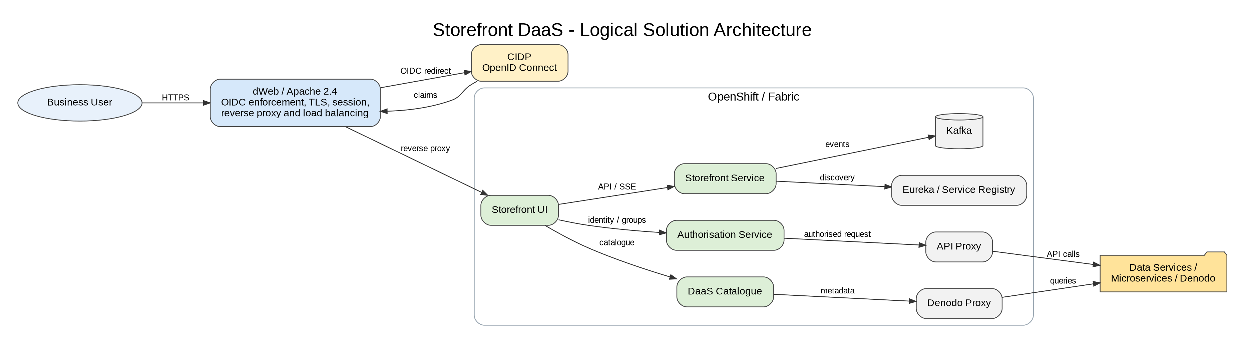
Document field | Value
Document status | Draft for architecture review
Version | 1.0
Prepared date | 22 July 2026
System | Storefront DaaS
Classification | Internal
Owner | TBD - Storefront Product / Technology Owner

Document Control
Version | Date | Author | Change
1.0 | 22-Jul-2026 | Architecture draft | Initial consolidated design based on available Storefront artefacts and configuration screenshots

Reviewers and Approvals
Role | Name | Status
Product Owner | TBD | Pending
Solution Architect | TBD | Pending
Security Architect | TBD | Pending
Platform Owner | TBD | Pending
Operations / SRE | TBD | Pending

Table of Contents
1. Introduction
2. Dependencies of Programs or Components
3. Functional Logic of Modules / Components
4. Logical and Physical Data Model
5. Service Specifications
6. Technical Component Specifications
7. Security and Authentication
8. Integration and Flow Specifications
9. Deployment and Infrastructure
10. Monitoring and Operational Support
11. Non-Functional Requirements
12. Risks, Assumptions and Open Decisions
Appendix A - Storefront SDA Flow Register

1. Introduction

1.1 Purpose
This document presents the low-level solution design for Storefront DaaS. It consolidates the available architecture diagrams, dWeb configuration, CIDP/OpenID Connect setup, reverse-proxy configuration and the intended data-exploration experience. It is intended to provide a baseline for implementation, security review, support and future enhancement.

1.2 Intended Audience
- Project and Product Managers
- Solution and Security Architects
- Frontend and Backend Engineers
- Platform / OpenShift Engineers
- Operations, SRE and Support Teams
- Application and Infrastructure Risk Reviewers

1.3 Scope
- User access to the Storefront web application through the enterprise dWeb endpoint.
- Authentication through CIDP using OpenID Connect.
- dWeb session handling, TLS termination, reverse proxying and load balancing.
- Storefront UI capability to browse catalogue entries, inspect service status and explore/test APIs.
- Integration with Authorisation Service, DaaS Catalogue, Storefront Service, API Proxy, Denodo Proxy, Eureka/service registry and Kafka where applicable.
- Operational monitoring, security controls and high-availability considerations.

1.4 Out of Scope
- Business logic and data models of individual downstream data services.
- Detailed Denodo virtualisation design and source-system mappings.
- CIDP platform internals and enterprise identity lifecycle management.
- Secrets, passwords, client secrets and private keys. These must never be embedded in this document.

1.5 Solution Overview


2. Dependencies of Programs or Components
Dependency | Purpose | Criticality
dWeb / Apache 2.4 | Enterprise web entry point, TLS, OIDC integration, session management, reverse proxy and load balancing | Critical
CIDP | Identity provider for OIDC authentication, MFA and claims | Critical
Storefront UI | User-facing web application for catalogue browsing and API/data exploration | Critical
Storefront Service | Backend support for event/data streams and application APIs | High
Authorisation Service | Validates user permissions and group-based access | Critical
DaaS Catalogue | Supplies service index, status and metadata | Critical
API Proxy | Mediates and routes API requests to target services | High
Denodo Proxy / Denodo | Provides governed access to virtualised data products | High
Eureka / Service Registry | Service discovery and runtime health registration where used | Medium
Kafka | Event and streaming integration where used by catalogue/data services | Medium
Fabric / OpenShift | Hosts Storefront UI and backend workloads | Critical

3. Functional Logic of Modules / Components

dWeb
Receives browser traffic for the Storefront URL, enforces OIDC authentication, creates the authenticated web session and forwards requests to healthy Storefront UI routes.

Storefront UI
Presents the data-service catalogue, service status and API test experience. Maintains local page state and a global store for current page, navigation link and user identity.

DaaS Catalogue
Returns a data-service index containing service metadata and status. This drives the Data Services page.

Translation Layer
Consumes service OpenAPI/Swagger definitions and converts heterogeneous API schemas into a normalised model used by the API Test page.

Storefront Service
Supports EventSource/SSE or API-based data streams used by data-service widgets such as FX and Currency services.

Authorisation Service
Applies access control using authenticated identity and group claims.

API Proxy / Denodo Proxy
Routes authorised API/data queries to service backends or Denodo while isolating the browser from internal endpoint details.

3.1 User Journey
1. User opens the Storefront URL.
2. dWeb checks for an authenticated session; unauthenticated users are redirected to CIDP.
3. CIDP authenticates the user, including MFA where required, and returns OIDC claims.
4. dWeb establishes a client-cookie session and proxies the request to Storefront UI.
5. Storefront UI retrieves the catalogue and displays services available to the user.
6. The user selects a service and inspects metadata, service status, API endpoints and parameters.
7. The UI sends an authorised request through the applicable proxy/service.
8. The response is normalised and rendered for exploration.
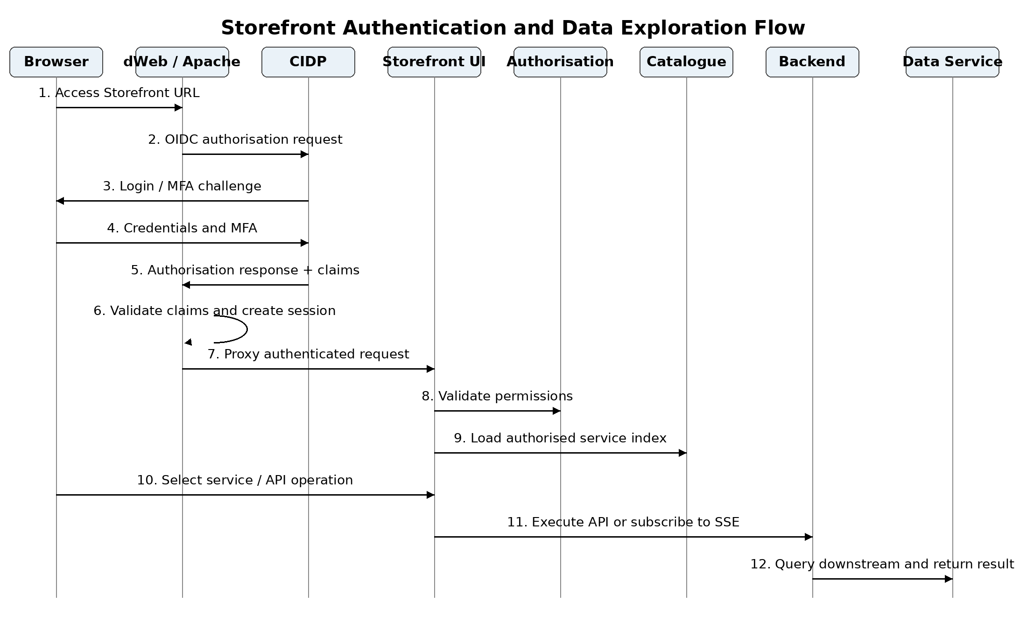

4. Logical and Physical Data Model

4.1 Logical Data Model
Storefront is primarily a metadata-driven application. It does not appear to own a core transactional data store. The logical entities below represent browser/application state and catalogue metadata rather than a system-of-record database model.
Logical entity | Representative attributes | Source
User Session | userId/email, groups, session start, expiry | CIDP and dWeb
Navigation State | current page, navigation link, selected service | Storefront UI global store
Service Catalogue Entry | service name, description, owner, status, links | DaaS Catalogue
API Definition | endpoint, method, parameters, request/response schema | OpenAPI/Swagger from data service
API Test Request | selected endpoint, parameter values, headers | Storefront UI
Normalised API Response | status, headers, structured payload, error details | Translation layer / backend response

4.2 Physical Data Model
No persistent Storefront database has been evidenced in the supplied artefacts. Local reducers/browser state are transient. Any persistence, audit store or catalogue repository must be documented by the owning service. This is an open design confirmation item.

5. Service Specifications
Service / Interface | Consumer | Purpose | Protocol | Authentication
Storefront public URL | Browser | Load application | HTTPS | OIDC session via dWeb
CIDP OIDC endpoints | dWeb | Authenticate user and obtain claims | HTTPS/OIDC | Enterprise identity + MFA
Storefront UI route | dWeb | Serve web UI | HTTPS | Trusted proxy session/header
Authorisation API | Storefront components | Validate user entitlements | HTTPS/JSON | Service identity + user context
DaaS Catalogue API | Storefront UI/backend | Retrieve service index and status | HTTPS/JSON | Authorised internal access
Storefront Service SSE/API | Storefront UI | Receive data stream / service data | HTTPS, SSE/JSON | Authenticated session/token
API Proxy | Storefront UI/backend | Route selected API request | HTTPS/JSON | User/service identity
Denodo Proxy | Storefront/backend | Query governed virtualised data | HTTPS/JSON | User/service identity

5.1 API Design Requirements
- OpenAPI/Swagger definitions must be versioned and discoverable.
- All requests should carry a correlation/request ID.
- User identity and effective groups must be propagated only through approved trusted headers or tokens.
- Error responses must use a consistent structure and must not expose internal stack traces or secrets.
- SSE endpoints must define reconnect, heartbeat, timeout and browser connection-limit behaviour.

6. Technical Component Specifications
Component | Current evidence / configuration | Design requirement
dWeb site | dws.storefront.intranet.db.com; Apache 2.4 | Managed enterprise entry point with TLS and OIDC enabled
OIDC | Provider metadata points to CIDP; scopes include openid, email and groups | Client secret stored only in protected platform configuration; rotate per policy
Session | client-cookie; inactivity timeout 600 seconds; maximum duration 36000 seconds | Confirm values against security policy and user experience
Identity header | CT-REMOTE-USER populated from email claim | Backend must trust this header only from dWeb and strip spoofed inbound values
Proxy balancer | By request count; JSESSIONID route stickiness | Health checks and failover status codes must be explicitly configured
Backend routes | Two Fabric/OpenShift routes across production clusters | Use HA routing and independently monitor both targets
Storefront UI | Fabric/OpenShift deployment | Stateless where practical; externalise runtime configuration
Catalogue | daas-catalogue service | Define availability SLO and cache/fallback behaviour

7. Security and Authentication

7.1 Authentication Flow
dWeb acts as the relying party and enforcement point for OpenID Connect. The browser is redirected to CIDP when no valid dWeb session exists. Following authentication, dWeb creates a client-cookie session and forwards identity context to Storefront. The application should not independently trust browser-supplied identity headers.

7.2 Required Security Controls
- TLS 1.2 or higher for browser, proxy and backend connections.
- OIDC state, nonce and issuer/audience validation.
- Client secret stored in a secret manager or protected dWeb configuration; never in source control or documentation.
- Strict allow-list of unauthenticated endpoints.
- Trusted-proxy enforcement for CT-REMOTE-USER and group headers.
- Role/group-based authorisation for each catalogue item and API operation.
- CORS limited to approved Storefront origins.
- Secure, HttpOnly and SameSite cookie settings.
- Security logging for successful/failed login, denied authorisation and privileged API execution.
- Input validation, rate limiting and response-size limits for API test functionality.

7.3 Threat Considerations
Threat | Control
Header spoofing | Strip identity headers at the edge and inject them only after successful dWeb authentication.
Open redirect / OIDC manipulation | Allow-list redirect URIs and validate state/nonce.
Session theft | Secure/HttpOnly/SameSite cookies, short inactivity timeout and reauthentication.
Unauthorised data discovery | Filter catalogue entries and endpoints using effective user entitlements.
Backend endpoint exposure | Route through API/Denodo proxy; do not reveal internal service addresses to the browser.
API test abuse | Rate limits, payload limits, method allow-list and full audit trail.
Secret leakage | Redact credentials from logs and prohibit secrets in UI/config exports.

8. Integration and Flow Specifications
ID | Description | Direction | U/D | Protocol | Port | Frequency | In scope
SF-01 | User accesses Storefront URL hosted by dWeb | User -> dWeb | Downstream | HTTPS | 443 | On demand | No
SF-02 | dWeb redirects unauthenticated user to CIDP | dWeb -> CIDP | Downstream | HTTPS/OIDC | 443 | On demand | No
SF-03 | CIDP returns authenticated OIDC response and claims | CIDP -> dWeb | Upstream | HTTPS/OIDC | 443 | On demand | No
SF-04 | dWeb establishes session and proxies Storefront request | dWeb -> Storefront UI | Downstream | HTTPS | 443 | On demand | Yes
SF-05 | Storefront validates permissions with Authorisation Service | Storefront -> Authorisation | Downstream | HTTPS/JSON | 443 | On demand | Yes
SF-06 | Storefront retrieves service index and status | Storefront -> DaaS Catalogue | Downstream | HTTPS/JSON | 443 | On demand | Yes
SF-07 | Catalogue returns service metadata | DaaS Catalogue -> Storefront | Upstream | HTTPS/JSON | 443 | On demand | Yes
SF-08 | Storefront subscribes to selected EventSource/data stream | Storefront UI -> Storefront Service | Downstream | HTTPS/SSE | 443 | On demand | Yes
SF-09 | Storefront requests selected API via API Proxy | Storefront -> API Proxy | Downstream | HTTPS/JSON | 443 | On demand | Yes
SF-10 | API Proxy calls target data service | API Proxy -> Microservice | Downstream | HTTPS/JSON | 443 | On demand | Yes
SF-11 | Storefront requests virtualised data via Denodo Proxy | Storefront -> Denodo Proxy | Downstream | HTTPS/JSON | 443 | On demand | Yes
SF-12 | Response is returned and rendered for exploration | Backend -> Storefront UI | Upstream | HTTPS/JSON or SSE | 443 | On demand | Yes

9. Deployment and Infrastructure

9.1 Deployment Topology
- Public enterprise entry point: dws.storefront.intranet.db.com on dWeb/Apache.
- Staging alias: staging.dws.storefront.intranet.db.com.
- dWeb reverse-proxy balancer targets two HTTPS Storefront UI OpenShift routes across production Fabric clusters.
- Load-balancing method is request-count based with JSESSIONID route stickiness.
- Storefront UI and daas-catalogue were evidenced as live services in project/instance dk2326.

9.2 Availability and Resilience
- Both backend routes must have active health checks; the supplied screen showed health-check expression/template as not set and fail-on-status-code as not set. These should be reviewed.
- Configure backend connection and read timeouts appropriate to UI and SSE traffic; the observed 559-second values require validation.
- Avoid server-side session dependency where possible. If stickiness is required, document failover behaviour when a route becomes unavailable.
- Deploy at least two replicas per critical service across failure domains.
- Provide graceful degradation when catalogue or optional data services are unavailable.

9.3 Configuration Management
- Promote dWeb revisions and OpenShift releases through controlled change management.
- Keep endpoint URLs, OIDC identifiers and feature flags external to the UI build.
- Store secrets in approved secret stores and rotate without rebuilding the application.
- Maintain separate non-production and production configuration with identical security controls.

10. Monitoring and Operational Support
Layer | Minimum monitoring
dWeb / Apache | Request rate, 4xx/5xx, OIDC failures, backend health, proxy timeout, TLS certificate expiry
Storefront UI | Page-load time, JavaScript errors, failed API calls, SSE disconnect/reconnect
Storefront Service | Latency, throughput, error rate, thread/connection pools and SSE active connections
DaaS Catalogue | Availability, response time, stale catalogue age and failed service discovery
Authorisation | Denied requests, latency and dependency errors
API / Denodo Proxy | Upstream latency, status codes, rate-limit events and backend availability
OpenShift | Pod availability, restarts, CPU, memory, ingress/route metrics
Security | Authentication failures, unusual session activity and unauthorised API attempts

10.1 Logging and Tracing
- Use a shared correlation ID from browser entry through proxies and backend services.
- Log user identity in a privacy-appropriate form, action, target service and outcome.
- Centralise logs in Splunk and define dashboards/alerts for critical journeys.
- Do not log tokens, cookies, client secrets, request credentials or sensitive payload fields.

10.2 Suggested Alerts
- Storefront URL unavailable or >2% 5xx for 5 minutes.
- Both dWeb backend workers unhealthy.
- OIDC authentication failure rate above baseline.
- Catalogue unavailable or stale beyond agreed threshold.
- SSE disconnect rate or API latency above SLO.
- TLS certificate expiry within 30 days.

11. Non-Functional Requirements
Category | Proposed requirement
Availability | Target 99.9% for the Storefront entry point, subject to business confirmation.
Performance | Initial page load <= 3 seconds at p95 on the corporate network; catalogue API <= 2 seconds p95.
Scalability | Stateless horizontal scaling for UI/backend; proxy capacity sized for peak concurrent users and SSE connections.
Security | Enterprise OIDC, least privilege, TLS, secure session and auditable API access.
Recoverability | Document RTO/RPO for catalogue and configuration; UI artefacts redeployable from source/repository.
Maintainability | Versioned APIs, automated build/deploy, externalised configuration and health endpoints.
Accessibility | Web UI should meet the enterprise accessibility standard and WCAG 2.1 AA where applicable.

12. Risks, Assumptions and Open Decisions
Type | Item | Action / Owner
Risk | Proxy health-check and fail-on-status-code settings appear unset. | dWeb/platform owner to configure and test failover.
Risk | Observed backend timeout values are very high and could retain failed connections. | Validate separate connect/read timeout values.
Risk | Identity is propagated through CT-REMOTE-USER. | Confirm header stripping, trusted proxy boundary and backend validation.
Risk | API test capability may provide broad access to downstream functions. | Apply endpoint-level authorisation, method allow-list, limits and audit.
Assumption | Storefront UI is stateless apart from browser/local reducer state. | Confirm with development team.
Assumption | No Storefront-owned persistent database exists. | Confirm catalogue/audit persistence.
Decision | Whether the browser calls backend services directly or only through Storefront Service/API Proxy. | Document final network and token propagation pattern.
Decision | Whether SSE is required for all data services or only selected services. | Define supported service patterns and connection limits.
Decision | Production SLOs and support model. | Product and operations sign-off.

Appendix A - Storefront SDA Flow Register
The following values are suitable as a starting point for the SDA Flows tab. Component IDs, source/destination network zones and certificate identifiers should be completed using the authoritative infrastructure inventory.
Flow ID | Description | Internal/External | Upstream/Downstream | Review Scope | Format | Frequency | Phase | Transport | Network | Port | Certificate
SF-01 | User accesses Storefront URL hosted on dWeb | Internal to DB | Downstream | No | HTTPS | On demand | N/A | HTTPS | Non-IPSec VPN | 443 | Internal dbPKI
SF-02 | dWeb redirects user to CIDP for authentication | Internal to DB | Downstream | No | OIDC | On demand | N/A | HTTPS | Non-IPSec VPN | 443 | Internal dbPKI
SF-03 | CIDP returns authentication response and user claims | Internal to DB | Upstream | No | OIDC | On demand | N/A | HTTPS | Non-IPSec VPN | 443 | Internal dbPKI
SF-04 | dWeb proxies authenticated request to Storefront UI | Internal to DB | Downstream | Yes | HTTPS | On demand | N/A | HTTPS | Non-IPSec VPN | 443 | Internal dbPKI
SF-05 | Storefront validates user permissions | Internal to DB | Downstream | Yes | JSON | On demand | N/A | HTTPS | Non-IPSec VPN | 443 | Internal dbPKI
SF-06 | Storefront retrieves service catalogue | Internal to DB | Downstream | Yes | JSON | On demand | N/A | HTTPS | Non-IPSec VPN | 443 | Internal dbPKI
SF-07 | Catalogue returns available services and status | Internal to DB | Upstream | Yes | JSON | On demand | N/A | HTTPS | Non-IPSec VPN | 443 | Internal dbPKI
SF-08 | Storefront subscribes to service EventSource stream | Internal to DB | Downstream | Yes | SSE/JSON | On demand | N/A | HTTPS | Non-IPSec VPN | 443 | Internal dbPKI
SF-09 | Storefront sends API test request to API Proxy | Internal to DB | Downstream | Yes | JSON | On demand | N/A | HTTPS | Non-IPSec VPN | 443 | Internal dbPKI
SF-10 | API Proxy forwards request to target service | Internal to DB | Downstream | Yes | JSON | On demand | N/A | HTTPS | Non-IPSec VPN | 443 | Internal dbPKI
SF-11 | Storefront queries data through Denodo Proxy | Internal to DB | Downstream | Yes | JSON | On demand | N/A | HTTPS | Non-IPSec VPN | 443 | Internal dbPKI
SF-12 | Backend response is returned to Storefront UI | Internal to DB | Upstream | Yes | JSON/SSE | On demand | N/A | HTTPS | Non-IPSec VPN | 443 | Internal dbPKI

Appendix B - PlantUML Diagram Sources
The diagrams in this document are maintained from the following PlantUML definitions. Save each block as a .puml file and render it with a PlantUML-compatible tool.

B.1 Logical Solution Architecture
@startuml Storefront_Logical_Architecture
skinparam componentStyle rectangle
skinparam shadowing false
skinparam defaultFontName Arial
skinparam packageStyle rectangle
left to right direction
actor "Business User" as User
rectangle "dWeb / Apache 2.4\nOIDC enforcement, TLS, session,\nreverse proxy and load balancing" as DWeb
cloud "CIDP\nOpenID Connect" as CIDP
package "OpenShift / Fabric" {
component "Storefront UI" as UI
component "Storefront Service" as SFS
component "Authorisation Service" as AuthZ
component "DaaS Catalogue" as Catalogue
component "API Proxy" as APIProxy
component "Denodo Proxy" as DenodoProxy
component "Eureka / Service Registry" as Registry
queue "Kafka" as Kafka
}
cloud "Data Services /\nMicroservices / Denodo" as DataServices
User --> DWeb : HTTPS
DWeb --> CIDP : OIDC redirect
CIDP --> DWeb : ID/access claims
DWeb --> UI : Reverse proxy\nJSESSIONID stickiness
UI --> AuthZ : Identity and groups
UI --> Catalogue : Catalogue metadata/status
UI --> SFS : API / SSE
AuthZ --> APIProxy : Authorised request
Catalogue --> DenodoProxy : Data service metadata
SFS --> Kafka : Events / streams
SFS --> Registry : Service discovery
APIProxy --> DataServices : API calls
DenodoProxy --> DataServices : Virtualised queries
@enduml

B.2 Authentication and Data Exploration Sequence
@startuml Storefront_Authentication_Data_Exploration
skinparam shadowing false
skinparam defaultFontName Arial
skinparam sequenceMessageAlign center
title Storefront Authentication and Data Exploration Flow
actor User
participant "Browser" as Browser
participant "dWeb / Apache" as DWeb
participant "CIDP" as CIDP
participant "Storefront UI" as UI
participant "Authorisation Service" as AuthZ
participant "DaaS Catalogue" as Catalogue
participant "API Proxy / Storefront Service" as Backend
participant "Data Service / Denodo" as Data
User -> Browser : Open Storefront URL
Browser -> DWeb : GET / (HTTPS)
alt No valid dWeb session
DWeb -> CIDP : OIDC authorisation request
CIDP --> Browser : Login and MFA challenge
Browser -> CIDP : Credentials / MFA
CIDP --> DWeb : Authorisation response + claims
DWeb -> DWeb : Validate state, nonce, issuer and audience\nCreate secure client-cookie session
end
DWeb -> UI : Proxy authenticated request\n(trusted identity context)
UI -> AuthZ : Validate user groups and permissions
AuthZ --> UI : Effective permissions
UI -> Catalogue : Request authorised service index
Catalogue --> UI : Service metadata and status
User -> UI : Select service / API operation
UI -> Backend : Execute API or subscribe to SSE
Backend -> Data : Query/call downstream service
Data --> Backend : Data response
Backend --> UI : Normalised response / stream
UI --> Browser : Render data exploration experience
Browser --> User : Display result
@enduml

