Machine Learning and Pattern Recognition LAB
Chandra Prakash,
July-Dec 2018
LAB 2:

VIPASHA DHIMAN
04401032015
B.Tech(IT)

Bayesian Classifier :

Outlook | Temprature | Humidity | Windy | Class
sunny | hot | high | FALSE | n
sunny | hot | high | TRUE | n
overcast | hot | high | FALSE | p
rain | mild | high | FALSE | p
rain | cool | normal | FALSE | p
rain | cool | normal | TRUE | n
overcast | cool | normal | TRUE | p
sunny | mild | high | FALSE | n
sunny | cool | normal | FALSE | p
rain | mild | normal | FALSE | p
sunny | mild | normal | TRUE | p
overcast | mild | high | TRUE | p
overcast | hot | normal | FALSE | p
rain | mild | high | TRUE | n

Consider the following dataset with 4 attributes/features and two class(Play and not Play Tennis). Write a program to classify a new sample X when:

Solution:

import csv
import random

def loadCsv(filename):
lines = csv.reader(open(filename, "rb"))
dataset = list(lines)
for i in range(len(dataset)):
dataset[i] = [x for x in dataset[i]]
return dataset

def splitDataset(dataset, splitRatio):
trainSize = int(len(dataset) * splitRatio)
trainSet = []
copy = list(dataset)
while len(trainSet) < trainSize:
index = random.randrange(len(copy))
trainSet.append(copy.pop(index))
return [trainSet, copy]

def Diff(li1, li2):
li_dif = [i for i in li1 + li2 if i not in li1 or i not in li2]
return li_dif

def classesInDataset(dataset):
classes = []
for i in range(len(dataset)):
vector=dataset[i]
if vector[-1] not in classes:
classes.append(vector[-1])
return classes

def classesInDatasetWithFreq(dataset):
classes = {}
for i in range(len(dataset)):
vector=dataset[i]
if vector[-1] not in classes:
classes[vector[-1]]=0
classes[vector[-1]]+=1
return classes

def separateByClassAndCalculateFrequency(dataset):
separated = {}
for i in range(len(dataset)):
vector = dataset[i]
if (vector[-1] not in separated):
separated[vector[-1]] = {}
for j in range(len(vector)-1):
if vector[j] not in separated[vector[-1]]:
separated[vector[-1]][vector[j]]=0
separated[vector[-1]][vector[j]]+=1
return separated

def calculateProbablity(dataset,classes,separated):
visited={}
cls=[]
for i in range(len(dataset)):
vector = dataset[i]
if (vector[-1] not in visited):
visited[vector[-1]] = []
cls.append(vector[-1])
for j in range(len(vector)-1):
if vector[j] not in visited[vector[-1]]:
separated[vector[-1]][vector[j]]=(separated[vector[-1]][vector[j]])/float(classes[vector[-1]])
visited[vector[-1]].append(vector[j])
leftFeatures=Diff(visited[cls[0]],visited[cls[1]])
for i in range(len(leftFeatures)):
for j in range(len(cls)):
if leftFeatures[i] not in visited[cls[j]]:
separated[cls[j]][leftFeatures[i]]=0.0
return separated

def predict(model,check,classes,classesWithFrequency):
max=0.0
prediction='none'
for i in range(len(classes)):
probablity=1.0
for j in range(len(check)):
probablity*=model[classes[i]][check[j]]
probablity*=classesWithFrequency[classes[i]]
if probablity>max:
max=probablity
prediction=classes[i]
return prediction

filename = 'np_dataset.csv'
dataset = loadCsv(filename)
trainingSet, testSet = splitDataset(dataset, 1.0)
classes=classesInDataset(trainingSet)
classesWithFrequency=classesInDatasetWithFreq(trainingSet)

frequency = separateByClassAndCalculateFrequency(trainingSet)

model=calculateProbablity(trainingSet,classesWithFrequency,frequency)

check=raw_input().split(",")

prediction=predict(model,check,classes,classesWithFrequency)
print 'For inputs', check ,'the predicted class is ',prediction

a)X=<sunny, cool, high, false>

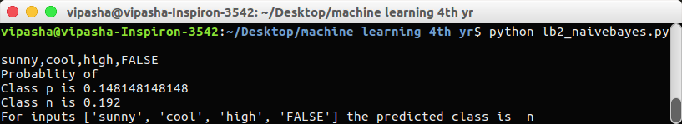

b)X = <rain, hot, high, false>

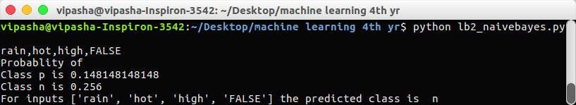

OBSERVATIONS:

Naive Bayes classifiers, a family of classifiers that are based on the popular Bayes’ probability theorem, are known for creating simple yet well performing models.

The formula I used in this is:

P(H/Multiple Evidences) = P(E1/ H)* P(E2/H) ...*P(En/H) * P(H) P(Multiple Evidences)

Another important observation I noticed is that with the limited amount of dataset I was unable to train my classifier very well.

We have two classes here i.e n: not play and p:play. We have 4 attributes which classify every set of input to a class.
Attributes: Overlook, Temprature, Humidity and Windy

