ARTIFICIAL INTELLIGENCE
Assignment 1 (due date: 10/02/2022):

This assignment is to assess your understanding of the introductory information of AI, environment, agents, rational decision, informed and uninformed searches, and local search. To answer these questions, you need to review the first four chapters of “Artificial Intelligence: A Modern Approach” which is available in course materials.

1: Many of the computational models of cognitive activities that have been proposed involve quite complex mathematical operations, such as convolving an image with a Gaussian or finding a minimum of the entropy function. Most humans (and certainly all animals) never learn this kind of mathematics at all, almost no one learns it before college, and almost no one can compute the convolution of a function with a Gaussian in their head. What sense does it make to say that the “vision system” is doing this kind of mathematics, whereas the actual person has no idea how to do it (10 points)?

2: This exercise explores the differences between agent functions and agent programs (20 points).

a. Can there be more than one agent program that implements a given agent function?
Give an example or show why one is not possible.

b. Are there agent functions that cannot be implemented by any agent program?

c. Given a fixed machine architecture, does each agent program implement exactly one agent function?

d. Given an architecture with n bits of storage, how many different possible agent programs are there?

e. Suppose we keep the agent program fixed but speed up the machine by a factor of two. Does that change the agent function?

3: Trace the operation of A* search applied to the problem of getting to Bucharest from Lugoj using the straight-line distance heuristic. That is, show the sequence of nodes that the algorithm will consider and the f, g, and h score for each node (10 points).

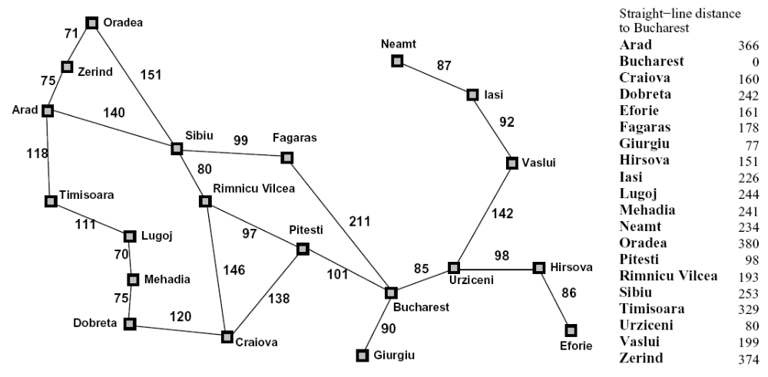

4: Implement DFS, BFS, and A* for the problem of getting to Bucharest from Arad. You can use python or R for the implementation. Please present he path each algorithm will choose (40 points).

5: Give the name of the algorithm that results from each of the following special cases (20 points):
a. Local beam search with k = 1.

b. Local beam search with one initial state and no limit on the number of states retained.

c. Simulated annealing with T = 0 at all times (and omitting the termination test).

d. Simulated annealing with T = ∞ at all times.

e. Genetic algorithm with population size N = 1.

