BOREAL

ECOMMERCE
WEBSITE

GROUP 3
Team Members :
Diya Sebastian
Edson Edwin Ninan
Elizebeth Mathew
Fathima Irfana
Feba Biju
Gayathri M
Goutham Sreekumar
Haines Jose Paulson
Heins Devasia
Jaganath Syam
Jestin Shaji
Jibin Chacko

ABSTRACT
BOREAL is a fashion-focused e-commerce web application developed using PHP and MySQL, designed to simulate a modern online storefront with a premium winterwear brand identity. The system showcases a curated catalog of fashion products such as coats, knitwear, footwear, accessories, and seasonal sale items through a visually appealing and structured interface. The platform allows users to explore products through category-based navigation, inspect product details, select variants such as size and color, and add items to a session-based shopping cart. A simple checkout flow enables customers to review selected products and place orders, creating a basic but functional online shopping experience.
The application combines both server-side processing and client-side interactivity to ensure a smooth and responsive user experience. Product information is stored in a MySQL database and accessed using PHP Data Objects (PDO), which provides secure and structured communication between the application and the database. On the client side, JavaScript, jQuery, and AJAX are used to support asynchronous operations such as dynamically loading product data, updating cart contents, and filtering products without requiring a full page reload.
The user interface is designed using Bootstrap along with custom CSS styling and modern typography to maintain a clean, premium visual appearance. The responsive layout ensures that the website adapts effectively to different screen sizes, including desktops, tablets, and mobile devices. Product sections, category menus, featured product displays, and promotional areas are carefully structured to highlight fashion items while maintaining a user-friendly navigation flow.
In addition to the customer-facing storefront, the application also includes user account functionality that allows customers to register, log in, and manage their profile information. The system supports session-based authentication to maintain user login states and protect restricted areas of the application. Alongside the user module, a lightweight administrative management system is included to support basic store operations. Administrators can manage product listings, update product details, handle variants such as size and color, maintain stock information, and review orders placed through the platform.
Backend API endpoints handle operations such as retrieving product data and processing cart actions, while frontend scripts manage user interactions and interface updates.
The primary objective of this project is to demonstrate the core workflow of a modern e-commerce platform in a compact full-stack implementation. By integrating product management, category browsing, shopping cart functionality, database connectivity, and basic administrative control, BOREAL provides a practical example of how web technologies can be combined to create a functional online retail environment. The project also serves as a learning framework for understanding the design, development, and testing processes involved in building a scalable and maintainable e-commerce web application.
1. PROJECT OVERVIEW
BOREAL is a fashion-focused e-commerce web application developed using PHP and MySQL to simulate a modern online storefront for a premium winterwear brand. The website allows users to browse fashion products such as coats, knitwear, footwear, and accessories through a clean and visually appealing interface. Customers can explore products by category, view detailed product information, choose variants like color and size, add items to a shopping cart, and place orders through a checkout process.
The system combines server-side processing and client-side interactivity to create a smooth shopping experience. PHP manages backend operations such as user authentication, product retrieval, cart management, and order processing, while MySQL stores data related to products, users, and orders. On the frontend, HTML, CSS, Bootstrap, JavaScript, and jQuery are used to design a responsive interface and enable dynamic features such as product filtering and cart updates using AJAX.
In addition to the customer storefront, the platform includes an administrative dashboard that allows administrators to manage products, update stock, and monitor orders. Overall, the project demonstrates the core functionality of a complete e-commerce system, integrating product management, shopping cart operations, user accounts, and order handling within a structured web application.

2. SYSTEM ARCHITECTURE
The application follows a simple client–server architecture, where the system is divided into three main layers: the Frontend Layer, Backend Layer, and Database Layer. Each layer performs a specific function to ensure smooth communication between the user interface, application logic, and stored data.

Frontend Layer
The frontend layer handles the user interface and user interaction of the website. It is built using HTML, CSS, Bootstrap, JavaScript, and jQuery, which together create a responsive and interactive design.
It includes:
• Responsive layouts for desktop, tablet, and mobile devices
• Product display cards showing images, prices, and categories
• Category filters for browsing different product types
• Shopping cart interface for managing selected items
• Dynamic search and product filtering
The frontend communicates with backend APIs through AJAX requests, allowing data to update dynamically without reloading the entire page.

Backend Layer
The backend layer manages the core application logic and server-side processing. It is responsible for handling requests from the frontend and performing operations related to the system's functionality.
The backend manages:
• Database communication and data retrieval
• Product listing and product detail retrieval
• Shopping cart operations and session storage
• User authentication and session handling
• Order processing and administrative actions
The backend is implemented using PHP, while MySQL is used to manage and store application data.

Database Layer
The database layer is responsible for storing all persistent data required for the e-commerce platform.
The database stores:
• Product information and descriptions
• Product categories and variants
• Prices and stock quantities
• User account details
• Order and order item records
• Image paths and product media
The database is accessed through PHP Data Objects (PDO), which provides secure and structured SQL queries for inserting, updating, and retrieving data from the MySQL database.

3. TOOLS AND TECHNOLOGIES USED
The BOREAL e-commerce storefront was developed using a combination of frontend, backend, database, and design technologies. These technologies work together to create a responsive interface, manage product data, and enable dynamic user interactions.
1. UI/UX Design
Figma
Figma was used during the design phase of the project to create the visual layout and user interface structure of the website. Wireframes and design prototypes were prepared in Figma before implementation. This helped the development team plan the layout of components such as the navigation bar, hero section, product cards, and shopping cart interface.
2. Frontend Technologies
HTML
HTML was used to build the structural layout of the web pages. It defines the structure of the website including product sections, navigation menus, category filters, and cart elements.
CSS
CSS was used to style the application and implement the visual theme of the website. Custom CSS styles were added to control typography, colors, spacing, and component appearance to achieve the winter-luxury aesthetic of the BOREAL storefront.
Bootstrap
Bootstrap was used to simplify responsive design and UI component creation. The framework provides pre-built components such as grids, buttons, cards, and navigation elements which ensure the website adapts properly to different screen sizes including mobile, tablet, and desktop.
Bootstrap Icons
Bootstrap Icons were used to enhance the user interface with visual icons such as the shopping cart icon and navigation indicators.
Google Fonts
Google Fonts were integrated to provide modern typography that improves the visual appeal and readability of the website.
3. Client-Side Scripting
JavaScript
JavaScript was used to handle dynamic interactions within the webpage such as updating the cart interface, managing product interactions, and triggering asynchronous requests to backend APIs.
jQuery
jQuery was used to simplify DOM manipulation and AJAX communication. It helps manage events such as button clicks, form input handling, and updating webpage content dynamically.

AJAX
AJAX (Asynchronous JavaScript and XML) was used to communicate with backend API endpoints without reloading the page. This allows operations like adding products to the cart, updating quantities, and retrieving cart information to happen smoothly in the background.
4. Backend Technologies
PHP
PHP was used as the server-side programming language to implement the business logic of the application. PHP handles database queries, processes API requests, manages sessions for the shopping cart, and returns responses to the frontend.
PDO (PHP Data Objects)
PDO was used to connect PHP with the MySQL database. It provides a secure and flexible way to execute database queries while supporting prepared statements and error handling.
5. Database
MySQL
MySQL was used as the relational database management system for storing product information. The database maintains records such as product names, categories, prices, stock quantities, descriptions, and image paths.
6. Development Environment
XAMPP
XAMPP was used as the local development environment for running the application. It provides Apache, PHP, and MySQL services in a single package, allowing the project to run locally on the developer’s machine using localhost.
phpMyAdmin
phpMyAdmin was used to manage the MySQL database through a graphical interface. It was used for creating the database, importing schema files, and verifying product records during testing.
7. Version Control
GitHub
GitHub was used to store and manage the project repository. It allows tracking of code changes, version management, and collaboration between development team members.

4. SYSTEM INTERFACE / SYSTEM SCREENSHOTS
Homepage Hero Section
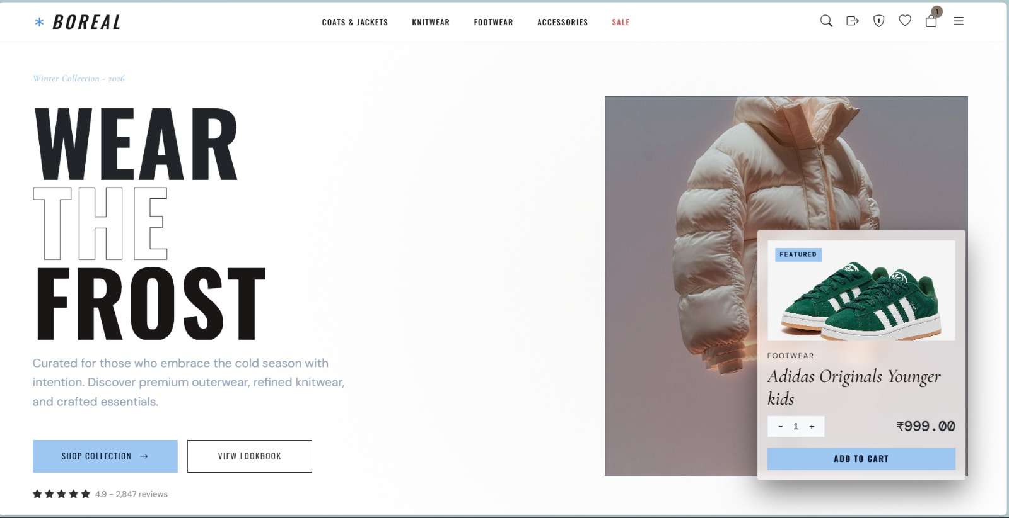
Login Page

Product Listing Section
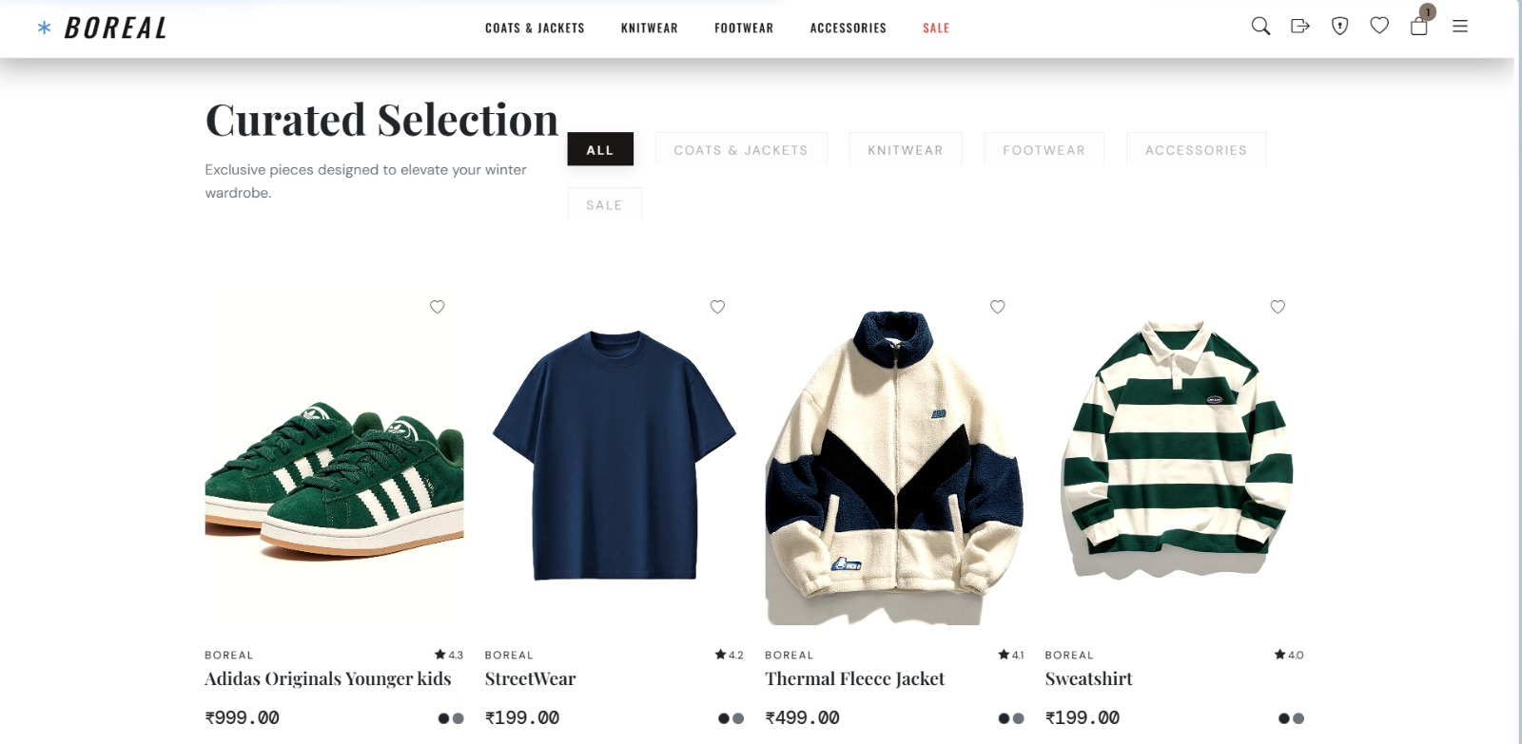

Admin Dashboard
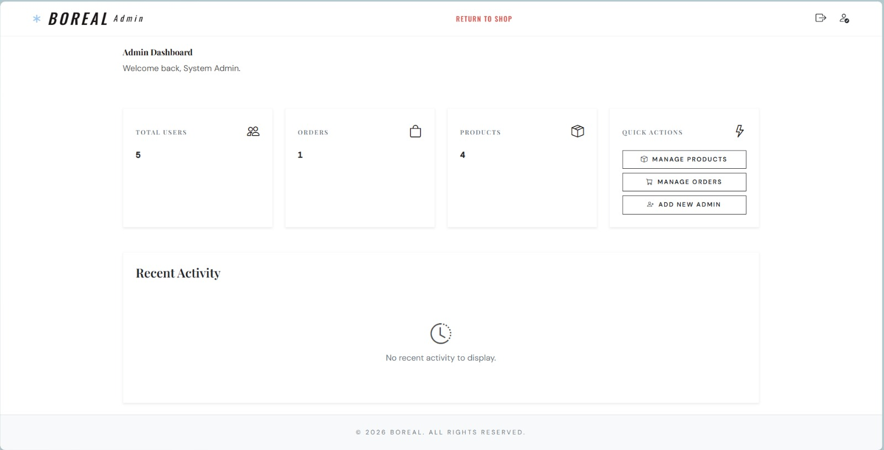

Product Management (Admin Panel)
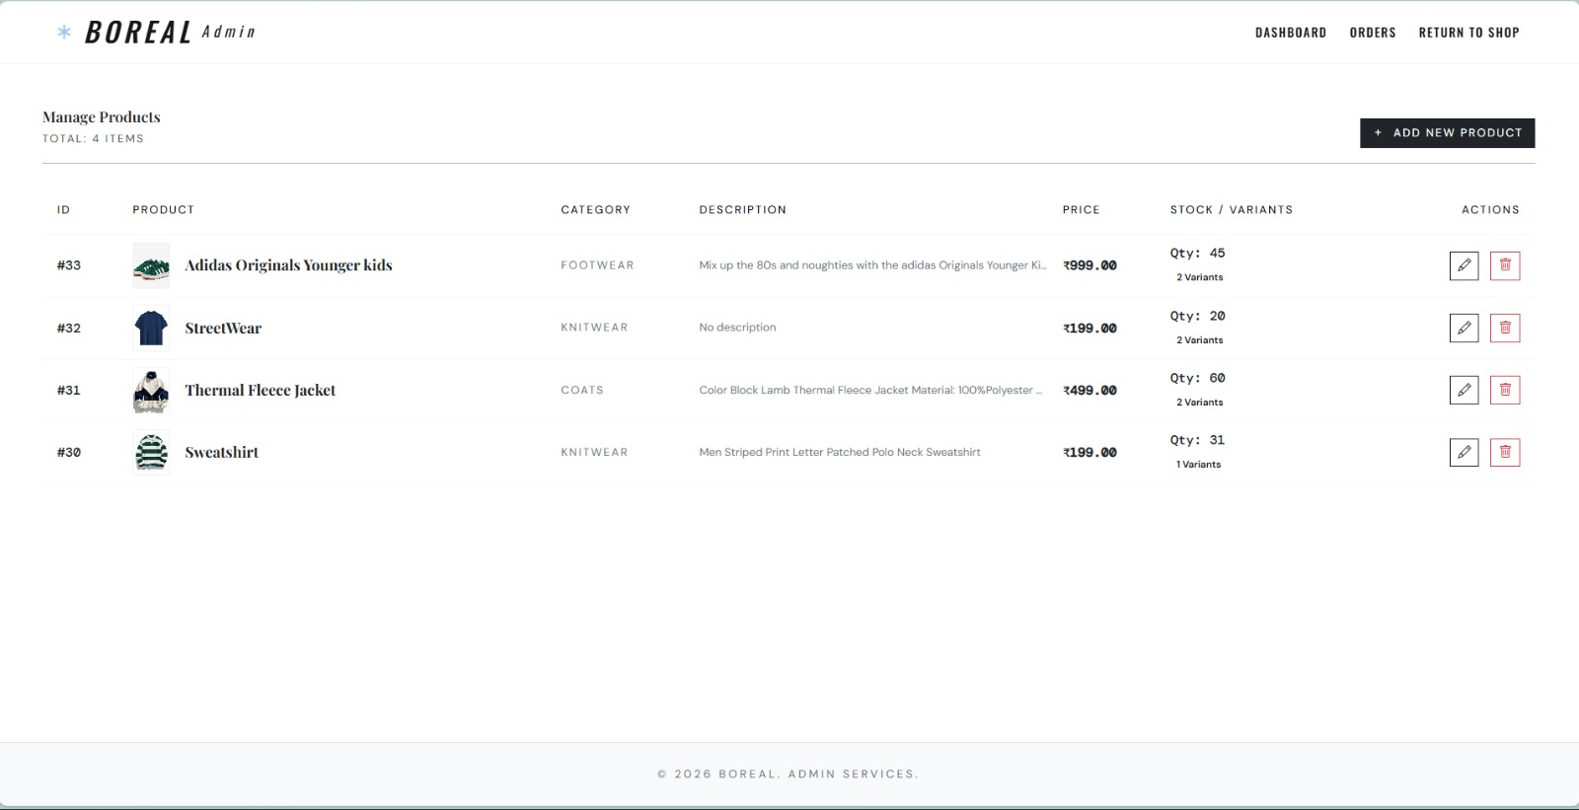
Product Detail Modal
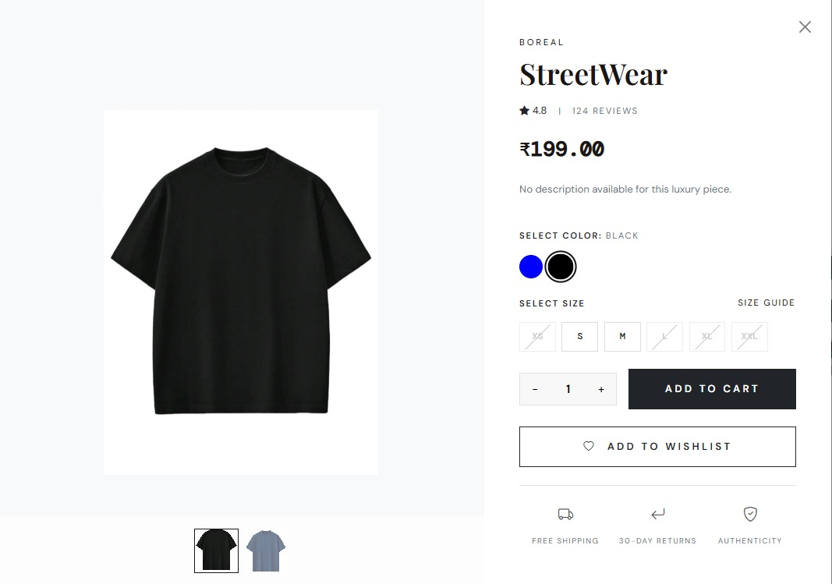
6. CURRENT TECHNICAL FINDINGS
To ensure the reliability, functionality, and usability of the BOREAL e-commerce website, several testing methods were performed. These tests help verify that the system works correctly, handles user interactions properly, and meets the expected functional requirements.
5.1 Black Box Testing
Black box testing focuses on testing the functionality of the system without examining the internal code structure. The tester provides input and observes the output to ensure that the application behaves as expected.
In the BOREAL website, black box testing was used to verify features such as:
• User registration and login functionality
• Product browsing and category filtering
• Searching products using keywords
• Adding products to the shopping cart
• Updating and removing items from the cart
• Checkout and order placement
The tester verifies whether the correct output is generated based on the user input without analyzing the internal program logic.
5.2 White Box Testing
White box testing focuses on examining the internal code structure, logic, and program flow of the application. This type of testing ensures that the backend code functions correctly and handles different conditions properly.
For the BOREAL project, white box testing involved:
• Checking PHP functions used for product retrieval
• Verifying session handling for cart storage
• Testing database queries executed through PDO
• Ensuring correct execution of API endpoints
• Validating order processing logic
This testing helps identify coding errors, incorrect conditions, or logical flaws in the backend implementation.
5.3 Functional Testing
Functional testing verifies that each feature of the system works according to the specified requirements.
The following functions were tested:
• Product listing display
• Product detail modal functionality
• Category filtering and product search
• Cart operations (add, update, remove items)
• Checkout process
• Admin product management and order updates
This ensures that all system features operate correctly.
5.4 User Interface (UI) Testing
UI testing focuses on verifying the visual elements and layout of the website.
The following aspects were checked:
• Navigation bar functionality
• Product card layout and responsiveness
• Modal display for product details
• Cart interface appearance
• Form input fields and buttons
UI testing ensures that the website interface is visually consistent and easy to use.
5.5 Usability Testing
Usability testing evaluates how easily users can interact with the system.
For the BOREAL website, usability testing involved:
• Checking if users can easily browse products
• Verifying if product categories are understandable
• Ensuring the cart process is simple and intuitive
• Confirming that checkout steps are clear for users
This testing helps improve the overall user experience.
5.6 Integration Testing
Integration testing verifies that different components of the system work together properly.
In this project, integration testing was performed to ensure:
• Frontend communicates correctly with backend APIs
• Cart operations correctly interact with session storage
• Product data is correctly retrieved from the database
• Orders are properly stored in the database during checkout

5.7 Database Testing
Database testing ensures that data stored in the MySQL database is accurate and consistent.
The following checks were performed:
• Product information retrieval
• Order data storage after checkout
• Stock updates after order placement
• User account information storage
This ensures that the database operations work correctly.

7. FUTURE ENHANCEMENTS
• Payment Gateway Integration – Add secure online payment methods such as credit cards, UPI, or digital wallets.
• Persistent Shopping Cart – Store cart data in the database so users can access their cart across different devices.
• Advanced Search and Filters – Implement filters based on price, size, color, and ratings to improve product discovery.
• Product Reviews and Ratings – Allow customers to leave reviews and ratings for products.
• Wishlist Feature – Enable users to save products for future purchases.
• Email Notifications – Send automatic emails for order confirmation, shipping updates, and promotions.
• Analytics Dashboard – Provide sales reports and product performance insights for administrators.

