**Resume**

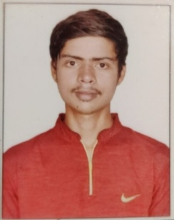

**Objectives**

I would like to be a part of an organization where I could use and enhance my knowledge and talent for the development of both the Organization and myself.

**Contact:-**

**Phone no**: 9167087436

**Whatsapp**: 7715865438

**Email:** [rameshchauhan02001@gmail.com](mailto:rameshchauhan02001@gmail.com)

Address: Cuffe-parade, Colaba,

Mumbai-400005

**Skills**

1] HTML

2] CSS

3] Bootstrap

4] Javascript

5] JQeury

6] PHP

7] MYSQL

8] Python (OOPS)

9] Flask framework

**Certifications:**

Joy of Computing in Python

Programming in Java

**Experience:**

Fresher

**Education:**

BSCIT

Jai Hind College

Average CGPI:

9.4

12th HSC (Science)

KishinChand Chellaram College

10th SSC

Colaba Municipal Secondary School

**Porjects:**

1] Online Hotel Booking Website (mini project)

2] Supply chain management system (Using DBMS)

3] Online voting app using Java (Major Project)

4] AI based face Recognition Attendance system using python and flask framework (Major Project)

**Hobbies:**

Like to Play Cricket

Like to Solve Rubik cube

Music Listening