1.viewport

<meta name="viewport" content="width=device-width, initial-scale=1.0"/>

2.fluid images

<div class ="jumbotron">

<img src="mai.jpg" style="max-width:100%;height:400px;

background-size: cover;">

<header>

<div class="intro-text">

<div class="intro-lead-in">Find perfect Rover for you</div>

<div class="intro-heading">Explore Our vehicles</div>

</div>

</header>

</div>

Before

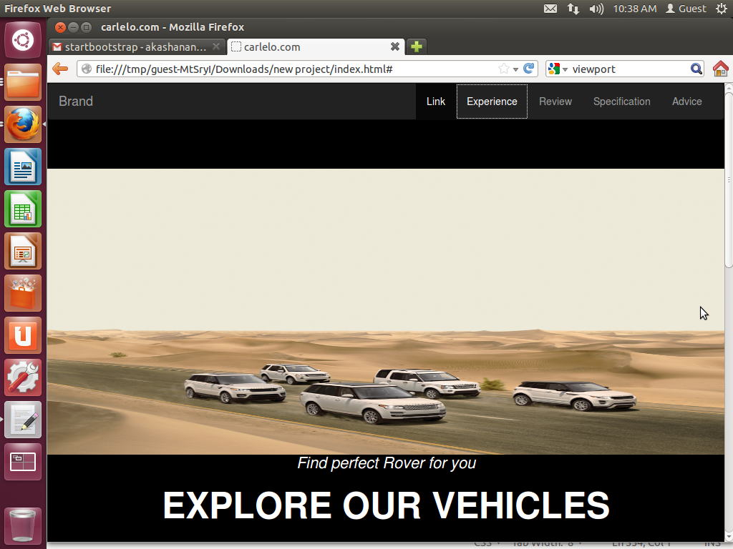

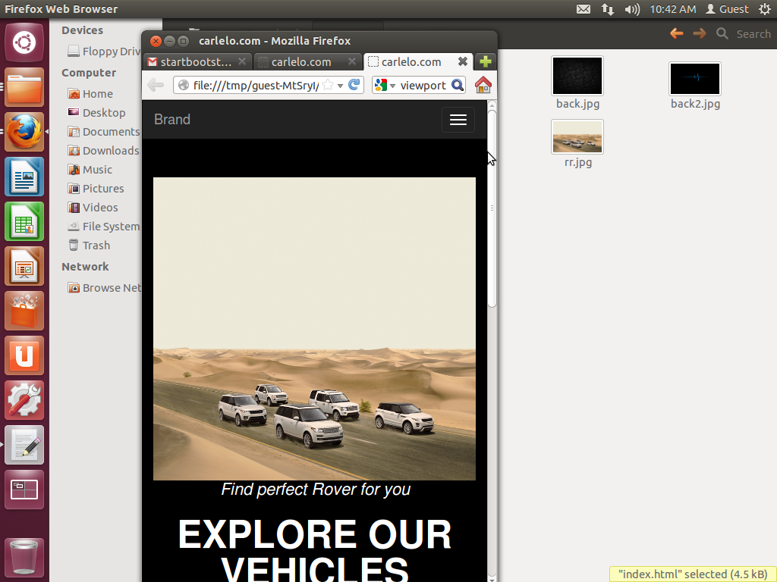After

3. media query

Content

header {

text-align: center;

color: #fff;

background-attachment: scroll;

background-image: url(../img/header-bg.jpg);

background-position: center center;

background-repeat: none;

-webkit-background-size: cover;

-moz-background-size: cover;

background-size: cover;

-o-background-size: cover;

}

header .intro-text {

padding-top: 100px;

padding-bottom: 50px;

color:white;

}

header .intro-text .intro-lead-in {

margin-bottom: 25px;

font-family: "Droid Serif","Helvetica Neue",Helvetica,Arial,sans-serif;

font-size: 22px;

font-style: italic;

line-height: 22px;

color:white;

}

header .intro-text .intro-heading {

margin-bottom: 25px;

text-transform: uppercase;

font-family: Montserrat,"Helvetica Neue",Helvetica,Arial,sans-serif;

font-size: 50px;

font-weight: 700;

line-height: 50px;

color:white;

}

section {

padding: 150px 0;

}

}

.service-heading {

margin: 15px 0;

text-transform: none;

color: white;

}

Navbar

@media(min-width:768px) {

.navbar-default {

padding: 25px 0;

border: 0;

background-color: transparent;

-webkit-transition: padding .3s;

-moz-transition: padding .3s;

transition: padding .3s;

}

.navbar-default .navbar-brand {

font-size: 2em;

-webkit-transition: all .3s;

-moz-transition: all .3s;

transition: all .3s;

}

.navbar-default .navbar-nav>.active>a {

border-radius: 3px;

}

.navbar-default.navbar-shrink {

padding: 10px 0;

background-color: #222;

}

.navbar-default.navbar-shrink .navbar-brand {

font-size: 1.5em;

}

}

@media (max-width: 767px) {

.navbar-inverse .navbar-nav .open .dropdown-menu > .dropdown-header {

border-color: #080808;

}

.navbar-inverse .navbar-nav .open .dropdown-menu .divider {

background-color: #080808;

}

.navbar-inverse .navbar-nav .open .dropdown-menu > li > a {

color: #9d9d9d;

}

.navbar-inverse .navbar-nav .open .dropdown-menu > li > a:hover,

.navbar-inverse .navbar-nav .open .dropdown-menu > li > a:focus {

color: #fff;

background-color: transparent;

}

.navbar-inverse .navbar-link {

color: #9d9d9d;

}

.navbar-inverse .navbar-link:hover {

color: #fff;

.navbar-inverse .btn-link[disabled]:hover,

fieldset[disabled] .navbar-inverse .btn-link:hover,

.navbar-inverse .btn-link[disabled]:focus,

fieldset[disabled] .navbar-inverse .btn-link:focus {

color: #444;

}

Before:

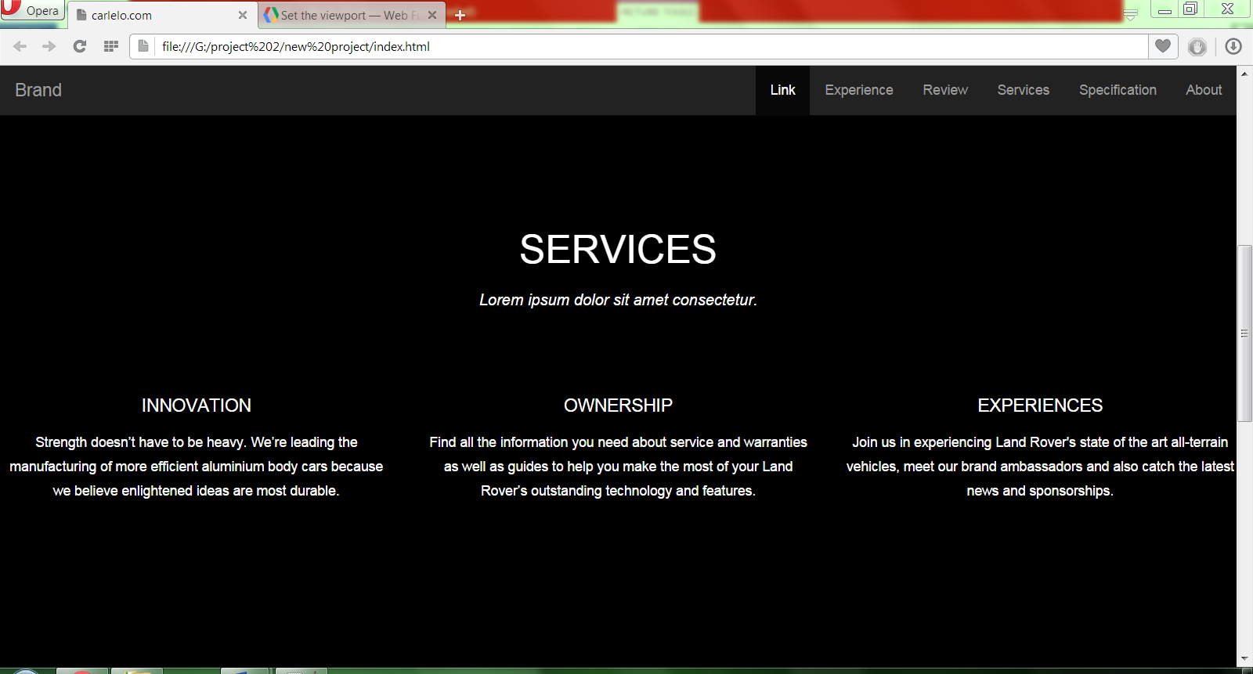

after

