SIX WEEKS SUMMER TRAINING

REPORT

on

Android App Development/Cake Online Shopping App

Submitted by

Vipin Goriparthi

Registration No:11914513

Program Name:B.tech(Information Technology)

Under the Guidance of

Sudipta Paitandi

School of Computer Science & Engineering

Lovely Professional University, Phagwara

(June-July, 2021)

**DECLARATION**

I hereby declare that I have completed my six weeks summer training at “Fifthforce”,Kolkata

from 05-06-2021 to 13-07-2021 under the guidance of Sudipta Paitandi. I declare that I have worked with full dedication during these six weeks of training and my learning outcomes full fill the requirements of training for the award of degree of android app development, Lovely Professional University, Phagwara.

Name of Student: Vipin Goriparthi

Registration no:11914513

ACKNOWLEDGEMENT

I would like to thank my teacher Anindya Banerjee for helping me with this project. He allowed me to work on this project.

I would also want to thank my group members who helped me in finalizing this project within a limited time frame.

Summer training Certificate

CONTENTS

|  |  |  |
| --- | --- | --- |
| SR. NO | CHAPTER NAME | PAGE NO |
| 1. | ABSTRACT | 4 |
| 2.1 | TOOLS AND TECHNOLOGY | 5 |
| 2.2 | PROFILE OF THE PROBLEM | 5 |
| 3. | INTRODUCTION | 6 |
| 4. | SNAPSHOTS | 7-16 |
| 5. | SOURCE CODE | 17-27 |
| 6. | SYSTEM REQUIREMENTS | 28 |
| 7. | FEATURES | 29 |
| 8. | DEVELOPMENT  TOOLS | 29 |
| 9. | FUTURE SCOPE | 29 |
| 10. | DATEWISE TOPICS | 30 |
| 10. | SUMMARY | 31 |

ABSTRACT

Modern hands held devices such as smart phones and PDAs have been increasingly powerful in recent years. Dramatic break throughs in processing power along with the number of extra features included in these devices have opened the doors to a wide range of commercial possibilities. In particular, most cell phones regularly include almost all feature that a PC provides.

As mobile devices have over-came the PC in terms hand on uses. Most of the works can be done through it such as payment, shopping, food ordering etc. We introduce the Online Cake Ordering App (Cherry Cakes) developed for the Android Users.

The prime objective of “Cherry Cakes” is to provide a platform for the cakes shops to increase their sales and improve reputation in the market. The user can find his/her liking shop to order the cake, they can also see the menu of that shop to order. User have to pay online through safe portals and cake will be delivered.

The project is developed in Java Programming Language. We use Android Software Development Kit (SDK) which includes a variety of custom tools that helps us develop mobile applications on Android Platform. We used Git Hub to share the code and development of the project among the Group Members.

TOOLS AND TECHNOLOGY

* Android Studio
* Git Hub
* Also.in

Reason: Code changes can be witnessed in the emulator or physical device on real-time without restarting the app or building a new APK (Android Application Package file) every time. Featuring an intelligent Code Editor equipped with IntelliJ IDEA interface, Android Studio makes code writing and analysis faster, easier and more accurate.

PROFILE OF PROBLEM

1. Help Cake business to go online
2. Increase sales and reputation
3. Help entrepreneurs to grow their business in digital world.
4. Online payment
5. Option to choose your liking shop
6. Attractive user interface

REULTS AND DISCUSIONS

Introduction

This chapter highlights the results of the project, code and snapshots for each of the activities are shown along with the discussion of each activity describing it’s working. Each snapshot describes every single step of the Cherry Cake App. All main activities as well as options provided to the users in each activities.

Snapshots of outputs

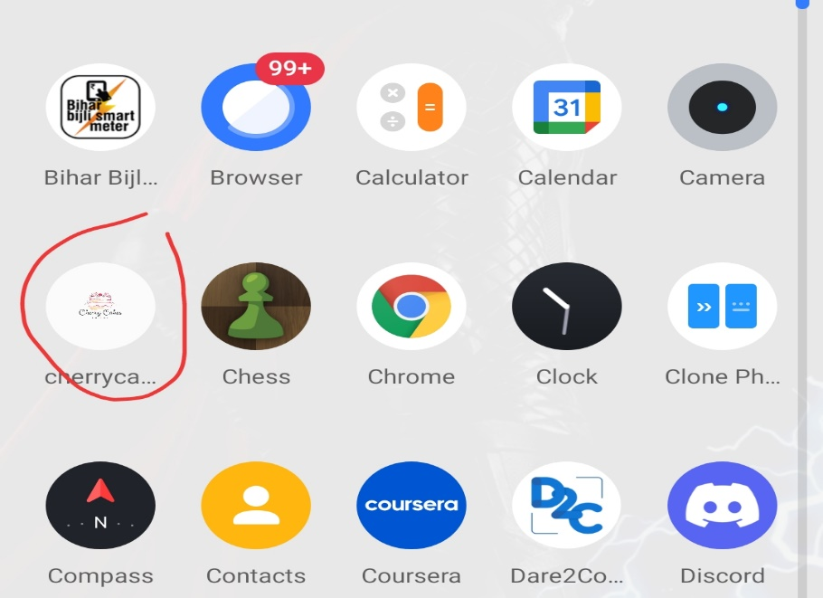

The circled icon is the image icon representation of the Cherry Cakes (online cake ordering app) on clicking it will open the application which results in the creation of the first activity.

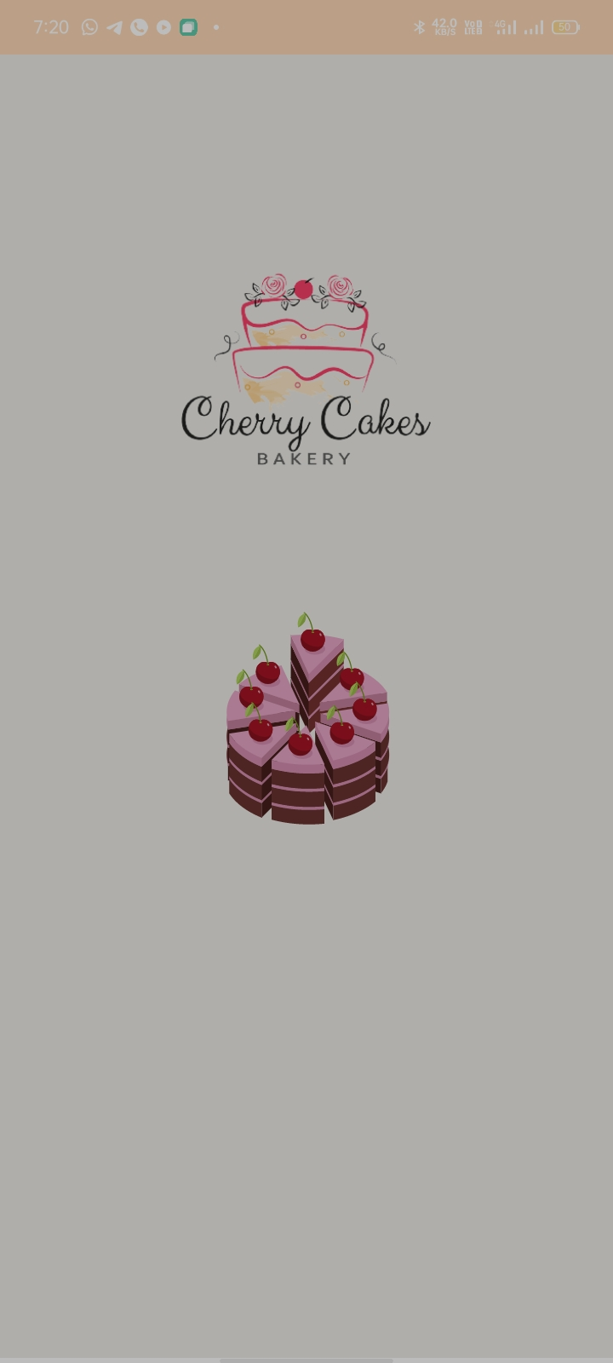

This is the first screen or activity of the project output, which will open the app with a little bit of animation which will lead to the user interface.

5.

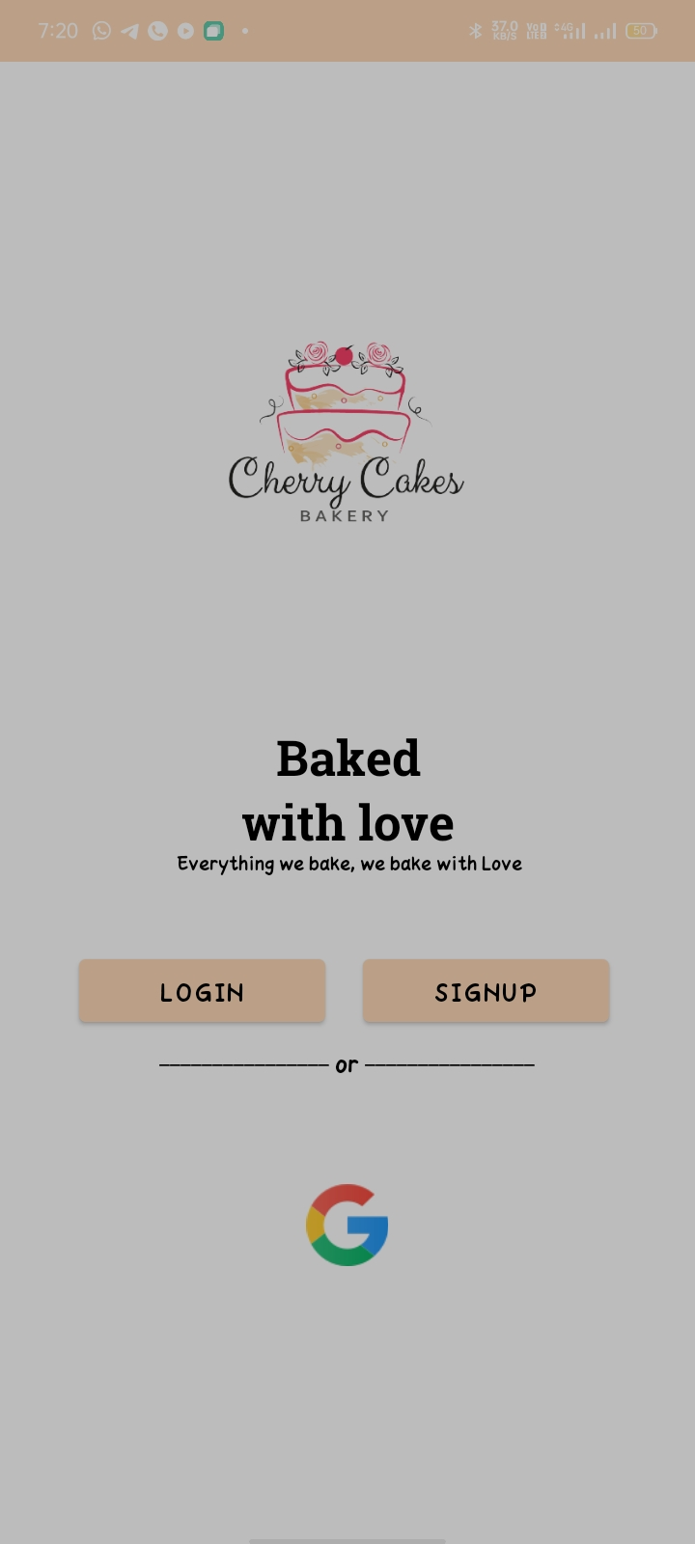

After the app starts the users will see this screen where they have to sign up for the new users or login who have already registered.

6.

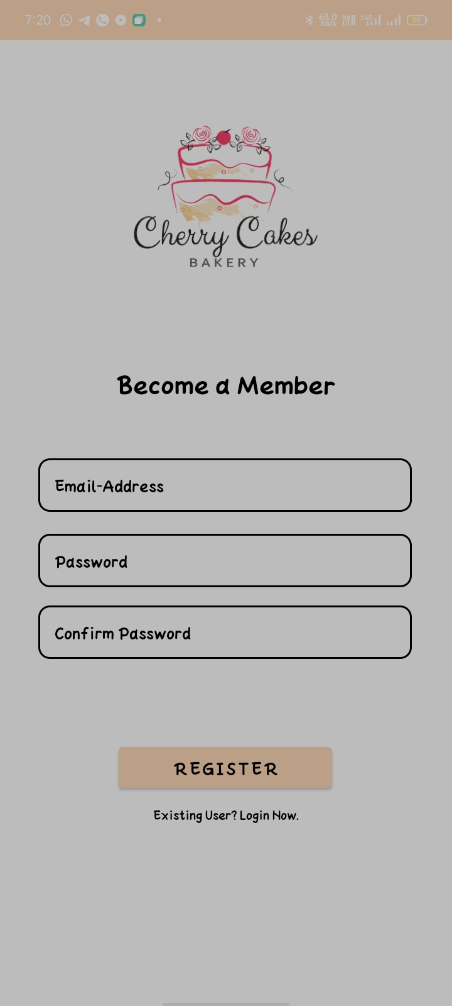

If the user taps on the signup option user will be directed to this page where he/she has to provide a valid email and a strong password to register.

7.

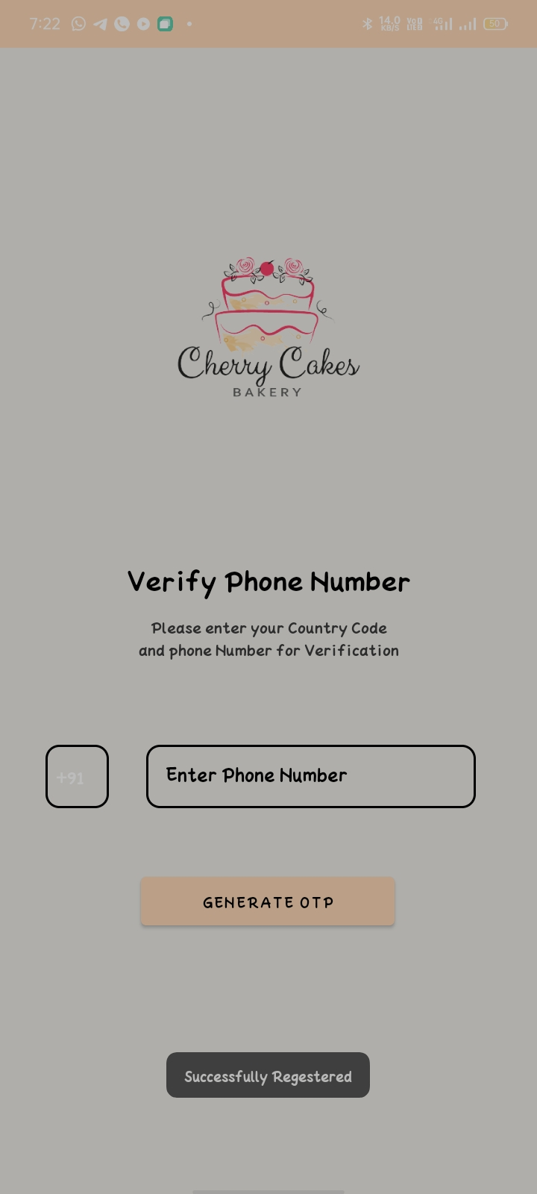

After clicking on the register option user have to provide a valid phone number for more security reasons and generate OTP.

9.

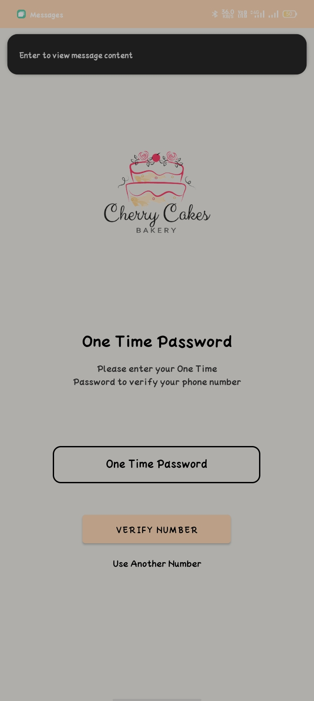

Now user have to type the OTP that has sent on the number provided during registration to verify the number. In case number does not matches, user have to try again.

10.

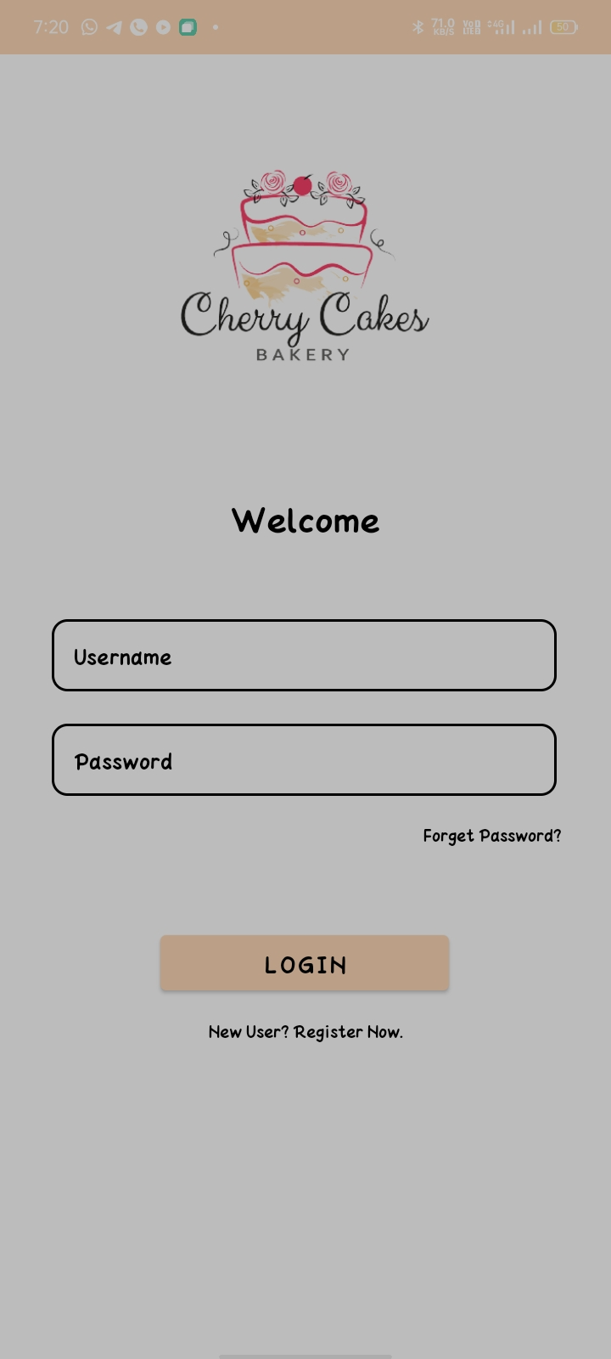

In case user have already registered, user have to provide login credentials to login. In user does not remember the password, there is option of “Forgot Password?” to help login with registered number.

11.

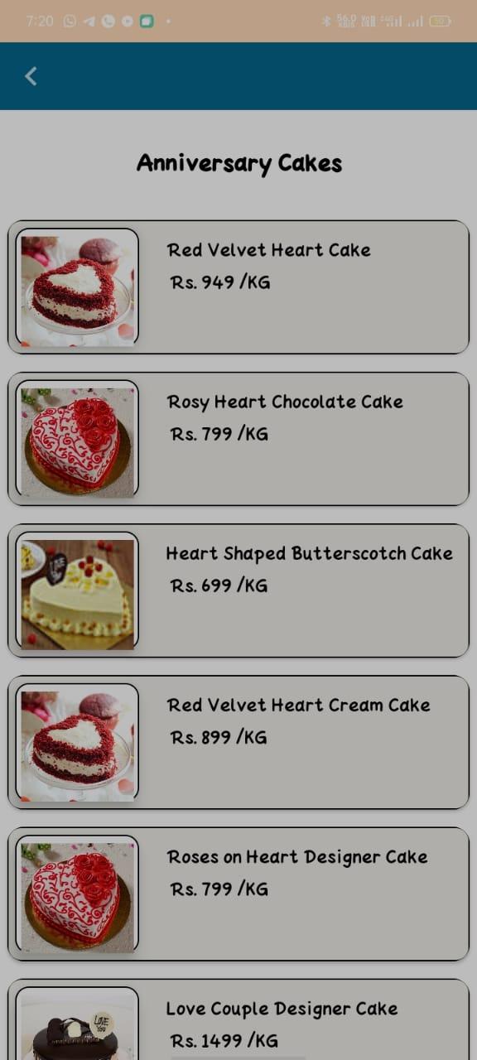

After successful login user will land on this page where he/she will see various kind of cakes and options to choose from them to order or explore.

12.

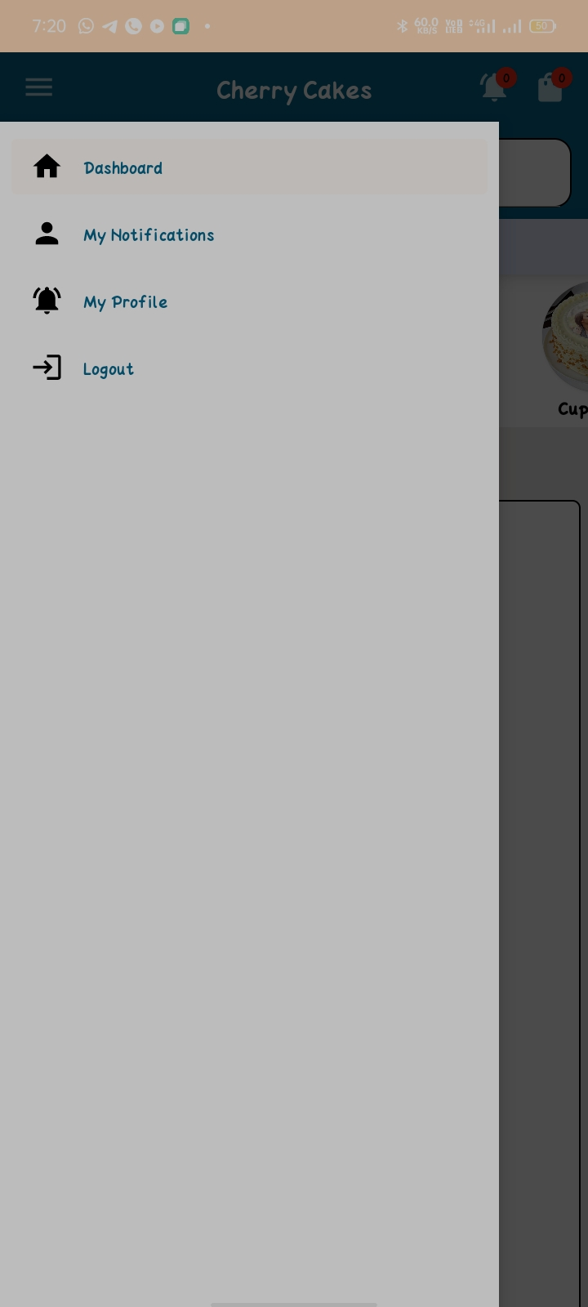

These are the options that are available for the user to help them to better their experience with the app. Here we have provided some of the basic options like notification, profile, logout etc.

13.

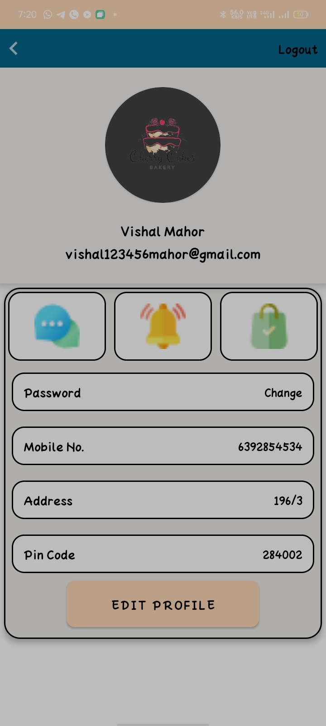

Here users can update their profile easily and update their address, password or mobile number for better choice.

14.

Source Code

Android Main.xml

*<?***xml version="1.0" encoding="utf-8"***?>*<**manifest xmlns:android="http://schemas.android.com/apk/res/android"  
 package="com.example.cherrycakes"**>  
  
 <**uses-permission android:name="android.permission.ACCESS_FINE_LOCATION"** />  
 <**uses-permission android:name="android.permission.ACCESS_FINE_LOCATION"** />  
 <**uses-permission android:name="android.permission.INTERNET"** />  
  
 <**application  
 android:allowBackup="true"  
 android:icon="@drawable/logo"  
 android:label="@string/app_name"  
 android:roundIcon="@mipmap/ic_launcher_round"  
 android:supportsRtl="true"  
 android:theme="@style/Theme.Cherrycakes"**>  
 <**activity android:name=".PaymentActivity"** />  
 <**activity android:name=".edit_profile_Activity"** />  
 <**activity android:name=".Profile_Activity"** />  
 <**activity android:name=".locationActivity"** />  
 <**activity android:name=".item_details_Activity"** />  
 <**activity android:name=".fruit_cake_Activity"** />  
 <**activity android:name=".sponge_cake_Activity"** />  
 <**activity android:name=".Red_velvet_cake_Activity"** />  
 <**activity android:name=".customize_cakes_Activity"** />  
 <**activity android:name=".photo_cake_Activity"** />  
 <**activity android:name=".Chocolate_Activity"** />  
 <**activity android:name=".square_cakes_Activity"** />  
 <**activity android:name=".Heart_cakes_Activity"** />  
 <**activity android:name=".RoundcakesActivity"** />  
 <**activity android:name=".homeActivity"** />  
 <**activity android:name=".OTPActivity"** />  
 <**activity android:name=".phoneActivity"** />  
 <**activity android:name=".signupActivity"** />  
 <**activity android:name=".welcomeActivity"** />  
 <**activity android:name=".LoginActivity"** />  
 <**activity android:name=".MainActivity"**>  
 <**intent-filter**>  
 <**action android:name="android.intent.action.MAIN"** />  
  
 <**category android:name="android.intent.category.LAUNCHER"** />  
 </**intent-filter**>  
 </**activity**>  
  
 <**meta-data  
 android:name="preloaded_fonts"  
 android:resource="@array/preloaded_fonts"** />  
 </**application**>  
  
</**manifest**>

Activity_main.xml

*<?***xml version="1.0" encoding="utf-8"***?>*<**androidx.constraintlayout.widget.ConstraintLayout xmlns:android="http://schemas.android.com/apk/res/android"  
 xmlns:app="http://schemas.android.com/apk/res-auto"  
 xmlns:tools="http://schemas.android.com/tools"  
 android:layout_width="match_parent"  
 android:layout_height="match_parent"  
 tools:context=".MainActivity"  
 android:background="@color/white"**>  
  
  
 <**ImageView  
 android:id="@+id/back_scene"  
 android:layout_width="match_parent"  
 android:layout_height="900dp"  
 android:background="@color/platinum"  
 app:layout_constraintBottom_toBottomOf="parent"  
 app:layout_constraintStart_toStartOf="parent"  
 app:layout_constraintTop_toTopOf="parent"  
 app:layout_constraintVertical_bias="0.0"** />  
  
 <**ImageView  
 android:id="@+id/logo"  
 android:layout_width="300dp"  
 android:layout_height="300dp"  
 android:background="@drawable/logo"  
 app:layout_constraintBottom_toBottomOf="parent"  
 app:layout_constraintEnd_toEndOf="parent"  
 app:layout_constraintHorizontal_bias="0.495"  
 app:layout_constraintStart_toStartOf="parent"  
 app:layout_constraintTop_toTopOf="parent"  
 app:layout_constraintVertical_bias="0.118"** />  
  
 <**com.airbnb.lottie.LottieAnimationView  
 android:id="@+id/splash_motion"  
 android:layout_width="wrap_content"  
 android:layout_height="200dp"  
 app:lottie_autoPlay="true"  
 app:lottie_rawRes="@raw/splash"  
 app:layout_constraintVertical_bias="0"  
 app:layout_constraintBottom_toBottomOf="parent"  
 app:layout_constraintEnd_toEndOf="parent"  
 app:layout_constraintStart_toStartOf="parent"  
 app:layout_constraintTop_toBottomOf="@+id/logo"** />  
  
</**androidx.constraintlayout.widget.ConstraintLayout**>

Activity_login.xml

*<?***xml version="1.0" encoding="utf-8"***?>*<**androidx.constraintlayout.widget.ConstraintLayout xmlns:android="http://schemas.android.com/apk/res/android"  
 xmlns:app="http://schemas.android.com/apk/res-auto"  
 xmlns:tools="http://schemas.android.com/tools"  
 android:layout_width="match_parent"  
 android:layout_height="match_parent"  
 tools:context=".LoginActivity"**>  
  
 <**ImageView  
 android:id="@+id/imageView"  
 android:layout_width="match_parent"  
 android:layout_height="match_parent"  
 android:background="@color/white"  
 app:layout_constraintBottom_toBottomOf="parent"  
 app:layout_constraintEnd_toEndOf="parent"  
 app:layout_constraintStart_toStartOf="parent"  
 app:layout_constraintTop_toTopOf="parent"** />  
  
 <**ImageView  
 android:id="@+id/imageView2"  
 android:layout_width="300dp"  
 android:layout_height="300dp"  
 android:src="@drawable/logo"  
 app:layout_constraintBottom_toBottomOf="parent"  
 app:layout_constraintEnd_toEndOf="parent"  
 app:layout_constraintHorizontal_bias="0.495"  
 app:layout_constraintStart_toStartOf="parent"  
 app:layout_constraintTop_toTopOf="parent"  
 app:layout_constraintVertical_bias="0"** />  
  
 <**TextView  
 android:id="@+id/textView3"  
 android:layout_width="wrap_content"  
 android:layout_height="wrap_content"  
 android:text="Welcome"  
 android:textColor="@color/black"  
 android:textSize="30dp"  
 app:layout_constraintBottom_toBottomOf="parent"  
 app:layout_constraintEnd_toEndOf="parent"  
 app:layout_constraintStart_toStartOf="parent"  
 app:layout_constraintTop_toBottomOf="@+id/imageView2"  
 app:layout_constraintVertical_bias="0"** />  
  
 <**EditText  
 android:id="@+id/txt_emails"  
 android:layout_width="350dp"  
 android:layout_height="50dp"  
 android:background="@drawable/sp"  
 android:hint="Username"  
 android:paddingLeft="15dp"  
 android:textColor="@color/black"  
 android:textColorHint="@color/black"  
 app:layout_constraintBottom_toBottomOf="@+id/imageView"  
 app:layout_constraintEnd_toEndOf="parent"  
 app:layout_constraintHorizontal_bias="0.491"  
 app:layout_constraintStart_toStartOf="parent"  
 app:layout_constraintTop_toBottomOf="@+id/textView3"  
 app:layout_constraintVertical_bias="0.1"** />  
  
 <**EditText  
 android:id="@+id/txt_passwords"  
 android:layout_width="350dp"  
 android:layout_height="50dp"  
 android:background="@drawable/sp"  
 android:hint="Password"  
 android:paddingLeft="15dp"  
 android:textColor="@color/black"  
 android:textColorHint="@color/black"  
 app:layout_constraintBottom_toBottomOf="@+id/imageView"  
 app:layout_constraintEnd_toEndOf="parent"  
 app:layout_constraintHorizontal_bias="0.491"  
 app:layout_constraintStart_toStartOf="parent"  
 app:layout_constraintTop_toBottomOf="@+id/txt_emails"  
 app:layout_constraintVertical_bias="0.054"** />  
  
 <**TextView  
 android:id="@+id/forget"  
 android:layout_width="wrap_content"  
 android:layout_height="wrap_content"  
 android:text="Forget Password?"  
 android:textColor="@color/black"  
 app:layout_constraintBottom_toBottomOf="@+id/imageView"  
 app:layout_constraintEnd_toEndOf="parent"  
 app:layout_constraintHorizontal_bias="0.895"  
 app:layout_constraintStart_toStartOf="parent"  
 app:layout_constraintTop_toBottomOf="@+id/txt_passwords"  
 app:layout_constraintVertical_bias="0.045"** />  
  
 <**Button  
 android:id="@+id/btn_login"  
 android:layout_width="200dp"  
 android:layout_height="50dp"  
 android:text="Login"  
 android:textColor="@color/black"  
 android:textSize="20dp"  
 app:layout_constraintBottom_toBottomOf="parent"  
 app:layout_constraintEnd_toEndOf="parent"  
 app:layout_constraintHorizontal_bias="0.497"  
 app:layout_constraintStart_toStartOf="parent"  
 app:layout_constraintTop_toBottomOf="@+id/forget"  
 app:layout_constraintVertical_bias="0.179"** />  
  
 <**TextView  
 android:id="@+id/go_to_register"  
 android:layout_width="wrap_content"  
 android:layout_height="wrap_content"  
 android:text="New User? Register Now."  
 android:textColor="@color/black"  
 app:layout_constraintVertical_bias="0.05"  
 app:layout_constraintBottom_toBottomOf="@+id/imageView"  
 app:layout_constraintEnd_toEndOf="parent"  
 app:layout_constraintStart_toStartOf="parent"  
 app:layout_constraintTop_toBottomOf="@+id/btn_login"** />  
  
</**androidx.constraintlayout.widget.ConstraintLayout**>

Activity_signup.xml

*<?***xml version="1.0" encoding="utf-8"***?>*<**androidx.constraintlayout.widget.ConstraintLayout xmlns:android="http://schemas.android.com/apk/res/android"  
 xmlns:app="http://schemas.android.com/apk/res-auto"  
 xmlns:tools="http://schemas.android.com/tools"  
 android:layout_width="match_parent"  
 android:layout_height="match_parent"  
 tools:context=".signupActivity"**>  
  
 <**ImageView  
 android:id="@+id/imageView"  
 android:layout_width="match_parent"  
 android:layout_height="match_parent"  
 android:background="@color/white"  
 app:layout_constraintBottom_toBottomOf="parent"  
 app:layout_constraintEnd_toEndOf="parent"  
 app:layout_constraintStart_toStartOf="parent"  
 app:layout_constraintTop_toTopOf="parent"** />  
  
 <**ImageView  
 android:id="@+id/imageView2"  
 android:layout_width="300dp"  
 android:layout_height="300dp"  
 android:src="@drawable/logo"  
 app:layout_constraintBottom_toBottomOf="parent"  
 app:layout_constraintEnd_toEndOf="parent"  
 app:layout_constraintHorizontal_bias="0.495"  
 app:layout_constraintStart_toStartOf="parent"  
 app:layout_constraintTop_toTopOf="parent"  
 app:layout_constraintVertical_bias="0"** />  
  
 <**TextView  
 android:id="@+id/textView3"  
 android:layout_width="wrap_content"  
 android:layout_height="wrap_content"  
 android:text="Become a Member"  
 android:textColor="@color/black"  
 android:textSize="30dp"  
 app:layout_constraintBottom_toBottomOf="parent"  
 app:layout_constraintEnd_toEndOf="parent"  
 app:layout_constraintStart_toStartOf="parent"  
 app:layout_constraintTop_toBottomOf="@+id/imageView2"  
 app:layout_constraintVertical_bias="0"** />  
  
 <**EditText  
 android:id="@+id/txt_email"  
 android:layout_width="350dp"  
 android:layout_height="50dp"  
 android:background="@drawable/sp"  
 android:hint="Email-Address"  
 android:paddingLeft="15dp"  
 android:textColor="@color/black"  
 android:textColorHint="@color/black"  
 app:layout_constraintBottom_toBottomOf="@+id/imageView"  
 app:layout_constraintEnd_toEndOf="parent"  
 app:layout_constraintHorizontal_bias="0.491"  
 app:layout_constraintStart_toStartOf="parent"  
 app:layout_constraintTop_toBottomOf="@+id/textView3"  
 app:layout_constraintVertical_bias="0.1"** />  
  
 <**EditText  
 android:id="@+id/txt_password"  
 android:layout_width="350dp"  
 android:layout_height="50dp"  
 android:background="@drawable/sp"  
 android:hint="Password"  
 android:inputType="textPassword"  
 android:paddingLeft="15dp"  
 android:textColor="@color/black"  
 android:textColorHint="@color/black"  
 app:layout_constraintBottom_toBottomOf="parent"  
 app:layout_constraintEnd_toEndOf="parent"  
 app:layout_constraintHorizontal_bias="0.488"  
 app:layout_constraintStart_toStartOf="parent"  
 app:layout_constraintTop_toBottomOf="@+id/txt_email"  
 app:layout_constraintVertical_bias="0.05"** />  
  
 <**EditText  
 android:id="@+id/txt_cpassword"  
 android:layout_width="350dp"  
 android:layout_height="50dp"  
 android:background="@drawable/sp"  
 android:hint="Confirm Password"  
 android:paddingLeft="15dp"  
 android:textColor="@color/black"  
 android:inputType="textPassword"  
 android:textColorHint="@color/black"  
 app:layout_constraintBottom_toBottomOf="@+id/imageView"  
 app:layout_constraintEnd_toEndOf="parent"  
 app:layout_constraintHorizontal_bias="0.491"  
 app:layout_constraintStart_toStartOf="parent"  
 app:layout_constraintTop_toBottomOf="@+id/txt_password"  
 app:layout_constraintVertical_bias="0.05"** />  
  
 <**Button  
 android:id="@+id/btn_register"  
 android:layout_width="200dp"  
 android:layout_height="50dp"  
 android:text="Register"  
 android:textColor="@color/black"  
 android:textSize="20dp"  
 app:layout_constraintBottom_toBottomOf="parent"  
 app:layout_constraintEnd_toEndOf="parent"  
 app:layout_constraintHorizontal_bias="0.497"  
 app:layout_constraintStart_toStartOf="parent"  
 app:layout_constraintTop_toBottomOf="@+id/txt_cpassword"  
 app:layout_constraintVertical_bias="0.278"** />  
  
 <**TextView  
 android:id="@+id/go_to_login"  
 android:layout_width="wrap_content"  
 android:layout_height="wrap_content"  
 android:text="Existing User? Login Now."  
 android:textColor="@color/black"  
 app:layout_constraintVertical_bias="0.05"  
 app:layout_constraintBottom_toBottomOf="@+id/imageView"  
 app:layout_constraintEnd_toEndOf="parent"  
 app:layout_constraintStart_toStartOf="parent"  
 app:layout_constraintTop_toBottomOf="@+id/btn_register"** />  
  
</**androidx.constraintlayout.widget.ConstraintLayout**>

Activity_editprofile.xml

*<?***xml version="1.0" encoding="utf-8"***?>*<**androidx.constraintlayout.widget.ConstraintLayout xmlns:android="http://schemas.android.com/apk/res/android"  
 xmlns:app="http://schemas.android.com/apk/res-auto"  
 xmlns:tools="http://schemas.android.com/tools"  
 android:layout_width="match_parent"  
 android:layout_height="match_parent"  
 android:background="@color/platinum"  
 tools:context=".edit_profile_Activity"**>  
  
 <**LinearLayout  
 android:id="@+id/back_to_home"  
 android:layout_width="match_parent"  
 android:layout_height="50dp"  
 app:layout_constraintVertical_bias="0"  
 android:background="@color/blue_sapphire"  
 app:layout_constraintBottom_toBottomOf="parent"  
 app:layout_constraintEnd_toEndOf="parent"  
 app:layout_constraintStart_toStartOf="parent"  
 app:layout_constraintTop_toTopOf="parent"**>  
  
 <**ImageView  
 android:layout_width="wrap_content"  
 android:layout_height="wrap_content"  
 android:layout_gravity="center"  
 android:layout_margin="10dp"  
 android:src="@drawable/ic_baseline_navigate_before_24"** />  
 <**TextView  
 android:id="@+id/users"  
 android:layout_width="wrap_content"  
 android:layout_height="wrap_content"**/>  
 </**LinearLayout**>  
  
 <**TextView  
 android:id="@+id/textView5"  
 android:layout_width="match_parent"  
 android:layout_height="wrap_content"  
 android:layout_margin="20dp"  
 android:gravity="center"  
 android:text="Edit Profile"  
 android:textColor="@color/black"  
 android:textSize="35dp"  
 app:layout_constraintBottom_toBottomOf="parent"  
 app:layout_constraintEnd_toEndOf="parent"  
 app:layout_constraintStart_toStartOf="parent"  
 app:layout_constraintTop_toBottomOf="@+id/back_to_home"  
 app:layout_constraintVertical_bias="0"** />  
  
 <**EditText  
 android:id="@+id/txts_name"  
 android:layout_width="match_parent"  
 android:layout_height="50dp"  
 android:textColor="@color/black"  
 android:layout_margin="20dp"  
 android:background="@drawable/sp"  
 android:hint="Name"  
 android:padding="15dp"  
 app:layout_constraintVertical_bias="0.1"  
 android:textColorHint="@color/black"  
 app:layout_constraintBottom_toBottomOf="parent"  
 app:layout_constraintEnd_toEndOf="parent"  
 app:layout_constraintStart_toStartOf="parent"  
 app:layout_constraintTop_toBottomOf="@+id/textView5"** />  
  
 <**EditText  
 android:id="@+id/txts_email"  
 android:textColor="@color/black"  
 android:layout_width="match_parent"  
 android:inputType="textEmailAddress"  
 android:layout_height="50dp"  
 android:layout_margin="20dp"  
 android:background="@drawable/sp"  
 android:hint="Email-Address"  
 android:padding="15dp"  
 android:textColorHint="@color/black"  
 app:layout_constraintBottom_toBottomOf="parent"  
 app:layout_constraintEnd_toEndOf="parent"  
 app:layout_constraintStart_toStartOf="parent"  
 app:layout_constraintTop_toBottomOf="@+id/txts_name"  
 app:layout_constraintVertical_bias="0"**/>  
  
 <**EditText  
 android:id="@+id/txts_mobile"  
 android:layout_width="match_parent"  
 android:textColor="@color/black"  
 android:layout_height="50dp"  
 android:layout_margin="20dp"  
 android:layout_marginBottom="16dp"  
 android:inputType="number"  
 android:background="@drawable/sp"  
 android:hint="Mobile No."  
 android:padding="15dp"  
 android:textColorHint="@color/black"  
 app:layout_constraintVertical_bias="0"  
 app:layout_constraintBottom_toBottomOf="parent"  
 app:layout_constraintEnd_toEndOf="parent"  
 app:layout_constraintStart_toStartOf="parent"  
 app:layout_constraintTop_toBottomOf="@+id/txts_email"** />  
  
 <**EditText  
 android:id="@+id/txts_Address"  
 android:layout_width="match_parent"  
 android:layout_height="50dp"  
 android:layout_margin="20dp"  
 android:textColor="@color/black"  
 android:layout_marginBottom="52dp"  
 android:background="@drawable/sp"  
 android:hint="Address"  
 android:padding="15dp"  
 android:textColorHint="@color/black"  
 app:layout_constraintBottom_toBottomOf="parent"  
 app:layout_constraintVertical_bias="0.04"  
 app:layout_constraintEnd_toEndOf="parent"  
 app:layout_constraintStart_toStartOf="parent"  
 app:layout_constraintTop_toBottomOf="@+id/txts_mobile"** />  
  
 <**EditText  
 android:id="@+id/txts_pincode"  
 android:layout_width="match_parent"  
 android:layout_height="50dp"  
 android:textColor="@color/black"  
 android:layout_margin="20dp"  
 android:inputType="number"  
 android:background="@drawable/sp"  
 android:hint="Pin Code"  
 android:padding="15dp"  
 android:textColorHint="@color/black"  
 app:layout_constraintBottom_toBottomOf="parent"  
 app:layout_constraintEnd_toEndOf="parent"  
 app:layout_constraintStart_toStartOf="parent"  
 app:layout_constraintTop_toBottomOf="@+id/txts_Address"  
 app:layout_constraintVertical_bias="0"** />  
  
 <**TextView  
 android:id="@+id/verify_nos"  
 android:layout_width="wrap_content"  
 android:layout_height="wrap_content"  
 android:text="Verify Mobile No.*"  
 android:layout_marginTop="5dp"  
 app:layout_constraintVertical_bias="0.09"  
 android:elevation="10dp"  
 app:layout_constraintHorizontal_bias="0.9"  
 android:textColor="@color/blue_sapphire"  
 app:layout_constraintBottom_toTopOf="@+id/txts_Address"  
 app:layout_constraintEnd_toEndOf="parent"  
 app:layout_constraintStart_toStartOf="parent"  
 app:layout_constraintTop_toBottomOf="@+id/txts_mobile"** />  
  
  
 <**LinearLayout  
 android:layout_width="match_parent"  
 android:layout_height="80dp"  
 app:layout_constraintBottom_toBottomOf="parent"  
 app:layout_constraintEnd_toEndOf="parent"  
 app:layout_constraintStart_toStartOf="parent"  
 app:layout_constraintVertical_bias="0.3"  
 app:layout_constraintTop_toBottomOf="@+id/txts_pincode"**>  
  
 <**Button  
 android:id="@+id/update_profile"  
 android:layout_width="match_parent"  
 android:layout_gravity="center"  
 android:layout_height="60dp"  
 android:layout_marginLeft="40dp"  
 android:layout_marginRight="40dp"  
 android:elevation="10dp"  
 android:text="Update Profile"  
 android:background="@drawable/button"  
 android:textColor="@color/black"  
 android:textSize="20dp"**/>  
  
 </**LinearLayout**>  
  
</**androidx.constraintlayout.widget.ConstraintLayout**>

MainActivity.java

**package** com.example.cherrycakes;  
  
**import** androidx.appcompat.app.AppCompatActivity;  
  
**import** android.content.Intent;  
**import** android.os.Bundle;  
**import** android.os.Handler;  
**import** android.widget.ImageView;  
  
**import** com.airbnb.lottie.LottieAnimationView;  
  
**public class** MainActivity **extends** AppCompatActivity {  
  
 ImageView logo, back;  
 LottieAnimationView;  
 **private static int** SPLASH_SCREEN = 6000;  
  
 @Override  
 **protected void** onCreate(Bundle savedInstanceState) {  
 **super**.onCreate(savedInstanceState);  
 setContentView(R.layout.activity_main);  
  
 logo = findViewById(R.id.logo);  
 back = findViewById(R.id.back_scene);  
 lottieAnimationView = findViewById(R.id.splash_motion);  
  
 back.animate().translationY(-2800).setDuration(1000).setStartDelay(4000);  
 logo.animate().translationY(1900).setDuration(1000).setStartDelay(4000);  
 lottieAnimationView.animate().translationY(1900).setDuration(1000).setStartDelay(4000);  
  
  
 **new** Handler().postDelayed(**new** Runnable() {  
 @Override  
 **public void** run() {  
 Intent = **new** Intent(MainActivity.**this**, welcomeActivity.**class**);  
 startActivity(intent);  
 finish();  
 }  
 }, SPLASH_SCREEN);  
  
 }  
}

SYSTEM REQUIREMENTS

On Client Side

1. Must be an Android User
2. Android Jelly Bean 4.2 or upper
3. Fast internet connection
4. Minimum RAM 512 mb

On Server Side

1.Dual-Core 1.6 Ghz or higher.

2.2 GB RAM.

3.500 MB free disk space.

4.Andoid studio

5.Secure server

6.Fast internet connection

Features

1. Secure Login-Logout (password encrypted)
2. User Friendly
3. Free for Use
4. Open Source
5. Fast Delivery

Development Tools

1. Android Studio
2. Java Programming Language
3. Git Hub
4. Also.in

Future Scope

1. Live Chat
2. Comments
3. Like Dislike
4. User validation using mail and password recovery
5. Improve Security
6. Cross Platform App

|  |  |
| --- | --- |
| **Day** | **Topic** |
| Day-1 | Your first Android App & button clicks |
| Day-2 | Using Intents |
| Day-3 | Returning Data from Intents, Using Action Buttons |
| Day-4 | Using List View |
| Day-5 | Using Alert Dialog |
| Day-6 | Using Notifications, Splash Screens |
| Day-7 | Using Multithreading, Async Task |
| Day-8 | Using Services |
| Day-9 | Using the Adapter class |
| Day-10 | Using Broadcast Receivers, Data Storage |
| Day-11 | Data Storage |
| Day-12 | Introducing SQLite |
| Day-13 | Introducing SQLite Continued |
| Day-14 | Using Maps, WebView |
| Day-15 | Webservice Intro, Resources & Assets |
| Day-16 | Using Camera, creating Charts, Fragments |
| Day-17 | Project Guidance |
| Day-18 | Project Guidance |
| Day-19 | Project Guidance |
| Day-20 | Project Guidance |
| Day-21 | Project Presentation & Viva |
|  |  |

Daywise Topics

SUMMARY

In this chapter we saw all the snapshots of all the activities, along with the features provided to the user. The image icon is the representation of the Cherry Cake App. The first activity has a user login/sign in interface for the user. After validating the sign in trough OTP, user see the dashboard of the app where he/she can search for the shops, see their menu and order the cake. On the left side there is a slide of various option for the user to choose such as my profile, favourite items, log out options etc. User can even search by the shapes of the cake. All members of the group have tested this app and its features. And we are happy to say it’s a very attractive and responsive app to order cake online.