- Execute the mcp_agent.py using python3 command : python3 mcp_agent.py
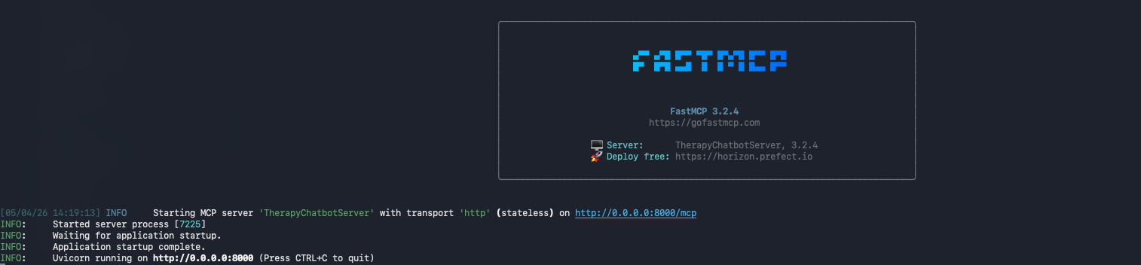

- Run : ngrok http 8000
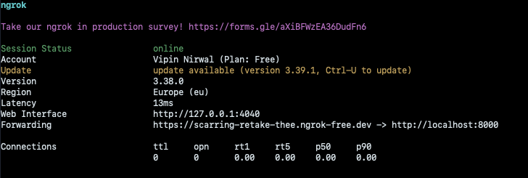

- After running ngrok, you will get a URL that could be exposed publicly and Boomi will be able to access this URL.
https://scarring-retake-thee.ngrok-free.dev
- Go to Boomi Agent Studio and then add source. Select MCP as source.
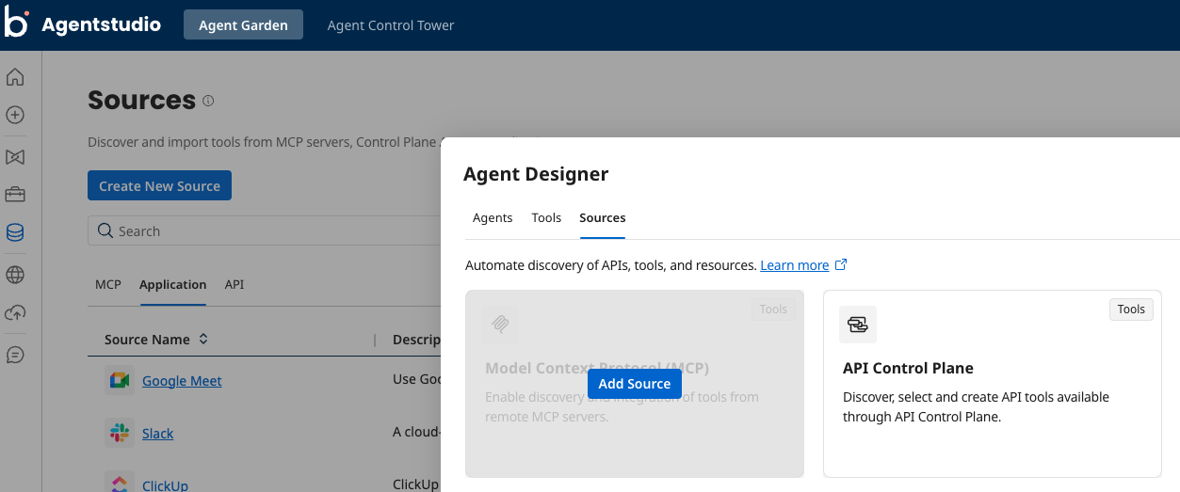
- Please note the /mcp at the end of the URL.

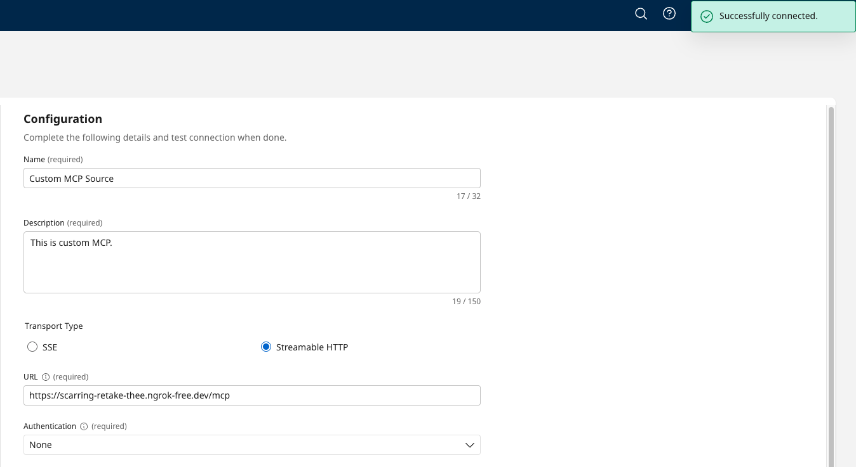

- Below is the tool that we had created in our MCP server.
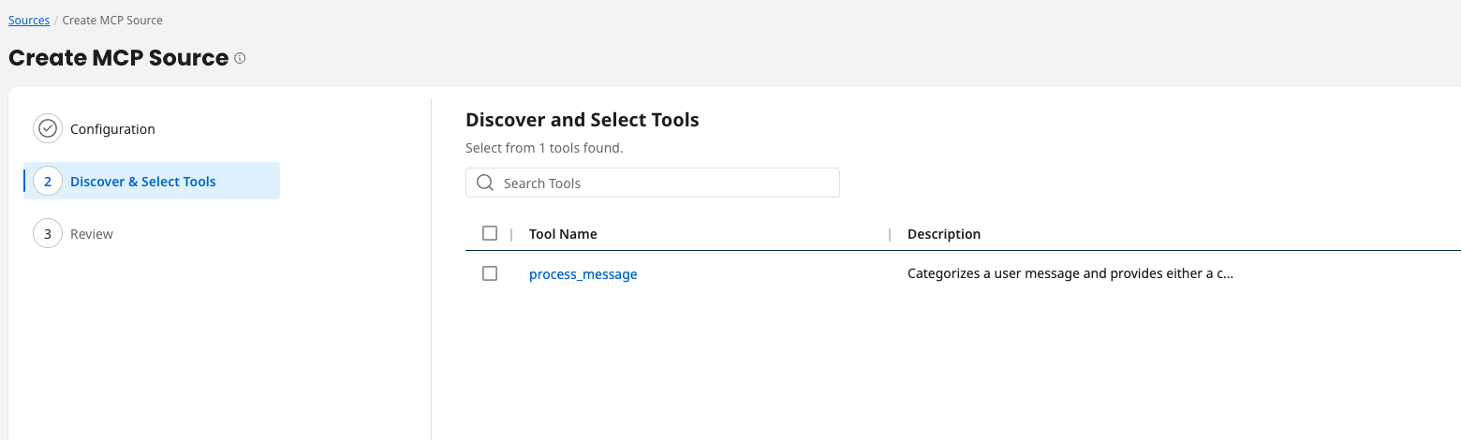
- Now Create Agent and this Agent will use the tool that we discovered via new MCP source.
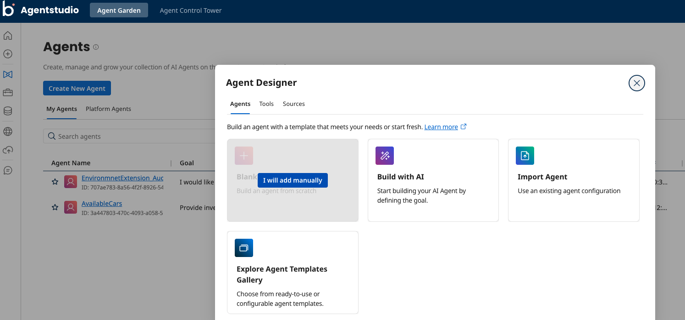

- Create a task in Agent and select the tool that we had discovered earlier.
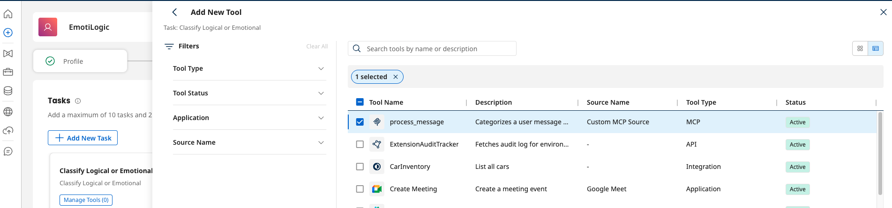

- Test result without deployment.
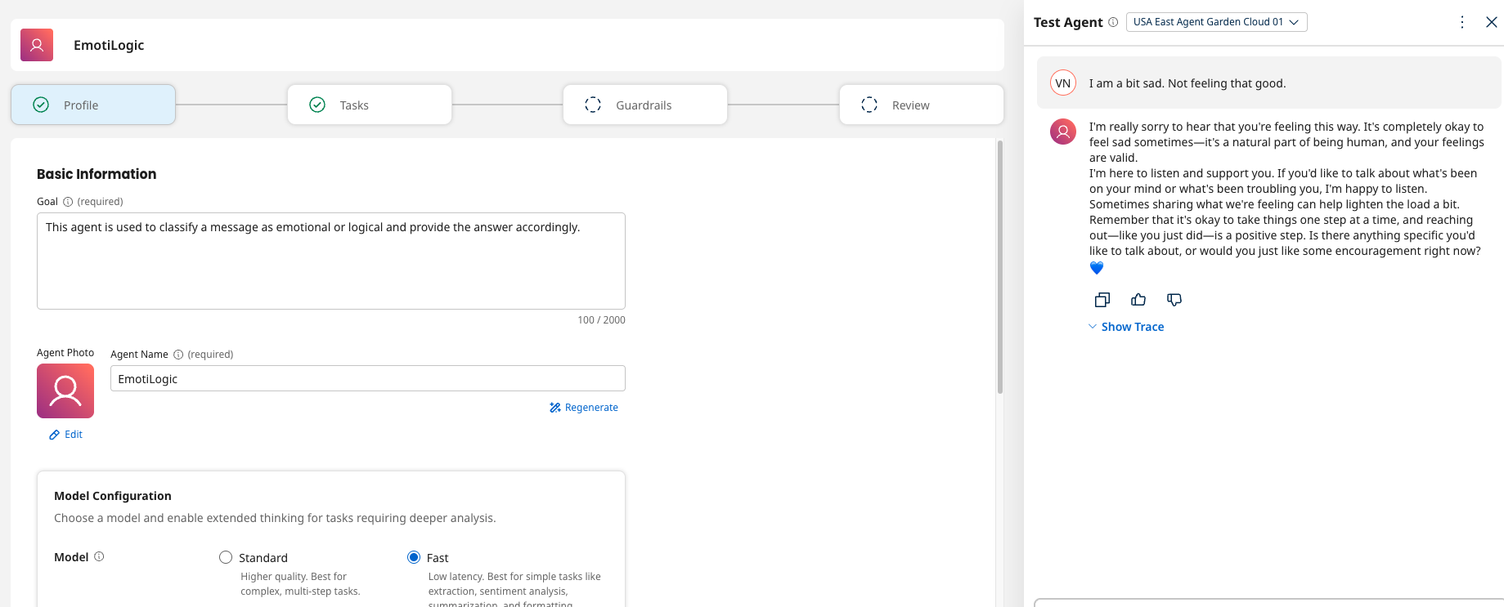

- In next step, configure this agent in Agent control tower. After this step, this agent will be available to be used in integration process.
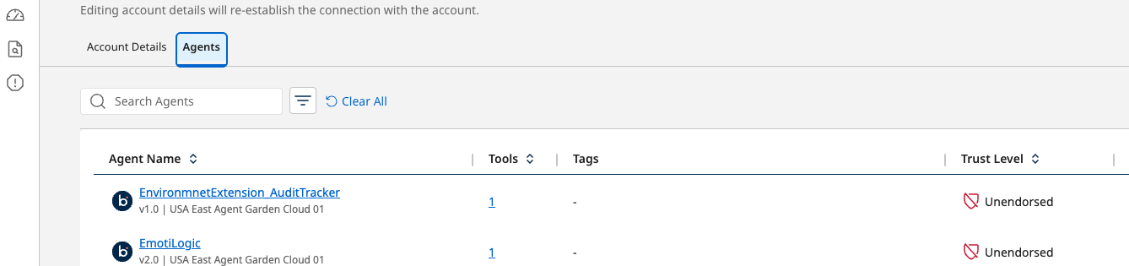

- Create a process in Integration and use this agent.
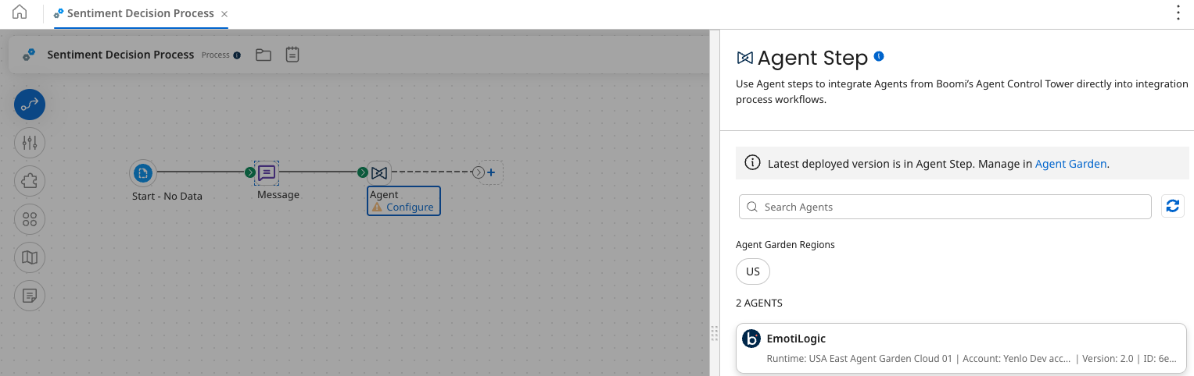

- Test the process locally first and once you see success result, then deploy to your environment.
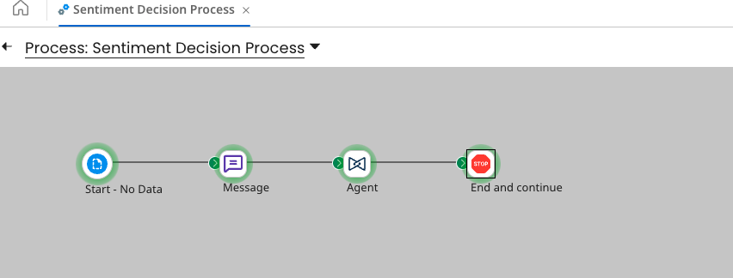

- Response for the question that was asked in this process:
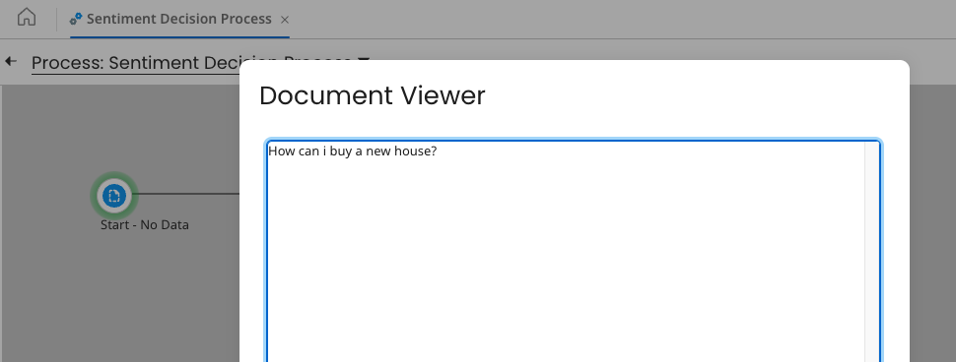

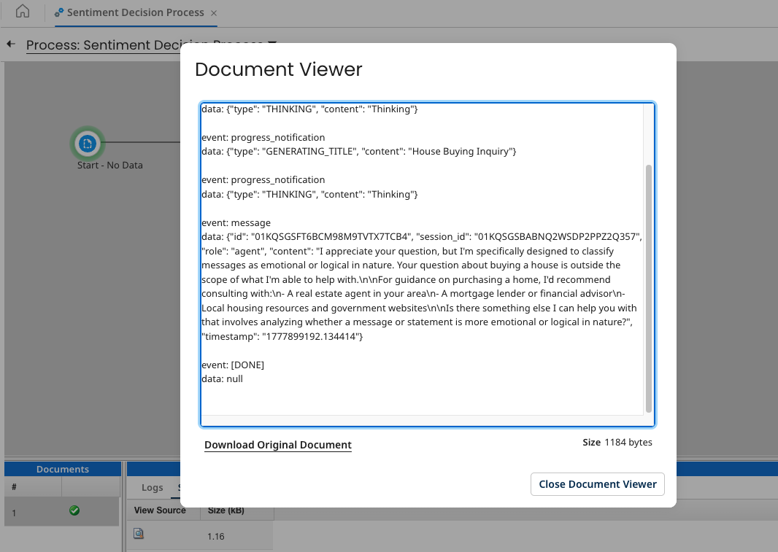

- Congratulation. You have created your first MCP and then invoked that successfully in Boomi via Agent creation.

