Quantum-Enhanced Generative AI for Precision Healthcare: Principles, Architectures, Clinical Applications, and Future Directions
Authors’ Information
Vipin, [Designation], [Department], Gurugram University, Gurugram, Haryana, India. Email: vipin@gurugramuniversity.ac.in. ORCID: [ORCID iD]
Arun, [Designation], [Department], [Institution], [City, Country]. Email: [email address]. ORCID: [ORCID iD]
[Author 3 Full Name], [Designation], [Department], [Institution], [City, Country]. Email: [email address]. ORCID: [ORCID iD]
Corresponding author: [Name, email address]
ABSTRACT
Generative artificial intelligence is being applied in precision healthcare for synthetic patient data, molecular design and image synthesis, yet classical models remain data-hungry. Quantum computing instead encodes probability distributions in the amplitudes of entangled states. The chapter asks whether quantum-enhanced generative models can be useful in precision medicine on present-day hardware. It combines a structured review of 25 foundational and applied studies with a reproducible simulation, in which quantum circuit Born machines and classical restricted Boltzmann machines each learn a six-variable cardiometabolic comorbidity distribution. The deepest quantum circuit reproduced pairwise clinical correlations about as accurately as the best classical baseline. On a likelihood-based divergence it did not beat that baseline at a similar parameter count. Results depended strongly on the measurement budget and only slightly on mild depolarising noise. Quantum generative AI shows promise but no clinical advantage yet, so any claimed benefit has to be tested against strong classical baselines.
Keywords: Quantum Generative Models; Quantum Circuit Born Machine; Precision Medicine; Synthetic Clinical Data; Hybrid Quantum-Classical Learning; NISQ Computing

1. INTRODUCTION

1.1 Background and Context
Precision healthcare tries to fit prevention, diagnosis and treatment to the biology, behaviour and environment of each patient, not to the average person in a population. That depends on finding reliable statistical structure in varied clinical data: electronic health records, genomic and proteomic assays, imaging studies and streams from continuous sensors. AI has shown that this structure can be used at scale, and in some diagnostic tasks deep learning systems now match specialists (Topol, 2019). More recently, attention has moved from discriminative models, which map inputs to labels, to generative models, which learn the joint distribution of the data and so can produce new, plausible samples.
Generative adversarial networks (Goodfellow et al., 2014), variational autoencoders (Kingma & Welling, 2014) and denoising diffusion models (Ho et al., 2020) now support applications such as synthetic electronic health records (Choi et al., 2017) and the reconstruction and augmentation of medical images (Kazerouni et al., 2023). Large foundation models trained on clinical text have extended generative modelling to medical question answering and documentation (Moor et al., 2023; Singhal et al., 2023). All of these approaches need very large training sets and very large numbers of parameters. That is a problem in rare diseases, paediatric cohorts and other settings where data are scarce or sensitive, or are held at separate institutions.
Quantum computing offers a different way of representing probability distributions. A register of n qubits occupies a Hilbert space of dimension 2ⁿ, and measurement of a prepared quantum state yields samples according to the Born rule. Variational circuits whose gate angles are set by a classical optimiser can serve directly as generative models, because the circuit output is already a sampled distribution (Benedetti et al., 2019; Liu & Wang, 2018). There is theoretical evidence that some of these circuits produce distributions no classical computer can sample efficiently (Coyle et al., 2020). Cordier et al. (2022) and Flöther (2023) discuss what that could mean for biology and medicine.

1.2 Research Problem and Significance
Evidence that quantum generative models add practical value in healthcare is still thin. Present devices belong to the noisy intermediate-scale quantum (NISQ) era, in which qubit counts are modest, gate errors are appreciable and circuit depth is constrained (Preskill, 2018). Training of parameterised circuits is complicated by vanishing gradients in large Hilbert spaces (McClean et al., 2018), and classical learners given sufficient data can sometimes match quantum models that were expected to be superior (Huang et al., 2021). Many of the studies reviewed here test quantum models on their own, against weak baselines, or on benchmark distributions with no clinical content. That leaves clinicians and health-system decision-makers unsure what is achievable today. The question taken up here is narrower. Can quantum generative models currently learn clinically meaningful distributions as faithfully and efficiently as established classical alternatives, and under which hardware conditions does that ability hold up?
Precision medicine would gain from any method that learns rich joint distributions from small samples, since such a model could generate privacy-preserving synthetic cohorts, supplement under-represented subgroups and propose candidate molecules (Chen et al., 2021). Overstated claims of quantum advantage cost something too: they can steer research funding to the wrong places and erode trust. Pairing conceptual analysis with open empirical benchmarking gives researchers, technology developers and health-care policymakers a way to judge those claims.

1.3 Research Objectives and Questions
The chapter has four objectives: (a) to explain how quantum circuits can work as generative models; (b) to classify the main quantum generative architectures and judge how well they suit clinical data; (c) to map documented and emerging applications in precision healthcare; and (d) to benchmark a representative quantum generative model against classical baselines on a clinically motivated task. From these come three research questions. RQ1: Which quantum generative architectures matter most for precision healthcare, and what are their theoretical strengths? RQ2: How does a quantum circuit Born machine compare with classical generative baselines when both learn a correlated comorbidity distribution under equal or similar parameter budgets? RQ3: How do hardware-related factors, namely noise and measurement budget, affect generative fidelity?

1.4 Organisation of the Chapter
Section 2 reviews classical and quantum generative modelling and points out where the literature falls short. Section 3 sets out the mixed-method design. Section 4 reports the results of the literature synthesis and the simulation study, and Section 5 reads those results against the research questions. Section 6 closes with the main findings, their implications and directions for further work.

2. LITERATURE REVIEW

2.1 Generative Artificial Intelligence in Healthcare
medGAN showed that an autoencoder combined with adversarial training can generate high-dimensional, multi-label discrete patient records whose statistics resemble those of real records while limiting direct disclosure of identities (Choi et al., 2017). Chen et al. (2021) argued that synthetic data can ease bottlenecks in data sharing, regulatory review and algorithmic auditing. They also warned that synthetic records may leak information or reproduce bias unless they are evaluated rigorously. In imaging, diffusion models are now the dominant generative family for denoising, reconstruction, segmentation support and cross-modality translation (Kazerouni et al., 2023).
Foundation models are the largest systems of this kind. Moor et al. (2023) proposed generalist medical AI that can read and produce outputs across several modalities. Singhal et al. (2023) showed that a large language model adapted to medicine can encode substantial clinical knowledge, although gaps in safety and reasoning persist. These studies show what generative modelling can do and what it costs: state-of-the-art systems need very large amounts of computation and data. Quantum approaches aim at that cost, though whether they can reduce it is still open.
Evaluation keeps coming up in this literature. Generated records or images can look realistic and still miss rare but clinically decisive patterns, and ordinary similarity scores can hide the miss. Chen et al. (2021) recommended judging synthetic data on several axes at once: statistical resemblance to the source, usefulness for downstream analytic tasks, resistance to re-identification and preservation of subgroup characteristics. The same criteria apply to quantum generators and serve as a reference point for the empirical work reported later in this chapter.

2.2 Principles of Quantum Computation for Generative Modelling
Quantum machine learning draws on superposition, entanglement and interference, which let it process information differently from classical computation (Biamonte et al., 2017). In a generative setting the central object is a parameterised quantum circuit (PQC), a sequence of tunable single-qubit rotations interleaved with entangling gates that prepares a state |ψ(θ)⟩. Measuring every qubit in the computational basis returns a bit string x with probability q(x; θ) = |⟨x|ψ(θ)⟩|², so the circuit defines an implicit probability distribution over 2ⁿ outcomes. Because the model is accessed only through samples, training typically minimises a sample-based discrepancy such as the maximum mean discrepancy (MMD).
Liu and Wang (2018) formalised the differentiable quantum circuit Born machine (QCBM) and showed that gradients of an MMD loss can be estimated on hardware by evaluating the circuit at shifted parameter values. The parameter-shift rule comes from earlier work on quantum circuit learning, which showed that analytic gradients of circuit outputs can be obtained without finite differences (Mitarai et al., 2018). Training then runs as a hybrid loop in which a classical optimiser updates the circuit, the general template for variational quantum algorithms (Cerezo et al., 2021). These circuits store information in exponentially large Hilbert spaces, which gives a conceptual basis for quantum-enhanced representation learning. But a large state space does not by itself guarantee a practical benefit (Biamonte et al., 2017).
Theory also sets limits. McClean et al. (2018) proved that randomly initialised deep circuits have barren plateaus, regions where gradients shrink exponentially with the number of qubits, so training becomes impractical without careful architecture and initialisation. Huang et al. (2021) showed that classical models given access to training data can approximate many quantum models efficiently, so a quantum advantage in learning cannot be assumed from the size of the Hilbert space alone. Claims of benefit have to be established empirically against capable classical competitors.

2.3 Quantum Generative Architectures
The literature falls into three architectural families. The first is the QCBM, which uses the Born rule directly as the model distribution. Benedetti et al. (2019) proposed it as a benchmark for shallow circuits and found that circuit depth and connectivity strongly affect how well structured distributions are learned. Coyle et al. (2020) introduced the Ising Born machine, argued that some instances are classically hard to sample, and tried alternative training costs such as the Stein discrepancy and the Sinkhorn divergence.
The second family is the quantum generative adversarial network (QGAN). Lloyd and Weedbrook (2018) extended adversarial learning to quantum data and argued that exponential advantages are possible when the data are themselves quantum. Dallaire-Demers and Killoran (2018) designed fully quantum generators and discriminators trained by gradient methods. Zoufal et al. (2019) used a hybrid QGAN to learn classical probability distributions and load them into quantum states, which is useful later for quantum amplitude estimation. The third family is made up of hybrid quantum-classical models, where a quantum circuit supplies a latent prior or serves as one layer of a classical network. Li et al. (2021) took this route for small-molecule generation. Their hybrid quantum generator matched a classical counterpart with under one-fifth of the parameters, and they noted that a fully quantum version would need many more qubits than are currently practical. Table 1 summarises the three families.
Table 1. Principal quantum generative architectures compared for healthcare use
Architecture | Generative mechanism | Typical training loss | Strengths for healthcare | Principal limitations
QCBM (Benedetti et al., 2019; Liu & Wang, 2018) | Born-rule sampling from a PQC | MMD, KL, Stein or Sinkhorn divergence | Compact representation of discrete, correlated variables such as comorbidities | Sampling cost; barren plateaus at depth
Quantum GAN (Dallaire-Demers & Killoran, 2018; Lloyd & Weedbrook, 2018) | Quantum generator with quantum or classical discriminator | Adversarial min-max loss | Flexible; can learn continuous and quantum data | Unstable training; mode collapse
Hybrid QGAN (Li et al., 2021; Zoufal et al., 2019) | Quantum circuit inside a classical pipeline | Adversarial loss with classical decoder | Parameter efficiency; feasible on NISQ devices | Advantage hard to attribute to the quantum part
Quantum-latent hybrid models (Cerezo et al., 2021) | PQC supplies prior or latent samples to a classical decoder | Reconstruction plus divergence term | Scales to images and records via classical decoder | Encoding bottleneck; little clinical evidence

2.4 Clinical and Biomedical Applications
Work on quantum generative modelling in health falls into four areas. In drug discovery, quantum chemistry is a natural target because molecular electronic structure is itself quantum mechanical (Cao et al., 2019), and generative models for candidate molecules have already been implemented with hybrid quantum generators (Li et al., 2021). In synthetic data generation, QCBMs and QGANs are proposed as compact learners of discrete clinical distributions, which continues the classical work on medGAN and synthetic cohorts (Chen et al., 2021; Choi et al., 2017). In medical imaging, quantum-latent models have been proposed to reduce parameter counts in image synthesis, but so far only on small, down-sampled images. In genomics and systems biology, Cordier et al. (2022) mapped where quantum advantages might plausibly arise and put combinatorial and simulation-heavy problems ahead of routine predictive tasks.
Flöther (2023) surveyed quantum computing applications in health and medicine and found that most published demonstrations are proofs of concept run on simulators or small devices, with little prospective clinical validation. That matches the NISQ picture given by Preskill (2018): useful experiments are possible, but broad and reliable advantage has not been shown.
Several other precision-medicine uses have been suggested but are largely unexplored. A generative model of joint risk-factor distributions could support individual risk stratification by simulating plausible disease trajectories for patients with similar profiles. Synthetic control cohorts could cut the number of participants needed in early-phase trials for rare conditions. Patient-level digital twins could combine generative priors with continuously updated clinical measurements (Topol, 2019). All of these depend on a model that reproduces dependencies among clinical variables accurately, including dependencies found only in small subgroups. That is why this study uses a correlated comorbidity distribution as its test case.

2.5 Research Gaps
Four gaps stand out in the literature. Quantum generative models are often tested on synthetic toy distributions, such as bars-and-stripes patterns, instead of distributions with clinical meaning. Comparisons with classical models seldom control for parameter count, so it is hard to tell whether apparent gains come from the quantum mechanism or only from model size. Few studies report how shot noise and gate noise affect clinically relevant fidelity measures, such as whether correlations between risk factors are preserved. And although validation frameworks covering utility, privacy and fairness exist for classical synthetic data (Chen et al., 2021), they have not been systematically adapted to quantum generators. This chapter addresses the first three gaps directly and gives a conceptual response to the fourth.

2.6 Conceptual Foundation
The framework is hybrid quantum-classical learning, built on variational quantum algorithms (Cerezo et al., 2021). Clinical data are encoded classically. A quantum circuit forms the generative core and a classical optimiser updates its parameters. Generated samples are checked against clinical validation criteria before any downstream use. From the expressivity argument of Coyle et al. (2020), entangling layers should let the circuit represent dependencies among variables that a product distribution cannot capture. McClean et al. (2018) and Huang et al. (2021) point the other way: trainability and classical competition may limit what is actually gained. The empirical study puts these two expectations to the test.

3. RESEARCH METHODOLOGY

3.1 Research Design
The study used a mixed-method design. A structured qualitative synthesis of the literature answers RQ1, and a quantitative, simulation-based benchmarking experiment answers RQ2 and RQ3. Figure 1 shows the conceptual framework behind both strands.
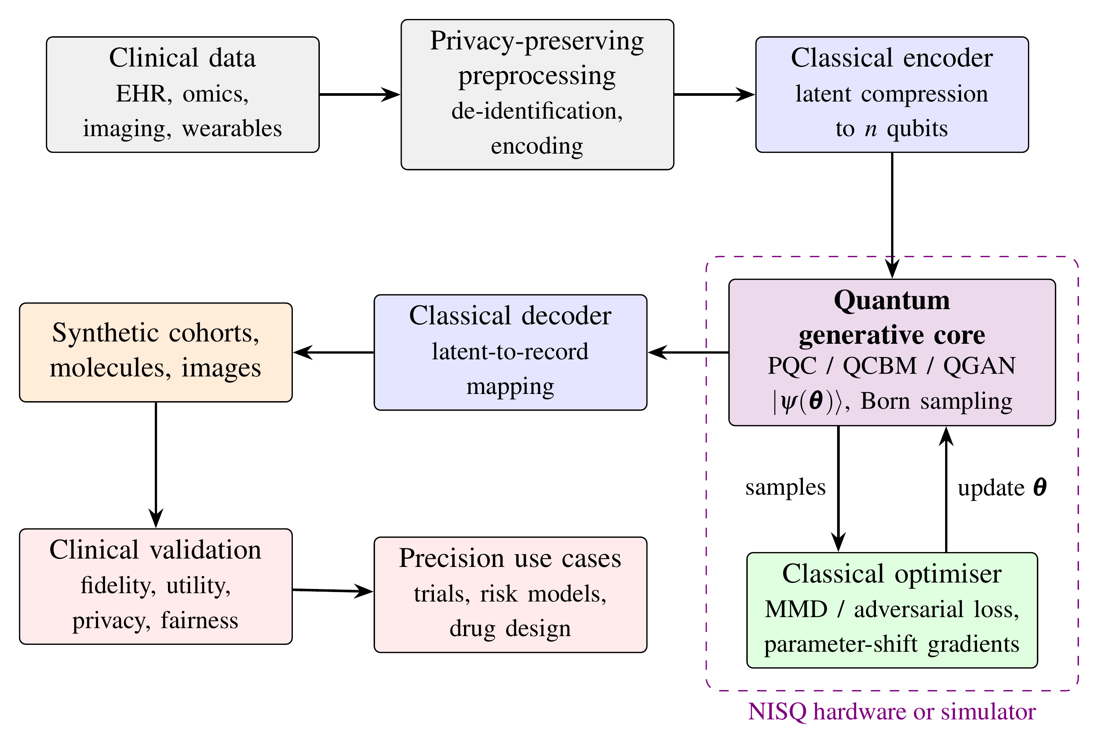
Figure 1. A hybrid quantum-classical generative pipeline for precision healthcare: conceptual framework

3.2 Structured Literature Synthesis
Sources came from purposive searches of Scopus, Web of Science, PubMed, IEEE Xplore and arXiv. The search terms were combinations of quantum generative model, quantum circuit Born machine, quantum generative adversarial network, synthetic health data and quantum computing in medicine. Inclusion required that a source be peer reviewed or a widely cited conference contribution, that it address either generative modelling principles or quantum computation relevant to biomedicine, and that it be published between 2014 and 2023. Twenty-five sources were retained as the core corpus. Each was coded on four dimensions: architectural family, training principle, application domain and level of evidence, distinguishing theoretical analysis, simulation, hardware demonstration and clinical validation.

3.3 Experimental Data
Because real patient records cannot be shared openly, a clinically motivated synthetic ground-truth distribution was constructed. A Bayesian network over six binary cardiometabolic risk factors (obesity, smoking, hypertension, type 2 diabetes, dyslipidaemia and chronic kidney disease) was specified with logistic conditional probabilities set to follow well-known directional dependencies: obesity and smoking raise the probability of hypertension; obesity and hypertension raise that of diabetes; diabetes and smoking raise that of dyslipidaemia; and hypertension and diabetes raise that of chronic kidney disease. The resulting distribution spans 64 comorbidity profiles, with marginal prevalences from 19.1% (chronic kidney disease) to 36.7% (dyslipidaemia). For each of five random seeds (11, 23, 37, 41 and 53), a training sample of 2,000 synthetic patients was drawn, a small cohort of the kind where generative augmentation would be used.

3.4 Generative Models
The study compared four model classes. An independent Bernoulli model, which assumes no dependence among risk factors, served as a lower bound. Classical restricted Boltzmann machines (RBMs) with two and four hidden units (20 and 34 parameters) served as strong, compact classical baselines. The quantum model was a six-qubit QCBM composed of layers of RY and RZ rotations on every qubit, separated by a ring of controlled-NOT gates. Depths of L = 1, 2 and 3 entangling layers gave 24, 36 and 48 trainable angles, respectively, so the circuits could be compared with the RBMs at similar parameter budgets.

3.5 Training Procedure
The QCBM was simulated exactly with a state-vector simulator written in Python and NumPy. It was trained for 300 iterations by minimising the squared MMD between model and empirical distributions, using a mixture of three Gaussian kernels on Hamming distance (bandwidths 0.25, 1 and 4). Gradients were computed with the parameter-shift rule (Liu & Wang, 2018; Mitarai et al., 2018), and parameters were updated with the Adam optimiser at a learning rate of 0.05. The RBMs were trained for 300 iterations with exact log-likelihood gradients, obtainable because all 64 states can be enumerated, again using Adam at a learning rate of 0.05.

3.6 Evaluation Metrics
Generative fidelity was assessed against the true distribution, not merely the training sample, using four measures: Kullback-Leibler (KL) divergence KL(P ‖ Q), where P is the true and Q the generated distribution, which penalises probability mass missing from rare profiles; total variation distance (TVD); MMD; and the mean absolute error in the 15 pairwise Pearson correlations between risk factors, which reflects whether clinically meaningful co-occurrence is preserved. For the deepest QCBM, two hardware factors were examined: a global depolarising channel of probability p ∈ {0, 0.02, 0.05, 0.10, 0.20} applied to the output distribution, and finite measurement budgets of 100 to 20,000 shots. All results are reported as means and standard deviations over the five seeds.
The four fidelity measures were chosen because they capture different clinical concerns. KL divergence is sensitive to whether every plausible comorbidity profile, including rare combinations, receives adequate probability. TVD expresses the largest possible difference in the probability that the true and generated distributions assign to any group of profiles, and so is easy to interpret as an error in estimated prevalence. MMD is the training objective of the QCBM and so indicates how well optimisation succeeded on its own terms. Correlation error maps onto epidemiological analyses of multimorbidity, where how conditions co-occur is the main question.

3.7 Ethical Considerations and Reproducibility
The study used no human participants and no identifiable records, so formal ethical approval was not needed. The use of a known ground truth makes it possible to measure fidelity exactly, which is not feasible with real clinical data. The full simulation code, random seeds and output files are available from the authors on request, so others can replicate the work.

4. RESULTS

4.1 Results of the Literature Synthesis
Coding the core corpus showed that the evidence base is mostly theoretical and simulation work. Hardware demonstrations exist for distribution loading and small generative tasks (Zoufal et al., 2019). None of the reviewed sources reported a prospective clinical evaluation of a quantum generative model. Table 2 maps application domains to the most suitable architectures and to how mature the supporting evidence is.
Table 2. Precision-healthcare applications matched to quantum generative architectures and the maturity of the evidence
Application domain | Clinical purpose | Best-suited architecture | Evidence maturity | Key sources
Synthetic patient records | Data sharing, augmentation of rare subgroups | QCBM; hybrid QGAN | Simulation | Chen et al. (2021); Choi et al. (2017); Liu & Wang (2018)
Small-molecule design | Candidate generation for targeted therapy | Hybrid QGAN | Simulation and small hardware runs | Cao et al. (2019); Li et al. (2021)
Medical image synthesis | Augmentation, reconstruction, translation | Quantum-latent hybrid | Early simulation | Kazerouni et al. (2023); Cerezo et al. (2021)
Genomics and systems biology | Modelling combinatorial biological states | QCBM; Ising Born machine | Theoretical | Coyle et al. (2020); Cordier et al. (2022)
Clinical language generation | Documentation and decision support | Classical (no viable quantum route yet) | Not applicable | Moor et al. (2023); Singhal et al. (2023)

4.2 Generative Fidelity of Quantum and Classical Models
Table 3 gives the fidelity of each model against the true comorbidity distribution. The independent Bernoulli model was worst on every measure, with a correlation error of 0.202, which shows that the target contains strong dependencies. All entangled QCBMs and both RBMs improved considerably on this baseline. QCBM fidelity rose steadily with depth: KL divergence fell from 0.150 at L = 1 to 0.056 at L = 3, and correlation error fell from 0.068 to 0.021. The four-unit RBM reached the lowest KL divergence (0.019) and TVD (0.059). Among the trained models the three-layer QCBM had the lowest correlation error (0.021 against 0.026 for the four-unit RBM), although that difference lies within one standard deviation of the RBM estimate. For reference, the empirical training distribution itself sat at a KL divergence of 0.048 from the truth, a gap that comes from sampling error in a cohort of 2,000.
Spread across seeds differed between the families. The classical models gave consistent results, with standard deviations in KL divergence of 0.007 or less, while the two- and three-layer QCBMs had standard deviations of about 0.03. For the deepest circuit, the best seeds came close to the four-unit RBM and the worst seeds looked more like the two-layer circuit. Both RBMs reached a lower KL divergence than the empirical training sample itself, which suggests that their structural assumptions smoothed out sampling noise. The three-layer QCBM did not get there on average.
Table 3. Generative fidelity on the six-variable comorbidity distribution (mean ± SD over five seeds)
Model | Parameters | KL divergence | TVD | MMD (×10⁻³) | Correlation error
Empirical training sample | — | 0.048 ± 0.026 | 0.055 ± 0.003 | 0.2 ± 0.0 | 0.018 ± 0.002
Independent Bernoulli | 6 | 0.338 ± 0.001 | 0.293 ± 0.003 | 12.0 ± 0.6 | 0.202 ± 0.000
RBM (h = 2) | 20 | 0.038 ± 0.007 | 0.088 ± 0.007 | 0.6 ± 0.1 | 0.041 ± 0.005
RBM (h = 4) | 34 | 0.019 ± 0.002 | 0.059 ± 0.006 | 0.3 ± 0.1 | 0.026 ± 0.005
QCBM (L = 1) | 24 | 0.150 ± 0.011 | 0.155 ± 0.003 | 1.8 ± 0.1 | 0.068 ± 0.006
QCBM (L = 2) | 36 | 0.093 ± 0.032 | 0.108 ± 0.018 | 0.7 ± 0.3 | 0.042 ± 0.013
QCBM (L = 3) | 48 | 0.056 ± 0.030 | 0.077 ± 0.012 | 0.4 ± 0.1 | 0.021 ± 0.002

4.3 Training Convergence
All trained models reduced KL divergence by more than an order of magnitude from initialisation. The RBMs converged smoothly throughout the 300 iterations. The single-layer QCBM plateaued after approximately 80 iterations, whereas the two- and three-layer circuits continued to improve until the end of training, with larger variation across seeds. The trajectories are analysed in Section 5.1.

4.4 Sensitivity to Noise and Measurement Budget
Table 4 summarises the effect of the two hardware factors on the three-layer QCBM. Mild depolarisation (p = 0.02 to 0.10) slightly lowered KL divergence relative to the noiseless circuit, while stronger depolarisation (p = 0.20) raised it above the noiseless level. A finite measurement budget had a much larger effect. With 100 shots, the KL divergence of the estimated distribution was 3.03, more than fifty times that of the exact Born distribution; at least 5,000 shots were needed to bring it below 0.11, and 20,000 shots were needed to approach the exact value.
Table 4. How depolarising noise and measurement budget change KL divergence in the three-layer QCBM (mean ± SD)
Depolarising probability p | KL divergence |  | Measurement shots | KL divergence
0.00 | 0.056 ± 0.030 |  | 100 | 3.032 ± 0.283
0.02 | 0.046 ± 0.023 |  | 500 | 0.575 ± 0.247
0.05 | 0.042 ± 0.019 |  | 1,000 | 0.316 ± 0.182
0.10 | 0.043 ± 0.015 |  | 5,000 | 0.105 ± 0.053
0.20 | 0.061 ± 0.011 |  | 20,000 | 0.058 ± 0.030

5. ANALYSIS

5.1 Convergence Behaviour and Trainability
Figure 2 plots mean KL divergence during training. The single-layer QCBM levels off early. The cause is limited expressivity: one entangling layer can represent only a restricted family of correlations, so extra iterations add nothing. Additional layers allowed further improvement, in line with the expressivity arguments of Benedetti et al. (2019) and Coyle et al. (2020). Deeper circuits also vary more across seeds (see the standard deviations in Table 3), which reflects a more rugged loss landscape. At six qubits the ruggedness is manageable, but it is an early sign of the barren-plateau problem that McClean et al. (2018) predicted for larger registers. The RBM curves are smoother because exact likelihood gradients are available, an advantage that disappears for classical models in high dimensions. Even so, they show how strong a carefully chosen classical baseline can be.
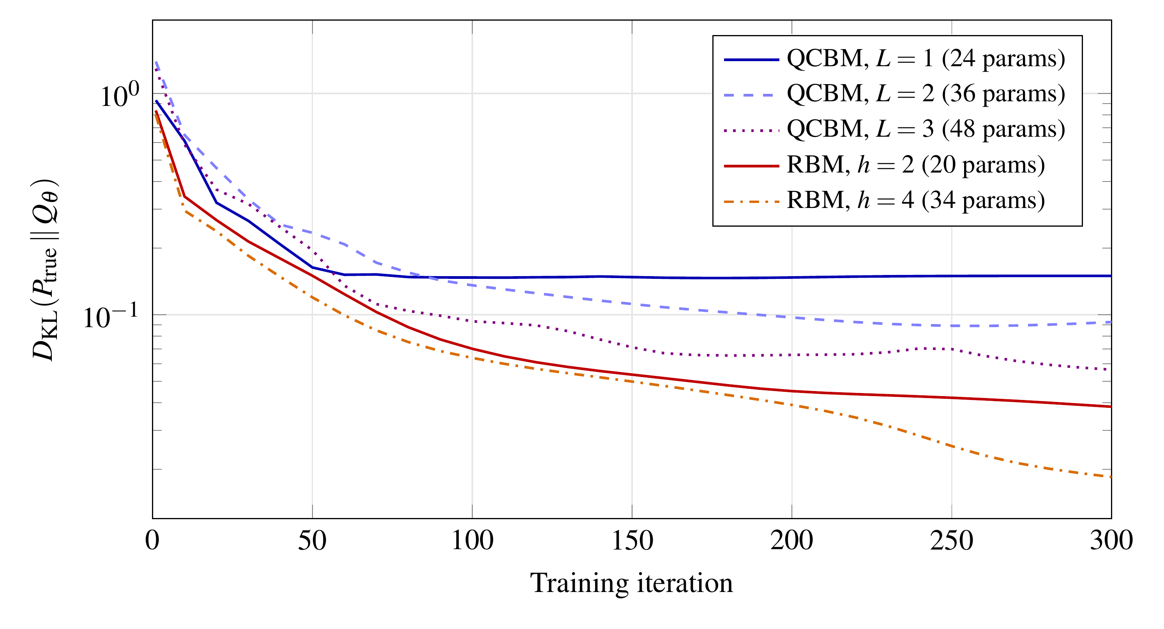
Figure 2. Convergence of quantum and classical generative models during training (mean over five seeds; logarithmic scale)

5.2 Expressivity and Parameter Efficiency
Figure 3 compares final fidelity across models and speaks to RQ2. Entanglement is clearly doing useful work: the QCBM beat the independent model by a factor of six in KL divergence and by nearly ten in correlation error, which confirms that entangling gates encode statistical dependence among clinical variables. Parameter efficiency is another matter. The two-layer QCBM, with 36 parameters, was outperformed on KL divergence by the RBM with 20, and the 48-parameter QCBM still trailed the 34-parameter RBM on KL divergence and TVD. On correlation preservation, which is what counts when synthetic cohorts are used to study comorbidity patterns, the QCBM matched the RBM.
The two metrics disagree because they reward different things. KL divergence heavily penalises probability deficits on rare profiles, and an MMD-trained circuit with a smooth kernel gets no direct reward for putting mass on those rare states. Correlation error is driven by common patterns. This is why the QCBM reproduced the dominant clinical structure well but under-represented rare multimorbidity profiles, which matters for applications aimed at rare-disease or high-risk populations. The result fits the caution of Huang et al. (2021): at this scale classical models stay competitive, and a quantum benefit has to be shown, not assumed. It also resembles Li et al. (2021), who reported parameter savings for a hybrid generator in a domain where the classical decoder carries much of the representational load.
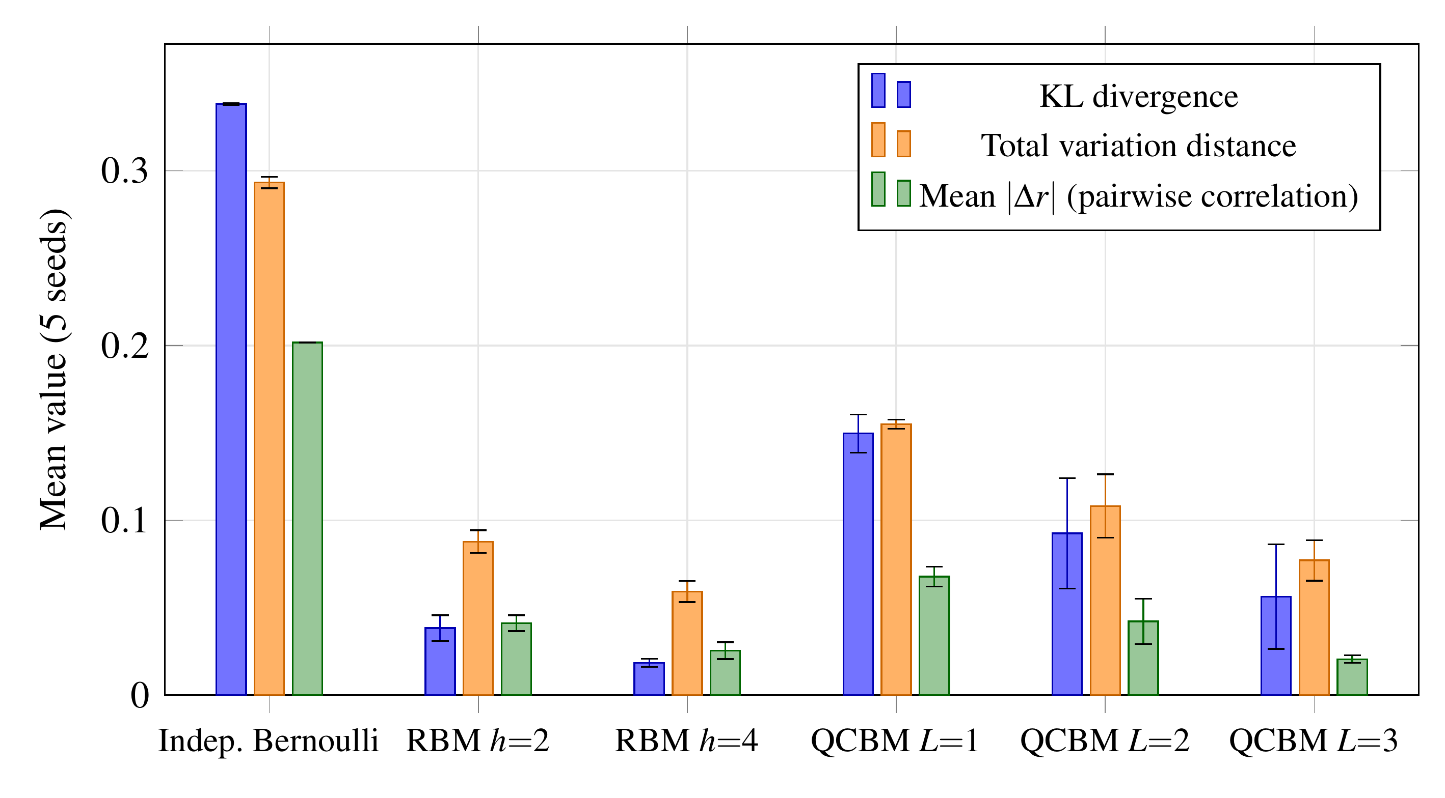
Figure 3. Generative fidelity of each model (mean ± SD over five seeds)

5.3 Hardware Constraints: Noise and Measurement Budget
Figure 4 speaks to RQ3. Panel (a) shows an unexpected effect: small amounts of depolarisation mix the learned distribution with the uniform distribution, which gives some probability to rare profiles that the circuit had under-weighted and so lowers KL divergence. This is accidental smoothing, so it should not be read as a benefit of noise, and at p = 0.20 the distortion of common profiles outweighs the gain. The simplified global noise model used here is optimistic. Real devices have gate-dependent and correlated errors, and those are likely to do more damage (Preskill, 2018).
Panel (b) shows the more serious practical constraint. A quantum generator can be accessed only through measurement, so the quality of any synthetic cohort is capped by the number of shots. Even a 64-state distribution needed thousands of shots to be reproduced reliably, and the requirement will grow with the number of clinical variables. Shots cost money on cloud quantum services and they also set a statistical ceiling on fidelity. Proof-of-concept studies tend to omit this because they report exact simulated distributions. A feasibility assessment of quantum synthetic-data generation in hospitals should count it.
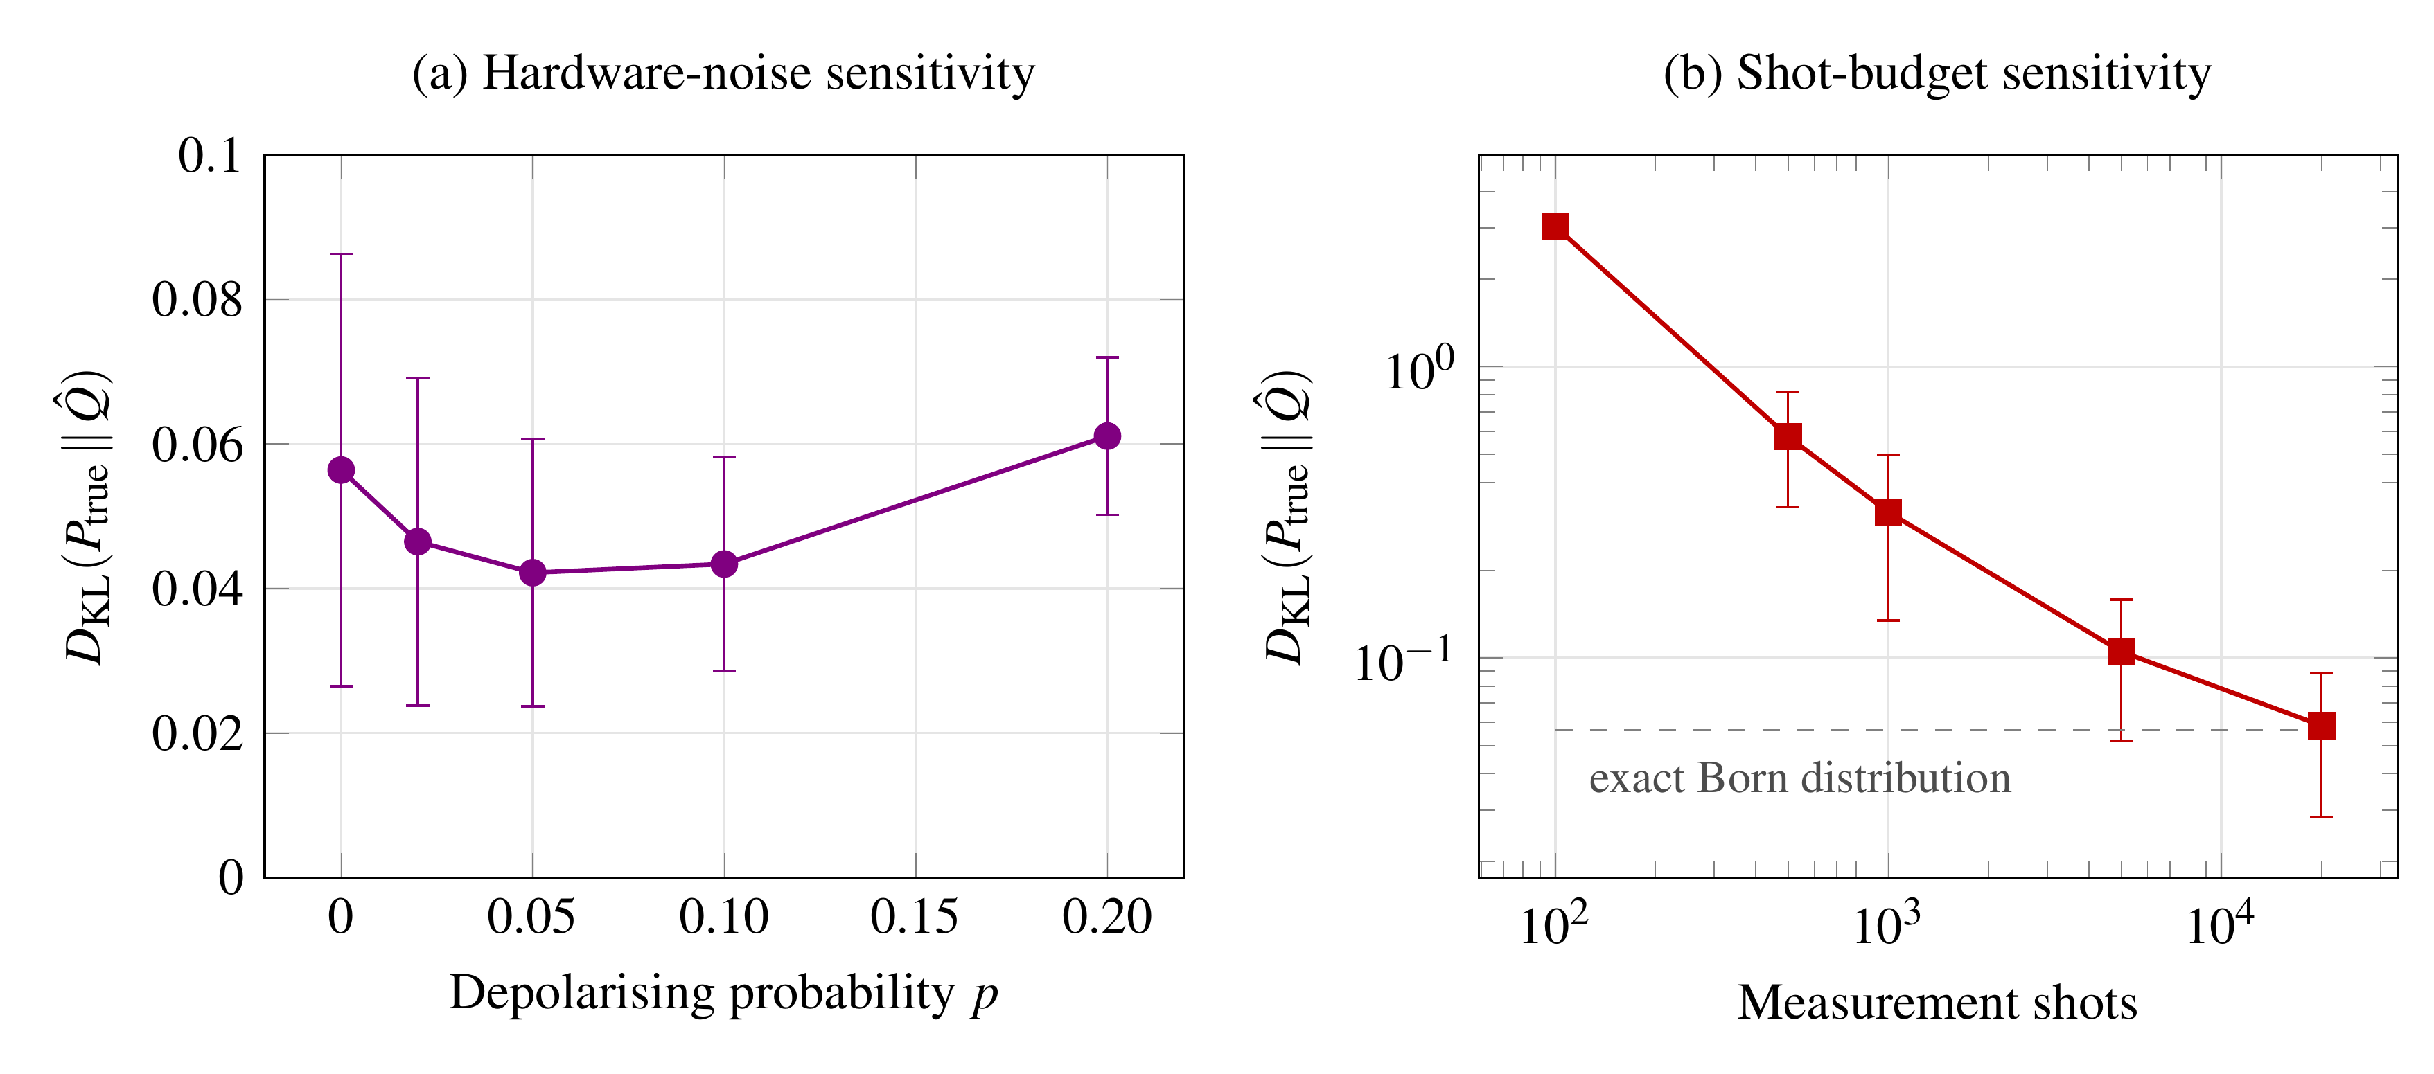
Figure 4. Response of the three-layer QCBM to (a) depolarising noise and (b) measurement budget (mean ± SD over five seeds)

5.4 Implications for Clinical Applications
Read together, the synthesis and the experiment answer RQ1 with some qualifications. QCBMs are best suited to compact, discrete clinical representations such as comorbidity profiles, genotype panels and discretised biomarker states, where their ability to encode correlations is directly useful. Hybrid QGANs are better suited to molecular design, where a classical decoder can map quantum latent samples to complex structures (Li et al., 2021). For high-dimensional imaging and clinical language, classical diffusion and foundation models remain the practical choice (Kazerouni et al., 2023; Moor et al., 2023), and quantum components are for now only a research interest.
For clinical deployment, the validation stage in Figure 1 matters most. Synthetic data from any model, quantum or classical, should be checked for statistical fidelity, downstream utility, resistance to membership inference and fairness across demographic subgroups (Chen et al., 2021). The present results add one requirement specific to quantum models: circuit depth, noise characteristics and shot budget should be documented, since they determine the quality of what reaches clinicians.
Governance raises a similar issue. Algorithms used in clinical pathways need to be open about their training data, intended use and failure modes, and quantum generators add opacity of their own: stochastic measurement, drift in device calibration, and dependence on vendor-specific compilers. One practical recommendation follows. Any quantum-generated clinical dataset should come with a provenance record that names the circuit, the hardware or simulator, the error-mitigation method, the shot count and the validation results, so that downstream users can judge whether it is fit for purpose.

5.5 Limitations
Several limits apply. The target distribution was synthetic and small so that fidelity could be evaluated exactly, whereas real clinical data have missing values, mixed data types and far higher dimensionality. The noise model was idealised, and the circuits were simulated, not run on hardware. Only one quantum ansatz and one training loss were tried, and losses that penalise errors on rare events more heavily might narrow the KL gap. The literature synthesis was purposive and not exhaustive. These constraints limit how far the results generalise. They leave the main conclusion in place: quantum models need to be compared with parameter-matched classical baselines.

6. CONCLUSION

6.1 Summary of Major Findings
The chapter set out to assess quantum-enhanced generative AI for precision healthcare, from its principles and architectures to its clinical prospects. The literature synthesis found QCBMs, QGANs and hybrid quantum-classical models to be theoretically well founded, with drug design and synthetic data generation as the most promising application areas, and it found no clinical validation yet. In simulation, an entangled QCBM learned a correlated cardiometabolic comorbidity distribution and preserved pairwise clinical correlations as accurately as a classical restricted Boltzmann machine. It did not reach a lower KL divergence at a similar parameter count, it under-represented rare multimorbidity profiles, and its practical fidelity depended strongly on the measurement budget.

6.2 Implications
Quantum generative models should be benchmarked against parameter-matched, well-tuned classical baselines and judged on several complementary metrics, including sensitivity to rare events. Developers should treat shot cost and noise as first-order design parameters and not as implementation details. For clinicians and policymakers, the evidence supports continued exploratory research but does not yet justify putting quantum generative tools into clinical workflows. The chapter also offers a reusable evaluation template: a clinically structured ground truth, parameter-matched classical baselines, complementary fidelity metrics and an explicit hardware sensitivity analysis. Other investigators can adapt it to larger problems and real devices.

6.3 Future Research Directions
Several lines of work follow from this study. Quantum generators should be trained on real, de-identified clinical datasets and checked with established synthetic-data validation protocols for utility, privacy and fairness. Training losses that explicitly protect rare clinical states need study, as do problem-informed circuit designs that avoid barren plateaus. Experiments on current hardware with error mitigation are needed to replace idealised noise assumptions with measured behaviour. Federated, privacy-preserving hybrid pipelines could pair the sampling properties of quantum circuits with the data-governance requirements of multi-institutional healthcare. Once fault-tolerant devices exist, molecular and genomic generative tasks that are quantum mechanical in nature are the most likely place for a demonstrable advantage.

REFERENCES
Benedetti, M., Garcia-Pintos, D., Perdomo, O., Leyton-Ortega, V., Nam, Y., & Perdomo-Ortiz, A. (2019). A generative modeling approach for benchmarking and training shallow quantum circuits. npj Quantum Information, 5, Article 45. https://doi.org/10.1038/s41534-019-0157-8
Biamonte, J., Wittek, P., Pancotti, N., Rebentrost, P., Wiebe, N., & Lloyd, S. (2017). Quantum machine learning. Nature, 549(7671), 195–202. https://doi.org/10.1038/nature23474
Cao, Y., Romero, J., Olson, J. P., Degroote, M., Johnson, P. D., Kieferová, M., Kivlichan, I. D., Menke, T., Peropadre, B., Sawaya, N. P. D., Sim, S., Veis, L., & Aspuru-Guzik, A. (2019). Quantum chemistry in the age of quantum computing. Chemical Reviews, 119(19), 10856–10915. https://doi.org/10.1021/acs.chemrev.8b00803
Cerezo, M., Arrasmith, A., Babbush, R., Benjamin, S. C., Endo, S., Fujii, K., McClean, J. R., Mitarai, K., Yuan, X., Cincio, L., & Coles, P. J. (2021). Variational quantum algorithms. Nature Reviews Physics, 3(9), 625–644. https://doi.org/10.1038/s42254-021-00348-9
Chen, R. J., Lu, M. Y., Chen, T. Y., Williamson, D. F. K., & Mahmood, F. (2021). Synthetic data in machine learning for medicine and healthcare. Nature Biomedical Engineering, 5(6), 493–497. https://doi.org/10.1038/s41551-021-00751-8
Choi, E., Biswal, S., Malin, B., Duke, J., Stewart, W. F., & Sun, J. (2017). Generating multi-label discrete patient records using generative adversarial networks. Proceedings of Machine Learning Research, 68, 286–305. https://proceedings.mlr.press/v68/choi17a.html
Cordier, B. A., Sawaya, N. P. D., Guerreschi, G. G., & McWeeney, S. K. (2022). Biology and medicine in the landscape of quantum advantages. Journal of the Royal Society Interface, 19(196), Article 20220541. https://doi.org/10.1098/rsif.2022.0541
Coyle, B., Mills, D., Danos, V., & Kashefi, E. (2020). The Born supremacy: Quantum advantage and training of an Ising Born machine. npj Quantum Information, 6, Article 60. https://doi.org/10.1038/s41534-020-00288-9
Dallaire-Demers, P.-L., & Killoran, N. (2018). Quantum generative adversarial networks. Physical Review A, 98(1), Article 012324. https://doi.org/10.1103/PhysRevA.98.012324
Flöther, F. F. (2023). The state of quantum computing applications in health and medicine. Research Directions: Quantum Technologies, 1, Article e10. https://doi.org/10.1017/qut.2023.4
Goodfellow, I., Pouget-Abadie, J., Mirza, M., Xu, B., Warde-Farley, D., Ozair, S., Courville, A., & Bengio, Y. (2014). Generative adversarial nets. In Z. Ghahramani, M. Welling, C. Cortes, N. Lawrence, & K. Q. Weinberger (Eds.), Advances in Neural Information Processing Systems (Vol. 27, pp. 2672–2680). Curran Associates.
Ho, J., Jain, A., & Abbeel, P. (2020). Denoising diffusion probabilistic models. In H. Larochelle, M. Ranzato, R. Hadsell, M. F. Balcan, & H. Lin (Eds.), Advances in Neural Information Processing Systems (Vol. 33, pp. 6840–6851). Curran Associates.
Huang, H.-Y., Broughton, M., Mohseni, M., Babbush, R., Boixo, S., Neven, H., & McClean, J. R. (2021). Power of data in quantum machine learning. Nature Communications, 12, Article 2631. https://doi.org/10.1038/s41467-021-22539-9
Kazerouni, A., Aghdam, E. K., Heidari, M., Azad, R., Fayyaz, M., Hacihaliloglu, I., & Merhof, D. (2023). Diffusion models in medical imaging: A comprehensive survey. Medical Image Analysis, 88, Article 102846. https://doi.org/10.1016/j.media.2023.102846
Kingma, D. P., & Welling, M. (2014). Auto-encoding variational Bayes. In Proceedings of the 2nd International Conference on Learning Representations. https://doi.org/10.48550/arXiv.1312.6114
Li, J., Topaloglu, R. O., & Ghosh, S. (2021). Quantum generative models for small molecule drug discovery. IEEE Transactions on Quantum Engineering, 2, Article 3103308. https://doi.org/10.1109/TQE.2021.3104804
Liu, J.-G., & Wang, L. (2018). Differentiable learning of quantum circuit Born machines. Physical Review A, 98(6), Article 062324. https://doi.org/10.1103/PhysRevA.98.062324
Lloyd, S., & Weedbrook, C. (2018). Quantum generative adversarial learning. Physical Review Letters, 121(4), Article 040502. https://doi.org/10.1103/PhysRevLett.121.040502
McClean, J. R., Boixo, S., Smelyanskiy, V. N., Babbush, R., & Neven, H. (2018). Barren plateaus in quantum neural network training landscapes. Nature Communications, 9, Article 4812. https://doi.org/10.1038/s41467-018-07090-4
Mitarai, K., Negoro, M., Kitagawa, M., & Fujii, K. (2018). Quantum circuit learning. Physical Review A, 98(3), Article 032309. https://doi.org/10.1103/PhysRevA.98.032309
Moor, M., Banerjee, O., Abad, Z. S. H., Krumholz, H. M., Leskovec, J., Topol, E. J., & Rajpurkar, P. (2023). Foundation models for generalist medical artificial intelligence. Nature, 616(7956), 259–265. https://doi.org/10.1038/s41586-023-05881-4
Preskill, J. (2018). Quantum computing in the NISQ era and beyond. Quantum, 2, Article 79. https://doi.org/10.22331/q-2018-08-06-79
Singhal, K., Azizi, S., Tu, T., Mahdavi, S. S., Wei, J., Chung, H. W., Scales, N., Tanwani, A., Cole-Lewis, H., Pfohl, S., Payne, P., Seneviratne, M., Gamble, P., Kelly, C., Babiker, A., Schärli, N., Chowdhery, A., Mansfield, P., Demner-Fushman, D., … Natarajan, V. (2023). Large language models encode clinical knowledge. Nature, 620(7972), 172–180. https://doi.org/10.1038/s41586-023-06291-2
Topol, E. J. (2019). High-performance medicine: The convergence of human and artificial intelligence. Nature Medicine, 25(1), 44–56. https://doi.org/10.1038/s41591-018-0300-7
Zoufal, C., Lucchi, A., & Woerner, S. (2019). Quantum generative adversarial networks for learning and loading random distributions. npj Quantum Information, 5, Article 103. https://doi.org/10.1038/s41534-019-0223-2

