1. Print a copy of **Grid.pdf**
2. Use the grid to sketch out the process flow.
3. Open **components.xml** then edit the xml by adding the active components based on your sketch. To make a component visible, set the value of **active to”1”** , input the position of the component based on the grid. In this example the position of **BI launch** **pad** is **“A1”**  
     
   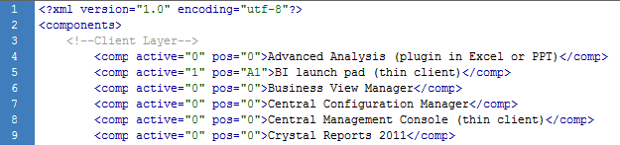  
     
   Note: You can add additional components by adding the tag  
   *<comp active="0" pos="0">Component Name <comp>*
4. Save components.xml
5. Open **arrows.xml**
6. Edit the following:
   1. **<processFlow>** 
      1. **Title** – Title of process flow
      2. **Steps –**  Number of steps in the process flow
   2. **<step>**
      1. **num** – step number
      2. **arrow** – set value to“1” to show an arrow for this step, “0” otherwise
      3. **Btn**- set value to “1” to show a button, “0” otherwise
      4. **btnpos**   
         - set value to “**mid**” to place the button at the middle of the arrow   
         - set value to “**beg**” to place the button at the start of the arrow  
         - set value to “**end**” to place the button at the end of the arrow
   3. **<begin>**
      1. **xpos** – arrow’s start x position based on the grid
      2. **ypos-** arrow’s start y position based on the grid
   4. **<end>**
      1. **xpos** – arrow’s end x position based on the grid
      2. **ypos-** arrow’s end y position based on the grid
   5. **<desc>** - description of the step
7. **Save arrows.xml  
   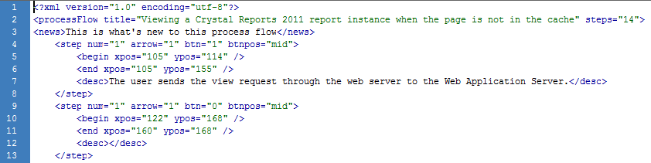**
8. Open the **swf** or **html** file to view the process flow