**GENERAL**

* Responsiveness needs to be perfected.
* Header is not clickable for me except for currency tool convertor
  + Header “login” button, must become a “logout” button after users log in
  + Also when users login, a new button should appear on the headerthat directs these users to the dashboard= “My Account” = “MiProfesi”
* All text fields are glitchy - there is no blinking cursor, cant highlight words.
* Text is not visible on Chrome
* Video doesnt play on Firefox

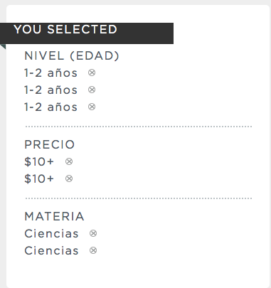

**Search and Filter**

* Filter shouldnt allow users to select same option multiple times.
* Search result is
  + 1)not pulling “description”from upload process
  + 2) File type stays the same 🡪 PDF (0MB), should adapt to different file types and sizes
  + 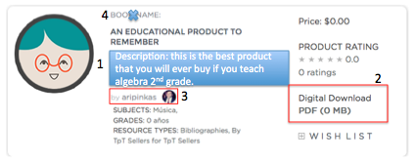3) not pulling “author”
  + 4)“book name” shouldnt appear here.
* “Sorting” tool not functioning. Default should be “Rating”

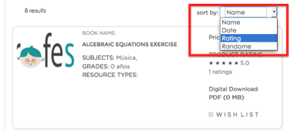

**Dashboard**

* “Start Selling” button should direct logged in users to dashboard (preferably to “add a new product” tab)
* Upload a new product:
  + Pick Price Range should be a drop down menu NOT multi select
  + Select Resource type disappeared. Let’s re-implement with categories from mindmap/filter.
* Profile tab
  + No need for “name of store” + “email to use for contact”
  + 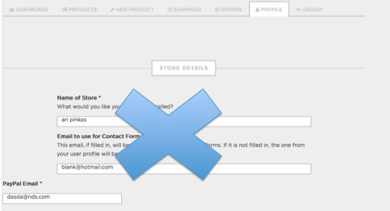

**Profile**

* + Profile info (country of origin, subject, grade) should sync with registration process/profile tab on dashboard
    - For some reason “Azerbaijan” is always there as country of origin.
  + “Follow me” function not working (it doesn’t work on Product Details page either)
  + lets get rid of products on the side (not clickable) and quote

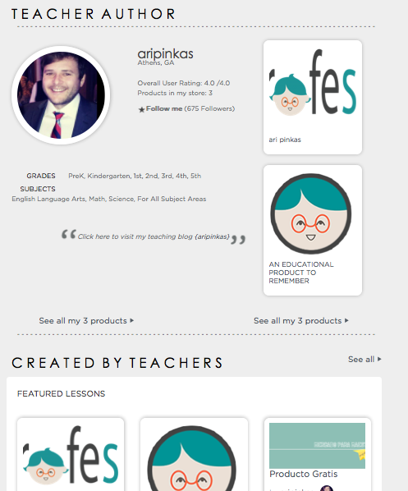

**Transactions**

* $0 product buy was unsuccessful: “No downloadable files found”
  + Wasnt able to download file from Purchase Receipt email either.
  + It doesnt appear in the “orders” tab in the dashboard either.
* Checkout page has action button: “remove” ….this button does not click.

Still to-do:

* Test Commissionson real payments
* Design / alignment tweaks