**PERSONA #2**

**Athlete**

**De’Aaron Fox**

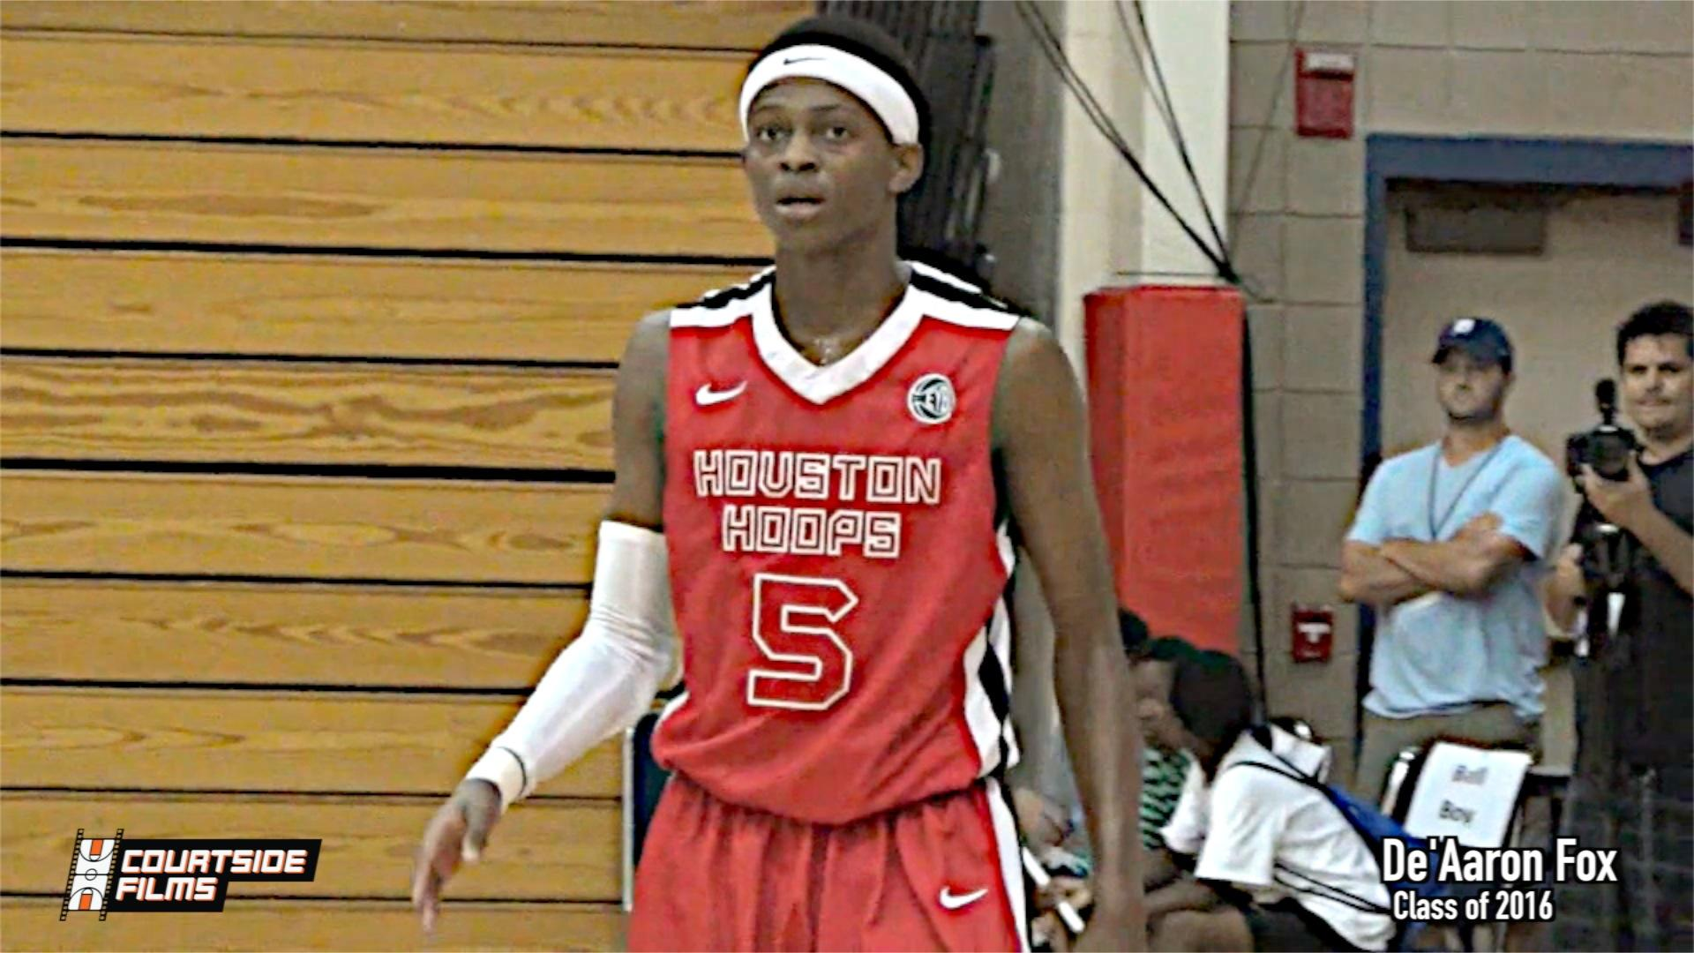

**Facts:**

* *I’ve had a smartphone since I was 14. Kids my age might not have money in the bank, but everybody has a smartphone.*
* *I’m 16 years old, but I play ball with kids ranging from 14-18 years old. If you can play, you can play. Age doesn’t matter.*
* *I need to be seen by college coaches. I’ve talked to a few coaches, but I should be getting a lot more calls and a lot more attention. I know some kids who aren’t nearly as good as I am and those guys are getting offers. Where are mine?*
* *All I need is to be seen. That’s it. I know I can play and if enough of these coaches see me play, the offers will start coming.*
* *I play ball 7 days a week. I play in tournaments every weekend of the summer, throughout the week I have practice, private workouts, and I go to the gym just to play.*
* *When I’m not playing ball I am playing video games, texting girls, watching basketball videos on YouTube, or going to parties.*
* *I go to school and do enough to pass, but I’m not a straight-A student or anything like that.*
* *I know a few guys who’ve been in trouble with the law, but I don’t ever do that kind of stuff.*

**Pains/Frustrations:**

* *The most frustrating feeling in my life is the fact I don’t have scholarship offers.*
* *I play against players who have offers and I kill them. I don’t understand why coaches aren’t seeing that.*
* *I don’t know what coaches want to see from me or what to do to get them to offer.*
* *I’m in a big city, so I have plenty of exposure. But I know a lot of kids who can play and never get seen because they’re from the country or smaller cities where college coaches don’t visit often.*
* *I think highlight films should help me get recruited, so that’s all I have to show coaches. When they want to know about how I play when I don’t have the ball, how hard I compete on defense, whether or not I rebound, etc. I don’t have any film to show them with that stuff. All I have is a bunch of dunks and three-pointers.*
* *I don’t even know how to get in touch with college coaches outside of the one or two who have texted me so far.*
* *I don’t even know about the majority of schools that have basketball programs. For example, I’ve had people tell me that St. Thomas and LeTourneau and some other small schools like the way I play, but I couldn’t tell you one thing about those schools. I definitely don’t know what their basketball team looks like. I just assume their players are sorry since I don’t know them and they’re not on TV.*
* *I think I am a Division I player, even though I’ve never been contacted by a Division I program. The coaches at Duke or University of Texas just need to see me play and they’ll see.*
* *People tell me I could be a really good Division II player, but I don’t want to hear that and I tune them out right away. But when my senior season comes around and I still don’t have any offers, I will try to remembers which Division II schools liked me.*
* *I can play, but I do know some other kids who can really play and don’t realize how good they are. They don’t try to play at the next level because they don’t think it’s an option for them, but they’d get a scholarship if they tried a little harder.*

**Goals:**

* *The main reason I joined this website is to get a chance to play ball in college.*
* *I want to maximize my exposure so that I can get a handful of offers and choose the one that is best for me and my family.*
* *I need to get an athletic scholarship, otherwise I am not going to college because my family can’t afford to pay for it. In fact, I don’t even know how kids pay for school if they don’t have a scholarship. The way I see it, that’s my only option.*
* *If there are ways other than scholarships to get my education paid for and play ball at the same time, I want to know about them. Nobody has told me about ways to pay for school other than getting an offer, but I am willing to do whatever it takes to play at the next level.*
* *Eventually, I think I have a chance to play in the NBA or at least professionally in some other country.*

**Bio:**

* *I play basketball every single day. I mean that literally. It is almost impossible for me to take a day off without at least getting to the gym for an hour to shoot.*
* *I hang out with my friends at night, but I usually get up before all the friends who aren’t athletes. You can tell my boys who are “ballers” because we’ll get up and hit the gym while those other dudes are still sleeping.*
* *I go to school and pay enough attention in class to pass. I don’t do a lot of homework, but school is easy and the teachers know I play ball so they cut me a break during the season.*
* *I spend virtually every weekend of the summer playing ball all over the country with my AAU team. We play over 100 games between April and August, which seems crazy, but that’s just what we do.*
* *If my team isn’t playing in a tournament, there are always exposure camps, college workouts, or other events going on somewhere.*

|  |  |  |  |
| --- | --- | --- | --- |
| **KEY FEATURE** | **SUBFEATURE** | **SUBFEATURE** | **SUBFEATURE (Future**)** |
| I want to get my profile, videos, and scouting report in front of a coach who is going to offer me a scholarship. | I want to upload my stats for my games so that coaches and my peers can see how good I am. | I want a “cool” profile that gives me some status. i don’t want to be on a site that takes anyone. | I want to keep up with boys and see how they’re doing. I want to be able to interact with them. |
| * *I open the website.* * *I log in.* * *I check my messages.* * *(I’ve already setup my profile and uploaded my video & uploaded my schedule.)* * *Review any coach responses and reply.* * *Review “Needs” posted by college coaches if the “Need” matches my profile via my alerts on the website.* * *I contact the coaches if I match and “Need” and I am also interested in their school.* * *If I am not interested right now, I choose the option to add the coach to my Network and save the “Need” match for later, in case I become interested at a later date.* * *I browse the database of college basketball coaches and request to add a few of them to my Network in hopes that they will add me and we can begin to talk.* | * *(I’ve already setup my profile and uploaded my video & uploaded my schedule.)* * *I load my stats from last night via the website prompt.* * *I tweet and post to Facebook that I added my stats to my CPN profile with the click of a button.* * *I check the stats leaders on the site to see where I stand compared to my peers.* * *I am in the top 10 on the site in scoring points per game so I share that on Twitter and Facebook as well.* | * *I log-in and click around the database of players via the messaging and stats pages. I am looking for other good players and I want to see signs that college coaches are offering scholarships to some of these other kids on the site.* * *I do not want to see a bunch of guys who can’t play because I will stop coming back to the site if I see that.* * *I want a profile that gives me some status and looks nice with graphics and a great user experience. That way I can show it to my friends and share it on social media proudly.* | * *Over my time of using the site I have added a lot of my friends, teammates and other players I know to my Network.* * *I check in on them from time-to-time to see their stats, whether their teams are winning games, if they have any offers, etc.* * *I send them messages if I see they scored 30 points in a game, or received an offer from a school, or something like that.* |