**PERSONA #3**

**High School/AAU Coach**

**Coach Steve Talton**

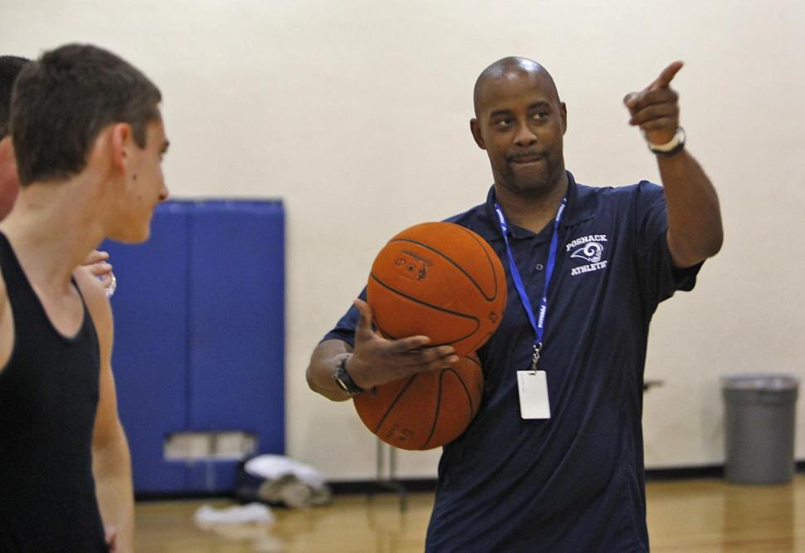

**Facts:**

* *I own a smartphone. Almost every HS/AAU coach I know has a cell phone and 80%-90% of those phones are smartphones.*
* *I’m 38 years old. Most of the assistant coaches I know are younger, maybe 23-35 years old. Most of my fellow head coaches are 36-65 years old.*
* *I am looking to help my athletes continue their playing careers at the next level if that is a possibility for them. There are a lot of coaches who, like I, truly want to help their players get a chance to play in college. Of course, there are also a good number of coaches who view this as a “paycheck” and don’t give the players another thought once practice is over.*

**Pains/Frustrations:**

* *I want to tell college coaches about a couple of my players, but I only know 3 or 4 college coaches.*
* *I’d like to meet more college coaches, but I’m not really sure how to do that and we’re all very busy.*
* *I think my players are good enough for the next level, but to be honest, I don’t have time to watch college basketball, so I am not even sure if they can make a team.*
* *I admit it; I’m biased. It’s hard not to overvalue the players I like on a personal level, and conversely it’s hard to give credit to the players I don’t really like to be around on a daily basis. In other words, it is impossible for me to be objective when assessing one of my players.*
* *I could probably chase down some college coaches eventually, but I don’t have the time. Between watching film, running practice, teaching classes, making time for my family, and trying to get a little sleep, there is not much time left to send out dozens of emails and phone calls on a player’s behalf.*
* *At the end of the day, even if I had the time, I don’t have knowledge about the different levels of college basketball. I don’t know what kind of players go to Junior College and what kind go to NAIA schools. I don’t know how tall a player needs to be in order to be a post player at a Division 3 school. I have no clue about stuff like that. All I know is that my players are pretty good.*
* *I’m not particularly “tech-savvy” so I need anything computer-related to be as simple as possible.*

**Goals:**

* *My main goal in using this site is to help my athletes continue their playing career in college and hopefully get a scholarship to help pay for their education.*
* *I would also like to get a college job someday, and I am hoping that I can develop a relationship with college coaches who will help me get one of those jobs down the road.*
* *For my own job security at my current school, I want to show that my kids get trained/coached well and that I help them make it to the next level. The parents will be happy, and when the parents are happy, my bosses are happy.*
* *Admittedly, I want recognition among my peers and local media attention. It feels good when I go to a coaches’ conference or other event and the other coaches know about the things I helped my players accomplish because I am going above and beyond the normal coaching duties.*

**Bio:**

* *In a given day, I watch game videos of my team so that I can give my players things to work on and help them improve.*
* *I also watch video to scout other teams because we have to be ready for how they play when we go up against them.*
* *I hold practices for my team and players at least 5 days a week. Those practices can last anywhere from 1.5 hours to 4 hours depending on the situation.*
* *On days when we don’t practice we are probably playing a game. Games are only an hour each, but with travel, preparation, etc. they take up my entire day.*
* *After a game I usually send in the score and stats to the local newspaper and to MaxPreps.com so that the players can see their stats in the media.*

|  |  |  |  |
| --- | --- | --- | --- |
| **KEY FEATURE** | **SUBFEATURE** | **SUBFEATURE** | **SUBFEATURE (Future**)** |
| I would like to see my players get a fair chance to play at the next level and earn a scholarship. | I would like to interact with college coaches in hopes of potentially getting a college-level job. | I would like to help other players as well, even if they are not my kids. | I enjoy the game of basketball. When I am not coaching or trying to help my players, I just like to watch highlight videos and read about players from around the country. |
| * *I open the website.* * *I log in.* * *I check my messages.* * *I check my alerts.* * *I check to see if there are any new “Needs” posted by college coaches so that I can refer a matching player if I have one that matches.* * *I check the stats that my players posted from our most recent game to verify that they entered accurate info.* * *I add one or two new college coaches to my Network in hopes that they also add me and we can begin to interact.* * *I check the database to see if our most recent opponent’s coach is a member because I’d like to talk to him.* * *I use the scheduling tool on the website to change the location and time our game this weekend because it was moved to a different gym and I want college coaches to have the correct information in case they are planning on attending.* * *I send a message to my best player to congratulate him on a great performance last night.* * *I log off the website.* | * *I go to the website and log-in.* * *I check my messages, alerts and any new “Needs.”* * *I scroll through the “Needs” to see if I might be able to help refer a players who matches any of them.* * *I see a “Need” posted by a college coach who needs a 6’8” Power Forward.* * *I remember coaching against a players a few weeks ago who would be a perfect fit for this coach.* * *I add the coach to my Network and send him a message about the player.* * *I log off the website.* * *The next day I log back on to see that he has replied to my message and would like to see the game film from when we played against that team with the 6’8” Power Forward.* * *I message him a link to the film on Dropbox or Krossover and ask him to let me know what he thinks.* * *I do all of this because he may appreciate the help and think about me when he hears about a job opening at the college level.* | * *I see a player on an opposing team who deserves to play at the next level.* * *After the game I log on to the CPN website and see that he is a member of the site. His name shows up because he plays for the team that we played against and the date of the event is now in the past.* * *I click on the alert and leave a short message about how well he played against us.* * *I also ask his coach to do the same for my players who are members of the site via the messaging feature on the site.* * *I add his coach to my Network so that we can continue to interact and help each other and our players.* | * *I go to the CPN main page but I do not log in to my account this time.* * *I look for the section of the site that with highlight videos, news articles, blogs, and opinion pieces about high school and AAU basketball events from around the country.* * *I leave comments on the articles and videos I like.* * *I share the best articles and videos through my social media accounts.* * *I end up spending over an hour on the site learning about players and teams that I would otherwise not know about.* |