# UITool Application

## Introduction

UITool is simple web application which retrieve data from couch DB and rendered it .There are two jsp

One is goc.jsp and another is barchart.jsp .Goc.jsp is used for GOC guys for monitoring. Based on colors you can identify the present condition.

Application polls couch DB in every 5 sec for changes and rendered the change on goc.jsp.

Type <http://localhost:8080/ApiMonitoring/web/jsp/goc.jsp> to browser and hit enter

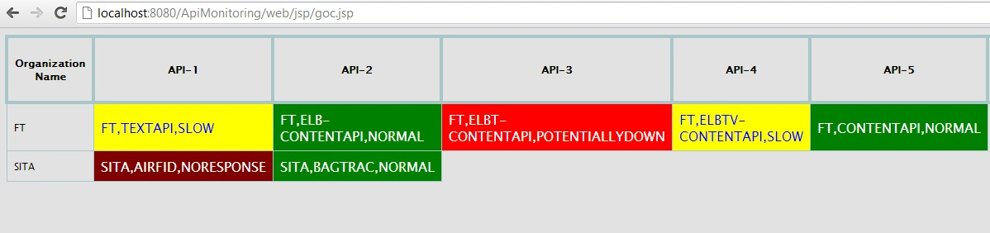

## Color Code

|  |  |
| --- | --- |
| Color | Status of API |
| Yellow | Slow |
| Green | Normal |
| Red | Potentially Down |
| Maroon | No Response |

In the Api cell we can clearly see that which api of which organization is down or normal and it refresh itself every 5 seconds.

## Bar Chart Data

Click on the cell having color to drill down and see the bar charts.it forwarded url to something like <http://localhost:8080/ApiMonitoring/web/jsp/barchart.jsp?value=FT,ELBTV-CONTENTAPI,SLOW>

