Informatica Project - Activity1

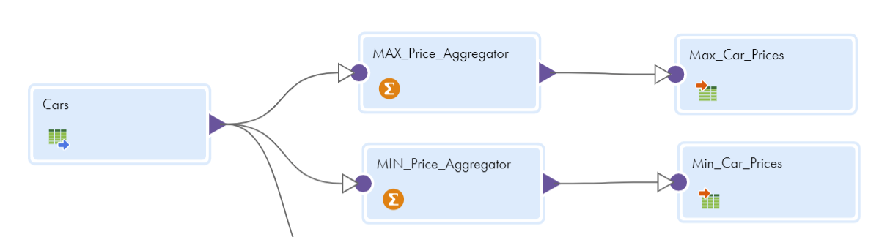

Max Price

Aggregator - Group By Car_Name with aggregate expression  [MAX(TO_INTEGER(Car_Price))](https://usw5.dm-us.informaticacloud.com/diUI/products/integrationDesign/?id=igr8)

Min Price

Aggregator - Group By Car_Name with aggregate expression  [MIN(TO_INTEGER(Car_Price))](https://usw5.dm-us.informaticacloud.com/diUI/products/integrationDesign/?id=igr8)