1. **Classes and Objects**

**Program:**

import java.util.*;

class Stud

{

int total,regno,java_mark,dbms_mark,os_mark;

float avg;

String name;

Scanner sc=new Scanner(System.in);

void readData()

{

System.out.print("Enter Roll no : ");

regno=sc.nextInt();

System.out.print("Enter Name : ");

name=sc.next();

System.out.print("Enter Java Mark : ");

java_mark=sc.nextInt();

System.out.print("Enter DBMS Mark : ");

dbms_mark=sc.nextInt();

System.out.print("Enter OS Mark: ");

os_mark=sc.nextInt();

}

void processData()

{

total = java_mark+dbms_mark+os_mark;

avg=total/3;

}

void display()

{

System.out.println("\n---------------------------------\n "+name+"'s mark statement");

System.out.println("\n---------------------------------\nRoll no : "+regno);

System.out.println("Name : " +name);

System.out.println("Java Mark : " +java_mark);

System.out.println("DBMS Mark : " +dbms_mark);

System.out.println("OS Mark : " +os_mark);

System.out.println("Total : " +total);

System.out.println("Average : " +avg+"\n--------------------------------------");

}

}

class Main

{

public static void main(String args[])

{

Stud ob=new Stud();

ob.readData();

ob.processData();

ob.display();

}

}

**Output:**

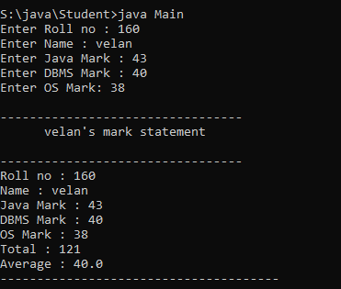

1. **Inheritance**

**Program:**

import java.util.*;

class Employee

{

String ename,job;

int sal,age,reg,ot,al,gp,totsal,bonus;

public void read_data()

{

Scanner sc=new Scanner(System.in);

System.out.print("Enter Employee Name ");

ename=sc.next();

System.out.print("Enter Employee Register NO:");

reg=sc.nextInt();

System.out.print("Enter Employee JOb:");

job=sc.next();

System.out.print("Enter Age:");

age=sc.nextInt();

System.out.print("Enter Employee Salary:");

sal=sc.nextInt();

System.out.print("Enter Amount For OT:");

ot=sc.nextInt();

System.out.print("Enter Allowance:");

al=sc.nextInt();

}

public void process_data()

{

totsal=sal+ot+al;

int pf=totsal/10;

int lic=totsal/15;

gp=totsal-pf-lic;

}

}

class Bonus extends Employee

{

public void emp_bonus()

{

if(gp>=100000)

{ bonus=gp/20; }

else if(gp>50000)

{ bonus=gp/30; }

else if(gp>20000)

{ bonus=gp/40; }

else

{ bonus=gp/5; }

}

public void display()

{

System.out.println("-----Employee Details-----");

System.out.println("Employee Name: "+ename);

System.out.println("Employee Register Number: "+reg);

System.out.println("Employee Age: "+age);

System.out.println("Employee Salary: "+sal);

System.out.println("Employee Allowance: "+al);

System.out.println("Employee Gross pay: "+gp);

System.out.println("Employee Bonus: "+bonus);

System.out.println("----- ******** -----");

}

}

class Emp_main

{

public static void main(String[] args)

{

Bonus obj=new Bonus();

obj.read_data();

obj.process_data();

obj.emp_bonus();

obj.display();

}

}

**Output:**

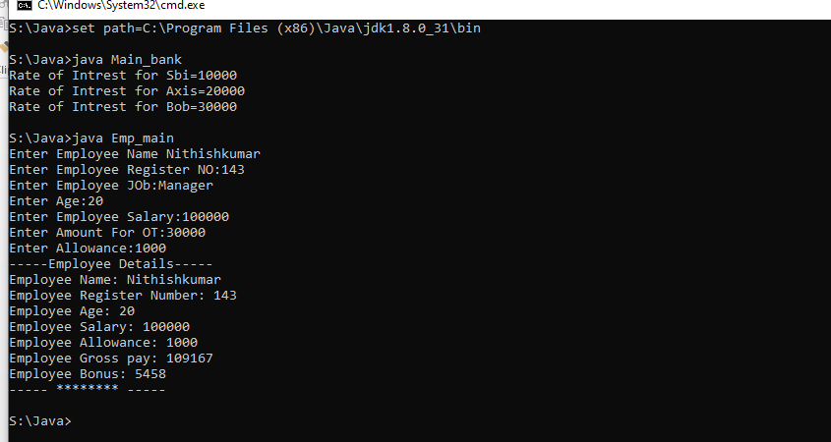

1. **Interfaces**

**Program:**

import java.util.*;

interface Ibank

{

//double int_amt;

void rate_of_intrest(int amt);

}

class SBI implements Ibank

{

double int_amt;

public void rate_of_intrest(int amt)

{

if(amt<10000)

{

int_amt=amt*0.025;

}

else

{

if(amt<50000)

{

int_amt=amt*0.035;

}

else

{

int_amt=amt*0.04;

}

}

System.out.println("Rate of intrest in SBI for "+ amt +" is : "+ int_amt);

}

}

class TMB implements Ibank

{

double int_amt;

public void rate_of_intrest(int amt)

{

if(amt<10000)

{

int_amt=amt*0.015;

}

else

{

if(amt<50000)

{

int_amt=amt*0.025;

}

else

{

int_amt=amt*0.34;

}

}

System.out.println("Rate of intrest in TMB for "+ amt +" is : "+ int_amt);

}

}

class AXIS implements Ibank

{

double int_amt;

public void rate_of_intrest(int amt)

{

if(amt<10000)

{

int_amt=amt*0.024;

}

else

{

if(amt<50000)

{

int_amt=amt*0.038;

}

else

{

int_amt=amt*0.042;

}

}

System.out.println("Rate of intrest in AXIS for "+ amt +" is : "+ int_amt);

}

}

class Main

{

public static void main(String args[])

{

Scanner sc=new Scanner(System.in);

System.out.print("Enter Your Amount : ");

int amt=sc.nextInt();

SBI b1=new SBI();

TMB b2=new TMB();

AXIS b3=new AXIS();

b1.rate_of_intrest(amt);

b2.rate_of_intrest(amt);

b3.rate_of_intrest(amt) ;

}

}

**Output**:

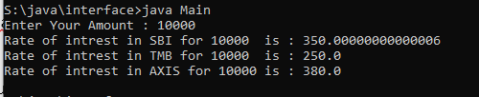

1. **Packages**

**Program:**

//Package

package Mypack;

public class Arth

{

public void add(int a,int b)

{

System.out.println("Given inputs - "+a+" and "+b);

System.out.println("Sum of "+a+" and "+b+" is "+a+b);

}

public void sub(int a,int b)

{

System.out.println("Subraction of "+a+" and "+b+" is "+(a-b));

}

public void mul(int a,int b)

{

System.out.println("Multiply of "+a+" and "+b+" is "+a*b);

}

public void div(int a,int b)

{

System.out.println("Division of "+a+" and "+b+" is "+a/b);

}

}

//Main program

import Mypack.*;

class Main

{

public static void main(String args[])

{

Arth ob=new Arth();

ob.add(1,2);

ob.sub(10,5);

ob.mul(2,7);

ob.div(10,5);

}

}

**Output:**

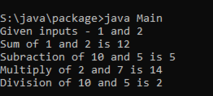

**5) Exception Handling**

**Program:**

import java.io.*;

import java.util.*;

class Exp

{

void div(int a,int b)

{

int d[]=new int[10];

try

{

float c=a/b;

System.out.println(c);

}

catch(Exception e)

{

System.out.println(e);

}

try{

d[20]=10;

}

catch(ArrayIndexOutOfBoundsException ex)

{

System.out.println(ex);

}

}

}

class Main_exp

{

public static void main(String args[])

{

Scanner sc=new Scanner(System.in);

System.out.println("Enter Firest Value");

int x=sc.nextInt();

System.out.println("Enter Second Value");

int y=sc.nextInt();

Exp obj=new Exp();

obj.div(x,y);

}

}

**Output:**

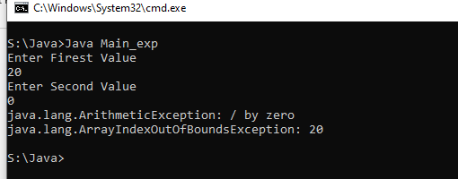

1. **Multithreading**

**Program:**

class Parent extends Thread

{

public void run()

{

System.out.println("Parent thread is running...");

}

}

class Child extends Thread

{

public void run()

{

System.out.println("Child thread is running...");

}

}

public class Main

{

public static void main(String[] args) {

Parent parent = new Parent();

Child child = new Child();

parent.start();

child.start();

}

}

**Output:**

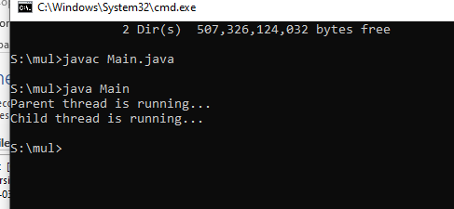

1. **Lambda Expression**

**Program:**

interface MathOperation

{

int Operation(int a, int b);

}

public class Lambdaexp

{

public static void main(String args[])

{

MathOperation add = (int a, int b)->a+b;

MathOperation sub = (int a, int b)->a-b;

MathOperation mul = (int a, int b)->a*b;

MathOperation div = (int a, int b)->a/b;

System.out.println("Addition:"+performOperation(10,5,add)); System.out.println("Subraction:"+performOperation(10,5,sub)); System.out.println("Multiplication:"+performOperation(10,5,mul)); System.out.println("Division:"+performOperation(10,2,div));

}

private static int performOperation(int a,int b,MathOperation mathoperation)

{

return mathoperation.Operation(a,b);

}

}

Output:

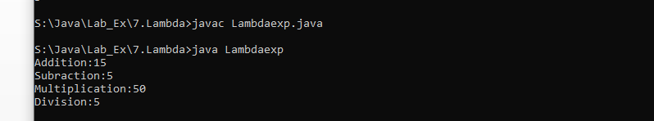

1. **Collection Interfaces**

**Program:**

import java.util.*;

import java.io.*;

class Main

{

public static void main(String args[])

{

ArrayList<String> Books=new ArrayList<>();

Books.add("Rich dad poor dad");

Books.add("Harry potter");

Books.add("Ponniyin selvan");

Books.add("let us c");

ListIterator<String>it=Books.listIterator();

System.out.println("Books : ");

while(it.hasNext())

{

System.out.println(it.next());

}

}

}

**Output:**

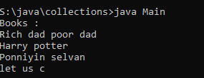

**9) I/o Stream**

**Program:**

import java.io.*;

public class Inputstreamexample

{

public static void main(String args[])

{

try {

FileOutputStream fout = new FileOutputStream("file.txt");

OutputStreamWriter write = new OutputStreamWriter(fout);

write.write("Hello I am NithishKumar From 1 MCA, How Are You ?.");

write.flush();

fout.close();

write.close();

}

catch (Exception e) {

System.out.println(e); }

try {

FileInputStream fin= new FileInputStream("file.txt");

InputStreamReader r = new InputStreamReader(fin);

int data = r.read();

System.out.println("File Created");

System.out.println("Data Inserted");

while(data != -1)

{

System.out.print((char)data);

data= r.read();

}

System.out.println("");

fin.close();

r.close(); }

catch(Exception e)

{

System.out.println(e);

} }}

**Output:**

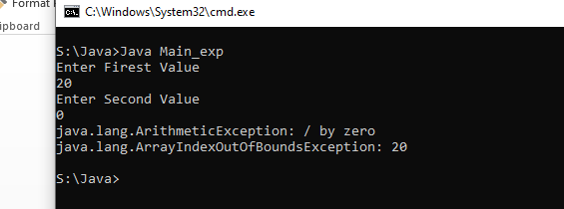

**9) Registration Form Using AWT Controls**

**Program:**

import java.awt.*;

import java.awt.event.*;

class MyApp extends Frame

{

Label lblTitle , lblName, lblFather ,lblAge, lblGender, lblCourse, lblHobbies, lblAddress,lblMother;

TextField txtName,txtFather,txtAge,txtMother;

TextArea txtAddress;

Checkbox CheckMale,CheckFemale,Hobbies1,Hobbies2,Hobbies3,Hobbies4;

CheckboxGroup cbg;

Choice Course;

Button btnSave,btnClear;

public MyApp()

{

super("User Registration Form");

setSize(1000,600);

setLayout(null);

setVisible(true);

Color c=new Color(20,50,60);

setBackground(c);

Font titleFont=new Font("arial",Font.BOLD,25);

Font labelFont=new Font("arial",Font.PLAIN,18);

Font textFont=new Font("arial",Font.BOLD,15);

lblTitle=new Label("User Registration Form");

lblTitle.setBounds(250,40,300,50);

lblTitle.setFont(titleFont);

lblTitle.setForeground(Color.YELLOW);

add(lblTitle);

lblName=new Label("Name");

lblName.setBounds(250,100,150,30);

lblName.setFont(labelFont);

lblName.setForeground(Color.WHITE);

add(lblName);

txtName=new TextField();

txtName.setBounds(400,100,400,30);

txtName.setFont(textFont);

add(txtName);

lblFather=new Label("Father Name");

lblFather.setBounds(250,150,150,30);

lblFather.setFont(labelFont);

lblFather.setForeground(Color.WHITE);

add(lblFather);

txtFather=new TextField();

txtFather.setBounds(400,150,400,30);

txtFather.setFont(textFont);

add(txtFather);

lblMother=new Label("Mother Name");

lblMother.setBounds(250,200,150,30);

lblMother.setFont(labelFont);

lblMother.setForeground(Color.WHITE);

add(lblMother);

txtMother=new TextField();

txtMother.setBounds(400,200,400,30);

txtMother.setFont(textFont);

add(txtMother);

lblAge=new Label("Age");

lblAge.setBounds(250,250,150,30);

lblAge.setFont(labelFont);

lblAge.setForeground(Color.WHITE);

add(lblAge);

txtAge=new TextField();

txtAge.setBounds(400,250,400,30);

txtAge.setFont(textFont);

add(txtAge);

lblGender=new Label("Gender");

lblGender.setBounds(250,300,150,30);

lblGender.setFont(labelFont);

lblGender.setForeground(Color.WHITE);

add(lblGender);

cbg=new CheckboxGroup();

CheckMale=new Checkbox("Male",cbg,true);

CheckMale.setBounds(400,300,100,30);

CheckMale.setFont(labelFont);

CheckMale.setForeground(Color.WHITE);

add(CheckMale);

CheckFemale=new Checkbox("Female",cbg,false);

CheckFemale.setBounds(500,300,100,30);

CheckFemale.setFont(labelFont);

CheckFemale.setForeground(Color.WHITE);

add(CheckFemale);

lblCourse=new Label("Course");

lblCourse.setBounds(250,350,150,30);

lblCourse.setFont(labelFont);

lblCourse.setForeground(Color.WHITE);

add(lblCourse);

Course=new Choice();

Course.setFont(labelFont);

Course.setBounds(400,350,150,30);

Course.add("c");

Course.add("C++");

Course.add("java");

add(Course);

lblHobbies=new Label("Hobbies");

lblHobbies.setBounds(250,400,150,30);

lblHobbies.setFont(labelFont);

lblHobbies.setForeground(Color.WHITE);

add(lblHobbies);

Hobbies1=new Checkbox("Drawing");

Hobbies1.setBounds(500,400,100,30);

Hobbies1.setFont(labelFont);

Hobbies1.setForeground(Color.WHITE);

add(Hobbies1);

Hobbies2=new Checkbox("Craft");

Hobbies2.setBounds(400,400,100,30);

Hobbies2.setFont(labelFont);

Hobbies2.setForeground(Color.WHITE);

add(Hobbies2);

lblAddress=new Label("Address");

lblAddress.setBounds(250,450,150,30);

lblAddress.setFont(labelFont);

lblAddress.setForeground(Color.WHITE);

add(lblAddress);

txtAddress=new TextArea();

txtAddress.setBounds(400,450,400,30);

txtAddress.setFont(textFont);

add(txtAddress);

btnSave=new Button("Save Details");

btnSave.setBounds(400,530,150,30);

btnSave.setFont(labelFont);

btnSave.setBackground(Color.BLUE);

btnSave.setForeground(Color.WHITE);

add(btnSave);

btnClear=new Button("Clear All");

btnClear.setBounds(560,530,150,30);

btnClear.setFont(labelFont);

btnClear.setBackground(Color.RED);

btnClear.setForeground(Color.WHITE);

add(btnClear);

this.addWindowListener(new WindowAdapter()

{

public void Windowclosing(WindowEvent we)

{

System.exit(0);

}

});

}

}

public class APP{

public static void main(String[] args) {

MyApp obj=new MyApp();

}

}

**Output:**

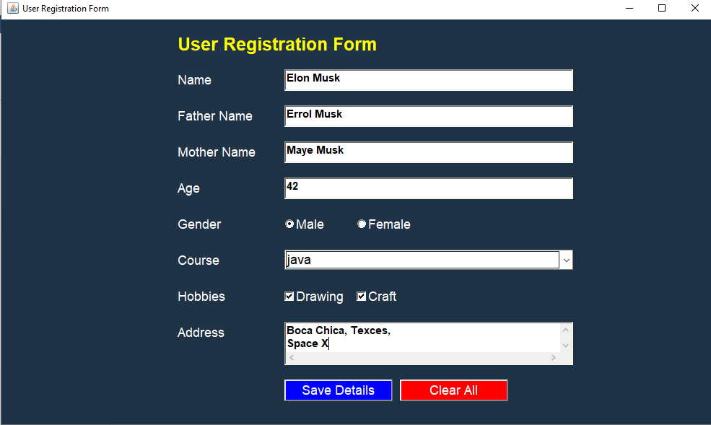

**11) Applying Swing concepts**

**A) Design a scientific Calculator using Swing Components**

**Program**:

import java.awt.event.*;

import java.awt.*;

import javax.swing.*;

public class Calculator extends JFrame implements ActionListener

{

JButton b10,b11,b12,b13,b14,b15;

JButton b[]=new JButton[10];

Integer i,r,n1,n2;

JTextField res;

char op;

public Calculator()

{

super("Calulator");

setLayout(new BorderLayout());

JPanel p=new JPanel();

p.setLayout(new GridLayout(4,4));

for(int i=0;i<=9;i++)

{

b[i]=new JButton(i+"");

p.add(b[i]);

b[i].addActionListener(this);

}

b10=new JButton("+");

p.add(b10);

b10.addActionListener(this);

b11=new JButton("-");

p.add(b11);

b11.addActionListener(this);

b12=new JButton("*");

p.add(b12);

b12.addActionListener(this);

b13=new JButton("/");

p.add(b13);

b13.addActionListener(this);

b14=new JButton("=");

p.add(b14);

b14.addActionListener(this);

b15=new JButton("C");

p.add(b15);

b15.addActionListener(this);

res=new JTextField(10);

add(p,BorderLayout.CENTER);

add(res,BorderLayout.NORTH);

setVisible(true);

setSize(200,200);

}

public void actionPerformed(ActionEvent ae)

{

JButton pb=(JButton)ae.getSource();

if(pb==b15)

{

r=n1=n2=0;

res.setText("");

}

else

if(pb==b14)

{

n2=Integer.parseInt(res.getText());

eval();

res.setText(""+r);

}

else

{

Boolean opf=false;

if(pb==b10)

{

op='+';

opf=true;

}

if(pb==b11){ op='-';opf=true;}

if(pb==b12){ op='*';opf=true;}

if(pb==b13){op='/';opf=true; }

if(opf==false)

{

for(i=0;i<10;i++)

{

if(pb==b[i])

{

String t=res.getText();

t+=i;

res.setText(t);

}

}

}

else

{

n1=Integer.parseInt(res.getText());

res.setText("");

}

}

}

int eval()

{

switch(op)

{

case '+': r=n1+n2; break;

case '-': r=n1-n2; break;

case '*': r=n1*n2; break;

case '/': r=n1/n2; break;

}

return 0;

}

public static void main(String arg[])

{

new Calculator();

}

}

**Output:**

