This is springboot rest Service application so it will be great if your STS having all require plugin to run spingboot application in STS

**Setup 1: run pro-kabaddi_mo service in to STS**

* Clone GIT Repository locally using this URL
* Import Maven Project in STS(Spring Tool suite)
* project: right-click on project -> Maven -> Update Project
* right-click on project->Run As-Spring Boot App

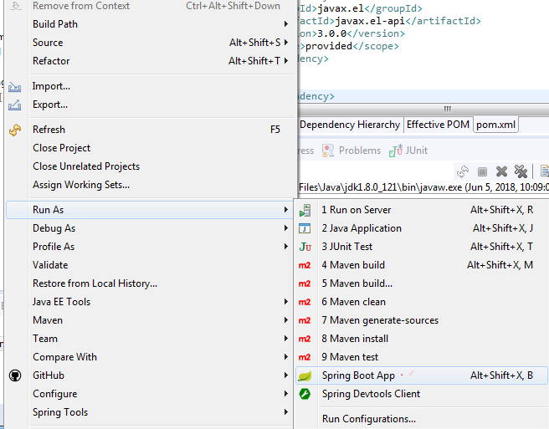

Note : In this project I have used “Lombok” to reduce getter/setter implementation so might be STS crate issue to build spring boot app .

Solution :

* If you use **STS**. You must have Lombok installed in your Eclipse by running lombok-xyz.jar
* Please Try the Following the Steps:
  1. Include pom in Maven .
  2. Exit/Shutdown STS
  3. Find lombok Jar in ~/.m2/repository/org/projectlombok/lombok/version.x
  4. From Command Prompt/Shell java -jar lombok-1.x.y.jar

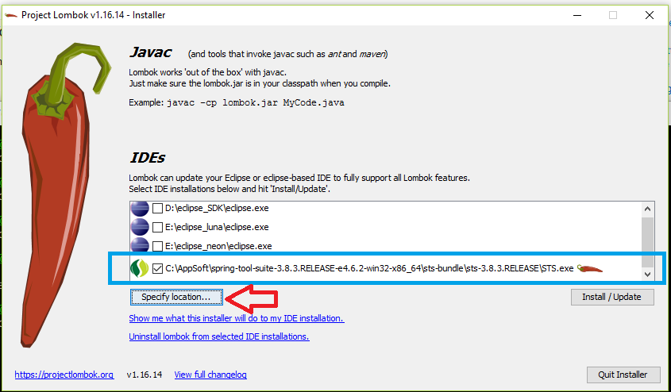

5. project: right-click on project -> Maven -> Update Project

[1]Hit below url to see Application rest service details (Swagger]

<http://localhost:8080/swagger-ui.html#/>

this url will give details Api :

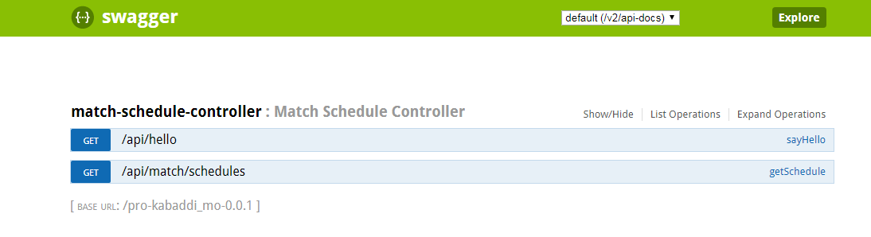

[2]Api url :

<http://localhost:8080/api/match/schedules?teamIds=1,2,3,4,5,6&startDate=10/12/2018>

Note

[A]Must follow date format else api will return empty response like below

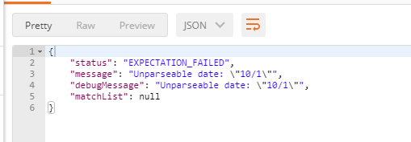

[B]Must pass valid teamids (1,2,3,4,5,6,7) else api will return below response:

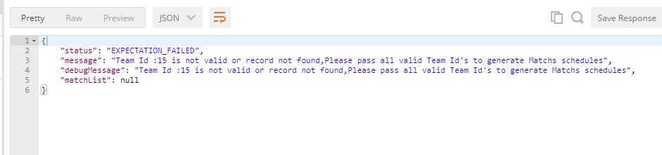

[C]you can add no of teams in teamsJson.txt file ( \pro-kabaddi_mo\src\main\resources\json\teamsJson.txt)

[d]Must pass unique teamids (1,2,3,4,5,6,7) else api will return below response:

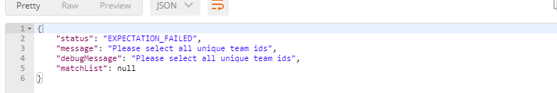

**Setup 2: deploy pro-kabaddi_mo service on tomcat:**

Note :

Please use tomcat 8 and above version (I have used apache-tomcat-8.5.31) else you might get “javax.el-api” related issue :

Details: Please check below link:

<https://stackoverflow.com/questions/49385257/tomcat-7-java-lang-noclassdeffounderror-javax-el-elmanager>

Deployment Steps :

* Clone GIT Repository locally using this URL
* Projectpath>project>mvn clean install
* Copy war file pro-kabaddi_mo-0.0.1.war from \pro-kabaddi_mo\target\
* Deploy war on tomcat

Open browser and type this URL to see available REST services exposed

http://localhost:8080/**<app-name>**/api/hello

app-name in our case : pro-kabaddi_mo-0.0.1

Final url for get rest service:

http://localhost:8080/pro-kabaddi_mo-0.0.1/api/hello

# Generate match schedule:

[2]Api url :

[http://localhost:8080/**pro-kabaddi_mo-0.0.1**/api/match/schedules?teamIds=1,2,3,4,5,6&startDate=10/12/2018](http://localhost:8080/pro-kabaddi_mo-0.0.1/api/match/schedules?teamIds=1,2,3,4,5,6&startDate=10/12/2018)

# Swagger url :

[http://localhost:8080/ pro-kabaddi_mo-0.0.1/swagger-ui.html#/](http://localhost:8080/%20pro-kabaddi_mo-0.0.1/swagger-ui.html#/)

**Junit test cases :**

**[1] validatDuplicateIds**

**[2] fetchParticipateTeamList**

**[3] generateMatchSchedule**

# 

http://localhost:8080/pro-kabaddi_mo-0.0.1/api/match/schedules?teamIds=1,2,3,4,5,6&startDate=10/12/2018