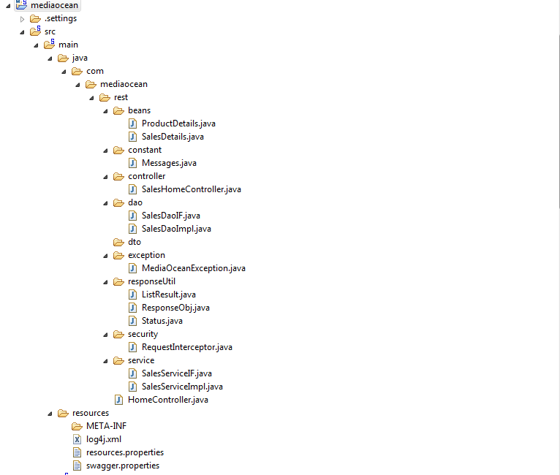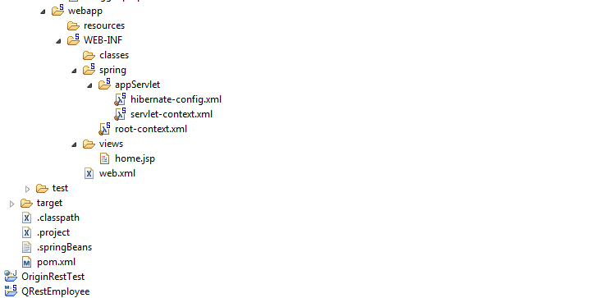

[1]I have created this project Using Spring MVC with maven and Configure Hibernate 4.0 version

[1]Please find attached database script :Database name is “salesinformation”.I have crated database structure using mysql workbench.

[2]For Hibernate Configuration purpose I have Created 2 files :

[A]**Hibernate-config.xml** :This file is take care all hibernate configuration like session Factory ,Properties ,Database name ,userId ,Password etc.

[B]I have also created a “**resource.Properties”** file This file is allow to configure database .

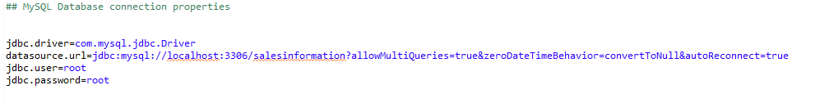

[3] A valid incoming REST request is expected to contain a HTTP header "AUTHENTICATION_ID" with a value of 99. Implement this validation in the code.

For this Implementation Purpose I have integrated Intercepter in servlet-context.xml file and created **One “RequestIntercepter.java “** .Which is take care of this above validation

[4] Foe expected result Purpose I have return Hibernate Criteria like below in DAOimpl

Criteria c = session.createCriteria(SalesDetails.class, "salesDetails");

         c.createAlias("salesDetails.productDetails", "productDetails");

 c.add(Restrictions.eqProperty("salesDetails.productId", "productDetails.productId")).setProjection(Projections.projectionList()

                           .add(Projections.groupProperty("productDetails.productId"))

                           .add(Projections.property("productDetails.productName"))

                           .add(Projections.sum("totalSale"))

                           .add(Projections.sum("totalAmount")));

[4]This project is Spring MVC with maven ,Which is take care of pom.xml file.

[5]I have test this rest service using postman.Please find attached postmain collection

Url :

<http://localhost:8080/mediaoceanRest/salesDetails/get/products/all>

Method :Get

Header : AUTHENTICATION_ID :99

If AUTHENTICATION_ID id is not valide then it will through

“>HTTP Status 401 - Request is not authorized, API request was rejected.”

This Rest Service sending response in Jason Format like below :

{

"result": [

[

1,

"Product1",

54,

1045

],

[

2,

"Product2",

12,

24

],

[

3,

"Product3",

68,

121

],

[

4,

"Product4",

12,

400

],

[

5,

"Product5",

12,

456

],

[

6,

"Product6",

12,

333

],

[

7,

"Product7",

12,

342

],

[

8,

"Product8",

123,

44456

],

[

9,

"Product9",

233,

4432

],

[

10,

"Product10",

333,

4444

]

],

"count": 10,

"status": "SUCCESS"

}