[1]This is shoppingcart application develop in core java .

We can run this application using main class (ShopingCartBill.java ) or Run As->Java Application ->ShopingCartBill

[2]Setup: We just need to import as maven project into STS.

[3]Tests Cases : PremiumAndRegularCustomerTest.java file containing all test cases.

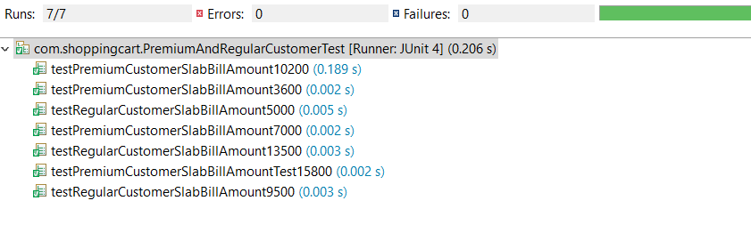

[4]WE can also run this application from ShopingCartBill.java file and see result on console as well.

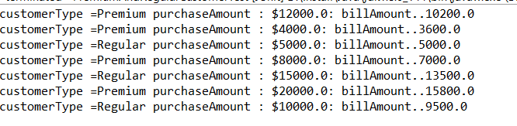

[5]If we want to introduce new customer Type we just need to define in customerTypesAndSlab.json file.

\shoppingcart\src\main\resources\Json\customerTypesAndSlab.json

[6]Application

