**Support Wheel of Fate - API**

A REST API that receives a request with Month and Year and given all engineers shift plan for first 2 weeks .

**Details Endpoints**

( Api ) - http://localhost:8085/swof/schedule/<month>/<year>

(Front End ) - http://localhost:8085/home/

**Details Code Setup**

[1]This Is maven base spring boot project So once we import maven project , update project and run using springboot you are able to test support wheel of fate api using swagger

[2]Configuration(One time configuration)

**File:**application.properties [path:src\main\resources]

#This is one time configration

#set how many weeks to take in count to filter engineers

#Min value should be 2

#eg 2:means 2 weeks (From schedule start date ).3 means 3 week ,4 means 4 weeks (one month)

**swif.week_scan_period=2**

#set which day you want to start the shift 1(Monday),2(Tuesday),3(Wednesday),4(Thrusday),5(Friday),6(Saturday),7(Sunday)

#This day will be consider first day of Month

#eg 1->First Monday of Month(month you pass in API)

**swif.schedule_start_day=1**

#set which day you want to give week off

#eg 1(Monday),2(Tuesday),3(Wednesday),4(Thrusday),5(Friday),6(Saturday),7(Sunday)

#note swif.schedule_start_day !=swif.weekend_off_day

#6,7:Saturday,Sunday (Max 2 days)

**swif.weekend_off_day=6,7**

#Set Moring shift time .This is is use only time information purpose

**swif.day_shift_time=12PM TO 11PM**

#Set Night shift time .This is is use only time information purpose

**swif.night_shift_time=12 AM TO 11AM**

#Default port is 8085 if you change port then swagger ,api ,web all url will access from that port

**server.port=8085**

**Details Application Url**

**[1]Swagger Integration :**

Swagger url : http://localhost:8085/swagger-ui.html

This url Giving complete details about Shift Controller (schedule api)

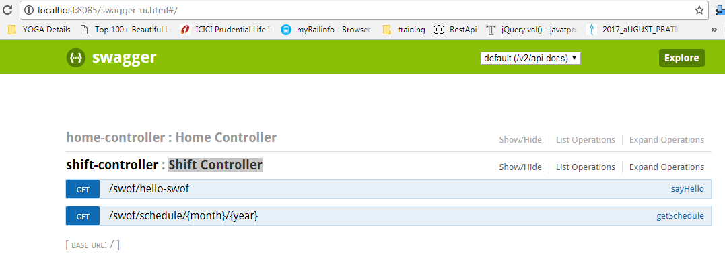

**[2]Web Integration :**

WebUrl: http://localhost:8085/home/

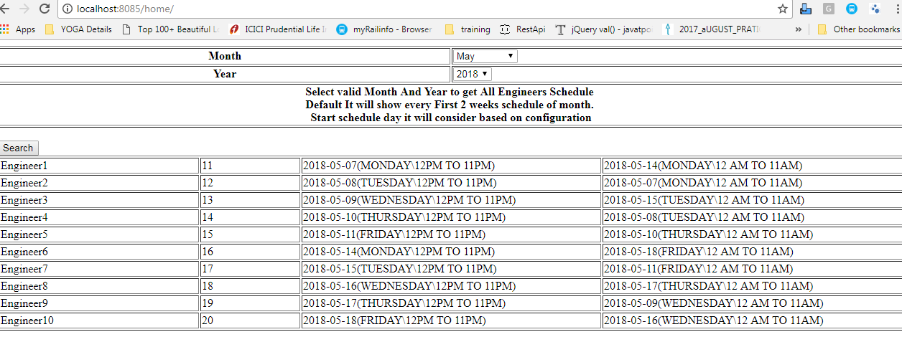

:

**Approach**

1 DateTimeExtensions:

This utility having different function which give require details using appliation.propery file

* getShiftStartDate(mionth,year) :

This Function is return date ,when shift should start .This function calculat date based on pass month ,year and schedule_start_day propery value

eg: Year 2018 ,Month:4 ,schedule_start_day :1 (Monday) ->Get First Monday date for April ,2018

* getShiftWeekendOffdays :

This Function return day off name based on weekend_off_day propery value its max value must be 2 parameters like 6,7 and not >7.

eg: Suppose property values 6,7 then its return SATURADAY,SUNDAY .So latter on this days will exclude form shift days.

* schedulePeriod:

This Function ruturn no of weeks for shift .Its get from week_scan_period property and return the same.

* getRandomNumberList:

This function is retunrn 2 seperate list(day ,night ) for random numbers (which is not greater then working day list size) ,its use as index to get date from working days list

2.ShiftDaoImpl:

This Class is take care all major business logic.

* getWorkingDates(String month,String year) :This Function is giving working days list based on no of weeks (schedulePeriod) -getShiftWeekendOffdays
* geShiftSchedule(String month,String year):This function is core part of application and its crating all Engineers shift plan .

3.GenerateEngineersData:

This class is responsible to generate List<Engineer> from json txt file on application init level.

src\main\resources\json\engineersJson.txt