B2B Rest API Client Application Microservice

B2BHackers = [Arpit Jain, Vipin Dhonkaria, Rashmi Acharya]

Live Link

<http://159.122.187.184:30070>

Technologies

Angular 6, Docker, Kubernetes, Angular Material, Springboot

Use Case

Our Application aims to modernize the existing IBM SI B2B APIs by converting them to microservices. Microservice feature of agile, monolithic and load balancing support along with OAuth authentication support.

Current B2B product is exposed list of APIs and not given a solution for a API gateway as-is from the product. This is a POC we added where customer can make use of API gateway feature deployed in kubernetes cluster and will never expose the actual API end points.

We made use of two Kube cluster deployed in two different data centres in IBM. We are seeing a faster response and throughput with this application with Spring Boot.

Our Application consists of three parts:  
  
**API End Point(A Microservice with Angular UI Components)**

It is responsible for all the interactions with API gateway or custom APIs and display the responses to the end users. This service is secured with IBM w3 authentication.  
  
**B2BAPI Gateway –(A microservice with Spring Boot)**

After successful login, responsible for API modelling .Requests from the previous microservice endpoint is redirected to API server and sense the response back to API End Point. Provides a gateway so that only authenticated users can have access to APII server .This microservice acts like a Netflix Zuul Proxy and additional scope can be added with load balancing features.

3 B2BAPIs Microservices (SpringBoot, IBM SI Dublin Server)  
  
UserAccountsAPI Application: Application that contains all the information of useraccounts. Contains several endpoints that can fetch single instance of  
useraccounts, all the instances of useraccounts, sort the useraccounts based on GivenName, Surname and Ids. Also provided a functionality to provide a  
limit on the number of instances to display.  
  
MailBoxAPI Application: Application that contains all the information of mailbox. Contains several endpoints that can fetch single instance of useraccounts, all the instances of mailbox, sort the mailboxes based on Ids. Also provide a functionality to provide a limit on the number of instances to display.  
  
UserVirtualRootsAPI Application: Application that contains all the information of uservirtualroots. Contains several endpoints that can fetch single instance of useraccounts, all the instances of uservirtualroots, sort the uservirtualroots based on Ids. Also provide a funtionalty to provide a limit on the number of instances to display.

Architecture

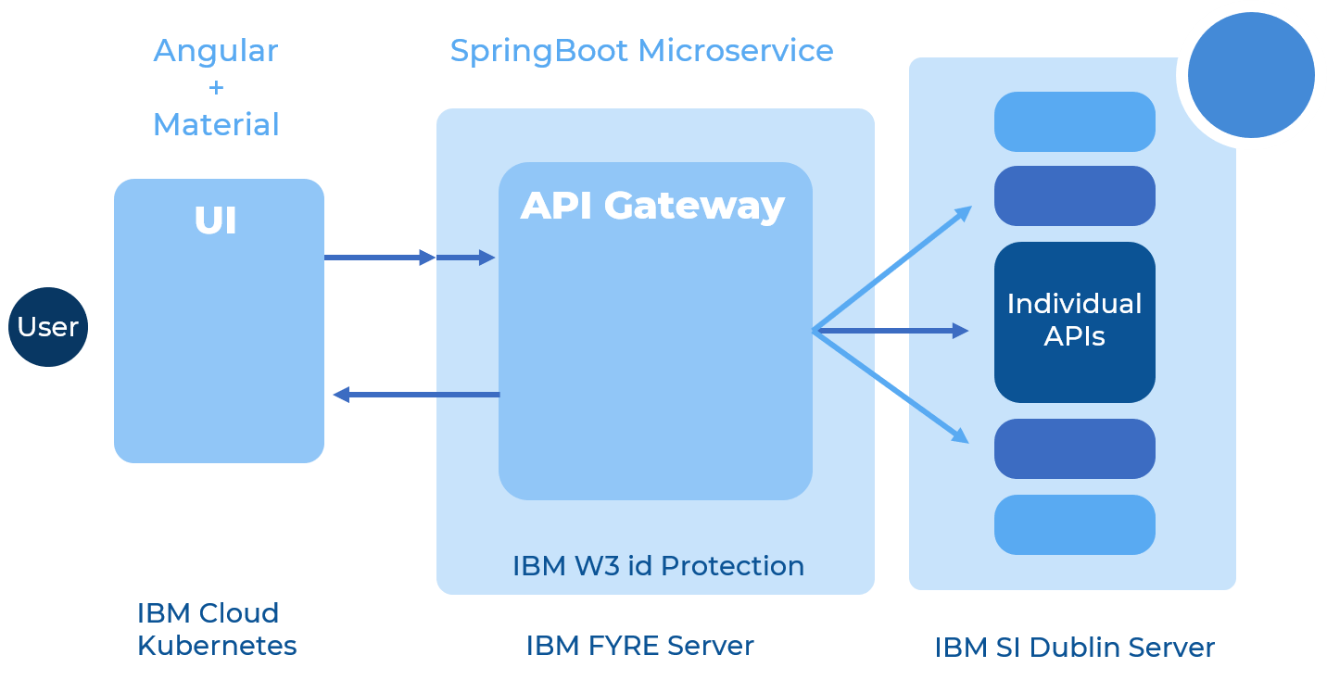

Scope

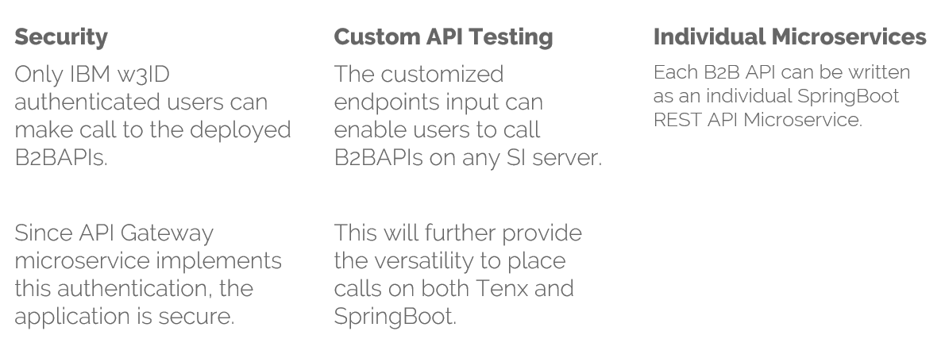

For more detailed information, check it on our ppt.

