**REST Client Adapter**

The REST Client adapter performs CRUD(Create, Read, Update, Delete) operations on B2BAPIs and generates XML response as output.

The following table provides an overview of the HTTP Client adapter:

| **System name** | **HTTP Client Adapter** |
| --- | --- |
| Graphical Process Modeler (GPM) category | None |
| Description | The REST Client adapter performs CRUD(Create, Read, Update, Delete) operations on B2BAPIs and generates XML response as output.   * Highly scalable (>150 concurrent transfers) * Supports large files up to 2 GB * Supports HTTP 1.1 |
| Business usage | Use this adapter to perform CRUD operations on B2BAPIs and use the response of one output into other. |
| Usage example | The Sterling B2B Integrator business process must call a B2BAPIs end points with some required parameters to fetch the response in process data. All CRUD operations can be performed on B2BAPIs and input can be passed as a file in both json format. Result of the GET operation can be stored in a desired output path. Can handles multiple operations in a single business process. |
| Preconfigured? | No |
| Requires third-party files? | Yes, required some jars i.e.  json.jar  json-simple-1.1.1.jar  hamcrest.core-1.1.jar  junit-4.10.jar |
| Platform availability | All supported Sterling B2B Integrator platforms |
| Related services | Related services:   * XmlJsonTransformer Service |
| Application requirements | No external requirements |
| Initiates business processes? | No |
| Invocation | Self invocation. |
| Business process context considerations | Business processes using HTTP client services should not be marked as Auto Resume. These services require an established session which will no longer exist after a restart. |
| Returned status values | Returned status values:   * 100s – Informational parameters and more status parameters will follow. * 200s – Request was OK. * 300s – Request failed and more status codes will follow. * 400s – Client Request Failed. This is a client error. * 500s – Server failed to handle a valid request. This is a server error.   **Note**For information on setting the SOAP fault status to return 500 HTTP error status, see *SOAP Outbound service*. |
| Restrictions | No restrictions. |
| Persistence level | N/A |
| Testing considerations | To test this adapter, run the rest client adapter business process and verify that it completes successfully. For more information about the rest client adapter business process, see the *Business Process Example*. Debug information related to this adapter can be found in the System and noapp logs. |

## Business Process Example

The following example business process illustrates the use of the REST Client adapter, which work through the CRUD operations using this adapter:

<process name="RestClient">

<sequence>

<!-- Simple Get Request with id for single instance -->

<operation name="REST Client GET Operation with Id ">

<participant name='RestClient'/>

<output message='xout'>

<!-- B2BAPIs End Points -->

<assign to='url'>

[http://9.55.53.11:51665/B2BAPIs/svc/cadigitalcertificates/b2b_demo</assign](http://9.55.53.11:51665/B2BAPIs/svc/cadigitalcertificates/b2b_demo%3c/assign)>

<!-- Operation Type -->

<assign to='restoperation'>GET</assign>

<!-- For Basic Authentication -->

<assign to='auth'>admin:password</assign>

<assign to='.' from='*' />

</output>

<input message="xin">

<assign to='.' from='*' />

</input>

</operation>

<operation name="REST Client GET with Id in Separate Assign Statement ">

<participant name='RestClient'/>

<output message='xout'>

<assign to='url'>

[http://9.55.53.11:51665/B2BAPIs/svc/cadigitalcertificates/b2b_demo</assign](http://9.55.53.11:51665/B2BAPIs/svc/cadigitalcertificates/b2b_demo%3c/assign)>

<assign to='id'>b2bi_demo</assign>

<assign to='restoperation'>GET</assign>

<assign to='auth'>admin:password</assign>

<assign to='.' from='*' />

</output>

<input message="xin">

<assign to='.' from='*' />

</input>

</operation>

<operation name="REST Client GET Operation for All Instances">

<participant name='RestClient'/>

<output message='xout'>

<assign to='url'>

[http://9.55.53.11:51665/B2BAPIs/svc/cadigitalcertificates/</assign](http://9.55.53.11:51665/B2BAPIs/svc/cadigitalcertificates/%3c/assign)>

<assign to='restoperation'>GET</assign>

<assign to='auth'>admin:password</assign>

<assign to='.' from='*' />

</output>

<input message="xin">

<assign to='.' from='*' />

</input>

</operation>

<operation name="REST Client GET Operation with Output storage in desired file path">

<participant name='RestClient'/>

<output message='xout'>

<assign to='url'>

[http://9.55.53.11:51665/B2BAPIs/svc/cadigitalcertificates/b2b_demo</assign](http://9.55.53.11:51665/B2BAPIs/svc/cadigitalcertificates/b2b_demo%3c/assign)>

<assign to='outputpath'>

/ais_local/share/jnaidu01/60/g/platform_core/install/noapp/Restoutput.xml</assign>

<assign to='restoperation'>GET</assign>

<assign to='auth'>admin:password</assign>

<assign to='.' from='*' />

</output>

<input message="xin">

<assign to='.' from='*' />

</input>

</operation>

<operation name="REST Client Delete Operation">

<participant name='RestClient'/>

<output message='xout'>

<assign to='url'>

[http://9.55.53.11:51665/B2BAPIs/svc/cadigitalcertificates/</assign](http://9.55.53.11:51665/B2BAPIs/svc/cadigitalcertificates/%3c/assign)>

<assign to='restoperation'>DELETE</assign>

<assign to='auth'>admin:password</assign>

<assign to='.' from='*' />

</output>

<input message="xin">

<assign to='.' from='*' />

</input>

</operation>

<operation name="REST Client POST Operation with json input in assign statement">

<participant name='RestClient'/>

<output message='xout'>

<assign to='url'>

[http://9.55.53.11:51665/B2BAPIs/svc/useraccounts/</assign](http://9.55.53.11:51665/B2BAPIs/svc/useraccounts/%3c/assign)>

<assign to='restoperation'>POST</assign>

<assign to='auth'>admin:password</assign>

<assign to="jsoninput1">

"authenticationHost": null,

"authenticationType": "Local",

"authorizedUserKeys": null,

"email": "arpit.jain@iiitdmj.ac.in",

"givenName": "arpi",

"groups": null,

"managerId": null,

"pager": null,

"password": "arpitdemo",

"permissions": null,

"policy": null,

"preferredLanguage": null,

"sessionTimeout": null,

"surname": "jai",

"userId": "2003"

</assign>

<assign to='.' from='*' />

</output>

<input message="xin">

<assign to='.' from='*' />

</input>

</operation>

<operation name="REST Client POST Operation with input from file">

<participant name='RestClient'/>

<output message='xout'>

<assign to='url'>

[http://9.55.53.11:51665/B2BAPIs/svc/useraccounts/</assign](http://9.55.53.11:51665/B2BAPIs/svc/useraccounts/%3c/assign)>

<assign to='restoperation'>POST</assign>

<assign to='auth'>admin:password</assign>

<assign to='.' from='PrimaryDocument/@SCIObjectID'></assign>

<!—sample json input to be passed in file -->

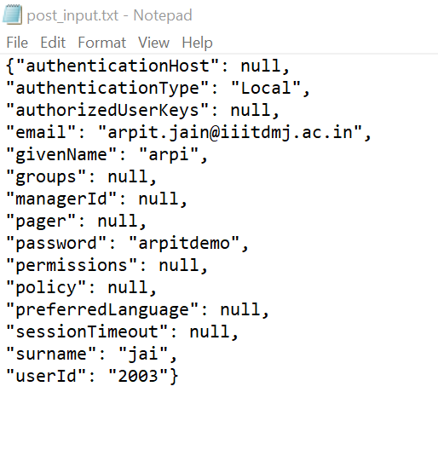

<assign to='.' from='*' />

</output>

<input message="xin">

<assign to='.' from='*' />

</input>

</operation>

<operation name="REST Client POST Operation with dynamic input from one operation to another">

<participant name=RestClient/>

<output message='xout'>

<assign to='url'>http://9.55.53.11:51665/B2BAPIs/svc/cadigitalcertificates/b2bi_demo/</assign>

<assign to='restoperation'>GET</assign>

<assign to='auth'>admin:password</assign>

<assign to='.' from='*' />

</output>

<input message="xin">

<assign to='.' from='*' />

</input>

</operation>

<operation name="Request1">

<participant name='genericrest1'/>

<output message='xout'>

<assign to='url'>http://9.55.53.11:51665/B2BAPIs/svc/cadigitalcertificates/</assign>

<assign to='restoperation'>POST</assign>

<assign to='auth'>admin:password</assign>

<assign to="jsoninput1" from='concat(&apos;"certName":"&apos;,/ProcessData/Response_0/Data/certName/text(),&apos;4"&apos;)'></assign>

<assign to="jsoninput2" from='concat(&apos;"certData":"&apos;,/ProcessData/Response_0/Data/certData/text(),&apos;"&apos;)'></assign>

</output>

<input message="xin">

<assign to='.' from='*'/>

</input>

</operation>

<operation name="REST Client PUT Operation with input in assign statement">

<participant name='RestClient'/>

<output message='xout'>

<assign to='url'>

http://9.55.53.11:51665/B2BAPIs/svc/useraccounts/2003>

<assign to='restoperation'>PUT</assign>

<assign to='auth'>admin:password</assign>

<assign to="jsoninput1">

"authenticationHost": null,

"authenticationType": "Local",

"authorizedUserKeys": null,

"email": "vipindhonkaria@iiitdmj.ac.in",

"givenName": "vipin",

"groups": null,

"managerId": null,

"pager": null,

"password": "vipindemo",

"permissions": null,

"policy": null,

"preferredLanguage": null,

"sessionTimeout": null,

"surname": "dhonkaria",

"userId": "1997"

</assign>

<assign to='.' from='*' />

</output>

<input message="xin">

<assign to='.' from='*' />

</input>

</operation>

<operation name="REST Client PUT Operation with input from file">

<participant name='RestClient'/>

<output message='xout'>

<assign to='url'>

[http://9.55.53.11:51665/B2BAPIs/svc/useraccounts/</assign](http://9.55.53.11:51665/B2BAPIs/svc/useraccounts/%3c/assign)>

<assign to='restoperation'>PUT</assign>

<assign to='auth'>admin:password</assign>

<assign to='.' from='PrimaryDocument/@SCIObjectID'></assign>

<!-- sample json input to be passed in file -->

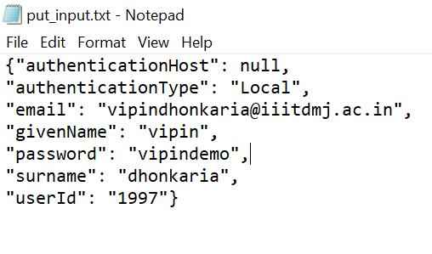

<assign to='.' from='*' />

</output>

<input message="xin">

<assign to='.' from='*' />

</input>

</operation>

<operation name="REST Client PUT Operation with dynamic input from one operation to other">

<participant name=RestClient />

<output message='xout'>

<assign to='url'>http://9.55.53.11:51665/B2BAPIs/svc/cadigitalcertificates/b2bi_demo/</assign>

<assign to='restoperation'>GET</assign>

<assign to='auth'>admin:password</assign>

<assign to='.' from='*' />

</output>

<input message="xin">

<assign to='.' from='*' />

</input>

</operation>

<operation name="Request1">

<participant name='genericrest1'/>

<output message='xout'>

<assign to='url'>http://9.55.53.11:51665/B2BAPIs/svc/cadigitalcertificates/</assign>

<assign to='restoperation'>PUT</assign>

<assign to='auth'>admin:password</assign>

<assign to="jsoninput1" from='concat(&apos;"certName":"&apos;,/ProcessData/Response_0/Data/certName/text(),&apos;4"&apos;)'></assign>

<assign to="jsoninput2" from='concat(&apos;"certData":"&apos;,/ProcessData/Response_0/Data/certData/text(),&apos;"&apos;)'></assign>

</output>

<input message="xin">

<assign to='.' from='*'/>

</input>

</operation>

<operation name="REST Client Multiple CRUD Operation in single service">

<participant name='RestClient'/>

<output message='xout'>

<assign to='url'>

http://9.55.53.11:51665/B2BAPIs/svc/cadigitalcertificates/b2bi_demo/,

http://9.55.53.11:51665/B2BAPIs/svc/cadigitalcertificates/b2bi_demo1/,

http://9.55.53.11:51665/B2BAPIs/svc/cadigitalcertificates/ b2bi_demo2/,

http://9.55.53.11:51665/B2BAPIs/svc/cadigitalcertificates/b2bi_demo3/

</assign>

<assign to='restoperation'> GET,DELETE,GET,DELETE </assign>

<assign to='auth'>admin:password</assign>

<assign to='.' from='*' />

</output>

<input message="xin">

<assign to='.' from='*' />

</input>

</operation>

<operation name="REST Client POST Operation with xml input from file and using xmltransformation service">

<participant name='xmljsontransformer'/>  
 <output message='xout'>  
 <assign to='inputtype'>XML</assign>  
 <assign to='outputpath'>/ais_local/share/jnaidu01/60/g/platform_core/install/noapp/output.json</assign>  
 <assign to='.' from='PrimaryDocument/@SCIObjectID'></assign>  
 <assign to='.' from='*' />  
 </output>  
 <input message="xin">  
 <assign to='service1' from='*' />  
 </input>  
 </operation>   
 <operation name="Request1">  
 <participant name='genericrest'/>  
 <output message='xout'>  
 <assign to='url'><http://9.55.53.11:51665/B2BAPIs/svc/cadigitalcertificates/></assign>  
 <assign to='restoperation'>POST</assign>  
 <assign to='auth'>admin:password</assign>  
 <assign to="jsoninput1" from='service1/Output/text()'></assign>  
 </output>  
 <input message="xin">  
 <assign to='service2' from='*'/>  
 </input>  
 </operation>

</sequence>

</process>