(1)

CODE :

<!DOCTYPE html>

<html lang="en">

<head>

<meta charset="UTF-8">

<meta http-equiv="X-UA-Compatible" content="IE=edge">

<meta name="viewport" content="width=device-width, initial-scale=1.0">

<title>Task-1</title>

</head>

<body>

<script>

function hello() {

let name = "Vipin";

let msg = " Hello " + name + " ! "

console.log(msg);

}

hello();

</script>

</body>

</html>

OUTPUT:

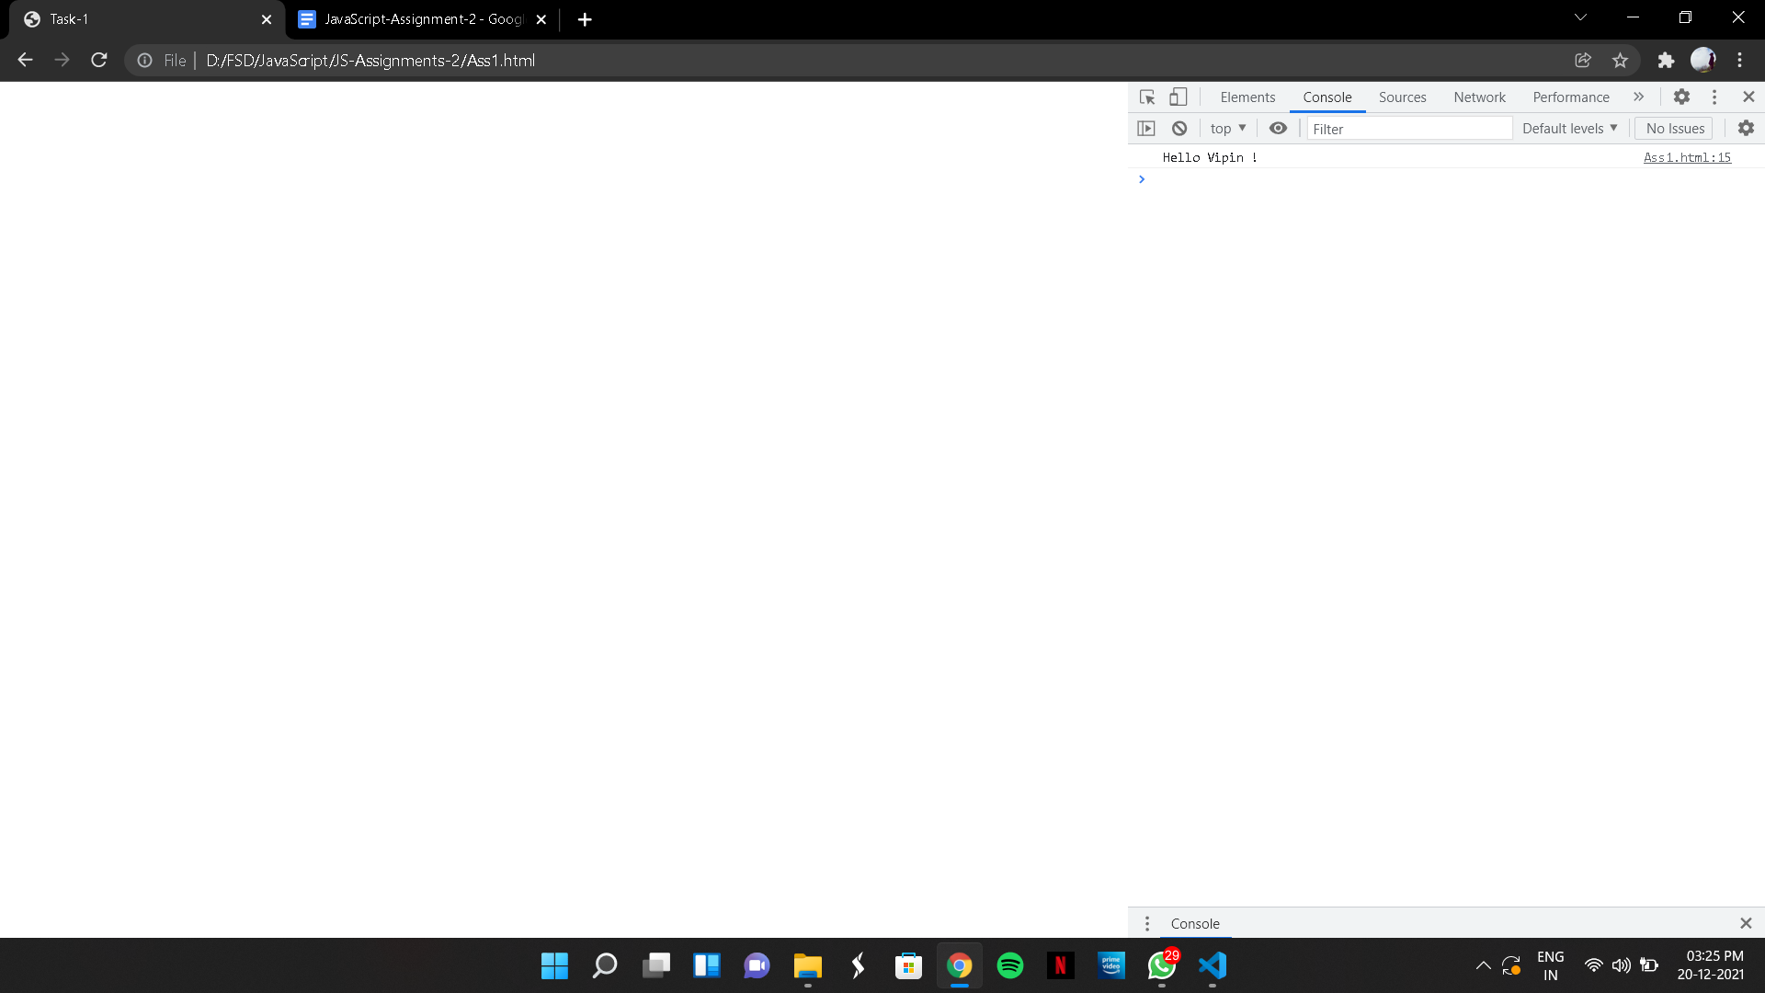

(2)

CODE:

<!DOCTYPE html>

<html lang="en">

<head>

<meta charset="UTF-8">

<meta http-equiv="X-UA-Compatible" content="IE=edge">

<meta name="viewport" content="width=device-width, initial-scale=1.0">

<title>Task-2</title>

</head>

<body>

<script>

function a() {

let name = "a";

let msg = " Hello " + name + " ! " ;

console.log(msg);

}

function b() {

let name = "b";

let msg = " Hello " + name + " ! " ;

console.log(msg);

}

a();

b();

</script>

</body>

</html>

OUTPUT:

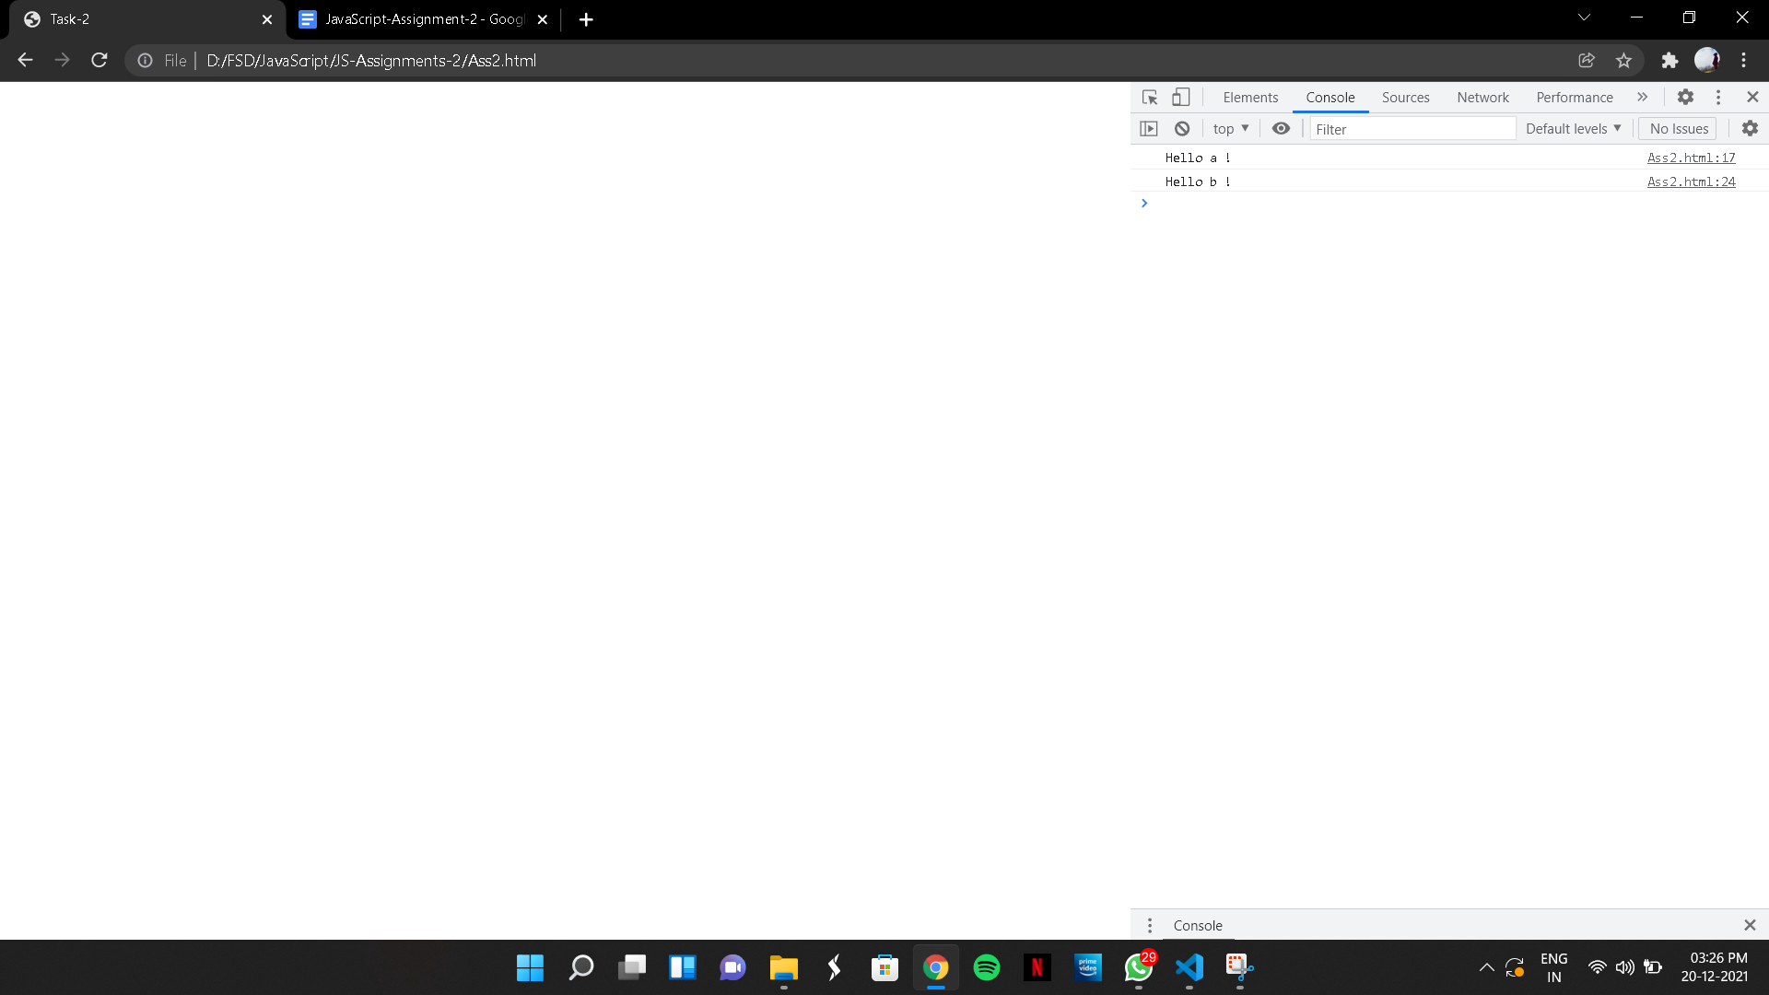

(3)

CODE:

<!DOCTYPE html>

<html lang="en">

<head>

<meta charset="UTF-8">

<meta http-equiv="X-UA-Compatible" content="IE=edge">

<meta name="viewport" content="width=device-width, initial-scale=1.0">

<title>Task-3</title>

</head>

<body>

<script>

let salutation;

let greet=(name)=>`${name}`;

salutation=greet('VIPIN');

console.log(salutation);

</script>

</body>

</html>

OUTPUT:

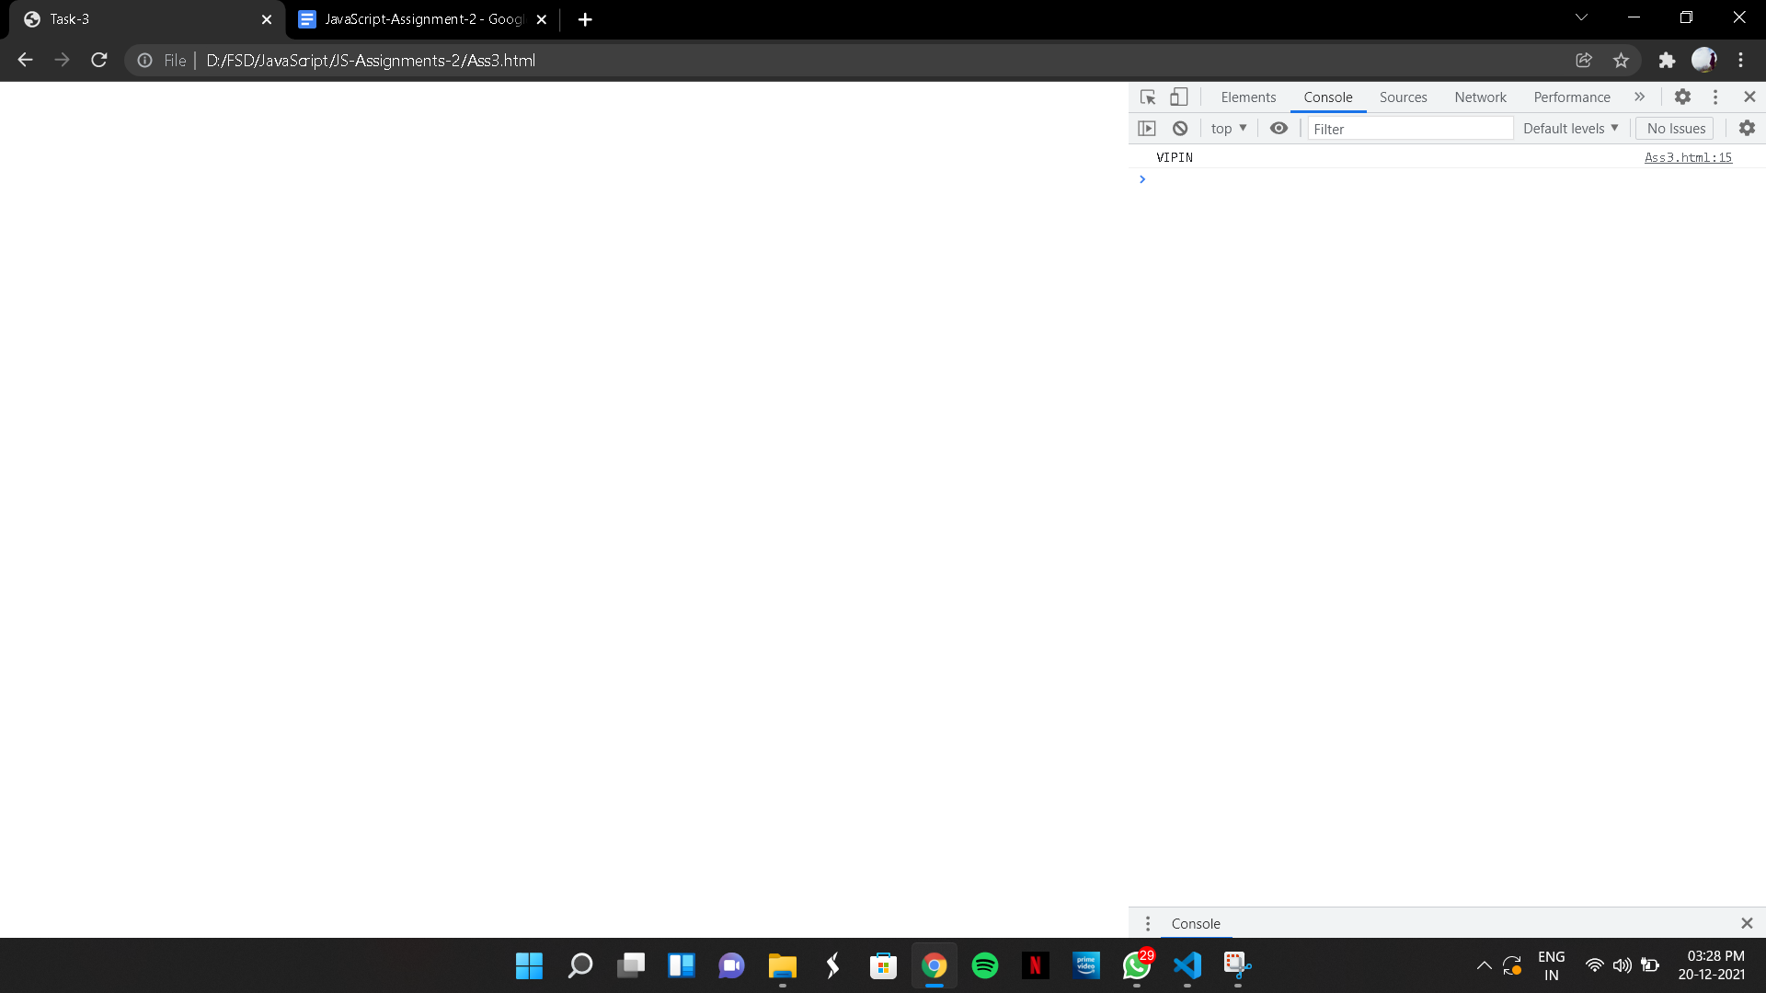

(4)

CODE:

<!DOCTYPE html>

<html lang="en">

<head>

<meta charset="UTF-8">

<meta http-equiv="X-UA-Compatible" content="IE=edge">

<meta name="viewport" content="width=device-width, initial-scale=1.0">

<title>Task-4</title>

</head>

<body>

<script>

function echo(parameter) {

console.log(parameter);

}

echo("SkillSafari");

echo("EduKeys");

</script>

</body>

</html>

OUTPUT:

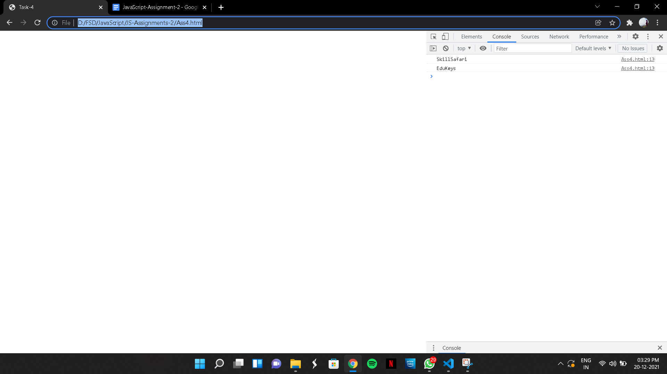

(5)

CODE:

<!DOCTYPE html>

<html lang="en">

<head>

<meta charset="UTF-8">

<meta http-equiv="X-UA-Compatible" content="IE=edge">

<meta name="viewport" content="width=device-width, initial-scale=1.0">

<title>Task-5</title>

</head>

<body>

<script>

function greet(name){

let msg = " Hello " + name + " ! " ;

console.log(msg);

}

greet("SkillSafari");

</script>

</body>

</html>

OUTPUT:

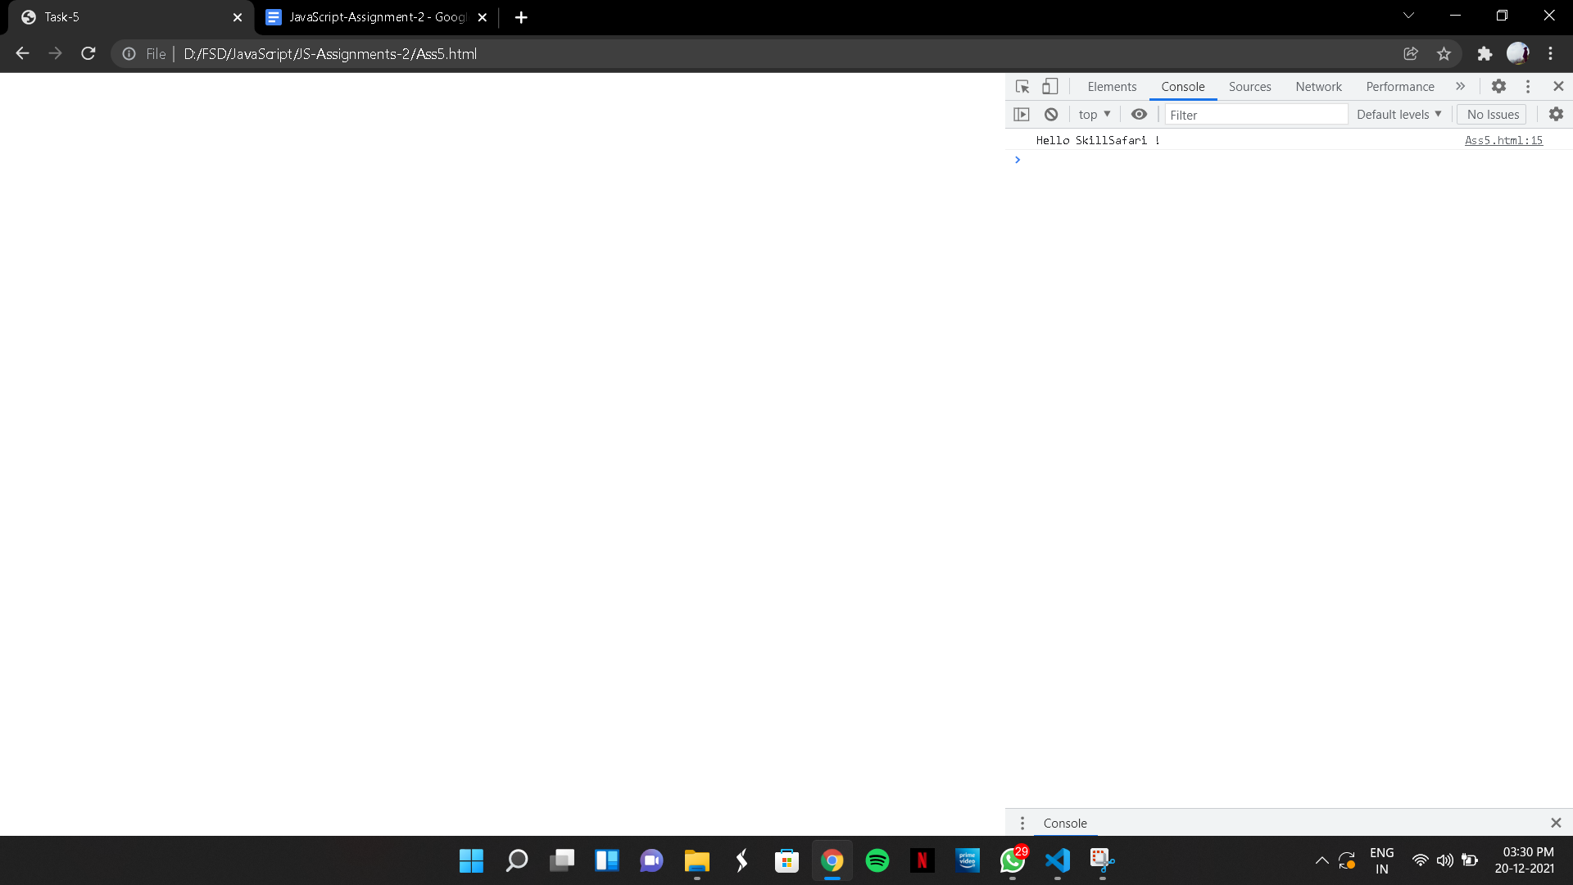

(6)

CODE:

<!DOCTYPE html>

<html lang="en">

<head>

<meta charset="UTF-8">

<meta http-equiv="X-UA-Compatible" content="IE=edge">

<meta name="viewport" content="width=device-width, initial-scale=1.0">

<title>Task-6</title>

</head>

<body>

<script>

function log(greet){

console.log(greet);

}

log("Hello SkillSafari !")

</script>

</body>

</html>

OUTPUT:

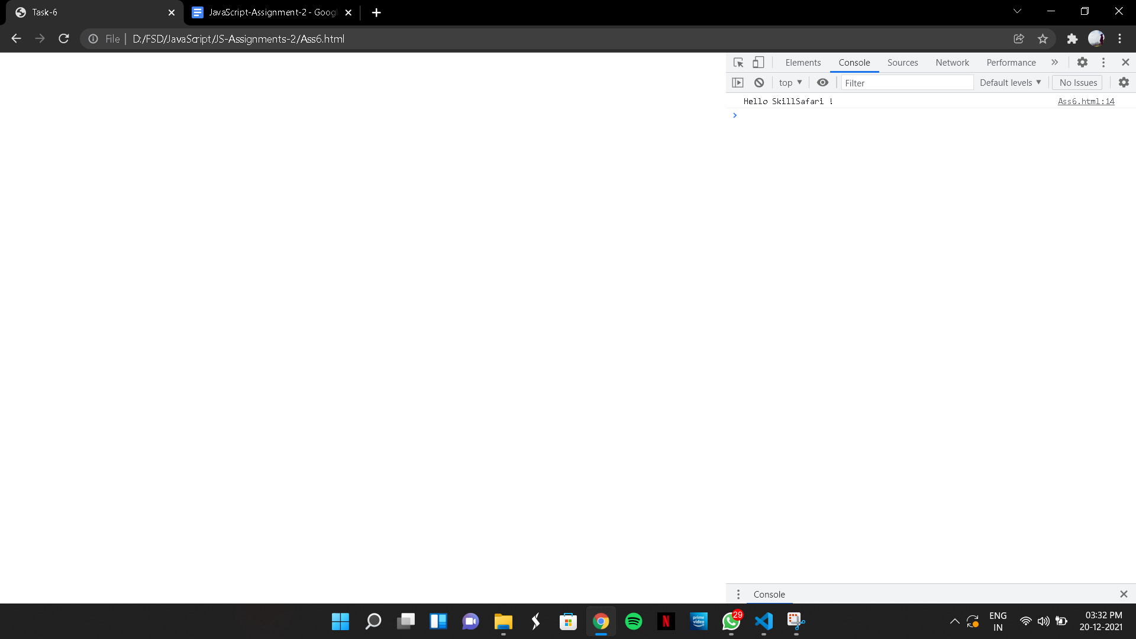

(7)

CODE:

<!DOCTYPE html>

<html lang="en">

<head>

<meta charset="UTF-8">

<meta http-equiv="X-UA-Compatible" content="IE=edge">

<meta name="viewport" content="width=device-width, initial-scale=1.0">

<title>Task-7</title>

</head>

<body>

<script>

function shout(x) {

return x.repeat(2);

}

console.log(shout("Hello"));

</script>

</body>

</html>

OUTPUT:

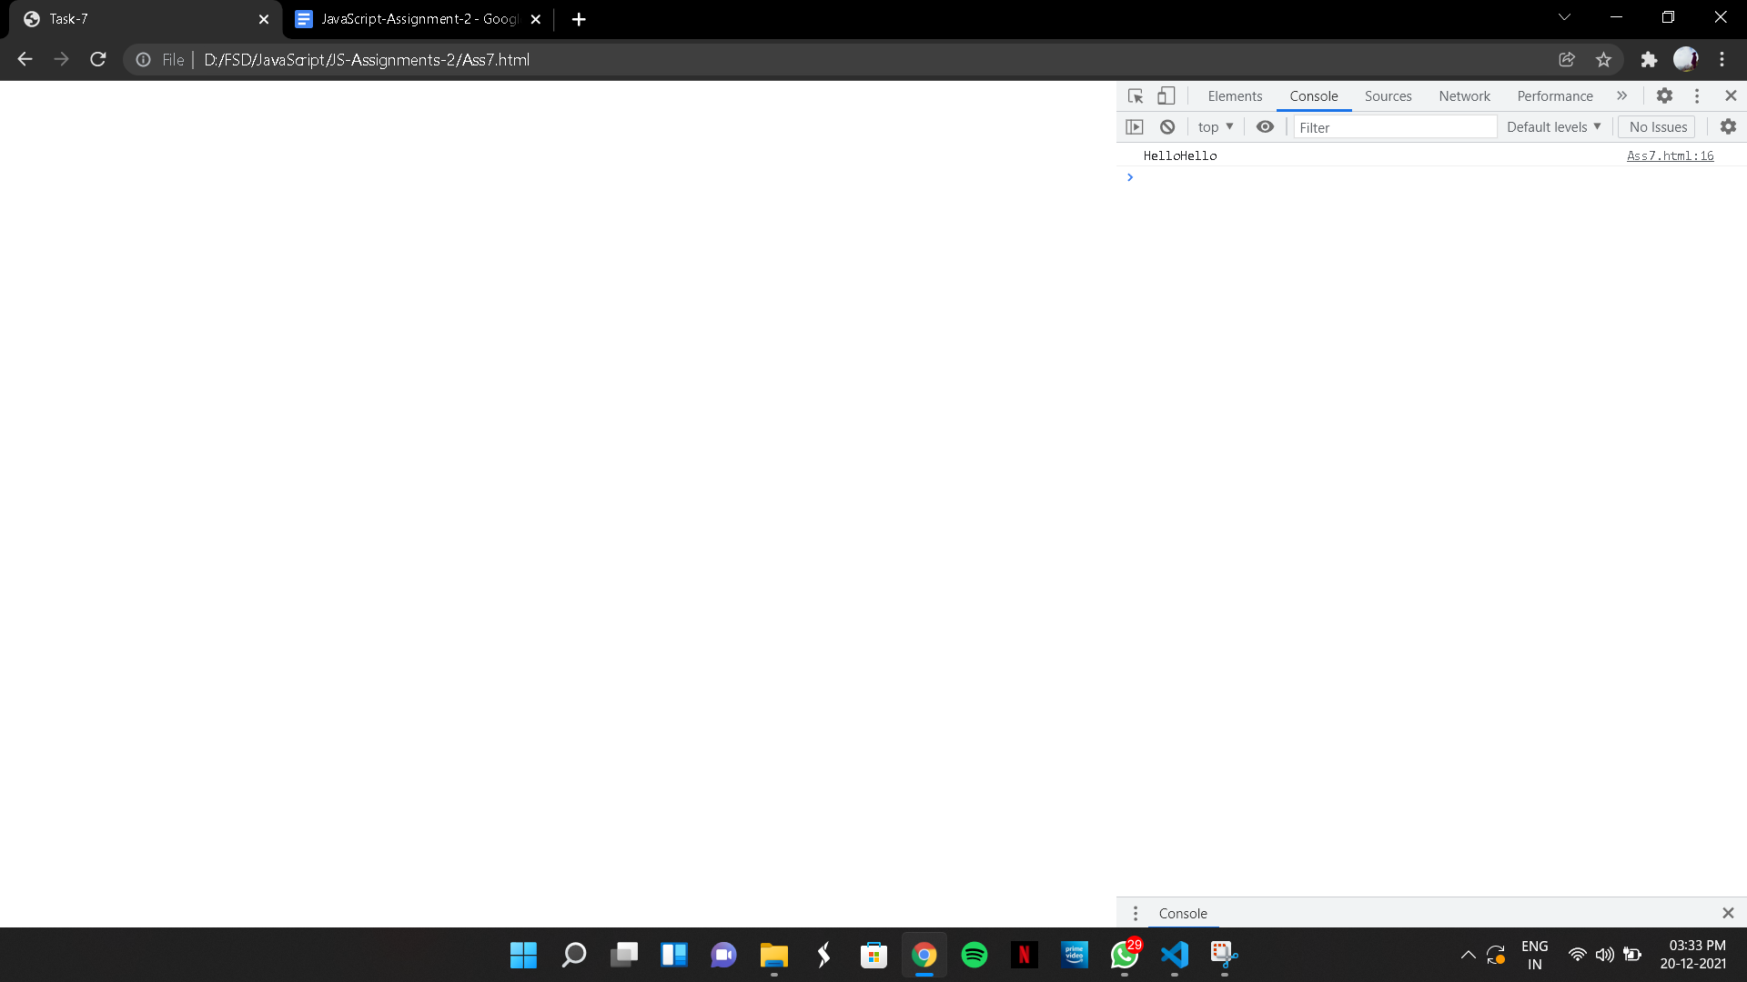

(8)

CODE:

<!DOCTYPE html>

<html lang="en">

<head>

<meta charset="UTF-8">

<meta http-equiv="X-UA-Compatible" content="IE=edge">

<meta name="viewport" content="width=device-width, initial-scale=1.0">

<title>Task-8</title>

</head>

<body>

<script>

function length() {

let string = "SkillSafari";

console.log(string.length);

}

length();

</script>

</body>

</html>

OUTPUT:

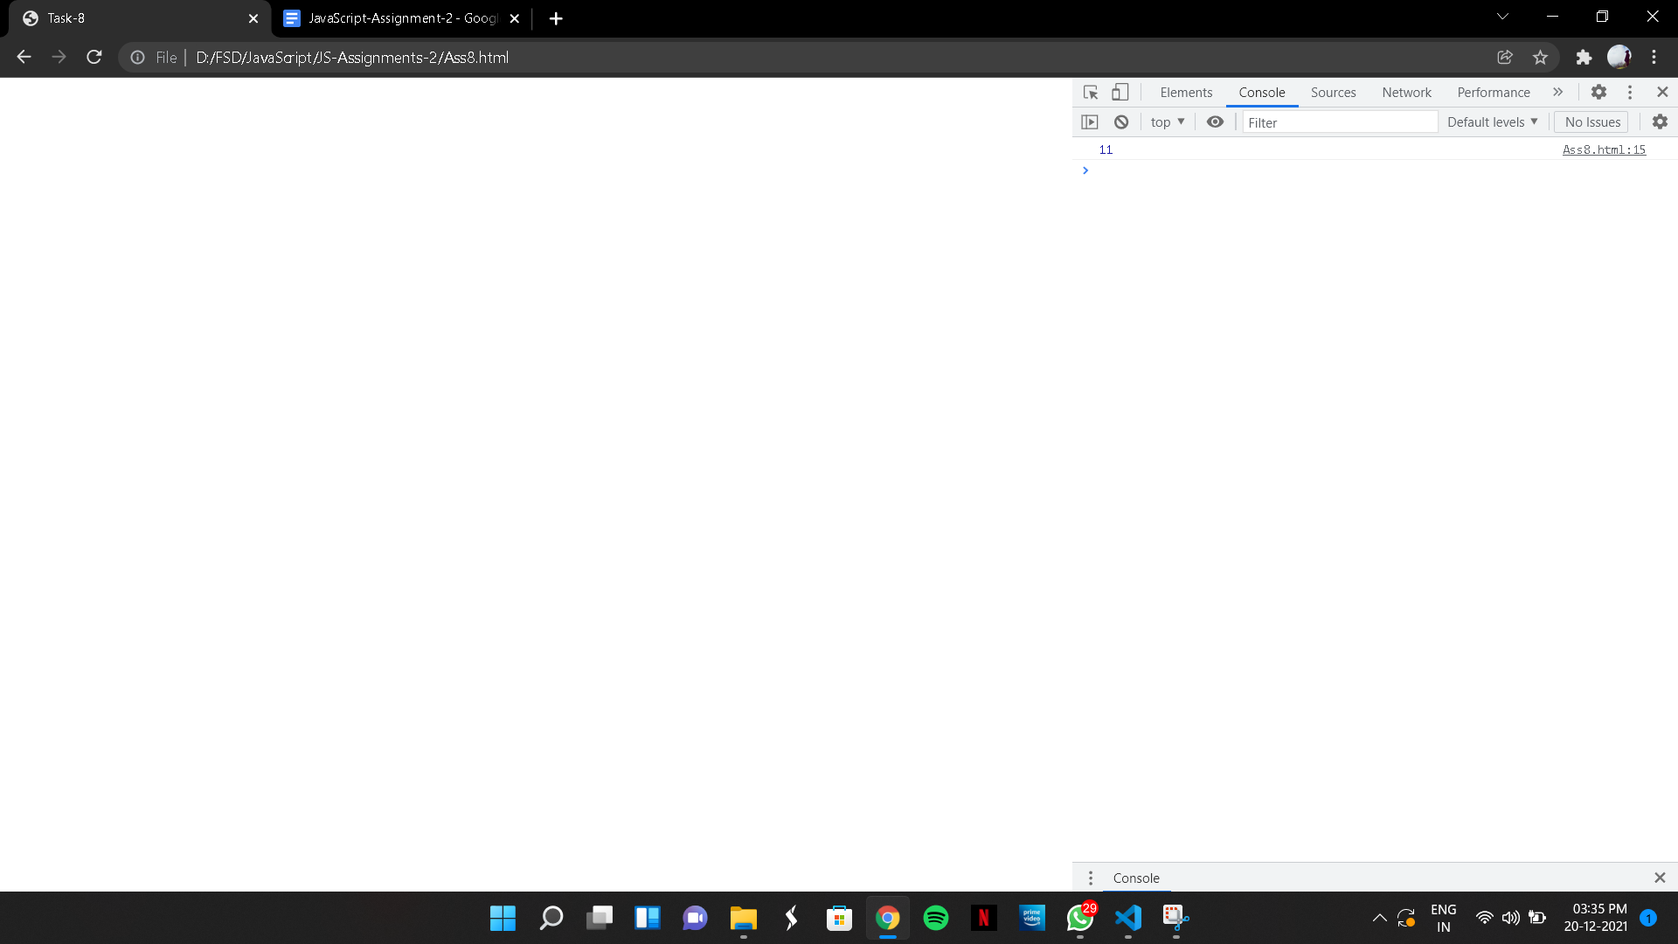

(9)

CODE:

<!DOCTYPE html>

<html lang="en">

<head>

<meta charset="UTF-8">

<meta http-equiv="X-UA-Compatible" content="IE=edge">

<meta name="viewport" content="width=device-width, initial-scale=1.0">

<title>Task-9</title>

</head>

<body>

<script>

function toCase(String) {

console.log(`${String.toLowerCase()}-${String.toUpperCase()}`);

}

toCase("HeLLo");

</script>

</body>

</html>

OUTPUT:

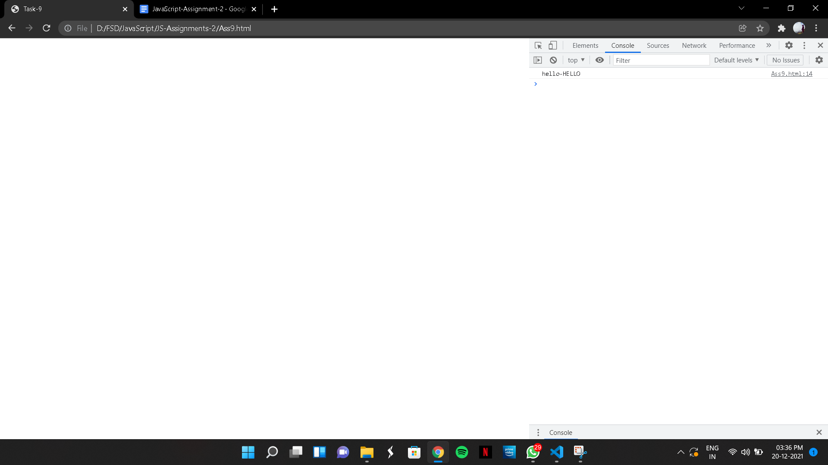

(10)

CODE:

<!DOCTYPE html>

<html lang="en">

<head>

<meta charset="UTF-8">

<meta http-equiv="X-UA-Compatible" content="IE=edge">

<meta name="viewport" content="width=device-width, initial-scale=1.0">

<title>Task-10</title>

</head>

<body>

<script>

function shortcut(a, b) {

console.log(`${a.charAt(0)}${b.charAt(0)}`)

}

shortcut("Java", "Script");

</script>

</body>

</html>

OUTPUT:

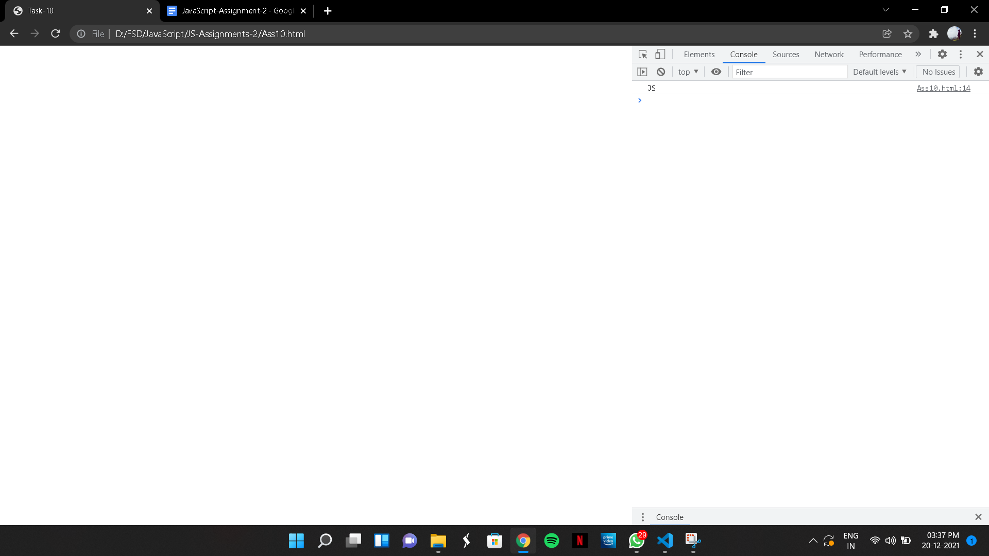

(11)

CODE:

<!DOCTYPE html>

<html lang="en">

<head>

<meta charset="UTF-8">

<meta http-equiv="X-UA-Compatible" content="IE=edge">

<meta name="viewport" content="width=device-width, initial-scale=1.0">

<title>Task-11</title>

</head>

<body>

<script>

function firstChar(string) {

return `${string.charAt(1)}` ;

}

console.log(firstChar(" Vipin "));

</script>

</body>

</html>

OUTPUT:

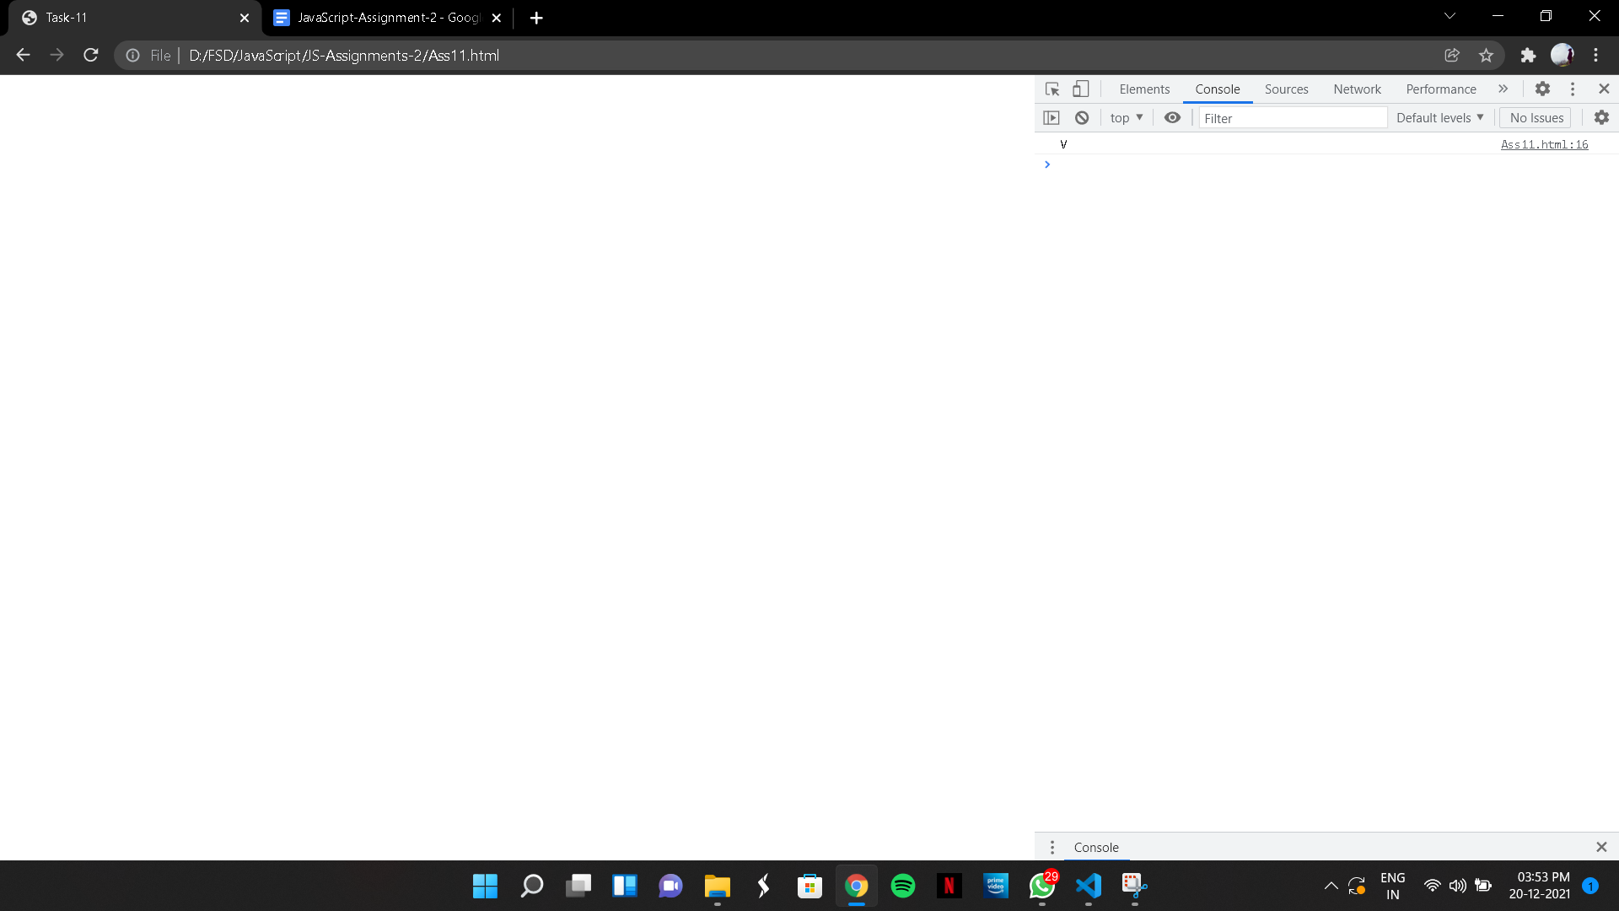

(12)

CODE:

<!DOCTYPE html>

<html lang="en">

<head>

<meta charset="UTF-8">

<meta http-equiv="X-UA-Compatible" content="IE=edge">

<meta name="viewport" content="width=device-width, initial-scale=1.0">

<title>Task-12</title>

</head>

<body>

<script>

function indexOfIgnoreCase(a,b) {

let aLower = a.toLowerCase();

let bLower = b.toLowerCase();

console.log(aLower.indexOf(bLower));

}

indexOfIgnoreCase("Skill", "kill");

</script>

</body>

</html>

OUTPUT:

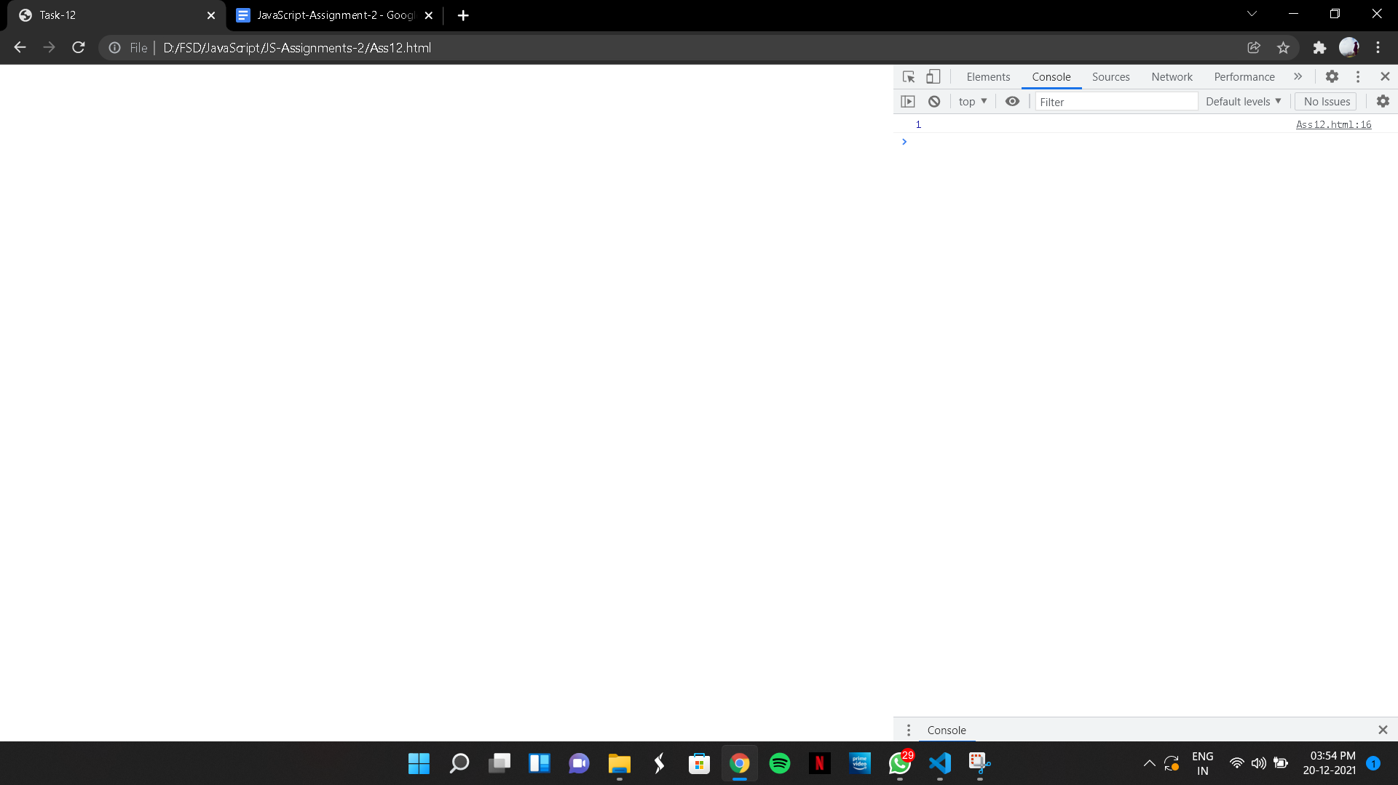

(13)

CODE:

<!DOCTYPE html>

<html lang="en">

<head>

<meta charset="UTF-8">

<meta http-equiv="X-UA-Compatible" content="IE=edge">

<meta name="viewport" content="width=device-width, initial-scale=1.0">

<title>Task-13</title>

</head>

<body>

<script>

let s1 = 'White Rabbit'.indexOf('it', 1);

let s2 = 'White Rabbit'.indexOf('it', 3);

function secondIndexOf(s1, s2) {

let firstIndex = s1.indexOf(s2);

return s1.indexOf(s2, firstIndex + 1);

}

console.log(s2)

</script>

</body>

</html>

OUTPUT:

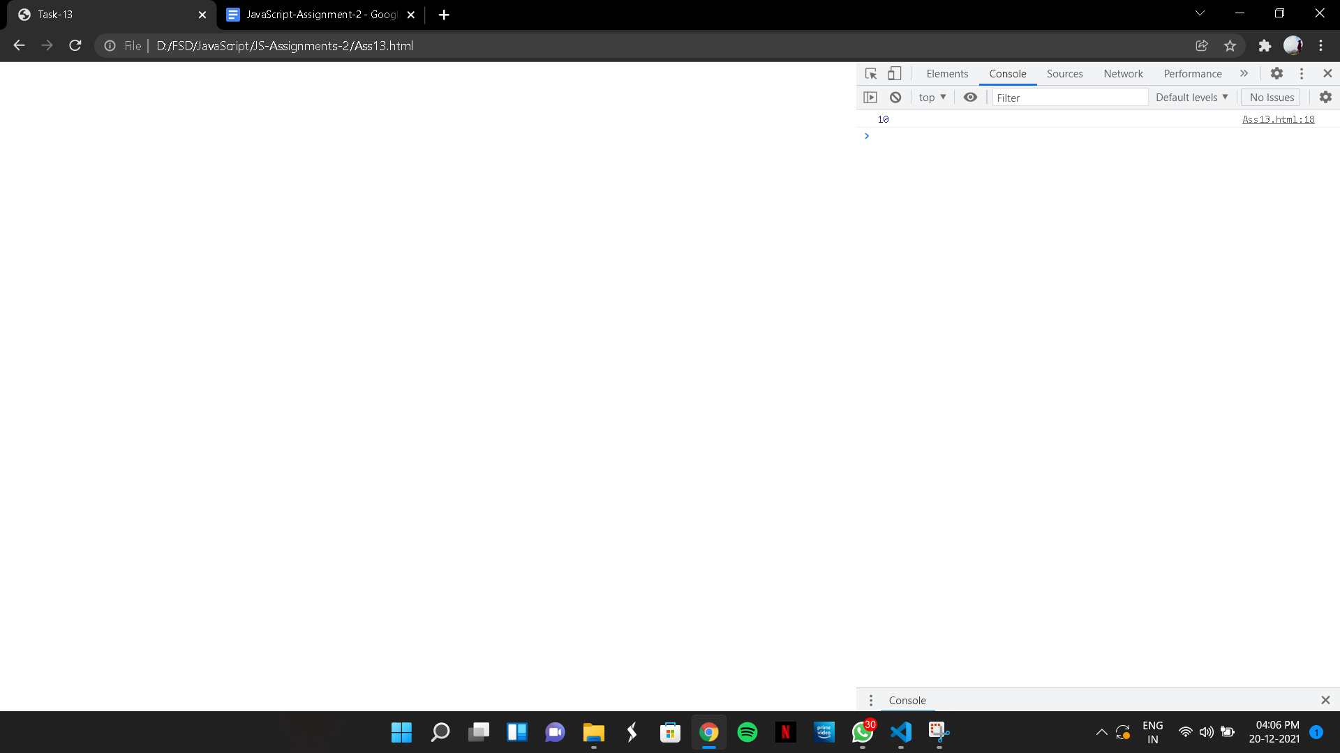

(14)

CODE:

<!DOCTYPE html>

<html lang="en">

<head>

<meta charset="UTF-8">

<meta http-equiv="X-UA-Compatible" content="IE=edge">

<meta name="viewport" content="width=device-width, initial-scale=1.0">

<title>Task-14</title>

</head>

<body>

<script>

function firstWord(String) {

console.log(String.split(" ")[0]);

}

firstWord("Skill and Safari");

</script>

</body>

</html>

OUTPUT:

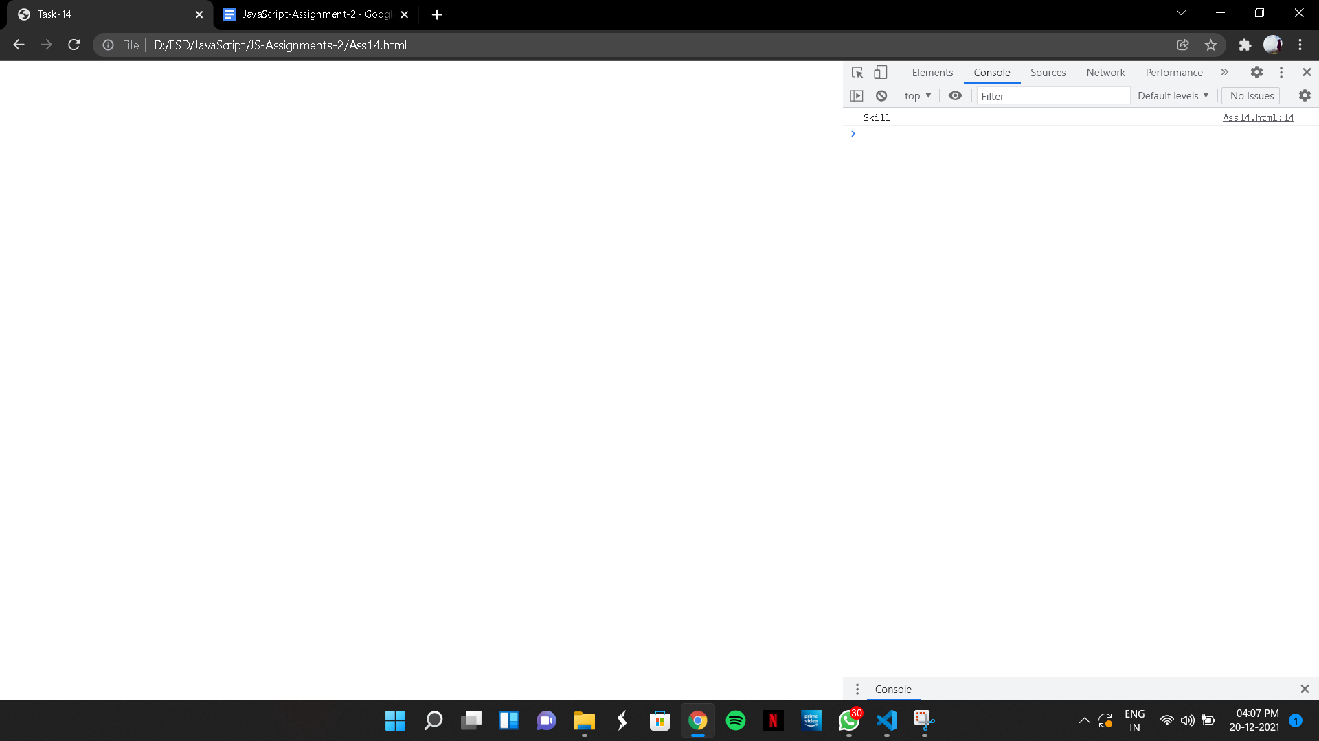

(15)

CODE:

<!DOCTYPE html>

<html lang="en">

<head>

<meta charset="UTF-8">

<meta http-equiv="X-UA-Compatible" content="IE=edge">

<meta name="viewport" content="width=device-width, initial-scale=1.0">

<title>Task-15</title>

</head>

<body>

<script>

function normalize(date) {

console.log(date.replace(/-/g,"/"));

}

normalize("20-12-2021");

</script>

</body>

</html>

OUTPUT:

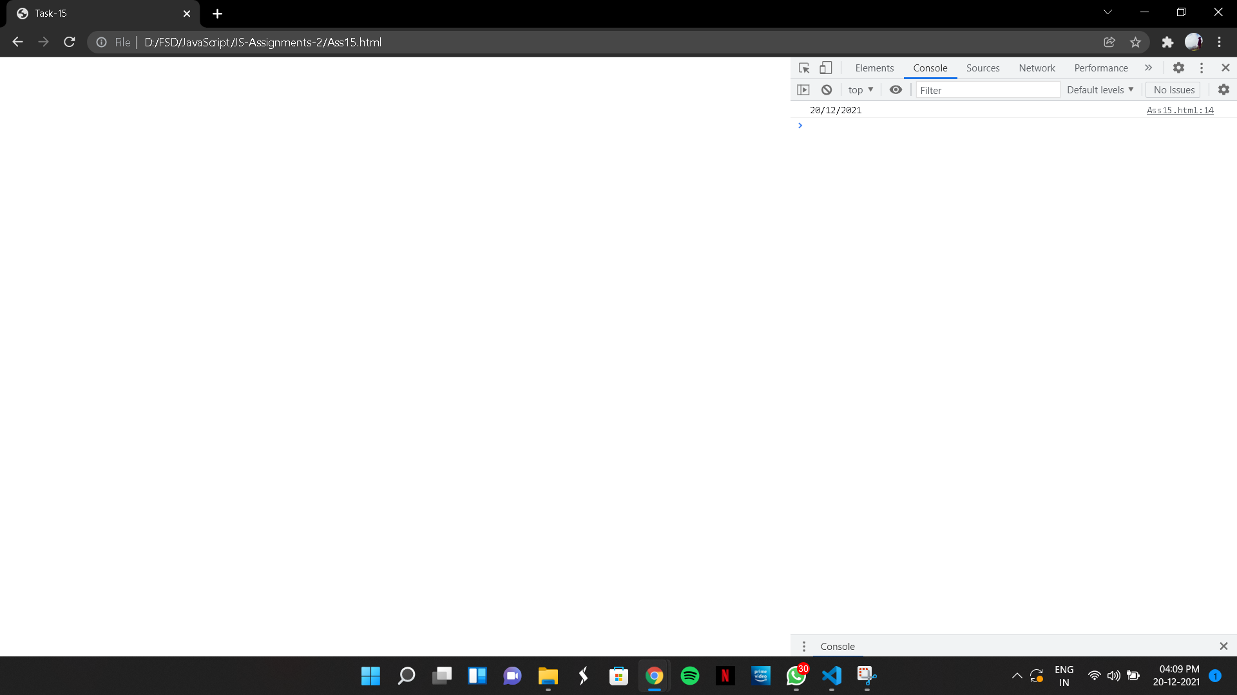

(16)

CODE:

<!DOCTYPE html>

<html lang="en">

<head>

<meta charset="UTF-8">

<meta http-equiv="X-UA-Compatible" content="IE=edge">

<meta name="viewport" content="width=device-width, initial-scale=1.0">

<title>Task-16</title>

</head>

<body>

<script>

let add = (a,b) => a + b ;

console.log(add(1,2)) ;

</script>

</body>

</html>

OUTPUT:

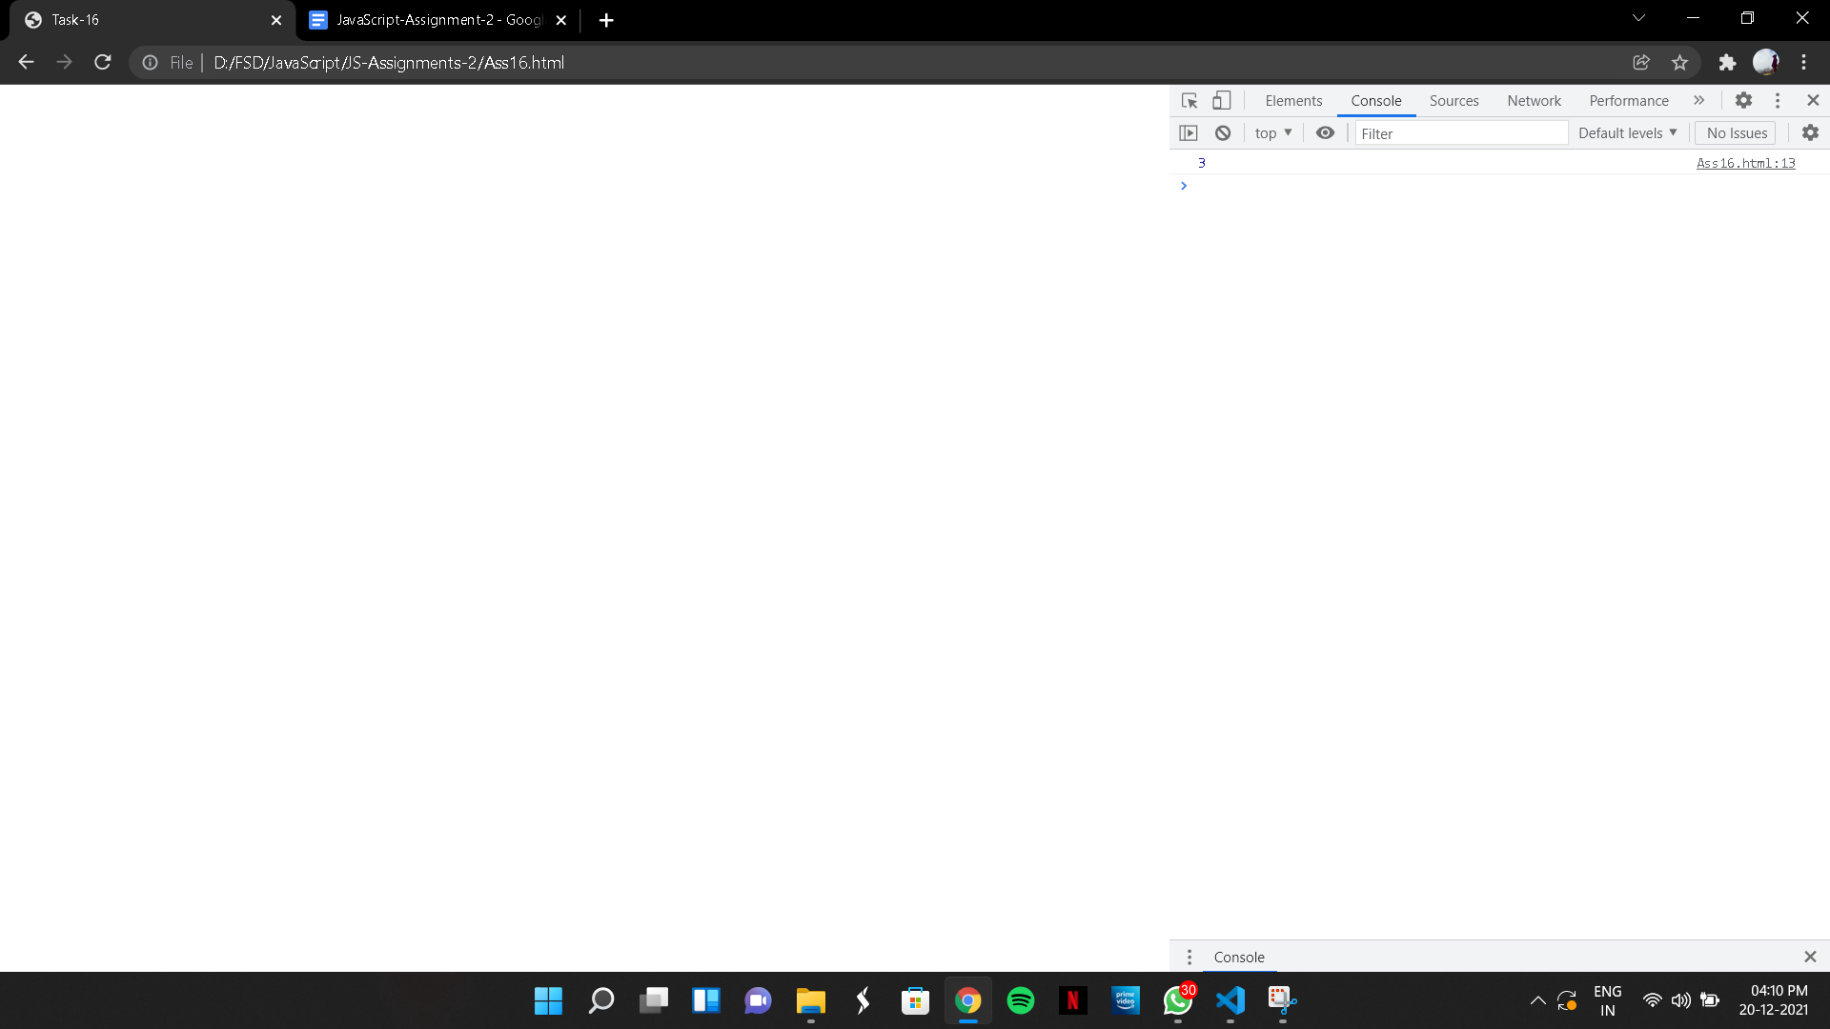

(17)

CODE:

<!DOCTYPE html>

<html lang="en">

<head>

<meta charset="UTF-8">

<meta http-equiv="X-UA-Compatible" content="IE=edge">

<meta name="viewport" content="width=device-width, initial-scale=1.0">

<title>Task-17</title>

</head>

<body>

<script>

let toFahreheit = i => i \* 9 / 5 + 32

console.log(toFahreheit(0));

</script>

</body>

</html>

OUTPUT:

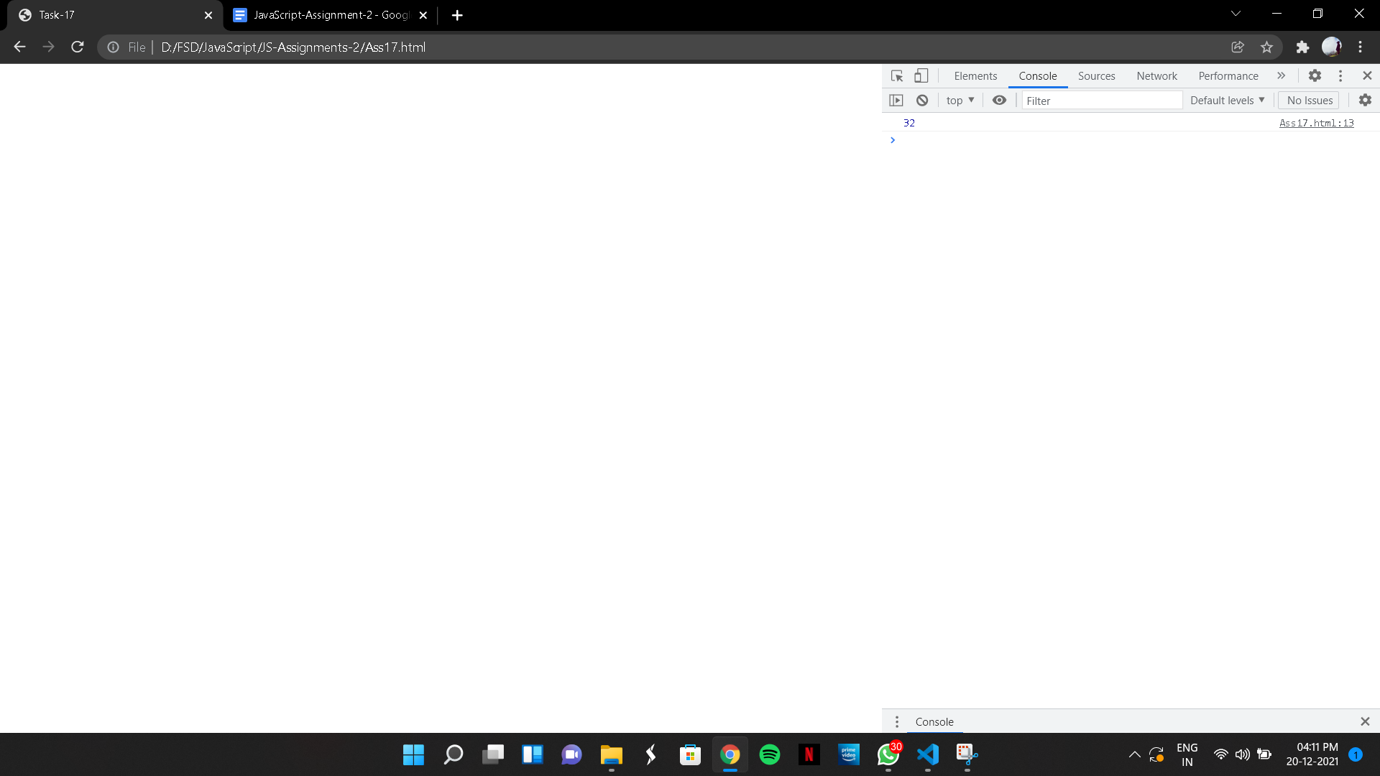

(18)

<!DOCTYPE html>

<html lang="en">

<head>

<meta charset="UTF-8">

<meta http-equiv="X-UA-Compatible" content="IE=edge">

<meta name="viewport" content="width=device-width, initial-scale=1.0">

<title>Task-18</title>

</head>

<body>

<script>

let mean = (a,b) => (a+b)/2;

console.log(mean(1,2));

</script>

</body>

</html>

OUTPUT:

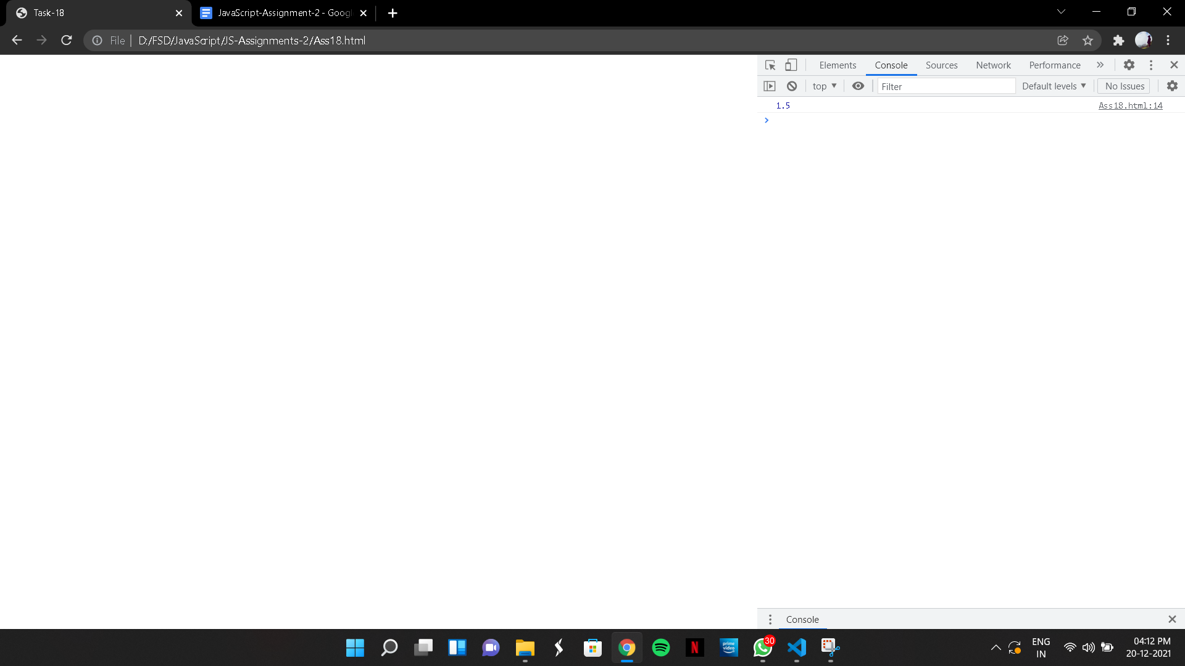

(19)

CODE:

<!DOCTYPE html>

<html lang="en">

<head>

<meta charset="UTF-8">

<meta http-equiv="X-UA-Compatible" content="IE=edge">

<meta name="viewport" content="width=device-width, initial-scale=1.0">

<title>Document</title>

</head>

<body>

<script>

function hypotenuse(a,b) {

let square = Math.pow(a,2) + Math.pow(b,2);

return Math.sqrt(square);

}

console.log(hypotenuse(3,4));

</script>

</body>

</html>

OUTPUT:

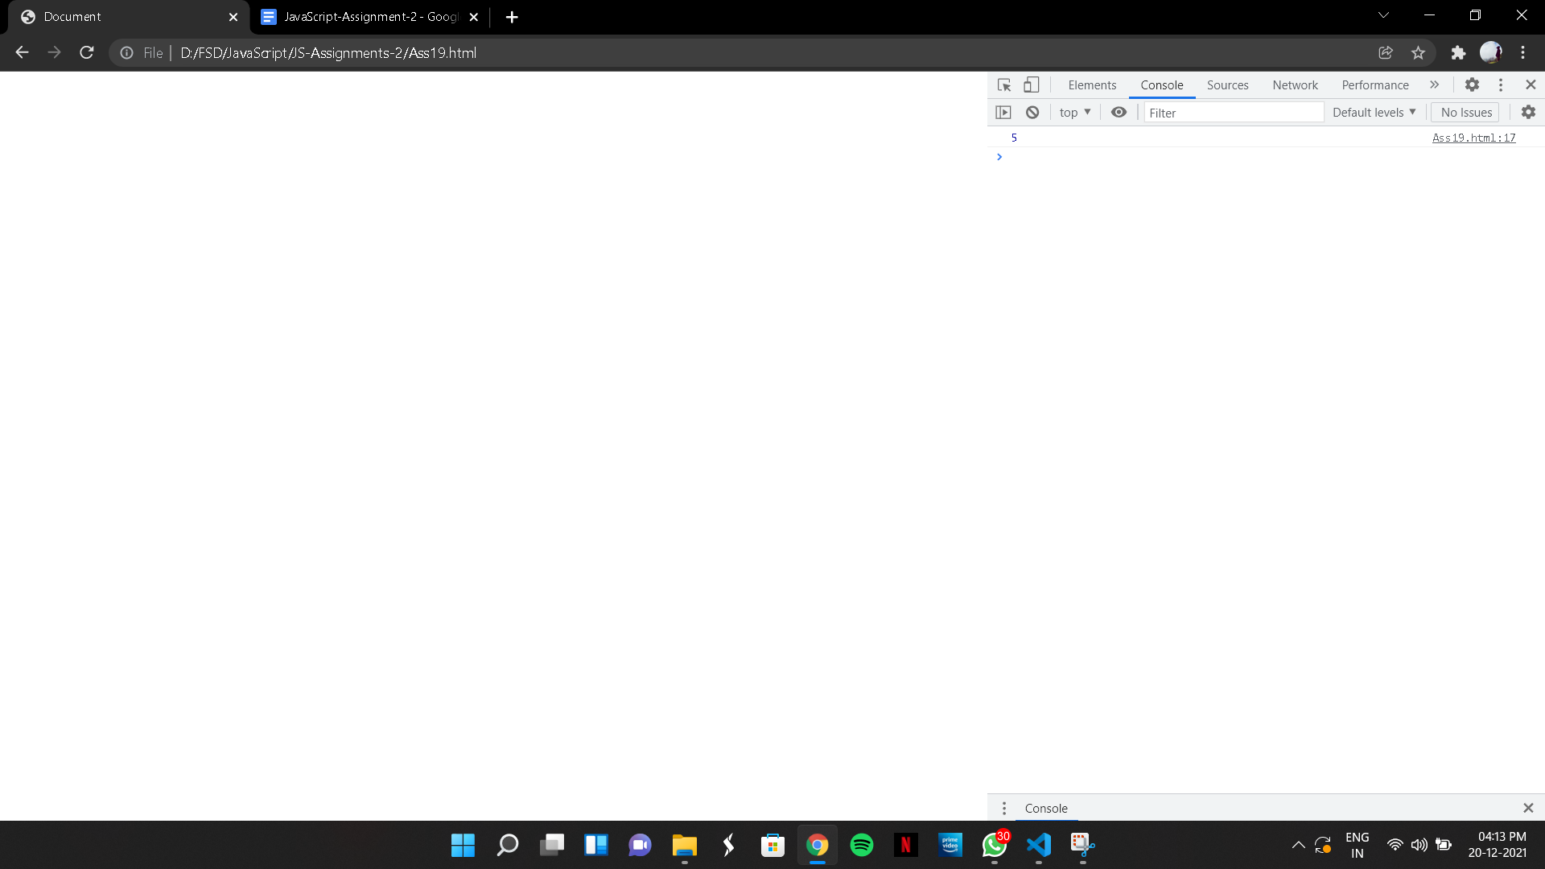

(20)

CODE:

<!DOCTYPE html>

<html lang="en">

<head>

<meta charset="UTF-8">

<meta http-equiv="X-UA-Compatible" content="IE=edge">

<meta name="viewport" content="width=device-width, initial-scale=1.0">

<title>Task-20</title>

</head>

<body>

<script>

function midrange(a,b,c) {

let min = Math.min(a,b,c);

let max = Math.max(a,b,c);

return (min + max)/ 2;

}

console.log(midrange(3,9,1));

</script>

</body>

</html>

OUTPUT:

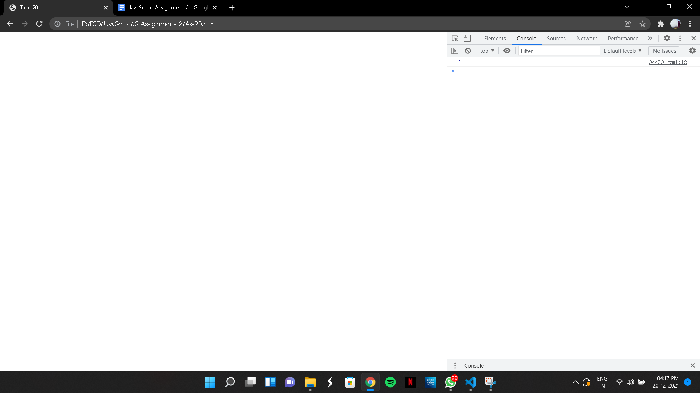

(21)

CODE:

<!DOCTYPE html>

<html lang="en">

<head>

<meta charset="UTF-8">

<meta http-equiv="X-UA-Compatible" content="IE=edge">

<meta name="viewport" content="width=device-width, initial-scale=1.0">

<title>Task-21</title>

</head>

<body>

<script>

function dice() {

console.log(Math.floor(Math.random()\*6 + 1));

}

dice();

</script>

</body>

</html>

OUTPUT:

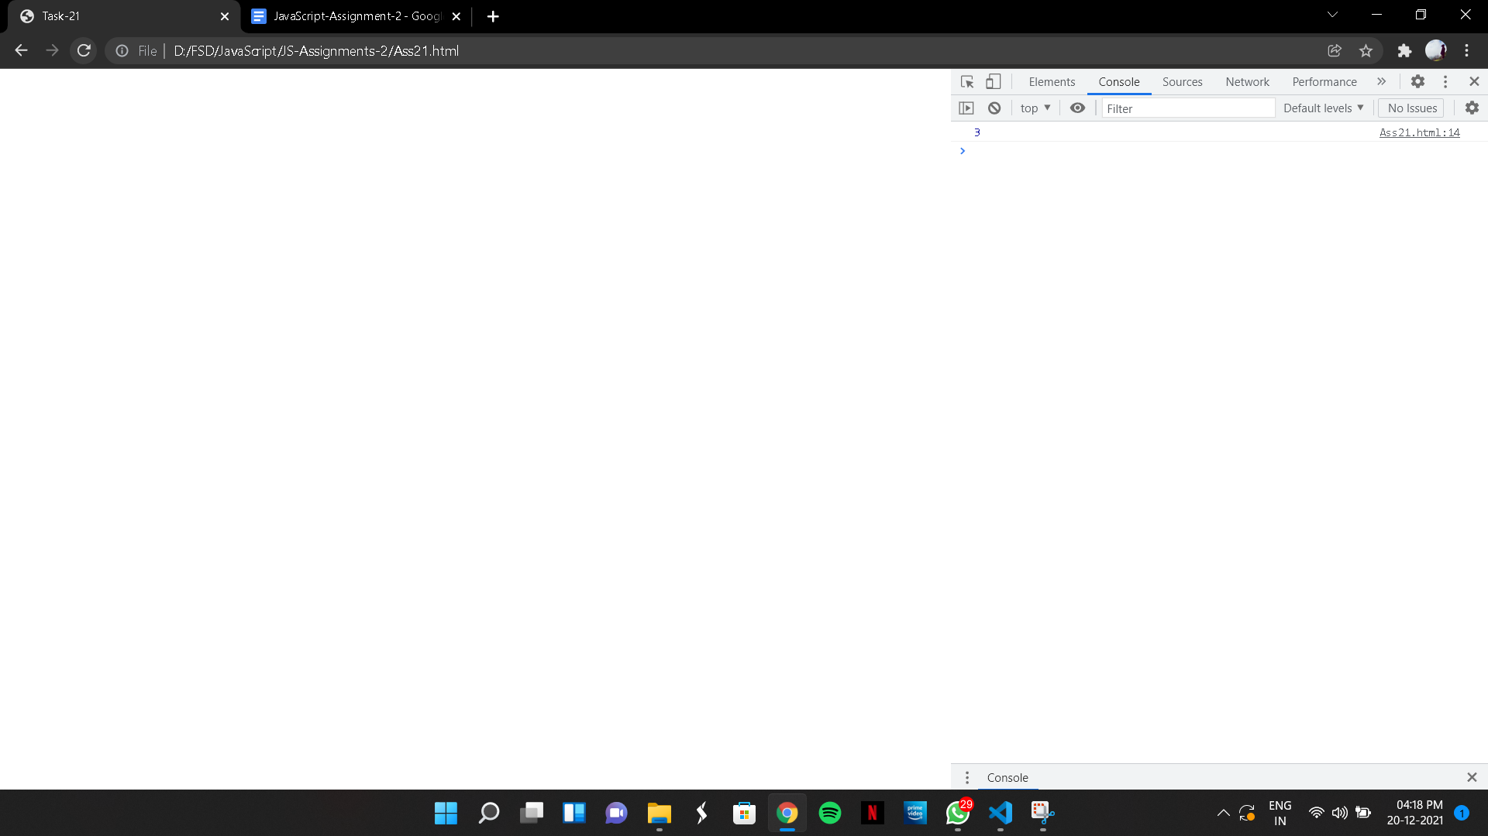

(22)

CODE:

<!DOCTYPE html>

<html lang="en">

<head>

<meta charset="UTF-8">

<meta http-equiv="X-UA-Compatible" content="IE=edge">

<meta name="viewport" content="width=device-width, initial-scale=1.0">

<title>Task-22</title>

</head>

<body>

<script>

function add(s) {

let sum1 = parseInt(s, 10);

let indPlus = s.indexOf('+');

let aftPlus = s.substr(indPlus + 1);

let sum2 = parseInt(aftPlus, 10);

return sum1 + sum2;

}

result = console.log(add('102+17'))

</script>

</body>

</html>

OUTPUT:

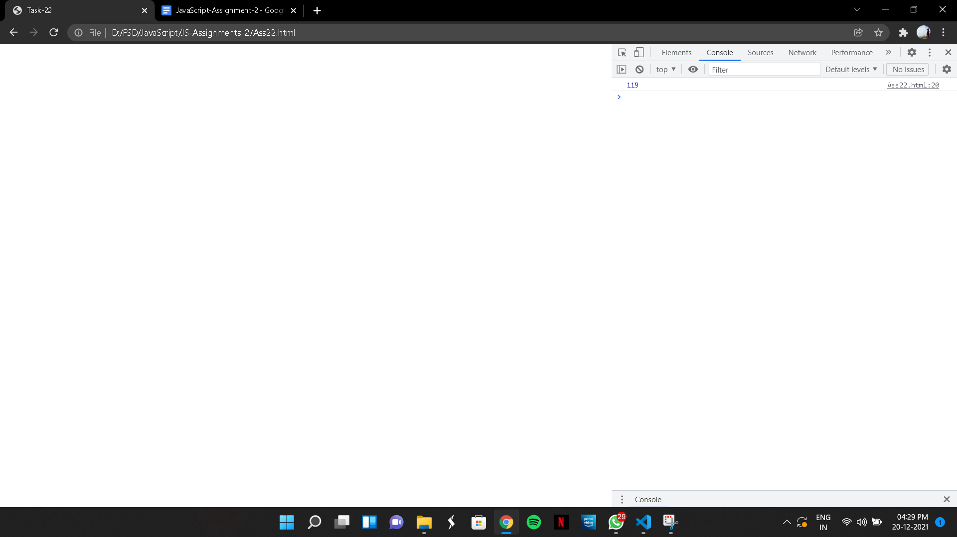

(23)

CODE:

<html lang="en">

<head>

<meta charset="UTF-8">

<meta http-equiv="X-UA-Compatible" content="IE=edge">

<meta name="viewport" content="width=device-width, initial-scale=1.0">

<title>Task-23</title>

</head>

<body>

<b>

23.Write a function ‘nand’ that takes two Boolean values. If both values are ‘true’, the result

should be ‘false’. In the other cases the return should be ‘true’. <br>

I.e.: The call nand(true, true) should return ‘false’. The

calls nand(true, false), nand(false, true) and nand(false, false) should return ‘true’.

</b>

<script>

function nand(a, b) {

let and = a && b;

console.log(!and);

}

nand(true, true);

nand(true, false);

nand(false, true);

nand(false, false);

</script>

</body>

</html>

OUTPUT:

(24)

CODE:

<!DOCTYPE html>

<html lang="en">

<head>

<meta charset="UTF-8">

<meta http-equiv="X-UA-Compatible" content="IE=edge">

<meta name="viewport" content="width=device-width, initial-scale=1.0">

<title>Task-24</title>

</head>

<body>

<script>

function isEven(a){

return (a%2==0)? true : false;

}

console.log(isEven(2));

</script>

</body>

</html>

OUTPUT:

