(1)

CODE:

<!DOCTYPE html>

<html lang="en">

<head>

<meta charset="UTF-8">

<meta http-equiv="X-UA-Compatible" content="IE=edge">

<meta name="viewport" content="width=device-width, initial-scale=1.0">

<meta name="Description" content="JavaScript-Assignment-1">

<title>JavaScript-Assignment-1</title>

</head>

<body>

<script>

console.log('Welcome to JavaScript');

alert('Welcome to JavaScript');

document.write('Welcome to JavaScript');

</script>

</body>

</html>

OUTPUT:





(2)

CODE:

<!DOCTYPE html>

<html lang="en">

<head>

<meta charset="UTF-8">

<meta http-equiv="X-UA-Compatible" content="IE=edge">

<meta name="viewport" content="width=device-width, initial-scale=1.0">

<meta name="Description" content="JavaScript-Assignment-2">

<title>JavaScript-Assignment-2</title>

</head>

<body>

<script src="Ass-2.js"></script>

</body>

</html>

OUTPUT:

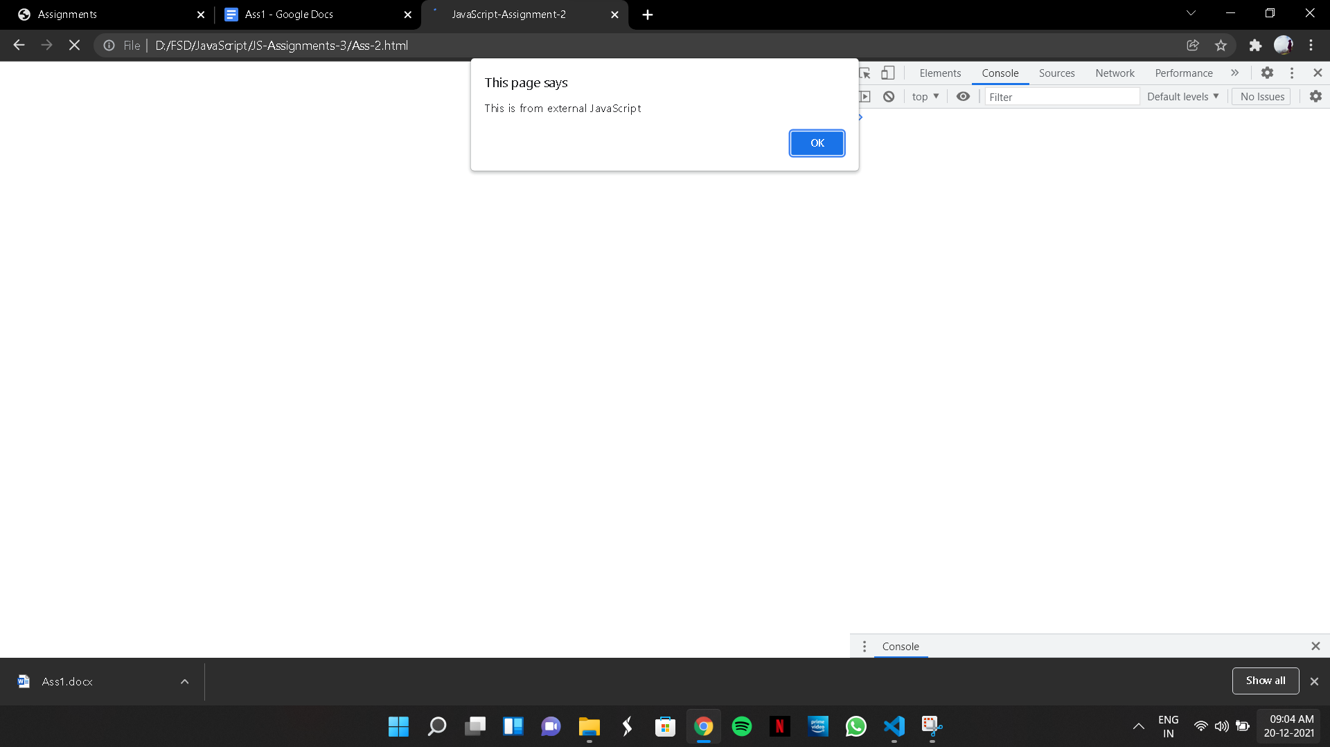

(3)

CODE:

<!DOCTYPE html>

<html lang="en">

<head>

<meta charset="UTF-8">

<meta http-equiv="X-UA-Compatible" content="IE=edge">

<meta name="viewport" content="width=device-width, initial-scale=1.0">

<meta name="Description" content="JavaScript-Assignment-3">

<title>JavaScript-Assignment-3</title>

</head>

<body>

<script>

const personDetails = {

userId: 123456,

firstName: 'Vipin',

lastName: 'Menon',

password: '@vip123',

email: 'vipinmenon006@gmail.com',

gender: 'male',

age: 22,

accountCreated: '19/12/21'

}

for (let key in personDetails) {

alert(`${key} - ${personDetails[key]}`)

}

for (let key in personDetails) {

console.log(`${key} - ${personDetails[key]}`)

}

for (let key in personDetails) {

document.write(`${key} - ${personDetails[key]}`)

}

</script>

</body>

</html>

OUTPUT:



(4)

CODE:

<!DOCTYPE html>

<html lang="en">

<head>

<meta charset="UTF-8">

<meta http-equiv="X-UA-Compatible" content="IE=edge">

<meta name="viewport" content="width=device-width, initial-scale=1.0">

<title>JavaScript-Assignment-4</title>

</head>

<body>

<b>

(4) Create the variables for storing the product details with appropriate variable names and

display the result in html document.

</b>

<br>

<br>

<script>

let product = 'Mobile Phone',

company = 'Apple',

subBrand = 'iPhone 13 pro',

screenSize = '13inch',

price = 111999;

const battery = '3600mah',

cameraFront = '12MP',

cameraBack = "20MP+5MP";

document.write(`Product:${product}<br>`);

document.write(`Mobile Brand:${company} <br>`);

document.write(`Model:${subBrand}<br>`);

document.write(`Screen size:${screenSize}<br>`);

document.write(`Front Camera:${cameraFront}<br>`);

document.write(`Back Camera:${cameraBack}<br>`);

document.write(`Battery in mAH:${battery}<br>`);

document.write(`Mobile Price:${price}`);

</script>

</body>

</html>

OUTPUT:



(5)

CODE:

<!DOCTYPE html>

<html lang="en">

<head>

<meta charset="UTF-8">

<meta http-equiv="X-UA-Compatible" content="IE=edge">

<meta name="viewport" content="width=device-width, initial-scale=1.0">

<title>JavaScript-Assignment-5</title>

</head>

<body>

<script>

function user(userId, firstName, lastName, password, email, gender, age, accountCreated) {

return {

userId,

firstName,

lastName,

password,

email,

gender,

age,

accountCreated

};

}

console.log(user(123456, 'Vipin', 'Menon', 'vip@123', 'vipinmenon006@gmail.com', 'male', 22, '19/12/21'));

</script>

</body>

</html>

OUTPUT:

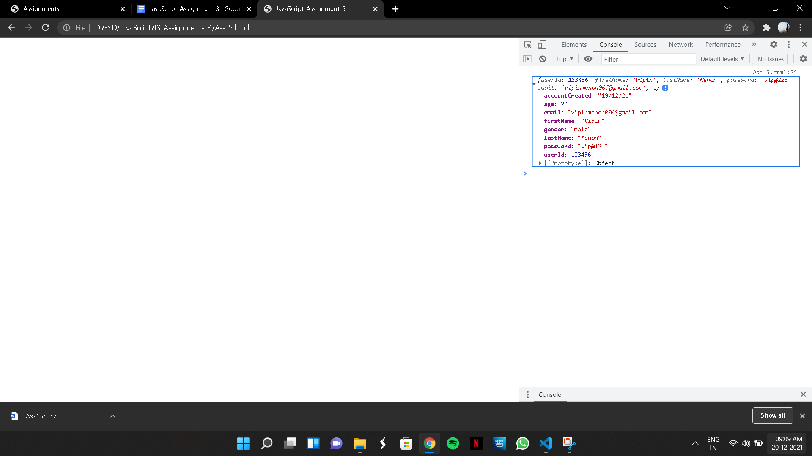

(6)

CODE:

<!DOCTYPE html>

<html lang="en">

<head>

<meta charset="UTF-8">

<meta http-equiv="X-UA-Compatible" content="IE=edge">

<meta name="viewport" content="width=device-width, initial-scale=1.0">

<title>JavaScript-Assignment-6</title>

</head>

<body>

<script>

let user = function (userId, firstName, lastName, password, email, gender, age, accountCreated){

return {

userId,

firstName,

lastName,

password,

email,

gender,

age,

accountCreated

}

};

console.log(user(123456, 'Vipin', 'Menon', '@vip123', 'vipinmenon006@gmail.com','Male','23','19/12/21'));

</script>

</body>

</html>

OUTPUT:



(7)

CODE:

<!DOCTYPE html>

<html lang="en">

<head>

<meta charset="UTF-8">

<meta http-equiv="X-UA-Compatible" content="IE=edge">

<meta name="viewport" content="width=device-width, initial-scale=1.0">

<title>JavaScript-Assignment-7</title>

</head>

<body>

<script>

let user = (userId, firstName, lastName, password, email, gender, age, accountCreated) =>

`userId-${userId}

firstName-${firstName}

lastName-${lastName}

password-${password}

email-${email}

gender-${gender}

age-${age}

accountCreated-${accountCreated}`

console.log(user(123456, 'Vipin', 'Menon', 'vip123@', 'vipinmenon006@gmail.com', 'male', 23, '19/12/21'));

</script>

</body>

</html>

OUTPUT:



(8)

CODE:

<!DOCTYPE html>

<html lang="en">

<head>

<meta charset="UTF-8">

<meta http-equiv="X-UA-Compatible" content="IE=edge">

<meta name="viewport" content="width=device-width, initial-scale=1.0">

<title>JavaScript-Assignment-8</title>

</head>

<body>

<script>

let user = {};

user.userId = 123456;

user.firstName = 'Vipin';

user.lastName = 'Menon';

user.password = 'vip123@';

user.country = 'India';

user.continent = 'Asia';

// (a)

console.log("(a)-Displaying all the values present in user object");

console.log(user.userId, user.firstName, user.lastName, user.password, user.country, user.continent);

// (b)

console.log("(b)-Deleting the country and continent property");

delete user.country;

delete user.continent;

console.log(user.userId, user.firstName, user.lastName, user.password);

// (c)

console.log("(c)-Displaying all the values present in user object using for loop after deleting ");

for (let key in user) {

console.log(user[key])

}

</script>

</body>

</html>

OUTPUT:



(9)

CODE:

<!DOCTYPE html>

<html lang="en">

<head>

<meta charset="UTF-8">

<meta http-equiv="X-UA-Compatible" content="IE=edge">

<meta name="viewport" content="width=device-width, initial-scale=1.0">

<title>JavaScript-Assignment-9</title>

</head>

<body>

<script>

let user = {};

user.userId = 123456;

user.firstName = 'Vipin';

user.lastName = 'Menon';

user.password = 'vip123@';

user.country = 'India';

user.continent = 'Asia';

function displayAge(age) {

return `Age is ${age}`;

}

function displayAccountCreated(date) {

return `Created on ${date}`;

}

user.age = displayAge;

user.accountCreated = displayAccountCreated;

alert(user.age(23));

alert(user.accountCreated('19/12/21'));

console.log(user);

</script>

</body>

</html>

OUTPUT:

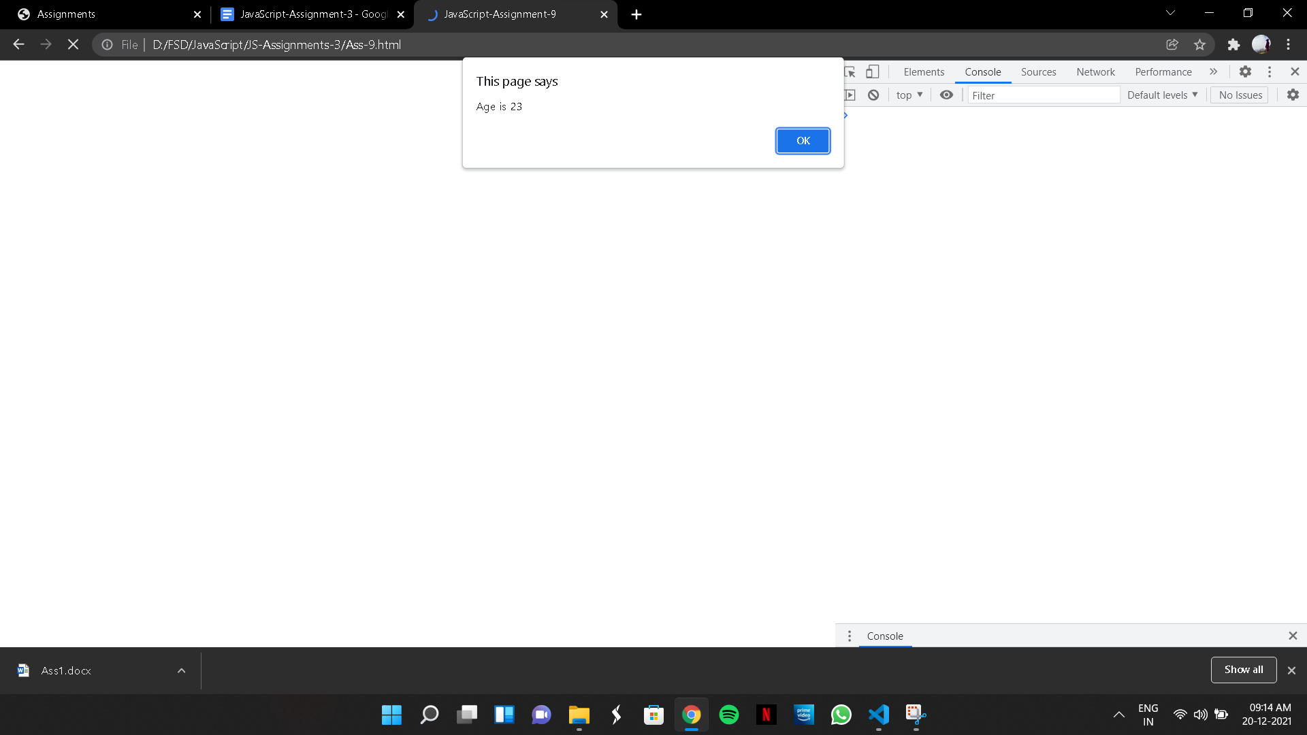

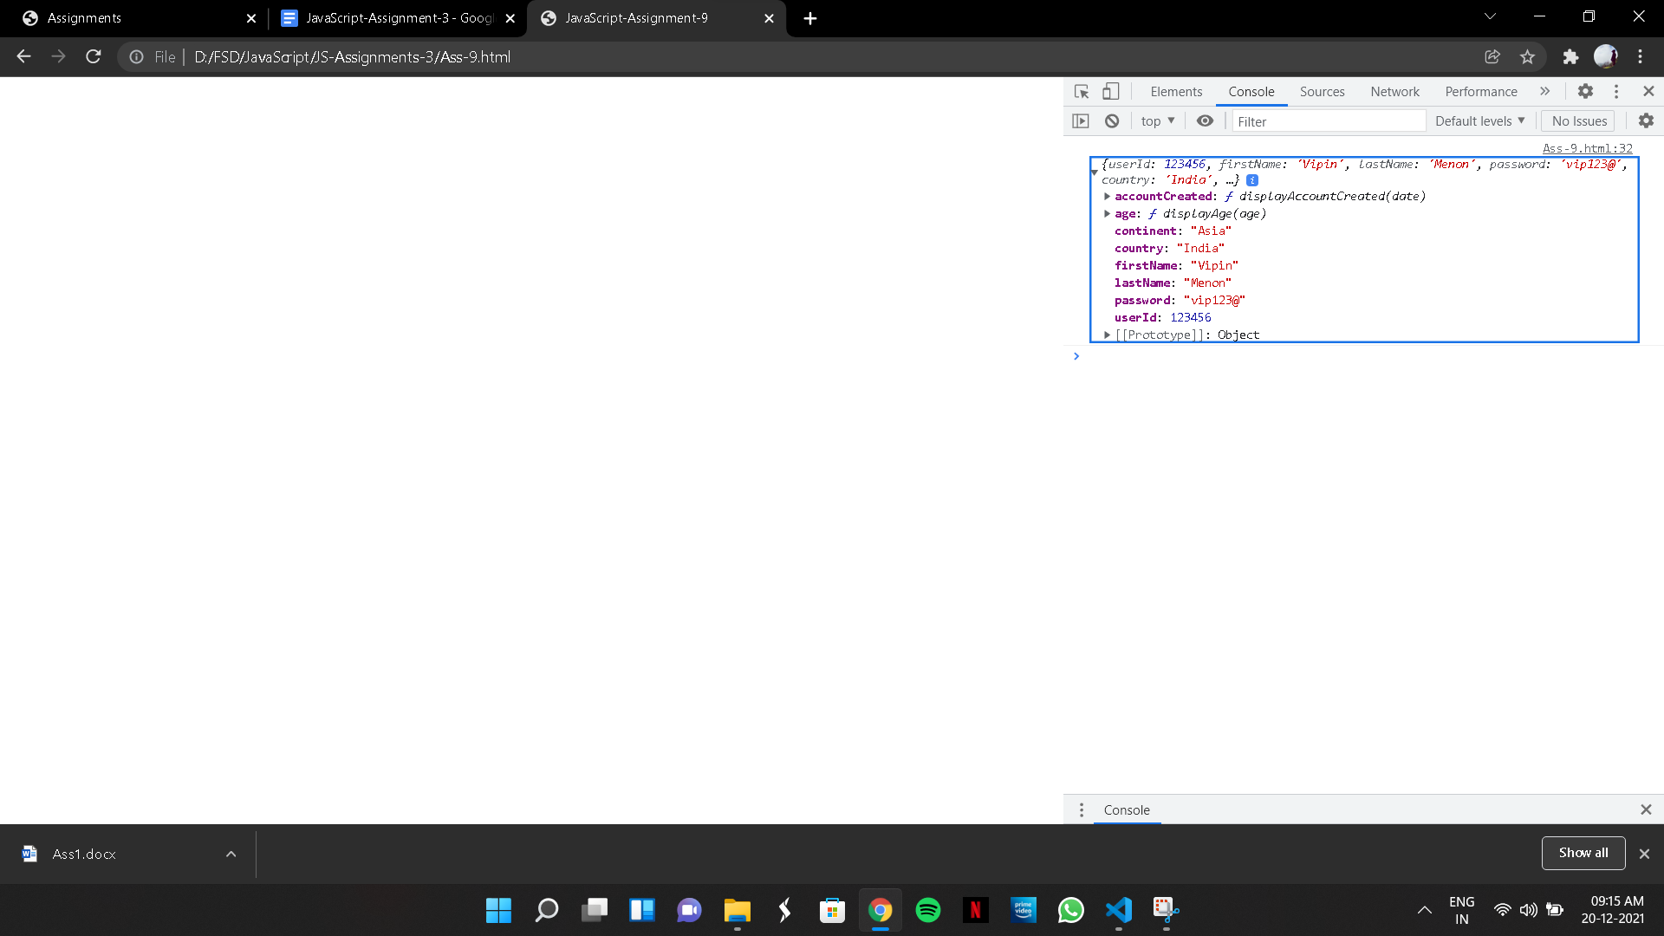

(10)

CODE:

<!DOCTYPE html>

<html lang="en">

<head>

<meta charset="UTF-8">

<meta http-equiv="X-UA-Compatible" content="IE=edge">

<meta name="viewport" content="width=device-width, initial-scale=1.0">

<title>JavaScript-Assignment-10</title>

</head>

<body>

<script>

let user = {};

user.userId = 1234;

user.firstName = 'Vipin';

user.lastName = 'Menon';

user.password = 'vip123@';

user.country = 'India';

user.continent = 'Asia';

user.accountCreated ='19/12/21';

user.age = 21;

user.displayAge = function() {

return `Age is ${this.age}`;

}

user.displayAccountCreated = function(){

return `Created on ${this.accountCreated}`;

}

alert(user.displayAge());

alert(user.displayAccountCreated());

console.log(user);

</script>

</body>

</html>

OUTPUT:

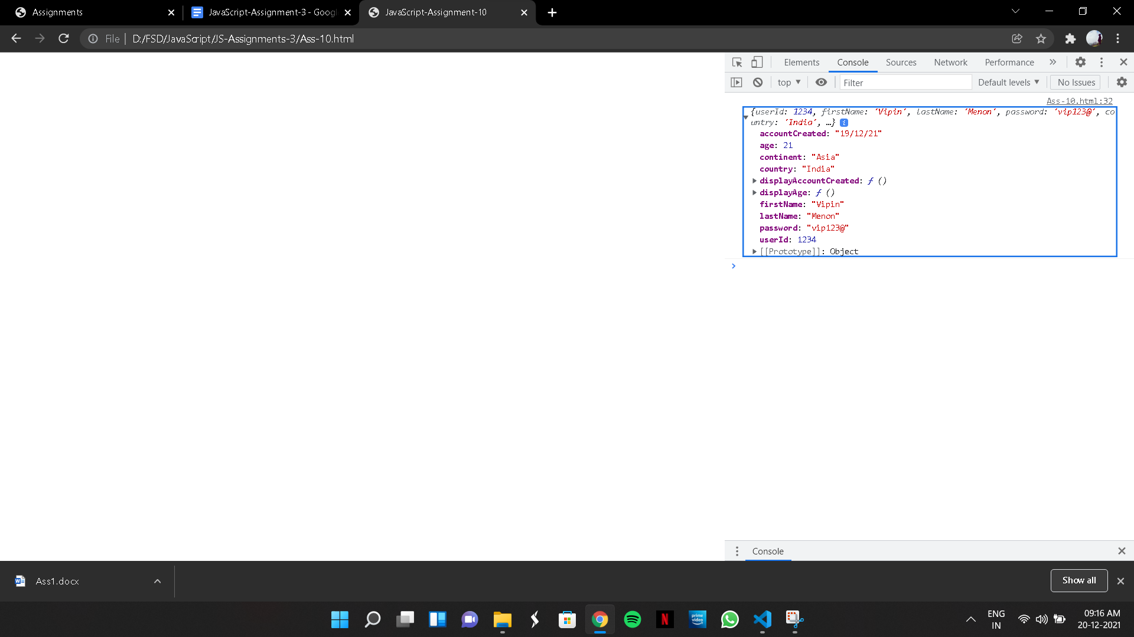

(11)

CODE:

<html lang="en">

<head>

<meta charset="UTF-8">

<meta http-equiv="X-UA-Compatible" content="IE=edge">

<meta name="viewport" content="width=device-width, initial-scale=1.0">

<title>Document</title>

</head>

<body>

<script>

function User(userId, firstName, lastName, password, email, gender, age, accountCreated) {

this.UserID = userId;

this.FirstName = firstName;

this.LastName = lastName;

this.password = password;

this.email = email;

this.gender = gender;

this.age = age;

this.createdOn = accountCreated

this.displayAge = function () {

console.log(`${firstName} ${lastName} is "${age}" years old`);

}

this.displayAccountCreated = function () {

console.log(`${firstName} ${lastName} created account on ${accountCreated}`)

}

}

let user1,user2,user3,user4,user5;

console.log(user1 = new User(1234, 'Vipin', 'Menon', 'vip123@', 'vipinmenon006@gamil.com', 'male', 23,

'12/12/12'));

console.log(user2 = new User(7590, 'Prem', 'Kumar', 'bbn567@', 'premkumar224@gmail.com', 'male', 19,

'10/06/16'));

console.log(user3 = new User(7891, 'Christoper', 'Devasekran', 'ttf789@', 'chris123@gamil.com', 'male', 23,

'26/11/08'));

console.log(user4 = new User(3124, 'Mustaq', 'Ahamed', '432tfc@', 'mustaqahamed10@gmail.com', 'male', 22,

'17/08/20'));

console.log(user5 = new User(4121, 'Hari', 'Krishnan', 'abc321@', 'harikrish2904@gmail.com', 'male', 20,

'22/02/16'));

//Calling the methods inside the constructors

user1.displayAge();

user1.displayAccountCreated();

user2.displayAge();

user2.displayAccountCreated();

user3.displayAge();

user3.displayAccountCreated();

user4.displayAge();

user4.displayAccountCreated();

user5.displayAge();

user5.displayAccountCreated();

</script>

</body>

</html>

OUTPUT:

