MiyeeIndia GST Return Downloader
by Vipin Nair
Step-by-step user guide: bulk download GSTR-1, GSTR-2B and GSTR-3B from the GST portal
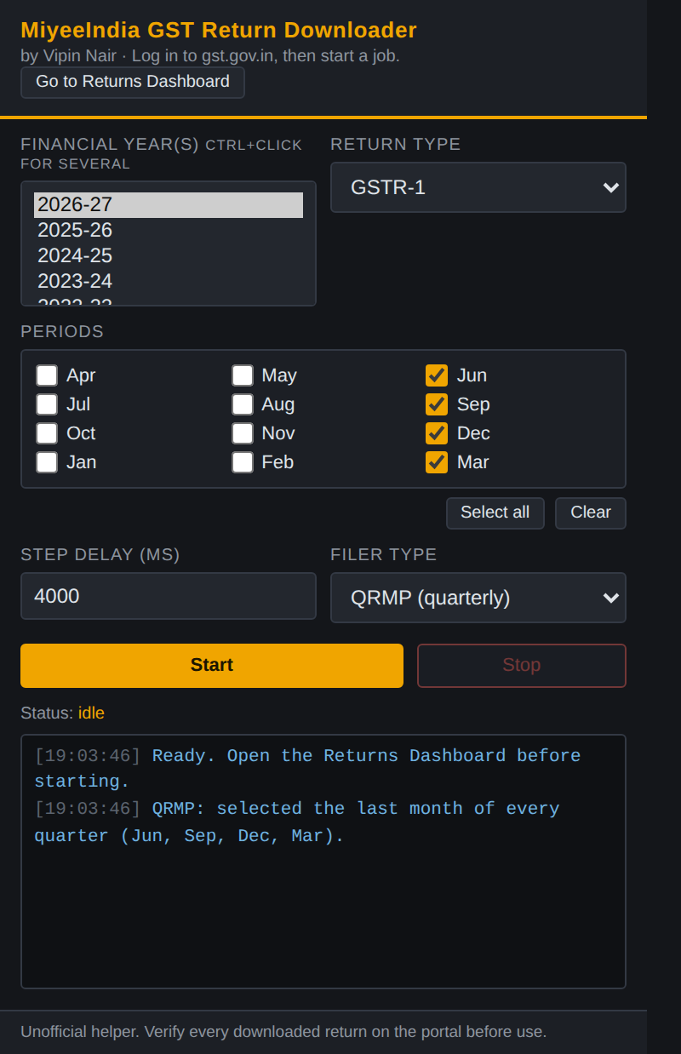
The extension window you will use

Before you start
You need:
- A Windows or Mac computer with Google Chrome (Microsoft Edge also works).
- Your GST portal login (username, password). You type these yourself; the tool never sees or stores them.
- About 10 minutes for the one-time setup.
Setup is done only once. After that, each time you only do Part 4 (log in, choose periods, click Start).

Part 1: Download the tool
- Open this link in Chrome: https://github.com/vipinnairv/miyeegstdownload
- Click the green Code button.
- Click Download ZIP. A file named miyeegstdownload-main.zip is saved in your Downloads folder.
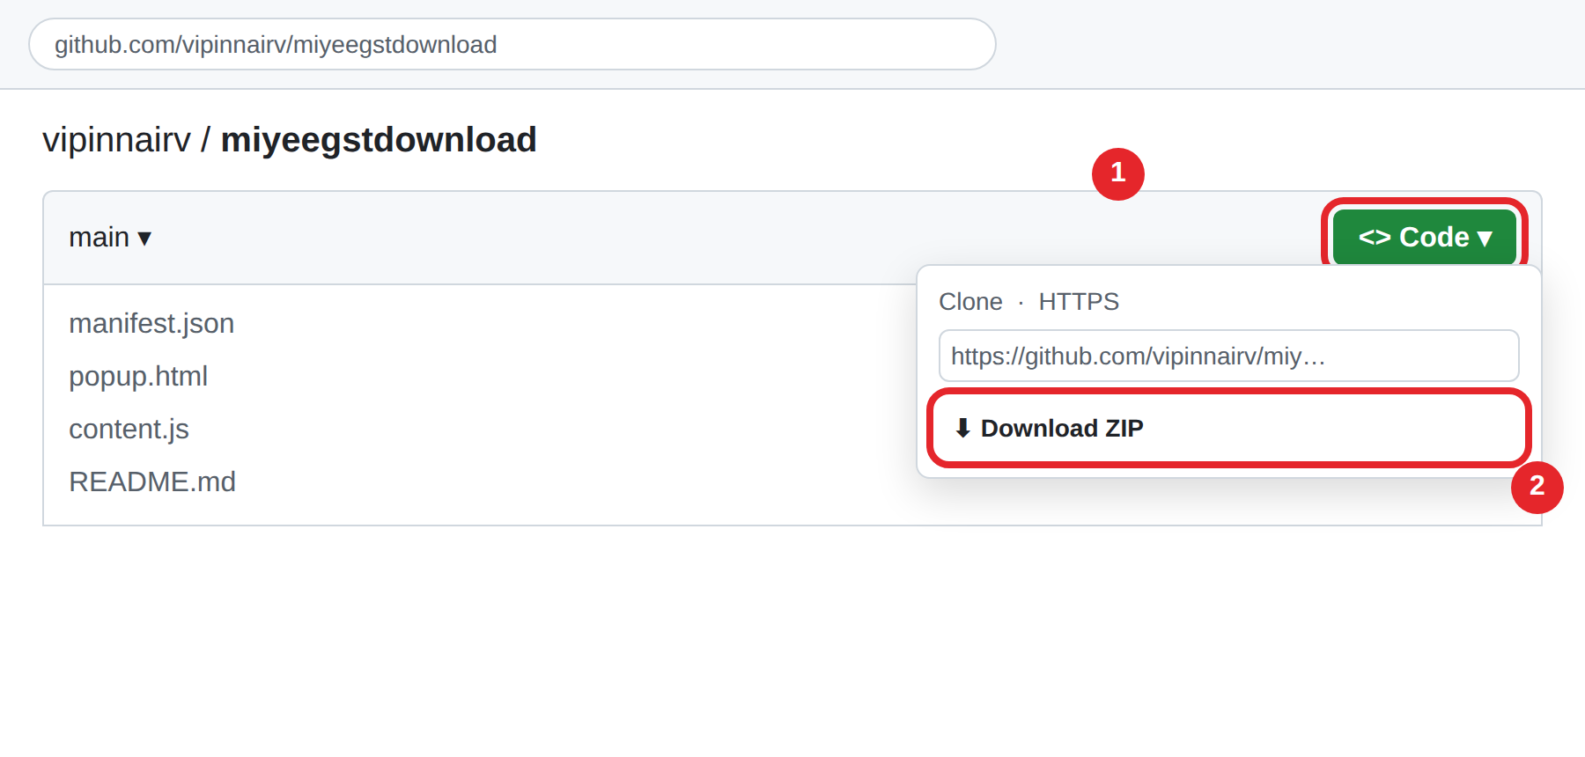
Click Code (1), then Download ZIP (2). Illustration.

Unzip it into a permanent folder
- Open your Downloads folder.
- Right-click miyeegstdownload-main.zip and choose Extract All… (Mac: double-click it).
- Move the extracted folder to a safe place, for example Documents\MiyeeIndia GST Tool.
Do not delete or move this folder later. Chrome loads the tool from it every time it starts.

Part 2: Install it in Chrome
- In the Chrome address bar type chrome://extensions and press Enter.
- Turn ON the Developer mode switch at the top right (1).
- Click Load unpacked (2).
- Select the folder you extracted (the one that contains manifest.json) and click Select Folder.
- The card MiyeeIndia GST Return Downloader appears. The round arrow (3) is the reload button, used when updating.
- Click the puzzle-piece icon in the Chrome toolbar and click the pin next to MiyeeIndia GST Return Downloader so it is always one click away.
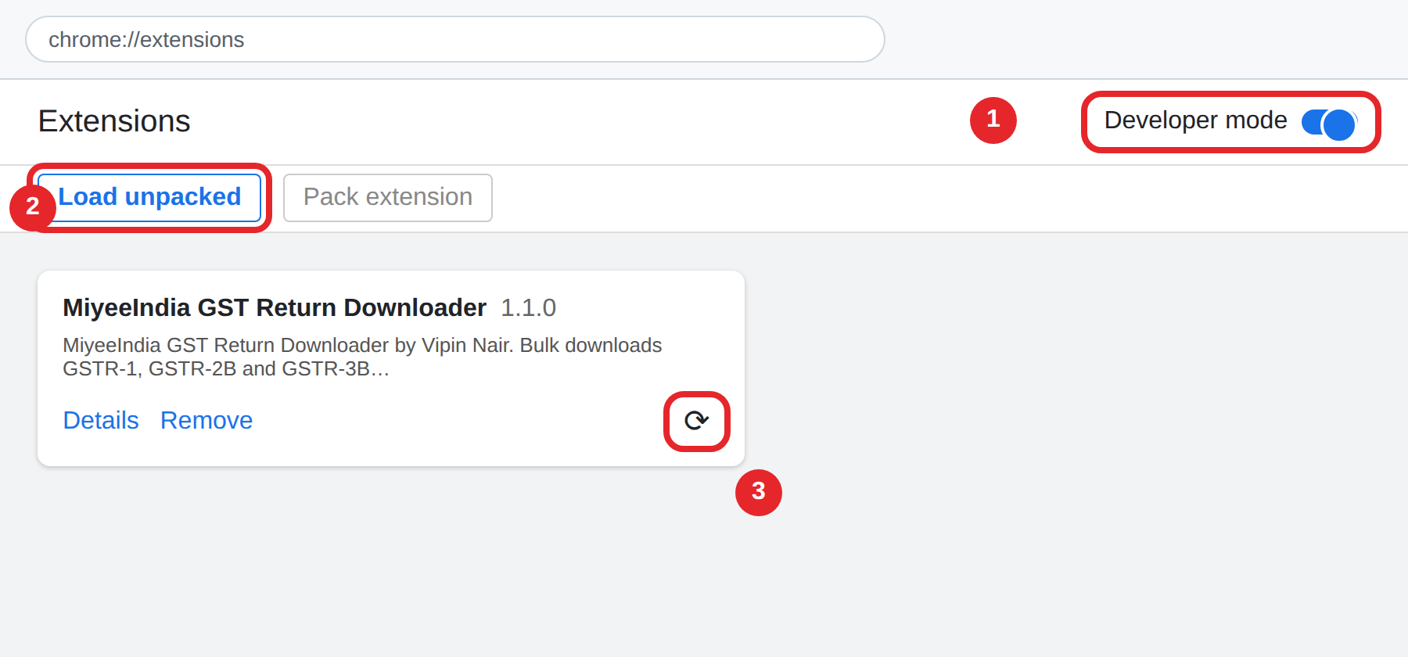
Developer mode (1), Load unpacked (2), Reload (3). Illustration.

Part 3: Let files save automatically
By default Chrome may ask "Save As" for every file. Switch that off so downloads run without stopping:
- Type chrome://settings/downloads in the address bar and press Enter.
- Turn OFF "Ask where to save each file before downloading".
- Optional: click Change next to Location to choose your download folder.
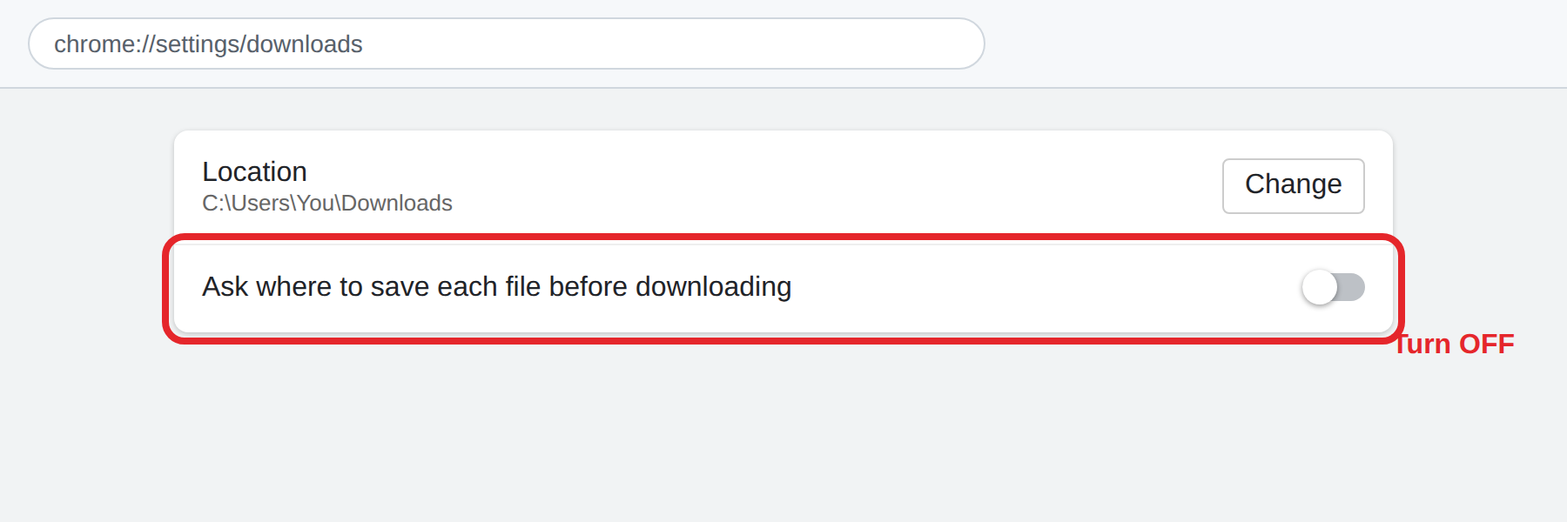
Turn off "Ask where to save each file". Illustration.
This setting applies to all downloads in Chrome. If you prefer to keep it for other sites, use a separate Chrome profile for GST work.

Part 4: Download your returns

Step 1: Log in to the GST portal
- Go to https://www.gst.gov.in and log in with your username, password and the CAPTCHA.
- Click the extension icon in the toolbar, then click Go to Returns Dashboard. (This replaces Services → Returns → Returns Dashboard.)
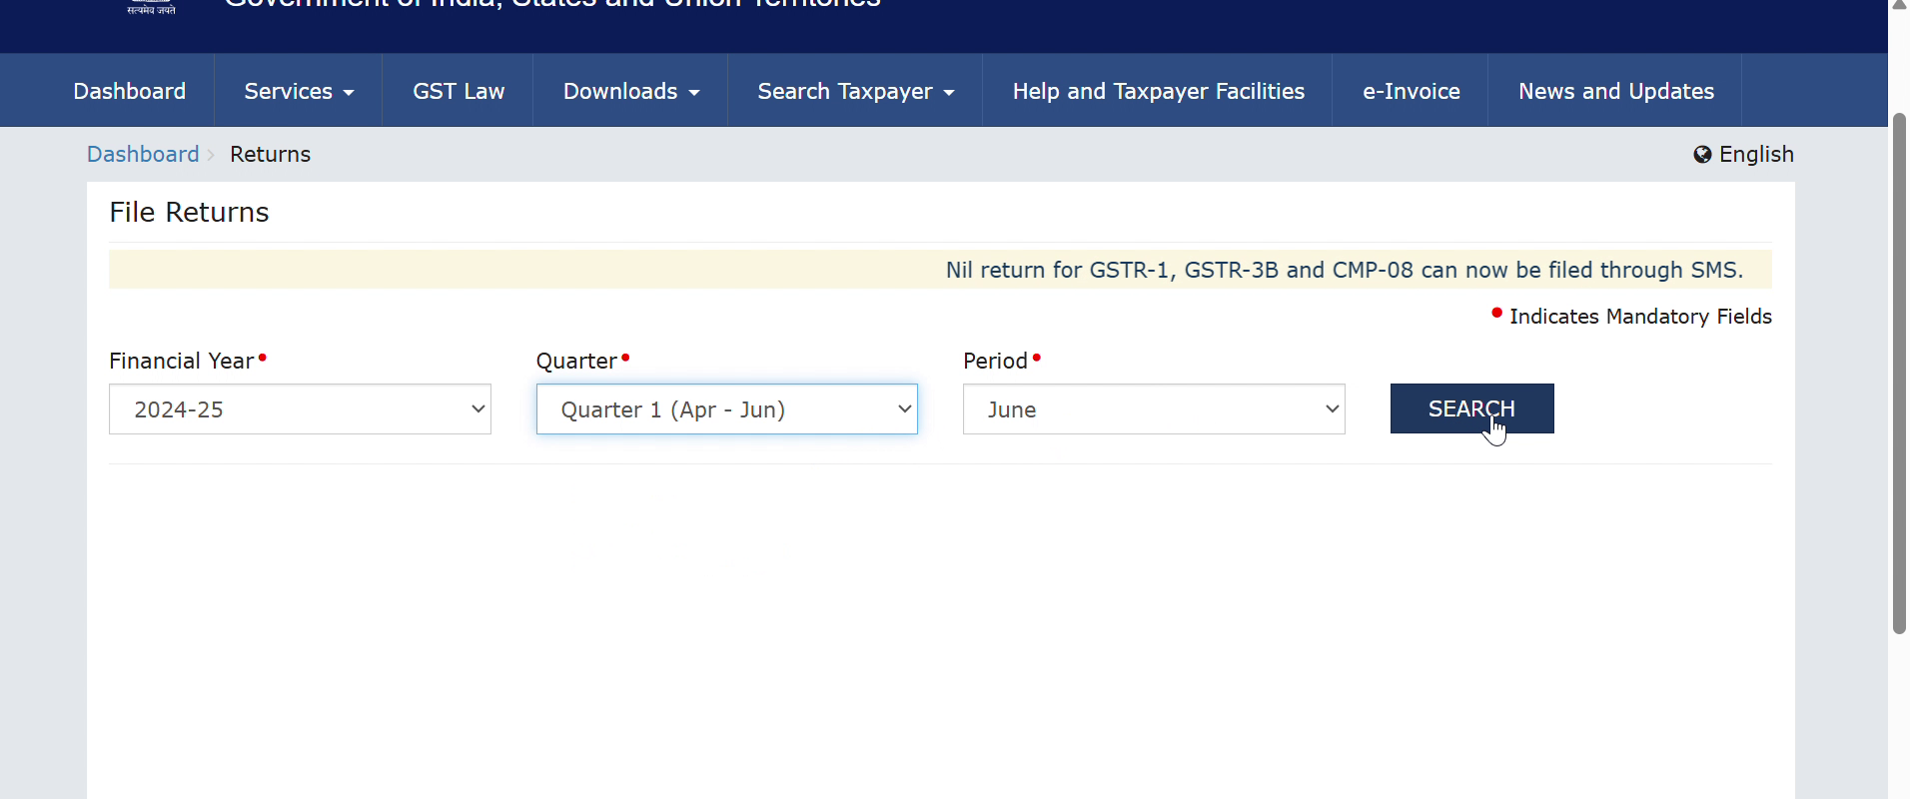
The Returns Dashboard. The tool fills these boxes for you.

Step 2: Choose what to download
The extension window
Setting | What to choose
Financial year(s) | Click one year. Hold Ctrl and click to choose several years in one go.
Return type | GSTR-1, GSTR-2B or GSTR-3B. Run once per return type.
Filer type | Monthly, or QRMP (quarterly). Choosing QRMP ticks Jun, Sep, Dec and Mar automatically (the last month of each quarter).
Periods | Tick the months you need. Select all / Clear help. For QRMP, Select all ticks only the quarter-end months.
Step delay (ms) | Leave at 4000. If the portal is slow and you see "timed out", raise it to 6000 to 8000.

Step 3: Click Start and wait
- Click Start. Watch the log box for progress, for example "June handled."
- Keep the GST tab open and logged in. You can use other tabs or windows meanwhile, but do not close the GST tab.
- Click Stop at any time to halt the job.
- At the end the log shows "Done. X succeeded, Y failed."

What the tool does for each return
After selecting the year, quarter and period and clicking SEARCH, the portal shows a box (tile) for each return:
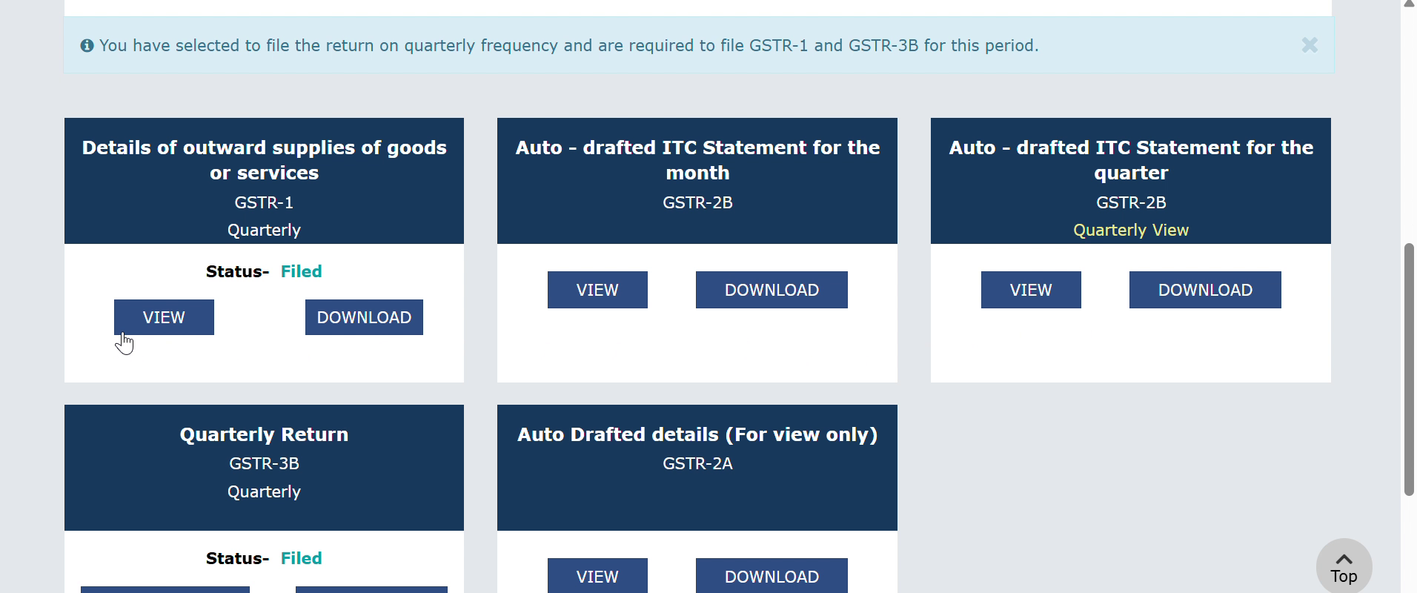
Return tiles on the Returns Dashboard
Return | What the tool clicks | File you get
GSTR-1 | VIEW on the GSTR-1 tile, then DOWNLOAD FILED (PDF) | PDF
GSTR-2B | VIEW on the GSTR-2B tile (quarterly tile for QRMP, monthly tile for Monthly), then DOWNLOAD GSTR-2B DETAILS (EXCEL) | Excel
GSTR-3B | DOWNLOAD on the GSTR-3B tile | PDF
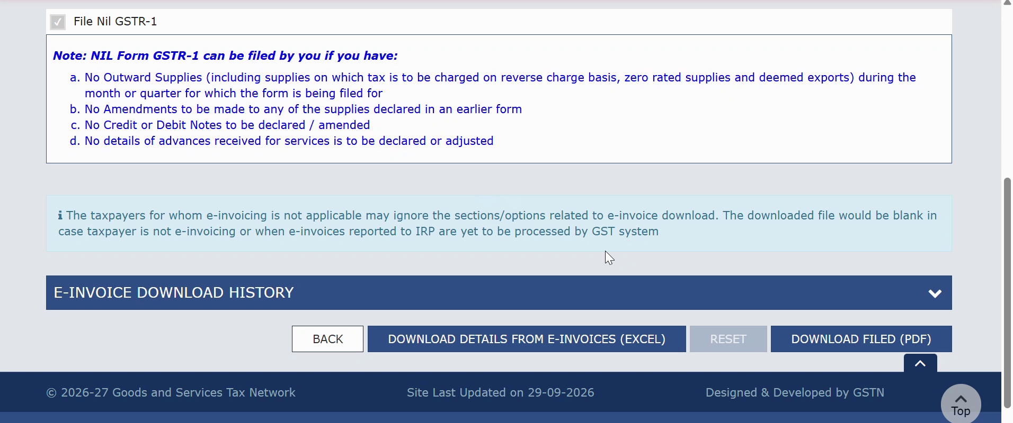
GSTR-1 page: the tool clicks DOWNLOAD FILED (PDF), then BACK
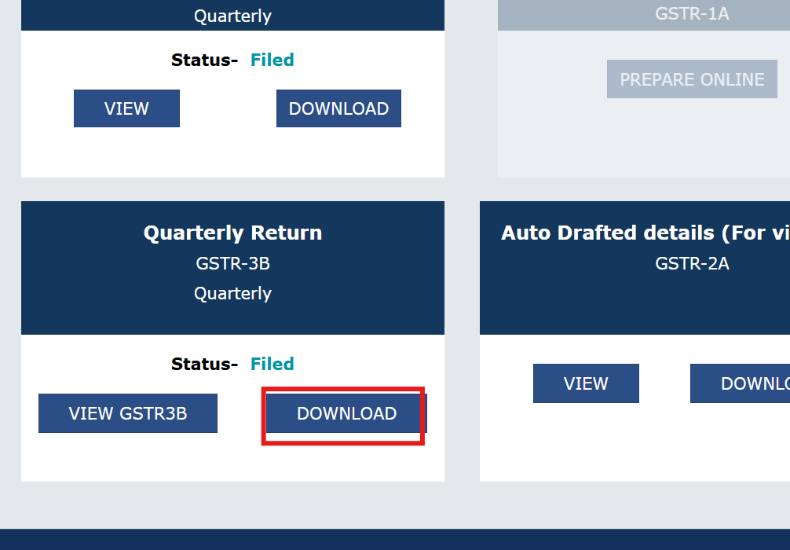
GSTR-3B tile: the tool clicks DOWNLOAD

Where your files are saved
Files are sorted automatically inside your Chrome download folder:
Downloads\GST\2025-26\June\GSTR-1_2025-26_June.pdf
If the same file is downloaded twice, Chrome adds a number, for example (1), instead of overwriting.

Updating to a new version
- Download the ZIP again from the same link (Part 1).
- Extract it and replace the files in your existing tool folder.
- Open chrome://extensions and click the round reload arrow on the MiyeeIndia card.
- Press F5 on the GST portal tab.

If something goes wrong
Message or problem | What to do
"Active tab is not on gst.gov.in" | Click the GST tab first, or use Go to Returns Dashboard.
"Timed out waiting for…" | The portal was slow. Raise Step delay to 6000 to 8000 and start again for the missed periods.
"Could not open the Returns Dashboard" | Your session has logged out. Log in again and click Start.
A period shows "failed" | Usually the return is not filed for that period. Check it on the portal and download by hand if needed.
GSTR-2B says still generating | Large GSTR-2B files are prepared by the portal. Try that period again after about 20 minutes.
A "Save As" window keeps opening | Do Part 3 again: turn off "Ask where to save each file".
Nothing happens after an update | Reload the extension in chrome://extensions, then press F5 on the GST tab.

Important
- This is an unofficial tool. It is not made or approved by GSTN or the Government of India.
- Never share your GST password or OTP with anyone. The tool does not read or store them, and sends nothing to any other server.
- Always check downloaded returns on the portal before relying on them for filing, reconciliation or audit.

