MiyeeIndia GST Return Downloader
by Vipin Nair
Step-by-step user guide: bulk download GSTR-1, GSTR-2B and GSTR-3B from the GST portal
Free • Open source • Runs only in your browser
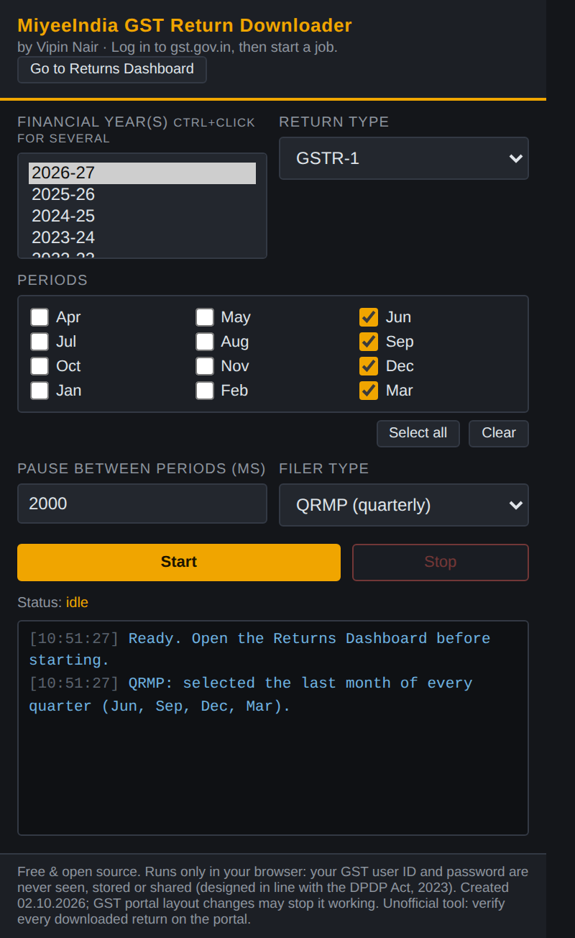
The extension window you will use

About this tool
Downloading GST returns one month at a time is slow and tiresome, especially when you need every GSTR-2B for the annual ITC reconciliation. MiyeeIndia GST Return Downloader automates those clicks on the GST portal for GSTR-1, GSTR-2B and GSTR-3B, across several months and financial years in one go.
The tool is free and open source. Anyone can read how it works.

Your privacy (designed in line with the DPDP Act, 2023)
- The tool runs entirely inside your own browser.
- You log in to gst.gov.in yourself. Your user ID, password and OTP are never seen, stored or shared by the tool.
- No personal data is collected, and nothing is sent to any server other than the GST portal you are already using.
- Downloaded returns are saved only on your own computer.
Disclaimer: this tool was created on 02.10.2026. The GST portal may change its layout at any time, which can stop the tool from working properly until it is updated. It is an unofficial tool, not made or approved by GSTN or the Government of India.

Before you start
You need:
- A Windows or Mac computer with Google Chrome (Microsoft Edge also works).
- Your GST portal login (username, password). You type these yourself; the tool never sees or stores them.
- About 10 minutes for the one-time setup.
Setup is done only once. After that, each time you only do Part 4 (log in, choose periods, click Start).

Part 1: Download the tool
- Open this link in Chrome: https://github.com/vipinnairv/miyeegstdownload
- Click the green Code button.
- Click Download ZIP. A file named miyeegstdownload-main.zip is saved in your Downloads folder.
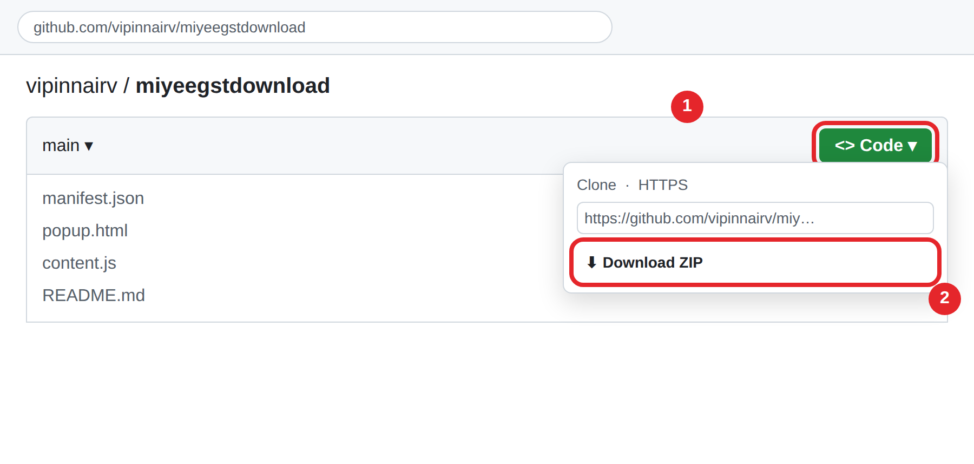
Click Code (1), then Download ZIP (2). Illustration.

Unzip it into a permanent folder
- Open your Downloads folder.
- Right-click miyeegstdownload-main.zip and choose Extract All… (Mac: double-click it).
- Move the extracted folder to a safe place, for example Documents\MiyeeIndia GST Tool.
Do not delete or move this folder later. Chrome loads the tool from it every time it starts.

Part 2: Install it in Chrome
- In the Chrome address bar type chrome://extensions and press Enter.
- Turn ON the Developer mode switch at the top right (1).
- Click Load unpacked (2).
- Select the folder you extracted (the one that contains manifest.json) and click Select Folder.
- The card MiyeeIndia GST Return Downloader appears. The round arrow (3) is the reload button, used when updating.
- Click the puzzle-piece icon in the Chrome toolbar and click the pin next to MiyeeIndia GST Return Downloader so it is always one click away.
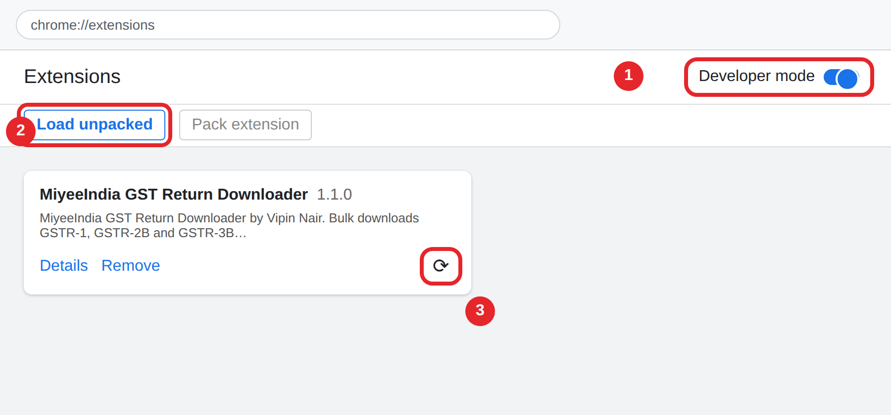
Developer mode (1), Load unpacked (2), Reload (3). Illustration.

Part 3: Let files save automatically
By default Chrome may ask "Save As" for every file. Switch that off so downloads run without stopping:
- Type chrome://settings/downloads in the address bar and press Enter.
- Turn OFF "Ask where to save each file before downloading".
- Optional: click Change next to Location to choose your download folder.
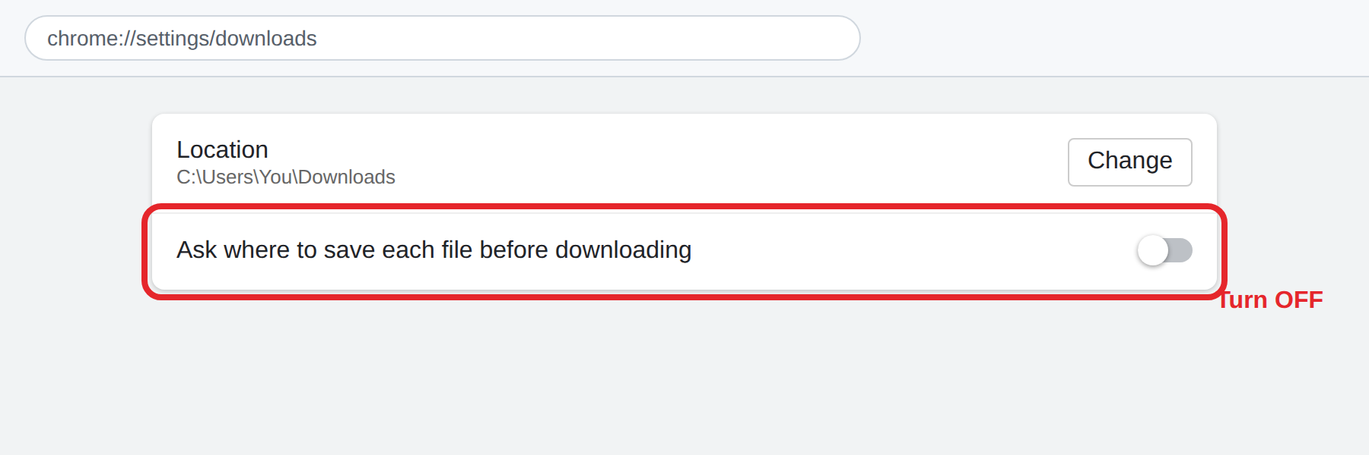
Turn off "Ask where to save each file". Illustration.
This setting applies to all downloads in Chrome. If you prefer to keep it for other sites, use a separate Chrome profile for GST work.

Part 4: Download your returns

Step 1: Log in to the GST portal
- Go to https://www.gst.gov.in and log in with your username, password and the CAPTCHA.
- Click the extension icon in the toolbar, then click Go to Returns Dashboard. (This replaces Services → Returns → Returns Dashboard.)
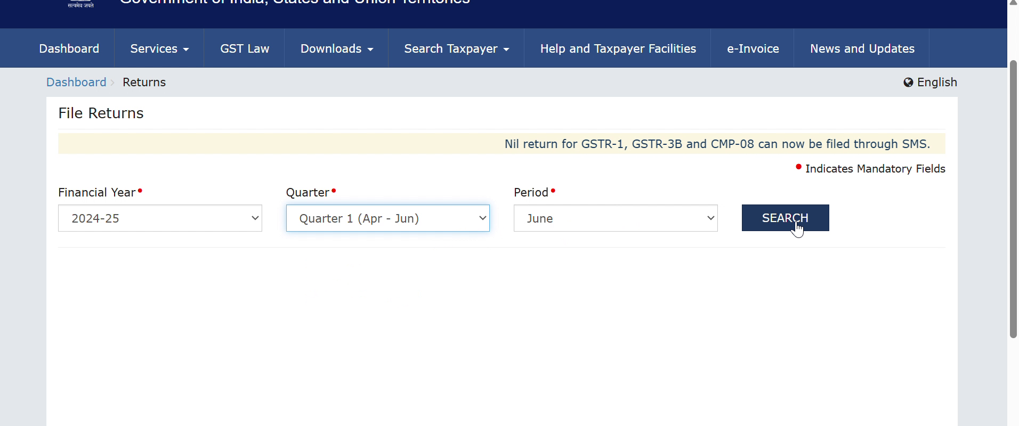
The Returns Dashboard. The tool fills these boxes for you.

Step 2: Choose what to download
The extension window
Setting | What to choose
Financial year(s) | Click one year. Hold Ctrl and click to choose several years in one go.
Return type | GSTR-1, GSTR-2B or GSTR-3B. Run once per return type.
Filer type | Monthly, or QRMP (quarterly). Choosing QRMP ticks Jun, Sep, Dec and Mar automatically (the last month of each quarter).
Periods | Tick the months you need. Select all / Clear help. For QRMP, Select all ticks only the quarter-end months.
Pause between periods (ms) | Leave at 2000. Each step already waits for the portal, so this is only a short breather between periods.

Step 3: Click Start and wait
- Click Start. Watch the log box for progress, for example "June handled."
- Keep the GST tab open and logged in. You can use other tabs or windows meanwhile, but do not close the GST tab.
- Click Stop at any time to halt the job.
- At the end the log shows "Done. X succeeded, Y failed."

What the tool does for each return
After selecting the year, quarter and period and clicking SEARCH, the portal shows a box (tile) for each return:
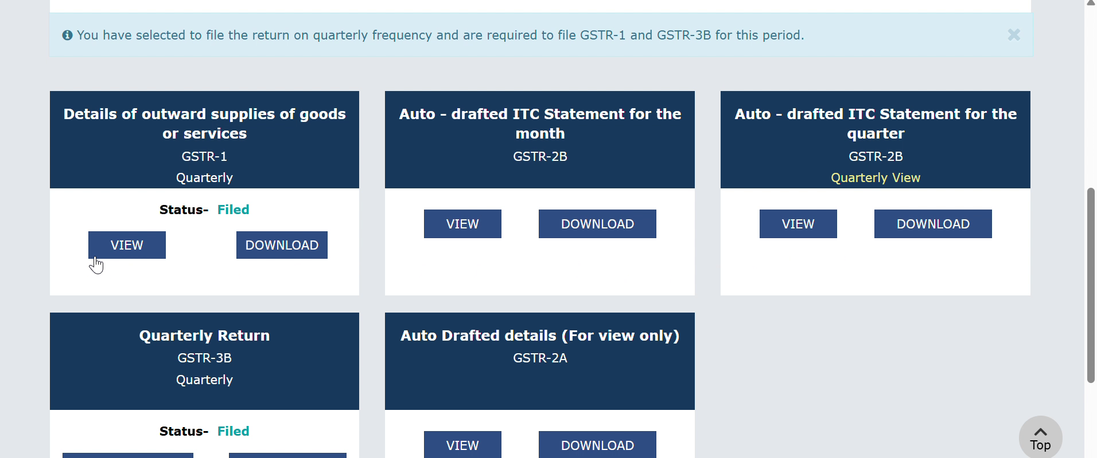
Return tiles on the Returns Dashboard
Return | What the tool clicks | File you get
GSTR-1 | VIEW on the GSTR-1 tile, then DOWNLOAD FILED (PDF) (QRMP). Monthly filers: VIEW, then VIEW SUMMARY, then DOWNLOAD PDF | PDF
GSTR-2B | VIEW on the GSTR-2B tile (QRMP: "for the quarter" tile; Monthly: "of the month" tile), then DOWNLOAD GSTR-2B DETAILS (EXCEL) | Excel
GSTR-3B | DOWNLOAD on the GSTR-3B tile | PDF
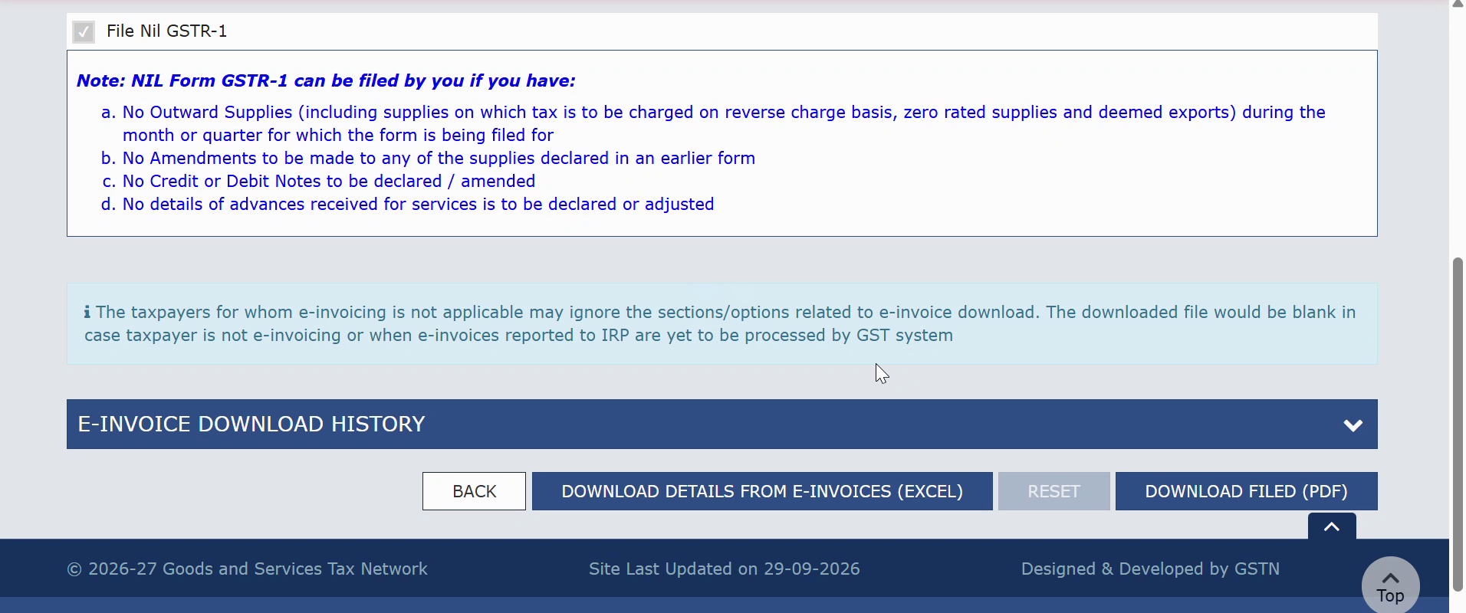
GSTR-1 page: the tool clicks DOWNLOAD FILED (PDF), then BACK
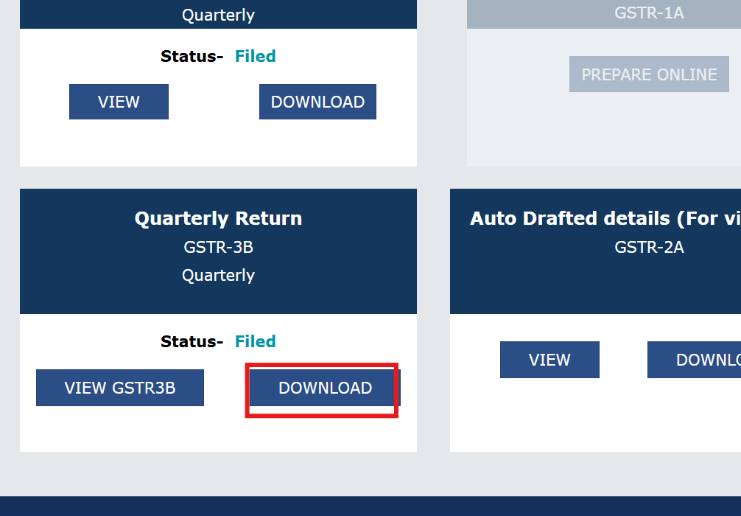
GSTR-3B tile: the tool clicks DOWNLOAD

Where your files are saved
Files are sorted automatically into one folder per return type (GSTR-1, GSTR-2B, GSTR-3B) inside your Chrome download folder, named ReturnType_FinancialYear_Month:
Downloads\GST\GSTR-1\GSTR-1_2025-26_April.pdf
QRMP filers get the quarter instead of the month, for example GSTR-1_2025-26_Q1.pdf. If the same file is downloaded twice, Chrome adds a number, for example (1), instead of overwriting.

Updating to a new version
- Download the ZIP again from the same link (Part 1).
- Extract it and replace the files in your existing tool folder.
- Open chrome://extensions and click the round reload arrow on the MiyeeIndia card.
- Press F5 on the GST portal tab.

If something goes wrong
Message or problem | What to do
"Active tab is not on gst.gov.in" | Click the GST tab first, or use Go to Returns Dashboard.
"Timed out waiting for…" | The portal was very slow or its layout changed. Start again for the missed periods; if it repeats, report it on GitHub.
"Could not open the Returns Dashboard" | Your session has logged out. Log in again and click Start.
A period shows "failed" | Usually the return is not filed for that period. Check it on the portal and download by hand if needed.
GSTR-2B says still generating | Large GSTR-2B files are prepared by the portal. Try that period again after about 20 minutes.
A "Save As" window keeps opening | Do Part 3 again: turn off "Ask where to save each file".
"The GST tab needs a refresh" | Press F5 on the GST tab once, then click Start again. Normal right after installing or updating.

Important reminders
- This is an unofficial tool. It is not made or approved by GSTN or the Government of India.
- Never share your GST password or OTP with anyone. The tool does not read or store them, and sends nothing to any other server.
- Always check downloaded returns on the portal before relying on them for filing, reconciliation or audit.

