IBM WCM Authoring Training

IBM WCM Content Dashboard Overview 3

Access to the WCM Authoring Tool / Content Dashboard 3

Logging in to the Content Dashboard 3

About the Content Dashboard 5

How to set a Favorite 7

Adding New Content using the Content Dashboard 8

Previewing Content 10

Read versus Edit Mode 16

Submitting Content For Review / Approval 16

Expiring Content On Demand 18

Template Details 19

Filename Best Practices 19

Content Title (Detail, Standard and News Templates) 19

Content Title (Chunklet) 19

Search Description 19

Location: Saving Content in the Right Location 20

Updating Author and Content Owner Field 22

Keywords 23

Compliance Number 23

Product Line 23

Licensed to Sell In 23

Content Access 23

Retention Code 24

Approver Group 25

Overview – Visual Format Editor 26

Working With Tables 26

Page Headings 28

Footnotes 28

Symbols 29

Adding Videos: Entering Brightcove Embed Code 30

Workflow – Standard and Compliance 31

Publish/Expiry/Review Dates 31

Creating Banners 32

How to create a large banner: 33

How to Create a Small Banner: 36

Where to Save Banners: 37

Reuse Chunklets 37

Create an Inline Link to Existing IBM WCM Content 37

Linking from public content to secure content 38

Login for More Information Links 38

Creating Links to Virtual Supply 39

Creating Links to Documents on secure02 39

Creating Links to Applications 40

Integrated Applications 40

Non-Integrated Applications 41

Creating Links to Integrated Applications 42

Creating Links to Non-Integrated Applications 45

How to Create a Friendly URL to Share Content 46

But I’ve Already Created All My Links ☹ 47

Authoring Templates: Defined 48

Next Steps 48

Detail 48

Standard Content 48

News 48

Product Chunklet 48

New Business Chunklet 49

Existing Business Chunklet 49

Odds and Ends 49

# IBM WCM Content Dashboard Overview

The Content Dashboard is the launch point for all your advisor site content authoring activities. From the Content Dashboard you can author, edit, preview and submit your content for approval.

## Access to the WCM Authoring Tool / Content Dashboard

To author content, you must have the appropriate AD group. Contact your representative of the Advisor Digital Content Governance Group for additional information:

|  |  |
| --- | --- |
| **Business Unit** | **Contact** |
| Annuities | Tiffany Allen |
| Individual Disability | Mary Porter |
| Marketer Services | Erinn Anderson |
| Corporate | Krysta White |
| Retirement | Ahnalee Wiltfang |
| Mutual Funds | Nathan Eshe |
| Life Insurance | Alane Dunn |
| Group & Voluntary Products | Gayle Feldotta |
| Princor | Allison Anderson |
| News | Yana Bull |

If you are having an issue with the Advisor Site or the Advisor Authoring System, please log a [Service Manager](https://docs.principal.com/display/IBMWPS/How+to+log+an+issue+with+the+Advisor+Hub) ticket.

* For the Advisor Site, type in **Websphere Portal (IBM)** for the "Item Impacted" and then hit the button to the right to fill the field.
* For the IBM WCM Authoring tool, type in **IBM WCM (Web Content)**for the "Item Impacted" and then hit the button to the right to fill the field.

## Logging in to the Content Dashboard

To login use***:*** <https://portalauth.theprincipal.net/wps/myportal/Applications/Authoring/>

***We strongly recommend you use Chrome to create and edit content.***

IE8 is no longer supported by IBM and you may encounter errors saving content.

Firefox can be used as an alternative to Chrome, although the Preview screen does not print to PDF as cleanly as Chrome.

## About the Content Dashboard

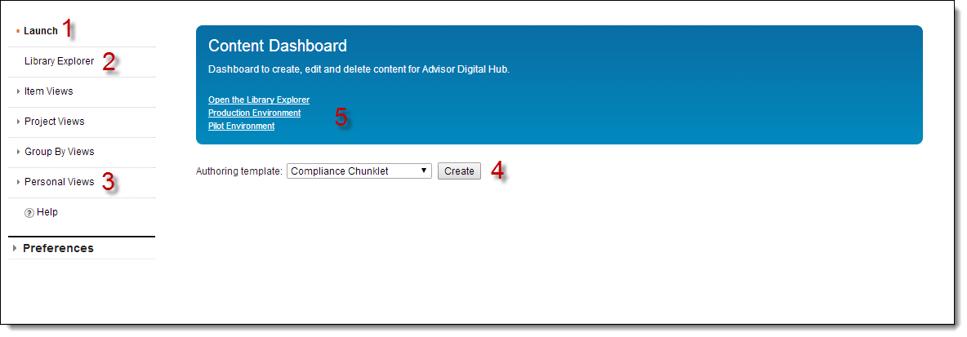

1. **Launch**: This is the “home” link for the IBM WCM authoring tool. Clicking **Launch** will always take you to the Content Dashboard main screen.
2. **Library Explorer**: This takes you to the directory structure of your content. You can find and edit your existing content here.

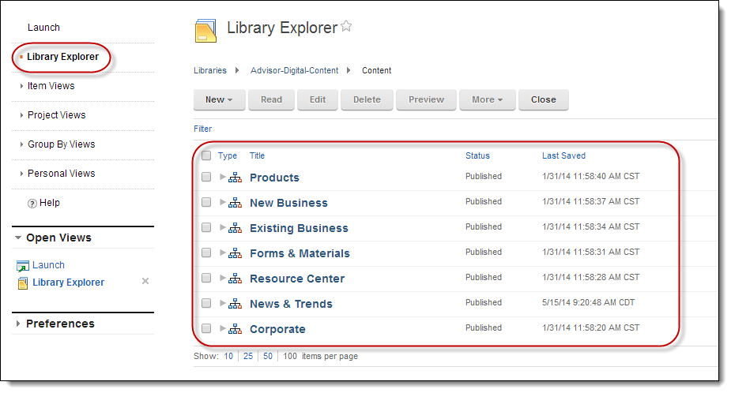

1. **Personal Views**: This lets you easily find the content you’ve authored.

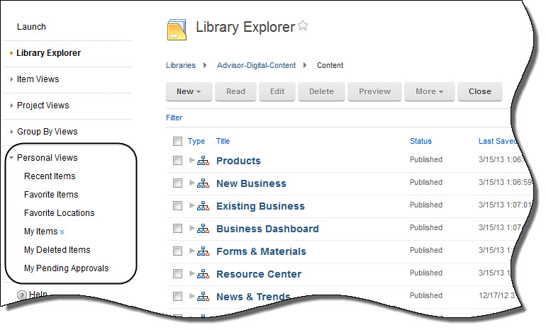

1. **Authoring Templates**: You’ll use this drop-down list to select an authoring template and begin entering content.

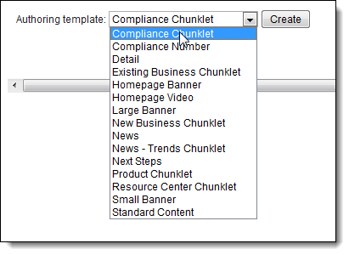

1. **Shortcut links** to Library Explorer, secure production and secure pilot. Pilot environment is reserved for QA testing only.

## How to set a Favorite

Check the location or file from the Library Explorer. From the **More** button drop down, select *Add to My Favorites.* You’ll see a green notification bar at the top of the page that says *Item _____________ added to My Favorites successfully.*

**Finding Your Favorites**

From the left hand side of the Launch page, select **Personal Views**. From here, choose *Favorite Items*. You’ll automatically be taken to a list of your Favorites.

### Do not use these links from the Content Dashboard

These links will ultimately be removed from the author’s view of the Content Dashboard. They are not needed for authoring. Please do not attempt to use them.

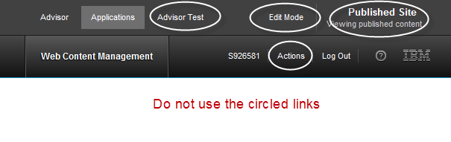

# Adding New Content using the Content Dashboard

Make sure you’re on the Launch screen. To create a page of content like this, you’re going to use two templates – first the Detail template and then a Chunklet template to add the chunklets.

**TIP:** For a ***new*** Megamenu or left nav link, contact your content governance group representative. You’ll need a Site Admin to create a new site area before you can add a detail, chunklet, standard or banner template, and any new Megamenu additions will need to be prioritized within a Sprint.

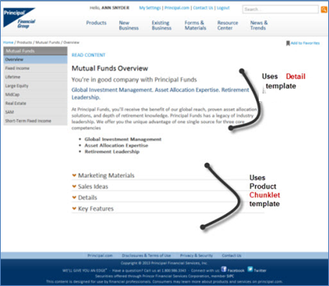

You’ll select and author each section of the content separately.

1. From the Launch screen, select the **Detail** template from the drop-down list and click **Create**.

**TIP**: Each site area (navigation tier) can only have one Detail page. Chunklets can only be associated with one Detail page within a site area. A Detail page must exist in order to create a Chunklet item. If you have additional content to add to a site area, use the Standard template.

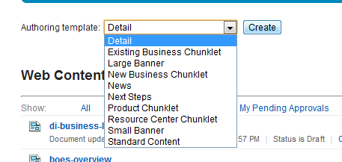

1. Enter the appropriate information in each field of the template.
   1. See the *Template Details* section of this document for full instructions for each field.
2. When the template is filled out you have the following options:
   1. To *save and preview* content,click **Save and Close**. The **Preview** button will let you preview the content within the authoring tool.

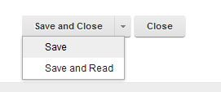

* 1. To *save and submit* your content, click **Save and Read.** A **Submit for Review** button will appear. This initiaties the workflow process to move your content to production.



# Previewing Content

Traditionally we’ve used pilot enviroments to send content out to review. Advisor pilot is reserved for QA testing only. We use the Preview feature instead to share content with business or compliance contacts who may not have access to the authoring tool. Use the steps below to generate a PDF for review.

**>> User Experience Best Practice:** Use the [Content Checklist](http://share.principal.com/sites/advisordigital/User%20Experience/advisorsite-content-checklist.docx) to make sure your finished page meets the criteria for successful digital content.

**TIP:** be sure to log in to WCM using Chrome or FireFox to create a PDF for content review. This functionality will NOT work in IE8.

To Preview any saved or published piece of content within the authoring tool, click the **Preview** button. A pop-up window will appear showing how your content will appear in production.

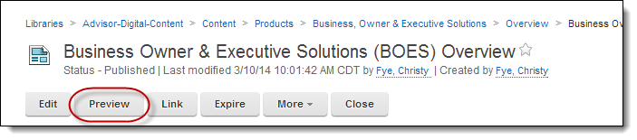

**TIP:** The Preview window shows only the content selected in draft state. Clicking on any links in the navigation will show how other site content appears in ***production***.

1. While the preview window is open, right click in a blank area of the screen to print the context menu

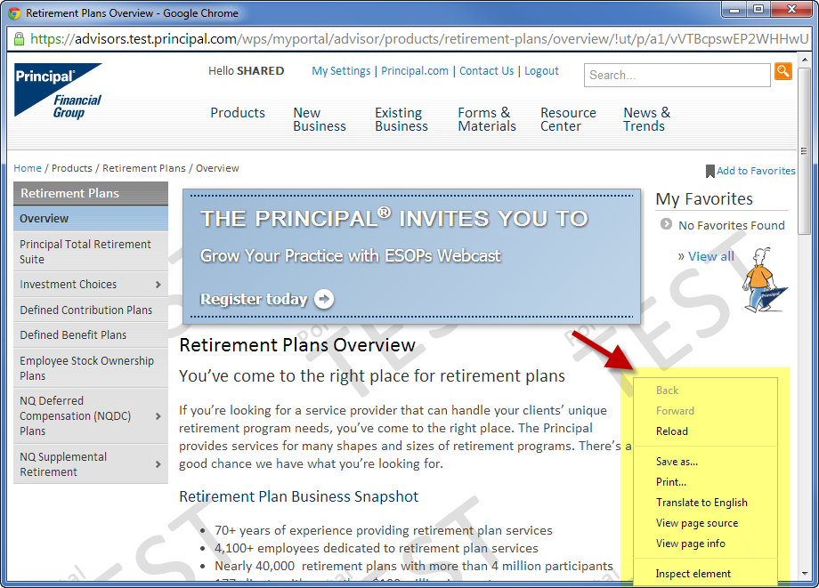

1. Select the *Print* option. This brings up the *Print* dialog box. Select Adobe PDF.

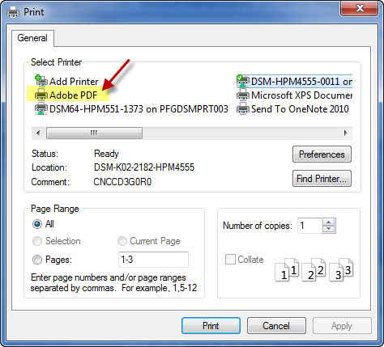

1. Clicking the *Print* button at the bottom will bring up a window of where you want to save the pdf.

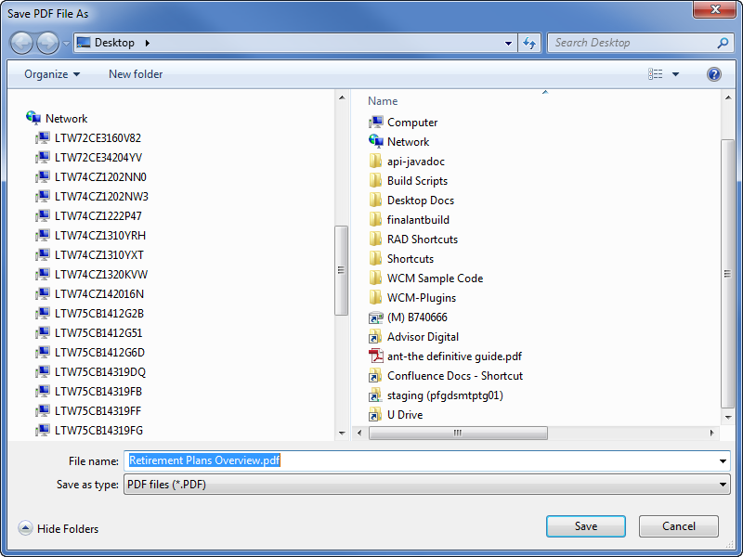

1. Save.

**Remember if your chunklet will appear in multiple places to provide screen shots of each location to your compliance approver.**

**Preview Examples**

**Previewing a chunklet – it will display just that chunklet**

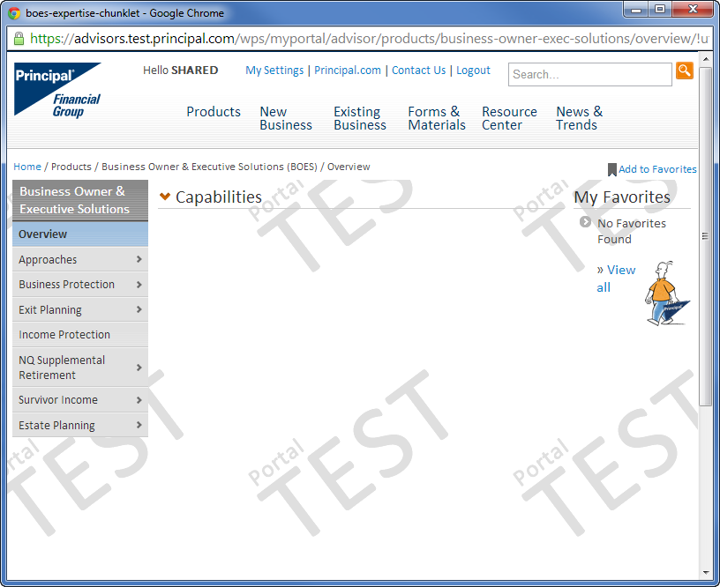 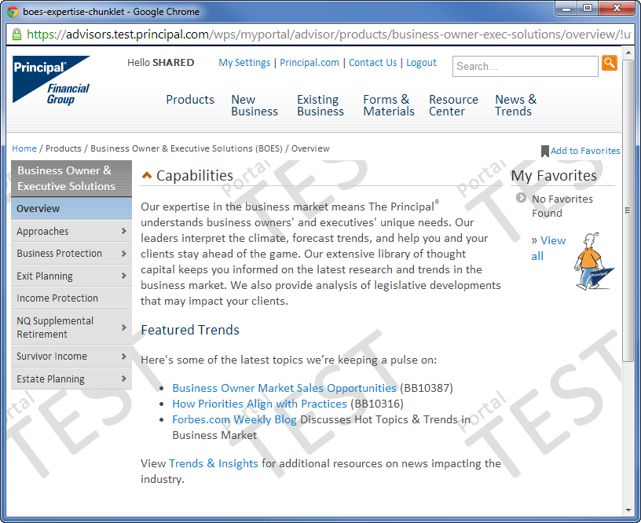

Click on chunklet title to expand

**Previewing the detail page**  
This will pull in all of the ***published***chunklets to give you the complete view of the page. Prior to publication each chunklet must be previewed independently.

**Note**: Allowing all draft chunklets to display from the detail page will be addressed in a future sprint.

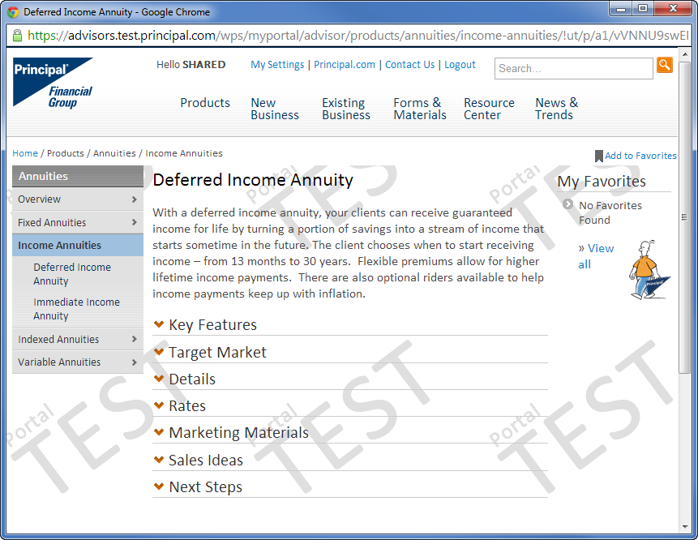

**Previewing Next Steps**

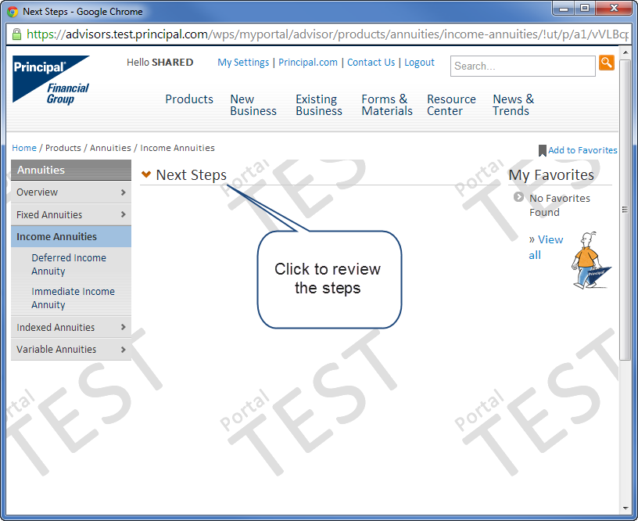

**Previewing Compliance Chunklet**

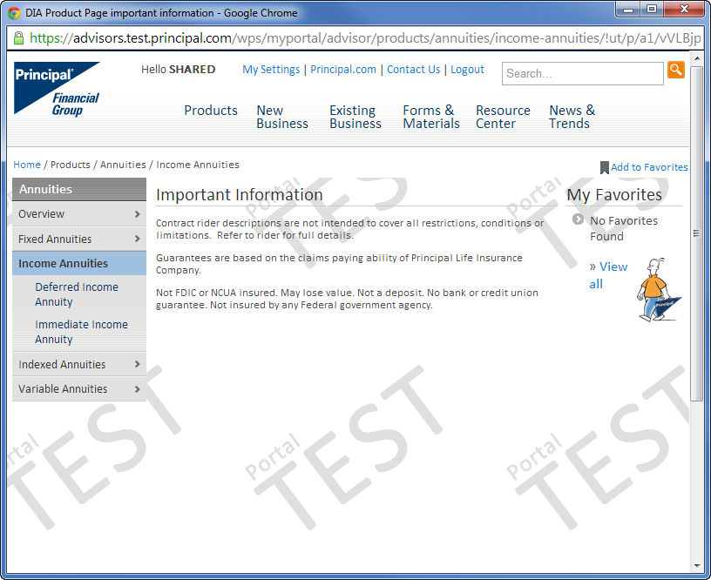

**Previewing a large banner**

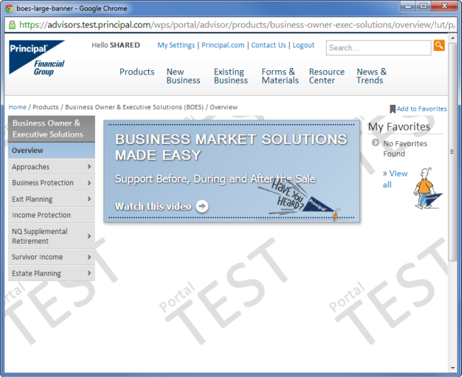

**Previewing a side (small) banner**This is the only strange preview. The side banner can only display draft in the center column. So you will see the draft and the published banner (if there is one)

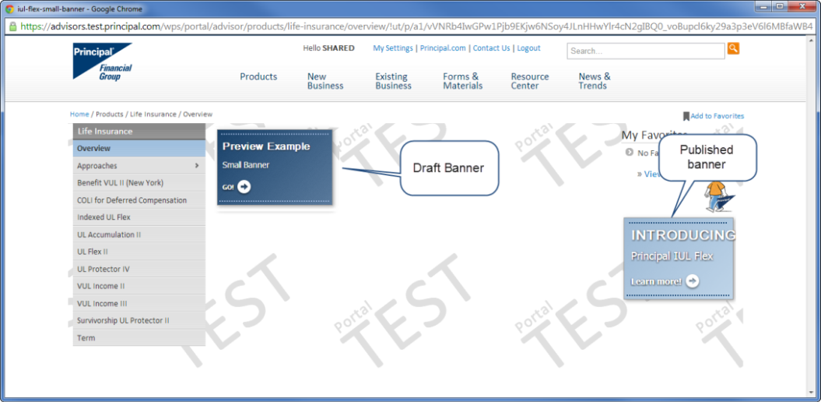

# Read versus Edit Mode

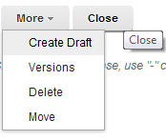**Read mode**: Doesn’t allow you to edit content. You’ll know you’re in read mode whenever the editable fields in a template are greyed out. In order to edit content you must :

1. Use the More menu to select **Create a Draft**.
2. Click **Edit**.

**Edit mode**: Allows you to edit content. Doh!

**TIP:** Choose to **Read** a file from Library Explorer. Never choose **Edit** from Library Explorer. For some users with approving rights, this will move your changes to production immediately upon Save and Close, skipping the Preview and Workflow steps.

# Submitting Content For Review / Approval

1. When you are finished editing your content and are ready to send it for final publication to your approver, you’ll select **Save and Read.**

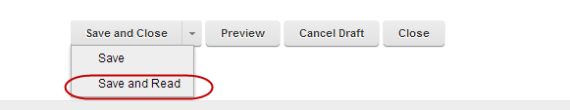

1. Click **Submit for Review**.

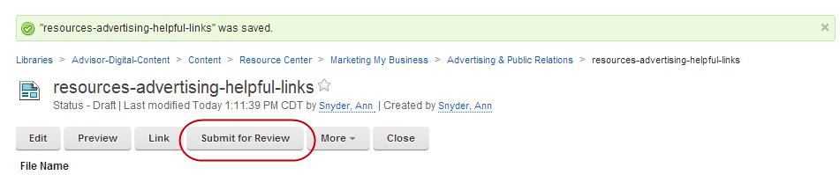

1. If you are an approver and have reviewed the content and are sure it is ready for publication, click **Publish**. If you do not have approving rights, you are done! You will receive an automated email message when someone from the approver group approves the job.

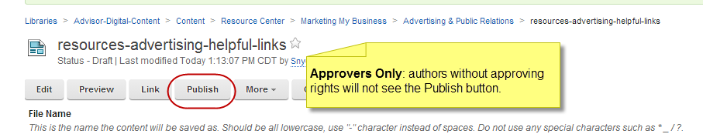

**ALERT:** Approvers do not currently get email notification when there are files pending approval.

* **Authors:** you can notify your approvers yourself to let them know a task is waiting to be finished.
* **Approvers:** you can check for outstanding approval jobs from the Launch page, under *Personal View* in the left nav.

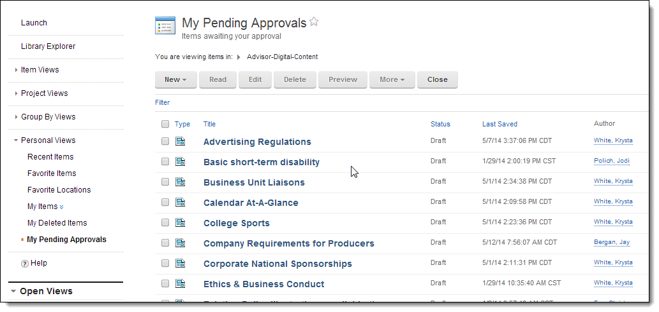

# Expiring Content On Demand

To expire a banner, news articles, standard content page or chunklet before the original Expiry Date set in the content template, contact Krysta White. This functionality will eventually be expanded to all authors to take advantage of in the normal course of your content management work.

**Note:** if your desired-to-be removed piece of content is associated with the MegaMenu or left nav, please work with a member of the Content Governance Group to coordinate removal of navigation elements to avoid user errors in production.

# Template Details

Required fields are represented by an *. Here are some key elements of the template to know.

## Filename Best Practices

1. Enter the filename in lower case and separate by hyphens
2. Make your filenames as useful as possible by using the megamenu name and the site section of template: **Site-section**-**subject-chunklet** .

## Content Title (Detail, Standard and News Templates)

The Content Title for the Detail template is a free form text box. This will be the Page Headline, and what will appear when you search for your content using the Library Explorer.

## Content Title (Chunklet)

The Content Title for Chunklets is a drop-down located in the middle of the template. It is a fixed word or phrase and cannot be changed. This will be the Page Headline displayed to the end user.

## Search Description

The search description benefits ends users as a potential source for Google to use when it creates the search snippet.

**>> User Experience Best Practice:** the search description should be written with the end user in mind, to describe why the user should want to use this content.

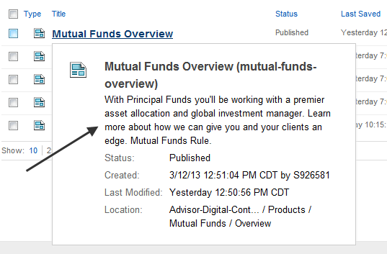

**TIP:** The search description is also helpful when reviewing content in the Library Explorer. As you hover over content files, the search description appears

## Location: Saving Content in the Right Location

The Location field in the template is where the file will be saved in Library Explorer, and where the content should display on the site.

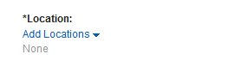

1. Click the words **Add Locations**.

**TIP**: **Do not** select the drop-down arrow. Drill down to your content location. This should mirror the location in the Megamenu/Left Nav.

1. Click the main site category **(e.g. Products).**

**TIP: Do not**  select the radio and click OK**.** The location you want is deeper.

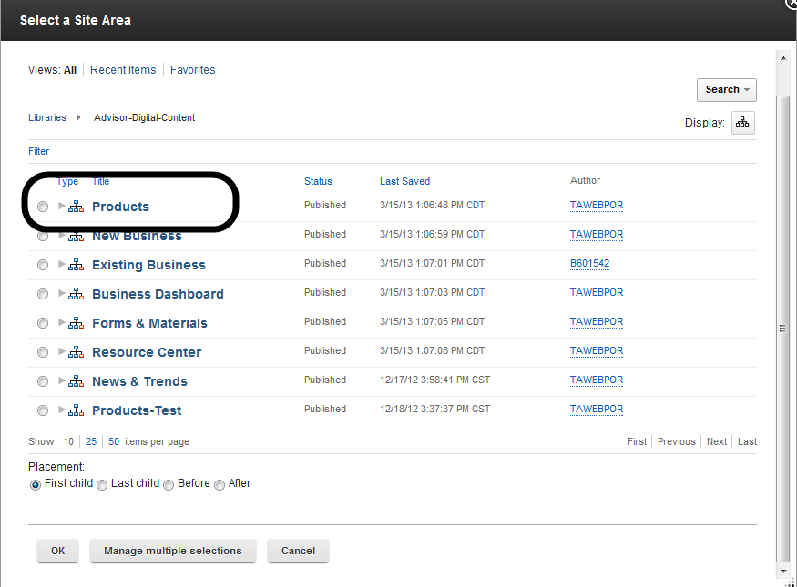

1. In this example, we’ll be creating product content in Group & Voluntary Benefits. So, we’ll click the **label** for Group & Voluntary Benefits.

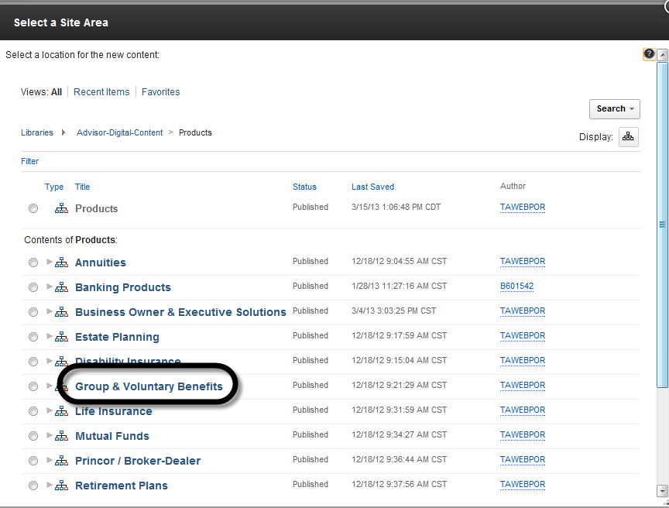

1. Select the Radio button for **Overview**.
   1. Select **First Child**.
   2. Click **OK.**

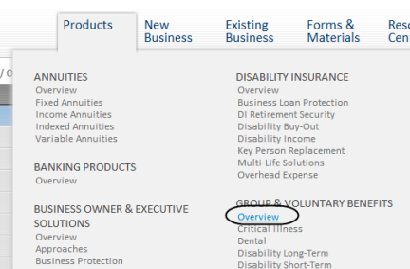Selecting **First Child** will cause this content to be in the first (top) position on the page.

**TIP:** When building subsequent chunklets or Standard pages, select Last Child.

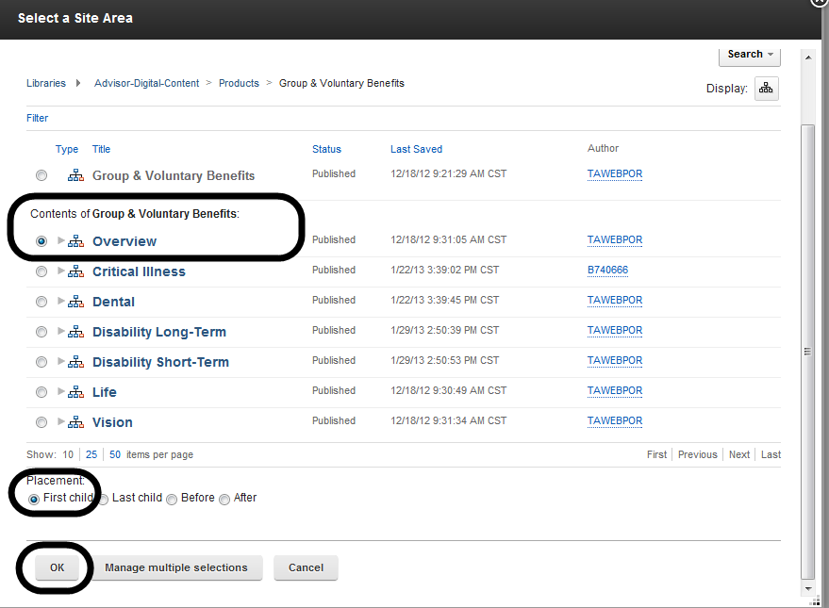

After clicking OK, the Location field will display the path to the content.

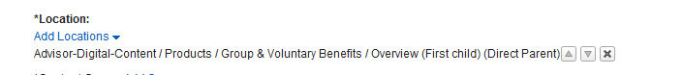

If you’ve saved the content in the wrong location; click the **X** at the end of the location description. This will cancel your selection and you can start again.

## Updating Author and Content Owner Field

1. This Author field defaults to the person who created the orginal template.
2. If the author listed is not you, or the content owner needs to be updated, click on the “X” by the name to remove.

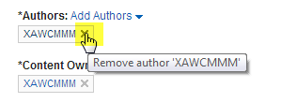

1. Click on the *Add Authors* link, which will bring up a search box.

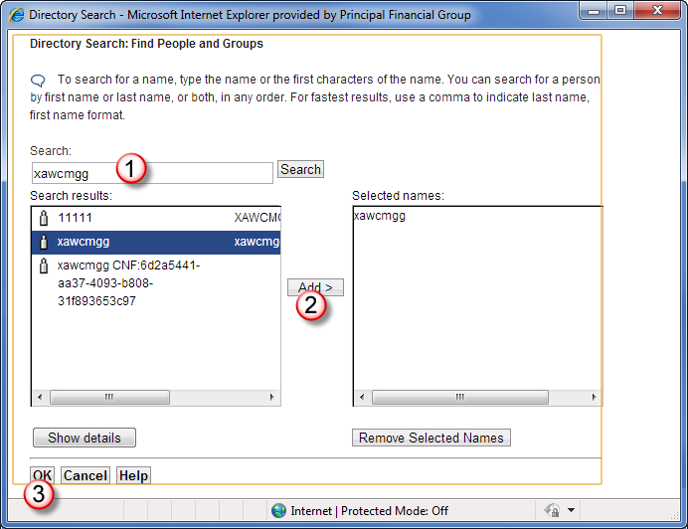

**1:** Enter **User ID** of the author.

**2:** Select the name > Click **Add**

**3:** Click **OK**

1. You should now see the new user ID as the *Content Author*. After saving, the person’s name should appear.



1. Repeat these same steps to update the Content Owner. A file can have multiple Owners.

## Keywords

Keywords should be used to enter synonyms, colloquial references to terms, common acronyms, etc. Keywords will also be used to for our initial taxonomy attempts. Separate by commas. No limit.

**>> User Experience Best Practice:** these should be made up of both words within your page content as well as common industry/audience terms.

*Example:* Disability Insurance is also known as Income Protection.

If you include abbreviations, also include the full phrase.

*Example:* IDI, individual disability insurance.

## Compliance Number

Use this field to input the compliance approval number for your content, if applicable.

**TIP:** The compliance approval number will show up on as a footnote on the page so you won’t need to include it in the body of your page. The compliance number *will not* show up in Preview, however will appear once the file is in production.

## Product Line

This is assigning what the content is about, based on Personalization Rules, and is *implicit* (applied at the Firm level). It is a filter, secondary to security.

**Personalization should not be confused with preference.** Preference is defined as a unique user being able to customize what type of content they wish to see, based on the security settings and personalization rules. It is *explicit*. This enhancement will be tackled in Wave 3.

**TIP:** Refer to the **Personalization Spreadsheet** or contact your content governance group member to verify which Product Line(s) you should select for a particular piece of content. DO NOT select everything as a default! Content that applies to all Product Lines may best be indentified as Corporate. **Example:** Compensation.

<http://share.principal.com/sites/advisordigital/Requirements%20Management/Portal%20Security-PZN.xlsx>

## Licensed to Sell In

Not required. May apply to some products.

## Content Access

1. Click **Select Category** within the *Content Access* field

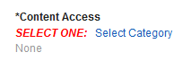

1. Select who this content should be **restricted** to meaning **only** those who can see this content and then click **OK**.

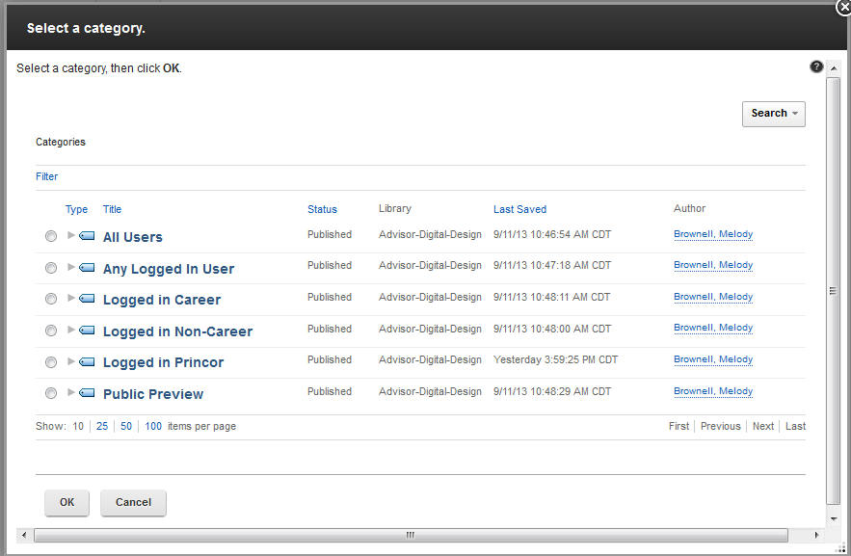

Definitions of each access category

* **All Users:** Use for Public content to be viewed by an anonymous user *and* also displayed to users who are logged in.
* **Any Logged-in User:** Use for Secured content to be viewed by any user who is logged in.
  + *This content is proprietary, or the user must be registered with The Principal to see it, but it doesn’t matter if you are Career or NonCareer.*
* **Logged in Career:** Use for Career content to be viewed only by a Career Advisor (and their delegates…once delegation is implemented).
  + *This content will NOT be displayed to NonCareer users who are logged in.*
* **Logged in Non-Career:** Use for NonCareer content to be viewed only by a NonCareer Advisor (and their delegates…once delegation is implemented).
  + *This content will NOT be displayed to Career users who are logged in.*
* **DO NOT USE UNTIL FURTHER NOTICE Logged in Princor:** Use for Princor content to be viewed only by a Princor Advisor (and their delegates…once delegation is implemented). This includes Princor content to be viewable by EITHER a Princor Career Agent OR a Princor Noncareer Broker.
  + *This content will NOT be displayed to NonPrincor users who are logged in.*
* **Public Preview:** Use for Public content to be viewed ONLY by an anonymous user.
  + *This content will NOT be displayed to users who are logged in. Examples are “More Information with Login” content.*

## Retention Code

Check with the business owner. For details about reference codes refer to: <http://inside.theprincipal.net/is/support/retention/docs/retsched.pdf>

## Approver Group

This is based on the content category.

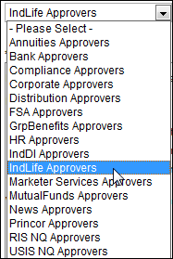

**TIP:** It is very important you pick the right approver group for your content, or your approver will be unable to publish the file. This also locks your draft from further editing.

Always check to make sure the correct approver group is selected.

**Common Error:** sometimes, when editing existing content, approver groups may disappear, leaving for example, only News Approvers. Try these steps to refresh the drop down:

* Go ahead and **Save and Close** your file without submitting
* Log out of the WCM authoring tool
* Close down your browser
* Log in again.
* You should be able to edit your draft and select from the full list of approver groups.
* Submit like normal

## Overview – Visual Format Editor

This is where the bulk of your viewable content will be entered.

**>> User Experience Best Practice:** Help your users get the most out of your content. For best practice guidelines, tips and examples on structuring your content for a digital platform, see the [Digital Writing Guidelines](http://share.principal.com/sites/advisordigital/User%20Experience/digitalwriting101.docx).

You’ll use what’s known as a WYSIWYG (what you see is what you get) editor. We are using a specific editor called ePhox.

**TIP:** When copying large amounts of data from Word, it is recommended you paste it into Notepad to strip out any extra formatting, then paste the content into the WYSIWYG editor a section at a time. This extra step will save you time in the long run because you won’t have to go back into your file to correct formatting problems.

## Working With Tables

To insert a table into the body of your content select the insert table icon.

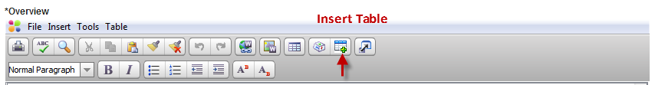

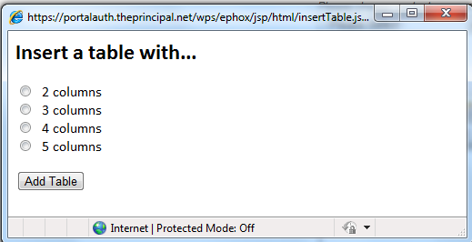This will open a window allowing you to select the number of colums for your table. A table will be inserted into your body copy with the number of colums you’ve selected and 2 rows.

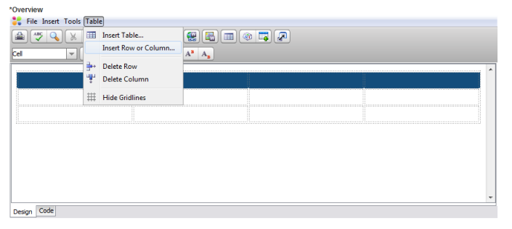

To add additional rows select **Table > Insert Row or Column**.

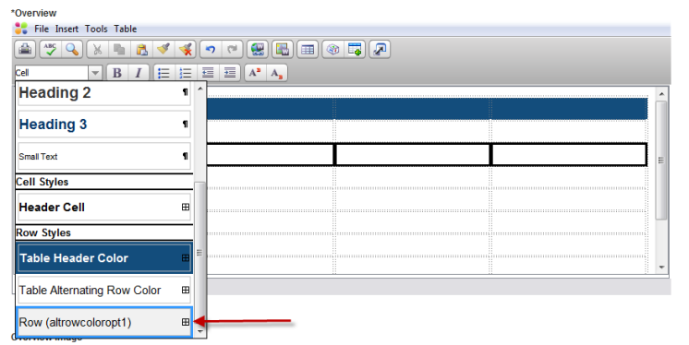To add alternate row colors, select a row and use the Row (altrowcoloropt1) from the formatting dropdown list.

### Alternate Options:

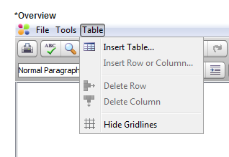To insert a table into the body of your content select **Table** > **Insert Table**.

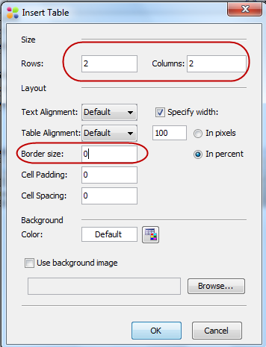From the Insert Table window:

1. Enter the number of rows and columns for your table.
2. Change the border size to “0”.
3. Click **OK**.
4. **Do not** change the default background color.

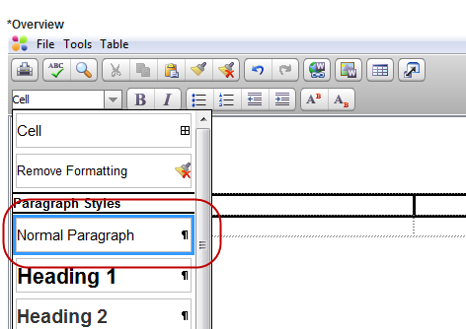Select the entire table and choose normal Paragraph for its style.

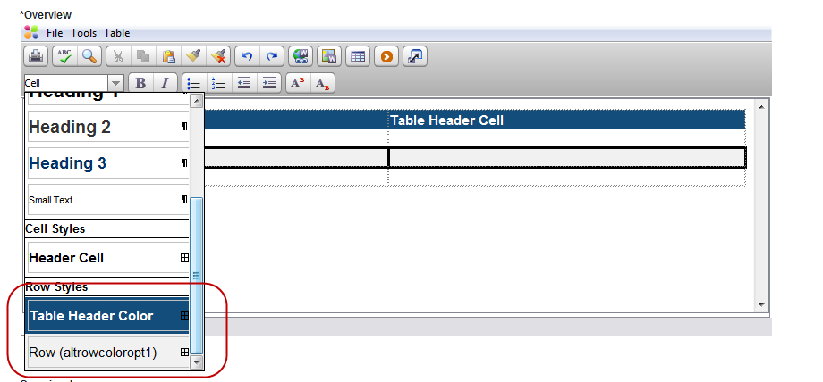Select the first row and choose Table Header Color. You can select individual rows and add alternate row colors.

## Page Headings

The *Content Title* field will be your default page headline. However, you also have the option to add two additional subheads to help structure your content within the body of the page. **Heading 2** is dark grey and **Heading 3** is dark blue. Both can be accessed from the style dropdown in the upper left hand corner of the visual editor.

**>> User Experience Best Practice:**  Use page headings to help break up sections of the page and establish priority. Always choose a heading level before bold regular text. See the [Digital Writing Guidelines](http://share.principal.com/sites/advisordigital/User%20Experience/digitalwriting101.docx) for more tips on how to write headlines for fast comprehension and search engine optimization.

## Footnotes

To style footnotes with smaller text:

1. Enter the footnote text
2. Highlight the text
3. Go to code view
4. Put this tag around the paragraph tags:
   1. <small><p>Paragraph goes here.</p></small>

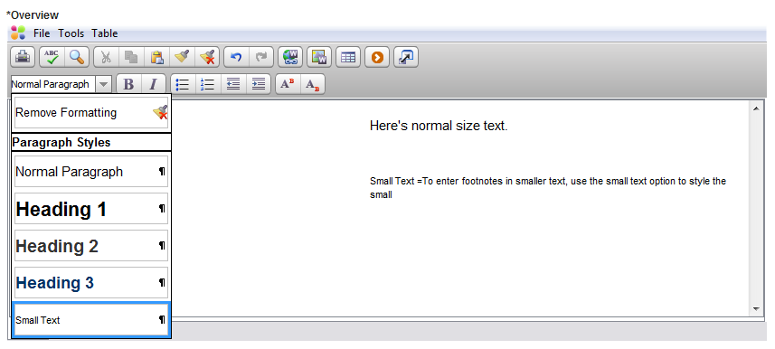

**TIP:** for Compliance disclosures, use the Compliance Chunklet template, available from the drop down on the Launch page.

## Symbols

To insert a symbol, go the the **Insert** drop down menu. Choices include *Copyright*, *Trademark* or select *Insert Symbol* to bring up the full list of options.

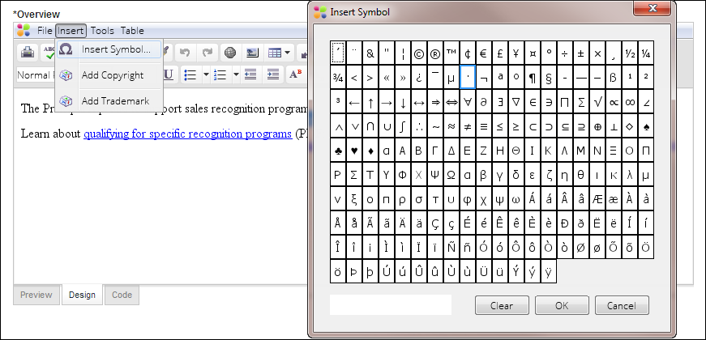

## Adding Videos: Entering Brightcove Embed Code

1. Paste in embed code supplied from your Brightcove administrator in the **Video Embed Code** field of the template. (You can also embed this code within the body of the Overview section.)

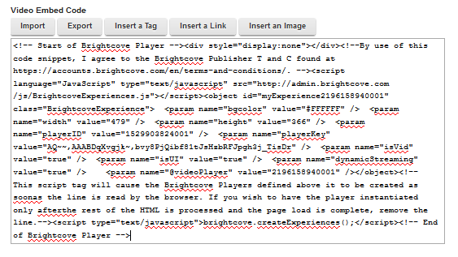

1. Make the following modifications to the script block
   1. Replace the line in red below with this: <http://sadmin.brightcove.com/js/BrightcoveExperiences.js>
   2. Add the block in orange
   3. Remove the block in green

<!-- Start of Brightcove Player -->  
<div style="display:none"></div>  
<!--By use of this code snippet, I agree to the Brightcove Publisher T and C found at <https://accounts.brightcove.com/en/terms-and-conditions/>. --><script language="JavaScript" type="text/javascript" src="**http://admin.brightcove.com/js/BrightcoveExperiences.js**"></script>  
<object id="myExperience2196158940001" class="BrightcoveExperience" style="position: absolute; z-index: -1000;">  
<param name="bgcolor" value="#FFFFFF" />  
<param name="width" value="479" />  
<param name="height" value="366" />  
<param name="playerID" value="1529903824001" />  
<param name="playerKey" value="AQ~~,AAABDqXvgjk~,bvy8PjQibf81tJsHzbRFJpgh3j_TisDr" />  
<param name="isVid" value="true" />  
<param name="isUI" value="true" />  
<param name="dynamicStreaming" value="true" />  
<param name="@videoPlayer" value="2196158940001" />  
<param name="secureConnections" value="true" />  
<param name="wmode" value="transparent"/>  
</object>  
**<!-- This script tag will cause the Brightcove Players defined above it to be created as soonas the line is read by the browser. If you wish to have the player instantiated only afterthe rest of the HTML is processed and the page load is complete, remove the line.--><script type="text/javascript">brightcove.createExperiences();</script>**

1. Save Content

## Workflow – Standard and Compliance

Choose Standard Workflow. Compliance Workflow is not set up at this point.

## Publish/Expiry/Review Dates

* *Publish date* - Leave blank if you want to start the workflow to send your changes to production immediately. Or, you can set your file to move at a preset date and time. The status will show up as **Publish Pending** in Library Explorer.
* *Expiry Date* – up to two years in the future. You’ll receive email notification 30 days out when your file gets close to this date.
* *Review Date* – up to six months in the future. You’ll receive email notification 30 days out when your file gets close to this date.

**TIP:** When expiring content, make sure you synchronize the Expiry and Review dates. Otherwise, you’ll get email notifications to review expired content.

# Creating Banners

Large banners are located at the start of Detail template content. Small banners located in the right column, beneath My Favorites, of Detail template content. These features are not available with the Standard template.

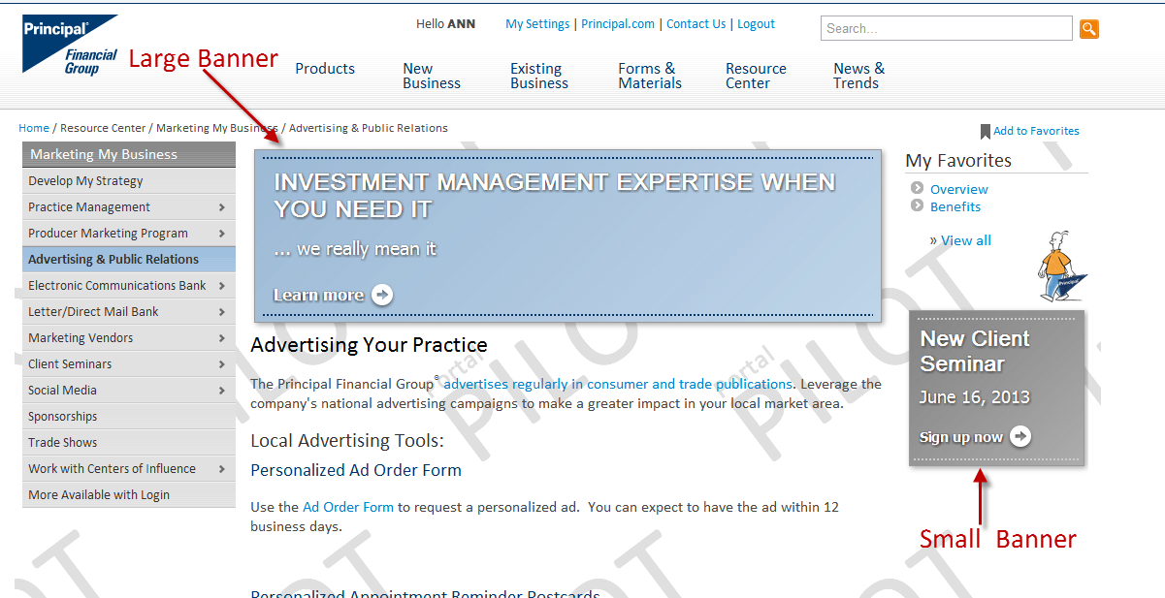

To create banners select the appropriate template from the list:

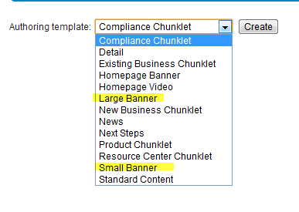

**TIP:** To request a **Homepage Banner**, contact Krysta White to reserve a spot on the schedule. A preview of the banner will be sent to you for sign off prior to publication.

## How to create a large banner:

The banner templates function like other templates, but have some unique fields applicable only to banners.

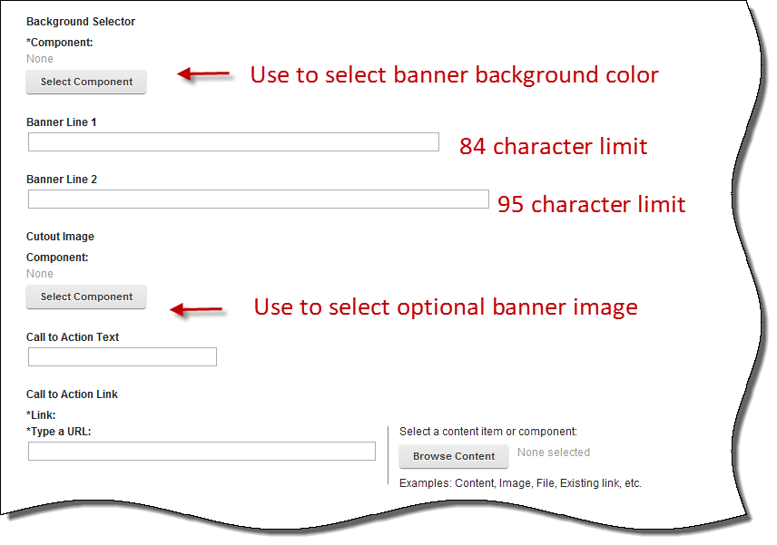

1. **Background Selector:**  The background lets you use whether you want a grey, white, dark blue or light blue banner background.

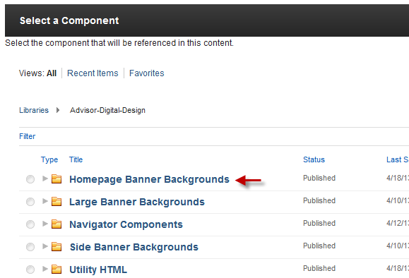

* Click **Select Component** button.
* Click **Homepage Banner Backgrounds.**
* Select the radio for the color you want and click **OK.**

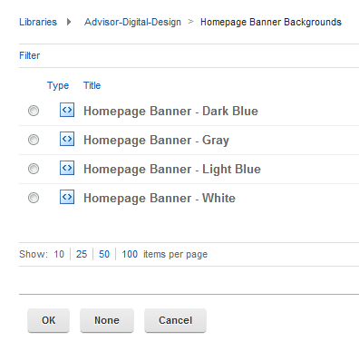

1. **Cutout Image:** To select an optional image for the banner:

* Click **Select Component** button.
* The selection option will place in the last location where you selected a component. If you’d previously selected the banner ba ckground you’ll be here:

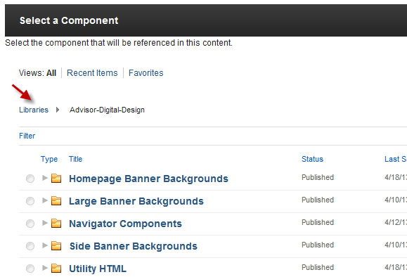

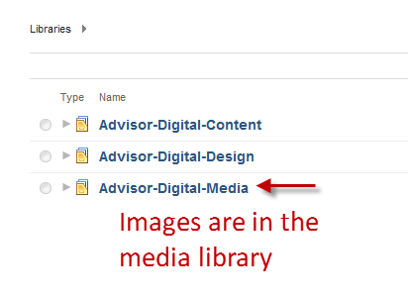

* Click the **Libraries** link. Drill down through the Advisor-Digital-Media folder to see the images you may select from.

**Note**: Images will be pre-populated. If you have images you would like to use, please contact Ann Snyder or Krysta White.

1. **Banner Line One:**

* Text cannot exceed **84** characters including spaces
* Line 1 will wrap up to two lines
* Text words will be
  + - White for Gray, Light Blue and Dark Blue banners
    - Black for White Banners

1. **Banner Line Two**:

* Text cannot exceed **95** characters including spaces
* The second banner line may require fewer characters so as to not run into the image, if used.

1. **Optional image**:

* The image has a maximum size of 140 x 150 pixels; the images to be selected will be sized appropriately and do not require adjustment by the author.

1. **Call to Action**
   * Text cannot exceed 35 characters
2. **Call to Action Link**
   * Preferred method is to link to content within Advisor. Click the **Browse** button to navigation to your content location.
   * *Please discuss with your content governance contact before typing in an URL to an external site or document.*

**>> User Experience Best Practice:** banners currently cannot pop a separate window. Whenever possible, link to content within Advisor to avoid the risk of the user losing their place or closing the site accidentally. If the linked item is important for later use or something that someone might refer to later the preferred destination is to create static web content within Advisor.

## How to Create a Small Banner:

Small banners are created in the same way as the large banner.

**Exceptions:**

* The small banner does not have an image option.
* Banner lines one and two have a 20 character limit. Contact Krysta White for help working within this limitation.

## Where to Save Banners:

Banners should be stored in the same site area with the detail template content they will be displayed. Each detail page can contain one large banner and one small banner.

# Reuse Chunklets

1. Through Library Explorer find the chunklet content you want to reuse.
2. Click the checkbox next to the item and click **Read**.
3. Click **Link**.
4. Click **Add**.
5. Navigate through the **Library Explorer** to the location where you want to share the chunklet.
6. Use the radio button to select the location where the chunklet should appear. (**Note:** always choose Last Child).
7. Click **OK.**

**TIP:** When linking chunklets, the site area you are linking to must have a detail page already published and configured as first item in that site area.

# Create an Inline Link to Existing IBM WCM Content

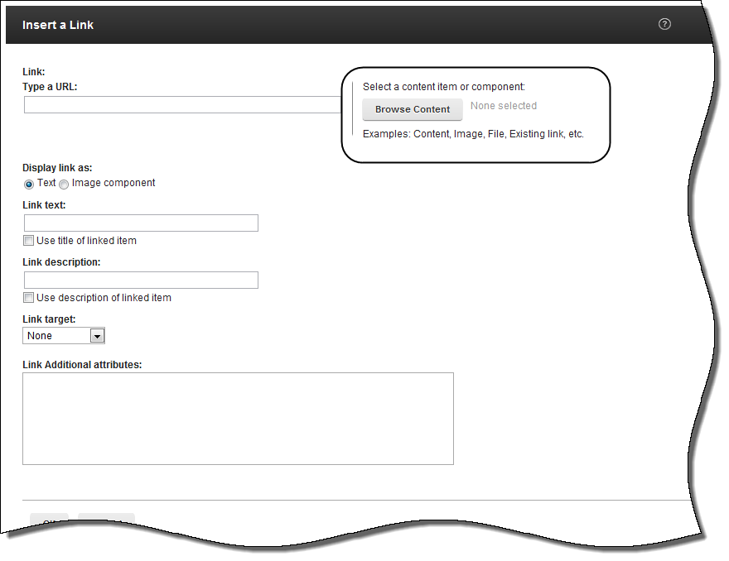Use the insert hyperlink function in the body WYSIWYG editor.

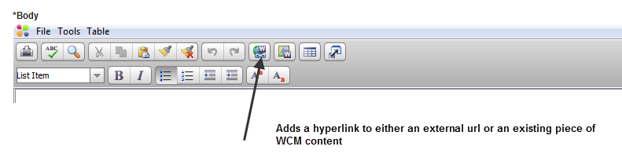

Use the **Browse Content** button to navigate to the content to be linked.

# Linking from public content to secure content

1. Create the link like normal in the WYSIWYG editor
2. Once the link is created, right click on the link and select **Hyperlink Properties**.

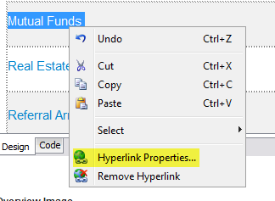

1. Move the cursor to the start of the hyperlink and edit the link as shown below. Link created by WYSIWYG editor with what we need to change highlighted in red

**FROM**:

Link created by WYSIWYG editor with what we need to change highlighted in red:

/wps/wcm/myconnect/advisor-digital-content/products/princor-broker-dealer/outside-selling-agreements/mutual-funds-529-plans/princor-outside-selling-agreements-mutual-funds-529-overview~~?contentIDR=22fd810c-b00e-43d6-8f08-fc10cc3ff4a9&#38;useDefaultText=0&#38;useDefaultDesc=0">~~

**TO**:

/wps/myportal/advisor/products/princor-broker-dealer/outside-selling-agreements/mutual-funds-529-plans/princor-outside-selling-agreements-mutual-funds-529-overview/

1. Change **/wcm/my connect/advisor-digital-content** to **/myportal/advisor**
2. Remove all the junk after the English words in the URL
3. End the URL with a backslash

# Login for More Information Links

To prompt a user to log in to get more information from a public content page, follow these guidelines:

1. The link text should be: “Login for more information”
2. The URL is: [/wps/myportal/authentication/loginPage.jsp](https://advisors.principal.com/wps/myportal/authentication/loginPage.jsp)

# Creating Links to Virtual Supply

Both the Standard and Chunklet templates can automatically format up to five Virtual Supply links.

If you must make a link to a Virtual Supply document outside of the template Virtual Supply fields, use the relative form of the url.

**Secured VSupply Document**: /vforms/GetFile?fm=BB8978&ty=VOP&EXT=.VOP

**Public VSupply Document**: /publicvsupply/GetFile?fm=BB8978&ty=VOP&EXT=.VOP

**TIP:** to always link to the most current document in Virtual Supply, remove the -# from the link. /publicvsupply/GetFile?fm=BB8978-18&ty=VOP&EXT=.VOP

**Note**: Depending on what type of the VSupply document you’re accessing your link following /vforms and /publicvsupply may be different.

# Creating Links to Documents on secure02

If you must make a link to an existing document on eFP use the relative form of the url.

**Example:** https://secure02.principal.com/efpData/Life/Underwriting/GI.pdf

Then the relative form of the url is: **/https.secure02/**efpData/Life/Underwriting/GI.pdf

Simply replace **https://secure02.principal.com** with **/https.secure02/**

**>> User Experience Best Practice**: Always change the **Target frame** when you’re linking to a document to **New Window**. This allows the user to open the document, but remain within the site.

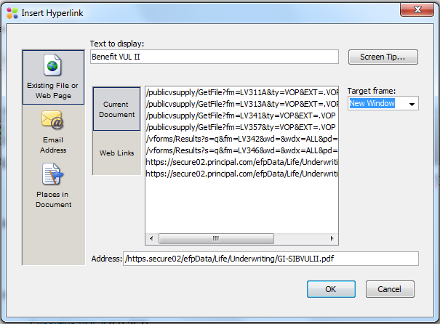

# Creating Links to Applications

There are many places throughout content where we’re linking to applications. To successfully create a link to an application from within a piece of content you need to know whether the link is integrated or non-integrated. Be sure to check out the “**But I’ve already created all my links ☹”** section.

## Integrated Applications

We’re using the term “integrated applications” to refer to applications that take on the look and feel of the portal.

**Examples include**: ***Pending Business Report***, ***Virtual******Supply*** and ***IDRT*** (Investment Data Reporting Tool)

These applications have a URL available on advisors.principal.com.

**>> User Experience Best Practice:** The user should see the application in the same window with the main navigation fully available.

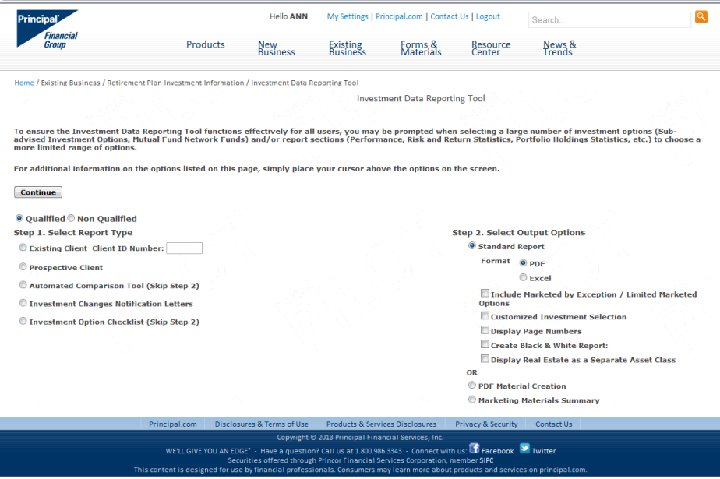

## Non-Integrated Applications

We’re using the term “non-integrated applications” to refer to applications that we’re simply linking to from the portal. The application retains its original navigation and look and feel.

Examples include: ***Policy Activity Report***, ***Schedule TeleApp***

These applications retain their URL containing one of the following:

* Secure02
* Secure05
* Secure09
* Or, they may be a third party application and have a url outside of our domain structure.

**>> User Experience Best Practice**: The user should see the application pop a new window to display the application.

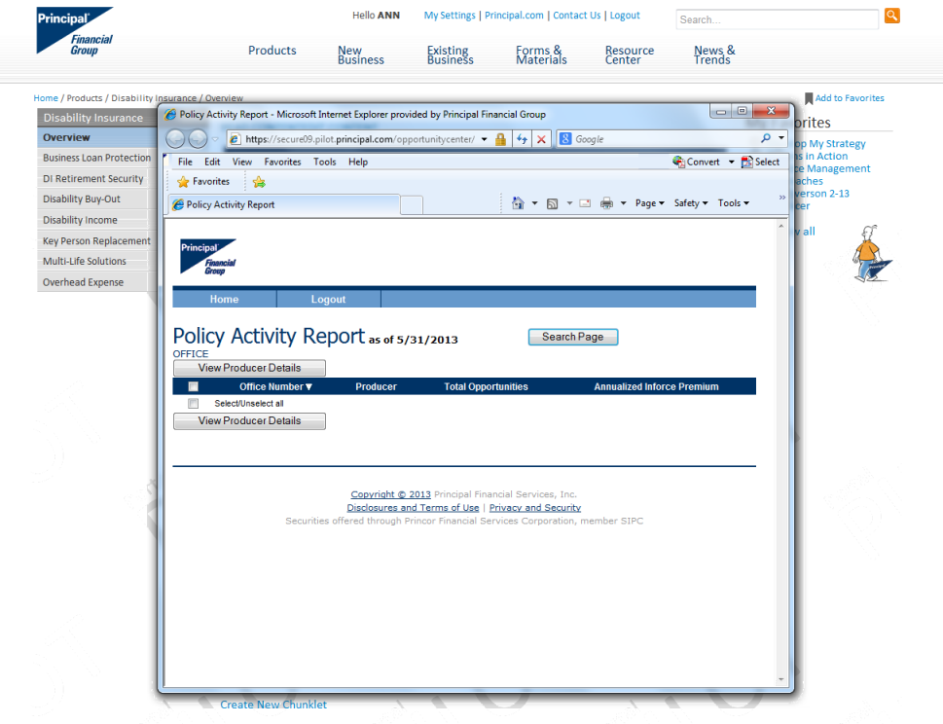

## Creating Links to Integrated Applications

To create a link to an integrated application:

1. Select the link from the megamenu. In this example I’ll use Pending Business Report.
2. Capture the full url.

[https://advisors.pilot.principal.com/wps/myportal/advisor/new-business/track-your-business/pending-business-report/!ut/p/b1/jY-9DoIwFEafhQcwvS39Y6wJtoWIhqaIXQyDMSQCDsbnFxkcjCJ3u8k5yXdQQDUKffNoL829Hfrm-voDP1HMNBjAVoKLwRaZMZ5WWEoxAscRSJTVkFBsNctTsCV3G0U8UMeW-YLk0lAHFio6-pnYG812BIAv8-HHKfjnH1CYkHeBLPwarEhJKc021ox_Al8SJ2CuYQJmRhZm6M7o1nlfQ2tXKoqexE2KhA!!/dl4/d5/L2dBISEvZ0FBIS9nQSEh/](https://advisors.pilot.principal.com/wps/myportal/advisor/new-business/track-your-business/pending-business-report/!ut/p/b1/jY-9DoIwFEafhQcwvS39Y6wJtoWIhqaIXQyDMSQCDsbnFxkcjCJ3u8k5yXdQQDUKffNoL829Hfrm-voDP1HMNBjAVoKLwRaZMZ5WWEoxAscRSJTVkFBsNctTsCV3G0U8UMeW)

1. Remove the domain: <https://advisors.pilot.principal.com> or <https://advisors.principal.com> So, now the url is:

[/wps/myportal/advisor/new-business/track-your-business/pending-business-report/!ut/p/b1/jY-9DoIwFEafhQcwvS39Y6wJtoWIhqaIXQyDMSQCDsbnFxkcjCJ3u8k5yXdQQDUKffNoL829Hfrm-voDP1HMNBjAVoKLwRaZMZ5WWEoxAscRSJTVkFBsNctTsCV3G0U8UMeW-YLk0lAHFio6-pnYG812BIAv8-HHKfjnH1CYkHeBLPwarEhJKc021ox_Al8SJ2CuYQJmRhZm6M7o1nlfQ2tXKoqexE2KhA!!/dl4/d5/L2dBISEvZ0FBIS9nQSEh/](https://advisors.pilot.principal.com/wps/myportal/advisor/new-business/track-your-business/pending-business-report/!ut/p/b1/jY-9DoIwFEafhQcwvS39Y6wJtoWIhqaIXQyDMSQCDsbnFxkcjCJ3u8k5yXdQQDUKffNoL829Hfrm-voDP1HMNBjAVoKLwRaZMZ5WWEoxAscRSJTVkFBsNctTsCV3G0U8UMeW)

1. Next, remove everything from **/!ut** onward. Another way to think of this is when the English stops, delete! So now the url is:

[/wps/myportal/advisor/new-business/track-your-business/pending-business-report](https://advisors.pilot.principal.com/wps/myportal/advisor/new-business/track-your-business/pending-business-report/!ut/p/b1/jY-9DoIwFEafhQcwvS39Y6wJtoWIhqaIXQyDMSQCDsbnFxkcjCJ3u8k5yXdQQDUKffNoL829Hfrm-voDP1HMNBjAVoKLwRaZMZ5WWEoxAscRSJTVkFBsNctTsCV3G0U8UMeW)

1. Take this url and paste it into the **Insert Link > Type a URL: field**. The Link Target option should be set to None. This means the application will open in the same window that the user is currently viewing.

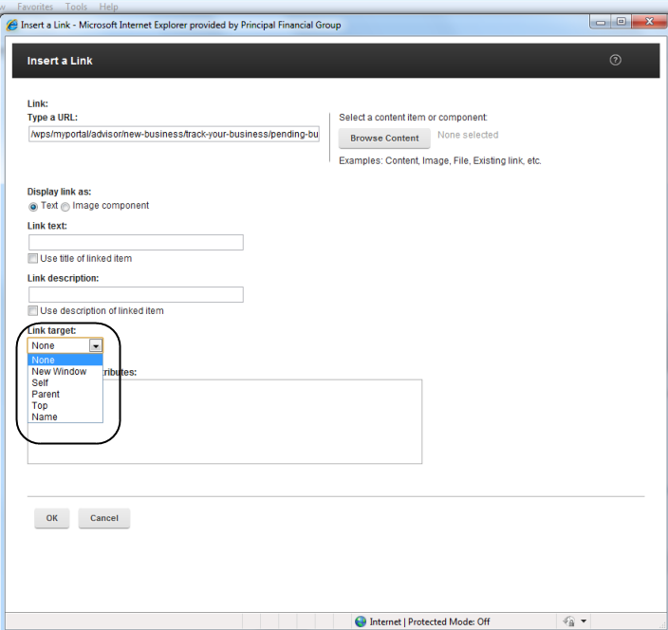

**Special Note: Virtual Supply Create an App**

When creating a link to Create an App link, first select the link from the megamenu:

https://advisors.principal.com/vforms/SalesPackage?ProductLine=LifeQuestions&JSPPageURLBase=/wps/myportal/advisor/new-business/submit-business/create-life-application-packet/!ut/p/a1/ldCxDoIwEIDhZ- EJei0tLSMm2h5EJNQidjFMhETRwfj8VjZjRLytyfc3uSOetMSP3WPou_twHbvz6-2TE6dCgwGKCmwMWObGON5QtacBHAOAL5PBsj7NUEPKAyjdClCuWa3MNtaV_LPXolgD1ondZMwBt2JZL1mhDLeA0PDQ57IyWuwYQPKrPxA_kbkfJjB3ognM3eAdfC55uzjnWhiwj6InRqprpw!!/&requestFromPortal=true

* Then you need to capture just this portion of the URL to use as your link: /wps/myportal/advisor/new-business/submit-business/create-life-application-packet/
* Make sure the link opens in the same window and not a in new window. (Link target set to None.)

## Creating Links to Non-Integrated Applications

To create a link to a non-integrated application:

1. Capture the full url. In the example I’ll use the ***Consumer Price Index*** tool.
2. The full url is <https://secure05.principal.com/RISInvestments/investmentview?page_name=monthlybenchmarkunitvaluehistory&benchmark_nmbr=3&year=2013>
3. To create a link from the advisor.principal.com domain to the secure05 domain we need to create a relative link. It’s easy, don’t worry.

**TIP:** Use the [Coding Relative Links](https://inside.theprincipal.net/webstyleguide/layout/relativelinks.shtm) table in the *Web Style Guide* to figure out the correct relative link to use with your content.

1. Simply replace **https://secure05.principal.com** with **/https.secure05/**
2. The url now becomes /https.secure05/RISInvestments/investmentview?page_name=monthlybenchmarkunitvaluehistory&benchmark_nmbr=3&year=2013
3. Lastly, make sure the Link Target option is set to **New Window**.

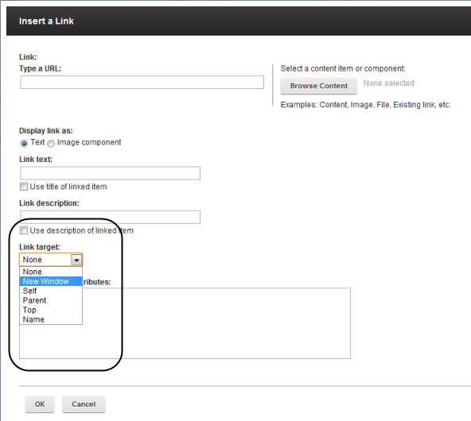

## How to Create a Friendly URL to Share Content

To create a link with a “friendly URL” – a short common language link – follow the steps below.

1. Go to the live site.
2. Access the main content level from the Megamenu
3. Shorten the Megamenu link like you normally would
4. If you hover over the sub left nav item, you should see the full URL, with the common language name
5. Add in the extra text for the sub left nav

**Example:** Resource Center > Marketing My Business > Electronic Communications Bank > BOES

1. Link from the Megamenu: <https://advisors.principal.com/wps/myportal/advisor/resource-center/marketing-my-business/electronic-communications-bank/!ut/p/a1/04_Sj9CPykssy0xPLMnMz0vMAfGjzOJNDE3dDTwMDD3dA51dDDz9XLwcXRyDjdz9DIAKIoEKDHAARwNC-sP1o8BKzI28LTxMgg08DcJMXA08vcwDPNxN_Y0MDMygCvBYUZAbYZDpqKgIAEwjhMc!/dl5/d5/L2dBISEvZ0FBIS9nQSEh/>
2. Shorten it: <https://advisors.principal.com/wps/myportal/advisor/resource-center/marketing-my-business/electronic-communications-bank/>
3. Additional sub left nav text = *boes*
4. Full “friendly” URL to share is <https://advisors.principal.com/wps/myportal/advisor/resource-center/marketing-my-business/electronic-communications-bank/boes>

## But I’ve Already Created All My Links ☹

Never fear. There’s a quick and easy way to adjust links after they’ve been added to your content. You’ll need to open up the piece of content in **Edit** mode.

1. Right-click on the existing link. Select the option for **Hyperlink Properties**.

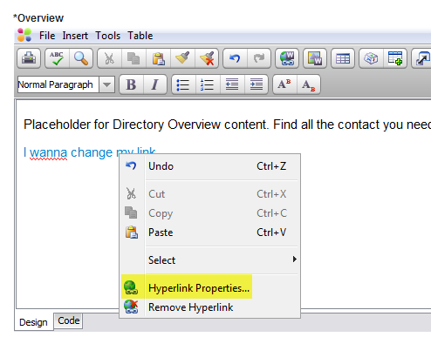

1. Then you can adjust the url, whether a new window should pop and even the display text for your url.

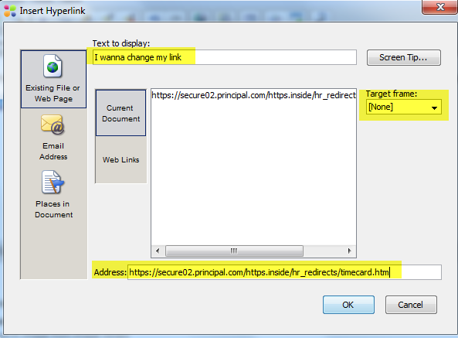

# Authoring Templates: Defined

The WCM Authoring templates are accessed from the drop-down menu, **Authoring template**, on the WCM Dashboard.

## Next Steps

**When to use**: Next steps are used to add important call out information to the detail pages. Only one next steps section is allowed per page. The most recently published Next Steps will always be the one that is displayed on the page

**Special Features**: Allows you to add up to 3 links or 3 text items. The links can to internal WCM content or external sites.

## Detail

**When to use:** The detail template is used as the “anchor” content for any section of content that requires chunklets, a large banner or small banner. It can be used for all the main content siteareas, with the exception of News.

## Standard Content

**When to use:** Standard content templates are used when creating content that simply consists of a title and a text area, and options to add video, images or Virtual Supply links. Chunklets **cannot** be used with the Standard content template.

**TIP:** Best practice is to use a Detail page for anything associated with the megamenu or left navigation. The standard template is for content that lives one level below the left sub nav or for standalone content.

## News

**When to use:** This template should be used when creating News content for the Advisor Hub**.**

**Special Features:** The home page will display the most recent news along with any “Critical/Need to Know” News articles. Articles are tagged with News Categories to allow easier filtering and access to News Library.

## Product Chunklet

**When to use:** Product Chunklets are used to organize and present specific product information on a Product Detail page

**Special Features:** Content authors can add one or many Product chunklets to a product detail page. Each chunklet is tagged with a categorization that is displayed as the collapsible “chunklet header”

## New Business Chunklet

**When to use:** New Business Chunklets are used to organize and present specific New Business information on a New Business page.

**Special Features:** Content authors can add one or many New Business chunkelts to a New Business page. Each chunklet is tagged with a categorization that is displayed as the collapsible “chunklet header”.

## Existing Business Chunklet

**When to use:** Existing Business Chunklets are used to organize and present specific Existing Business information on a Existing Business page.

**Special Features:** Content authors can add one or many Existing Business chunkelts to a Existing Business page. Each chunklet is tagged with a categorization that is displayed as the collapsible “chunklet header”.

## Odds and Ends

1. Can I change the publish date for a piece of content which has already been approved?
   1. **Answer**: The scenario is a piece of content has been approved for publication at 5:00 p.m. today. At 4:45 p.m. the content owner or author realizes that the content cannot go live. The author can create a new draft of the content and extend the date of publication to a future date and resubmit for approval. This should then return the content to draft mode and overwrite the initial publication date. If this is new content, the content should not go to production until the future date has been approved..
2. How do I confirm when a piece of content is scheduled for publication? In other words, the approver has approved and it is in a published state, but may not yet be visible to end users on the site.
   1. **Answer**: Open the content piece and review workflow details in Workflow Actions at the bottom of the template.

