Wazuh SOC Lab — Architecture & Detection Engineering
Personal security lab · Windows 10 + Ubuntu endpoints monitored by Wazuh, attacked from Kali

1. Overview
This lab builds a small Security Operations Center (SOC) around Wazuh, collecting telemetry from a Windows 10 endpoint and an Ubuntu endpoint, correlating it with custom detection rules, and visualizing results in OpenSearch Dashboards. Kali Linux is used as an attacker-simulation host to generate realistic test traffic (brute force, port scans, PowerShell abuse, etc.) against both endpoints.
The goal was not just to deploy Wazuh, but to engineer and validate detections end-to-end: confirm telemetry collection, write custom rules, test with both synthetic (wazuh-logtest) and live attack simulation, and document where detections work cleanly versus where platform limitations required a different approach.

2. Architecture Diagram
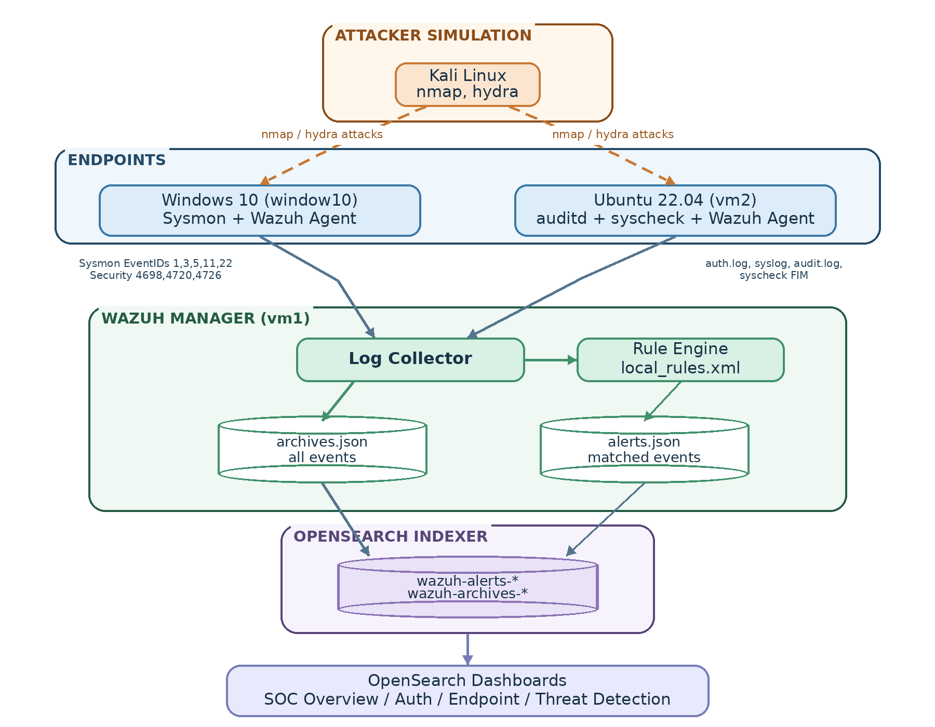

3. Components
Component | Role | Key config
vm1 | Wazuh Manager + Indexer + Dashboards | local_rules.xml, ossec.conf (logall_json: yes)
window10 | Windows 10 endpoint | Sysmon (Event IDs 1, 3, 5, 11, 22), Security auditing (4698, 4720, 4726), Wazuh agent
vm2 | Ubuntu 22.04 endpoint | auditd (execve, connect syscalls), syscheck/FIM (whodata), auth.log/syslog collection, Wazuh agent
Kali | Attack simulation | nmap (port scanning), hydra (SSH brute force)

4. Telemetry Sources

Windows (Sysmon + Security log)
- Event ID 1 — Process creation (image, command line, parent process, hashes, user)
- Event ID 3 — Network connection (source/destination IP and port, initiating process)
- Event ID 5 — Process termination
- Event ID 11 — File creation
- Event ID 22 — DNS query
- Security 4698 / 4720 / 4726 — Scheduled task created, user account created, user account deleted

Linux (auditd + syscheck + syslog)
- /var/log/auth.log — SSH, sudo, user/group management
- /var/log/syslog, /var/log/kern.log, /var/log/dpkg.log
- auditd rules keyed audit-wazuh-w (identity/config file watches), audit-wazuh-c (execve — process execution), audit-wazuh-net (connect syscall — outbound network)
- syscheck (FIM) with whodata on /etc/ssh, /etc/sudoers.d, /home, /etc/cron.d, /etc/crontab, /var/spool/cron/crontabs

5. Detection Rules Summary
# | Detection | Platform | Rule IDs | MITRE
001 | Local admin tool visibility (Notepad / Store apps) | Windows | 100100–100102 | —
002 | SSH brute force → successful login after brute force | Linux | 100200, 100201 | T1110, T1078
003 | Suspicious PowerShell | Windows | 100300 | T1059.001
004 | Encoded PowerShell | Windows | 100301 | T1059.001, T1027
005 | Suspicious parent→child process (Office/browser/PDF → shell) | Windows | 100302–100304 | T1566.001, T1059
006 | Port scanning | Windows | 100400, 100401 | T1046
007 | New user account created | Windows / Linux | 100501, 100510, 100511 | T1136.001
— | User account deleted / anti-forensic create+delete | Windows / Linux | 100503, 100512, 100513 | T1531, T1136.001
008 | Privilege escalation / sudo abuse (tiered) | Linux | 100520–100525 | T1548.003, T1078, T1059.004, T1105
009 | Persistence (cron / scheduled task) | Linux / Windows | 100530, 100531, 100532, 100533 | T1053.003, T1053.005, T1059
010 | Suspicious network activity / C2 beaconing | Windows / Linux | 100600–100605, 100610–100613 | T1071, T1571, T1568, T1105

6. Detection 008 — Tiered Design (example of the methodology)
Sudo activity is not treated as binary malicious/benign. Three tiers separate routine administration from genuinely suspicious behavior:
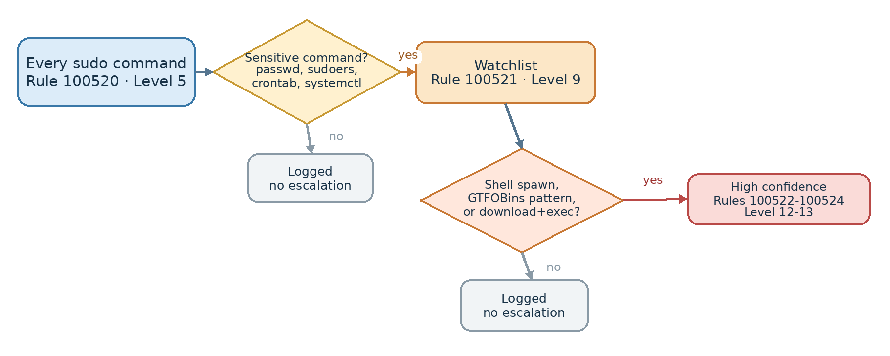
This design was validated with explicit negative tests (e.g. sudo crontab -l escalates only to Tier 2, never Tier 3; sudo whoami stays Tier 1) to prove the rules discriminate risk rather than flag all sudo usage equally.

7. Detection 010 — Cross-Platform Capability Gap
The most significant engineering finding in this lab: Windows (Sysmon) and Linux (auditd) do not offer equivalent network visibility.
Layer | Windows (Sysmon) | Linux (auditd)
Process | ✅ Image field | ✅ audit.exe field
Destination IP | ✅ clean DestinationIp field | ⚠️ raw hex in saddr, not parsed by this Wazuh version
Port | ✅ clean DestinationPort field | ⚠️ same limitation as above
Frequency/beaconing | ✅ keyed on image + destination IP | ⚠️ keyed on process only (destination unavailable)
DNS | ✅ Event ID 22, queryName field | ❌ not implemented (no equivalent built in this lab)
Inbound scan detection | ✅ via Sysmon Event 3 (reflects both directions) | ❌ auditd connect() only sees outbound; inbound scans require UFW log monitoring instead (built separately, Detection 006 Linux follow-up)
Root causes identified during testing:
- auditd's connect syscall audit fires for all socket families, including local Unix domain sockets (AF_UNIX) used by systemd, sudo, and wazuh-logcollector itself — requiring exclusion filtering (a2=0x10 restricting to sockaddr_in size) to avoid overwhelming noise.
- Even filtered, Wazuh's bundled auditd decoder does not expose a structured destination IP/port field from the raw SOCKADDR record — only full_log contains it, in hex.
- The predefined rule group audit_command only applies to events carrying an EXECVE block; a bare connect() syscall record has none, so rules conditioned on if_group: audit_command silently never matched — fixed by switching to <decoded_as>auditd</decoded_as>.
Practical resolution: Linux network detection (100610–100613) was scoped down to process-identity-based beaconing (same process, repeated connections, regardless of destination) rather than attempting destination-based correlation — a deliberate, documented trade-off rather than an unexplained gap.

8. Dashboards
Dashboard | Panels
SOC Overview | Total Events, Total Alerts, Critical/High/Medium Alerts (by rule.level), Active Agents
Authentication | Failed Logins, Successful Logins, Top Users, Top Source IPs, Authentication Timeline
Endpoint | Top Processes (Win/Linux), PowerShell Activity, New Processes Timeline, File Changes, DNS Queries, Network Connections (Win/Linux)
Threat Detection | Brute Force, Port Scanning, Privilege Escalation, Persistence, Suspicious PowerShell, Malware Indicators
All dashboards built from OpenSearch Metric, Data Table, and Vertical Bar visualizations against wazuh-alerts-* (and wazuh-archives-* for raw event volume), filtered by rule.id, rule.groups, rule.level, or rule.mitre.id as appropriate per panel.

9. Testing Methodology
Each detection was validated through a consistent process:
- Confirm collection — verify raw telemetry reaches archives.json before trusting any rule result.
- Confirm decoding — run a real captured event through wazuh-logtest to see exact field paths rather than assuming schema.
- Positive test — trigger the behavior the rule targets; confirm the expected rule ID fires.
- Negative test — trigger adjacent, benign behavior; confirm the rule does not fire, proving it discriminates rather than over-alerts.
- Live attack simulation — where applicable, reproduce the test using Kali (nmap, hydra) rather than only synthetic data, to validate against realistic adversary tooling.

10. Key Lessons
- Silent drops are common and easy to misdiagnose. Firewalls dropping SYN packets, nc without -k accepting only one connection, and Test-NetConnection sometimes not generating a true Sysmon network event all produced "no alert" results that looked like rule failures but were actually upstream data gaps.
- Frequency/correlation rules require if_matched_sid, not if_sid, and timeframe is a rule attribute, not a child element — both caused early rule-load failures.
- Wazuh's internal rule groups (e.g. sysmon_event1, audit_command) do not always propagate into an alert's own rule.groups array, so dashboard filters must target fields that are actually present on the alert document (e.g. data.win.system.eventID, decoded_as), not internal matching-only group names.
- Platform parity is not guaranteed. A detection that is clean and reliable on Windows (via Sysmon's structured fields) may require a materially different, less precise approach on Linux (via auditd's raw syscall records) — this asymmetry is itself a legitimate and important finding to document, not a defect to hide.

