INCIDENT RESPONSE REPORT
IR-001 — SSH Brute Force Investigation
Wazuh • Ubuntu Linux • SSH Authentication

Incident ID | IR-001
Status | Investigating
Severity | High (provisional)
Affected asset | ubuntu_vm2 / 192.168.34.143
Source IP | 192.168.34.138
Date | 17 October 2026
Analyst | Vipin Kumar

1. Executive Summary
Wazuh detected repeated SSH password failures against Ubuntu endpoint ubuntu_vm2 (192.168.34.143) from source 192.168.34.138. Custom rule 100200 generated a Level 10 alert. Endpoint logs also show a successful password-based SSH login for account vm2 from the same source at 12:11:35.546 (UTC+05:30), followed by a sudo session at 12:12:09.
The sequence is suspicious and requires validation. The evidence does not establish whether the source was authorized or whether the account was compromised. Verdict: Suspicious activity — investigation required.

2. Incident Details
Field | Value
Incident ID | IR-001
Incident type | SSH authentication attack investigation
Severity | High (provisional; validate authorization)
Status | Investigating
Detection platform | Wazuh
Wazuh manager | vm1
Affected asset | ubuntu_vm2 — 192.168.34.143
Source IP | 192.168.34.138
Target account | vm2
Log source | /var/log/auth.log
Custom detection | Rule 100200 (Level 10)
Related rule | 100201 (successful login after brute-force alert; validation incomplete)
Investigation date | 17 October 2026 (UTC+05:30)
Analyst | Vipin Kumar

3. Detection Summary
Rule 100200 is configured to correlate SSH authentication failures from the same source: frequency 5, timeframe 180 seconds, ignore 180 seconds, parent rule 5760, and same-source-IP correlation. Wazuh shows five visible failed-password records in the alert context and the alert was generated at Level 10.
The configuration and correlation behavior should still be tested with wazuh-logtest and controlled events. The existence of an alert alone does not validate every threshold or suppression condition.

4. Key Evidence
Time (UTC+05:30) | Observed event
11:56:00.762 | Failed SSH password for vm2 from 192.168.34.138
11:56:02.964 | Failed SSH password for vm2 from 192.168.34.138
11:56:07.020 | Failed SSH password for vm2 from 192.168.34.138
11:56:08.662 | Failed SSH password for vm2 from 192.168.34.138
11:56:10.848 | Failed SSH password; associated with Wazuh rule 100200
12:10:51–12:11:07 | Further failed SSH password attempts from 192.168.34.138
12:11:35.546 | Successful password-based SSH login for vm2 from 192.168.34.138, port 33084
12:11:35.552 | SSH session opened for vm2
12:12:09.442 | Sudo session opened by vm2 to run tail -n 50 /var/log/auth.log

The source IP, target account, and activity are observed facts. They are not independently confirmed malicious indicators.

5. Findings

Finding 1 — Repeated SSH authentication failures
Multiple failed password events were recorded during two periods: approximately 11:55:58–11:56:15 and 12:10:51–12:11:08. The source was 192.168.34.138 and the target account was vm2. Confidence that repeated failures occurred: high; intent remains unconfirmed.

Finding 2 — Wazuh alert generated
Wazuh generated custom rule 100200, Level 10, with description “Multiple SSH authentication failures from same source - possible brute force.”

Finding 3 — Successful login after failures
The endpoint logged “Accepted password for vm2 from 192.168.34.138 port 33084 ssh2” at 12:11:35.546. Authentication success is confirmed; authorization and compromise are not.

Finding 4 — Sudo activity after login
At 12:12:09, a sudo session was opened by vm2 to run /usr/bin/tail -n 50 /var/log/auth.log. This can be legitimate troubleshooting or investigation; context is required.

6. MITRE ATT&CK
Technique | Assessment
T1110 — Brute Force (Credential Access) | Repeated password failures are consistent with brute-force behavior; automated or malicious intent is not proven.
T1078 — Valid Accounts | Successful authentication occurred, but unauthorized use of valid credentials is not established. Treat as a hypothesis until validated.

7. Impact Assessment
Confirmed: repeated SSH authentication failures, one Wazuh Level 10 alert, a successful SSH login, and a subsequent sudo session.
Not established: unauthorized access, account compromise, persistence, lateral movement, data exfiltration, or malicious commands. No malicious file hash, domain, or malware artifact was identified in the supplied evidence.

8. Analyst Verdict
SUSPICIOUS ACTIVITY — INVESTIGATION REQUIRED.
The successful login after repeated failures increases concern, but the available evidence cannot distinguish an authorized lab test or administrative action from unauthorized access. Keep the case open until the source machine and login are confirmed.

9. Recommended Response
- Confirm whether 192.168.34.138 is the authorized lab/Kali or administrator machine and whether the successful login was expected.
- Preserve SSH/authentication logs, sudo records, and relevant Wazuh alerts.
- Review commands, processes, sessions, account changes, SSH keys, cron jobs, services, and subsequent logins around and after 12:11:35.
- If the login is unauthorized or cannot be explained, restrict source access, terminate suspicious sessions where appropriate, reset credentials from a trusted session, and check for persistence.
- Do not block the source or declare compromise solely because this alert fired; document the authorization check and response actions.

10. Detection Validation & Improvements
- Run wazuh-logtest against representative failed SSH events and verify rule 100200 matching and source-IP correlation.
- Test the five-event/180-second threshold and 180-second suppression behavior using controlled lab events.
- Test rule 100201 with a successful login following a qualifying alert within its configured five-minute window. The supplied screenshots show three rule 100201 alerts in the selected time range, but the matching event details and correlation should be validated before treating this as proven causal correlation.
- Correlate events by source IP, username, host, and event time; distinguish endpoint event timestamps from Wazuh indexed timestamps.
- Add source asset identity and expected-login context to triage notes where possible.

11. Conclusion
The supplied evidence confirms repeated SSH authentication failures against ubuntu_vm2 from 192.168.34.138, a Wazuh Level 10 alert under rule 100200, a subsequent successful password-based SSH login for vm2, and a sudo session shortly afterward. This is suspicious and merits follow-up, but compromise is not confirmed. Close the incident only after validating whether the login was authorized and reviewing post-login activity.

12. Evidence Index
Evidence ID | Filename | Description
E01 | E01-wazuh-alert.png | Wazuh alert results for rule 100200
E02 | E02-alert-details.png | Wazuh document details including source/target metadata
E03 | E03-alert-search-results.png | Search results showing five rule 100200 alerts
E04 | E04-successful-login-correlation.png | Search results for rule 100201 showing three alerts
E05 | E05-custom-detection-rule.png | Screenshot of custom rule configuration
E06 | E06-wazuh-dashboard.png | Wazuh dashboard view filtered to rule 100200

Evidence note: these are the screenshots supplied for this report. The supplied set does not include a standalone full terminal capture of all authentication and sudo log lines or a wazuh-logtest validation transcript. Add those only after capturing the actual output.

Appendix A — Screenshot Evidence
Screenshots are included in the evidence/ folder. Each image is presented as supplied; captions describe what is visible and do not imply uncollected evidence.

E01-wazuh-alert-dashboard.png
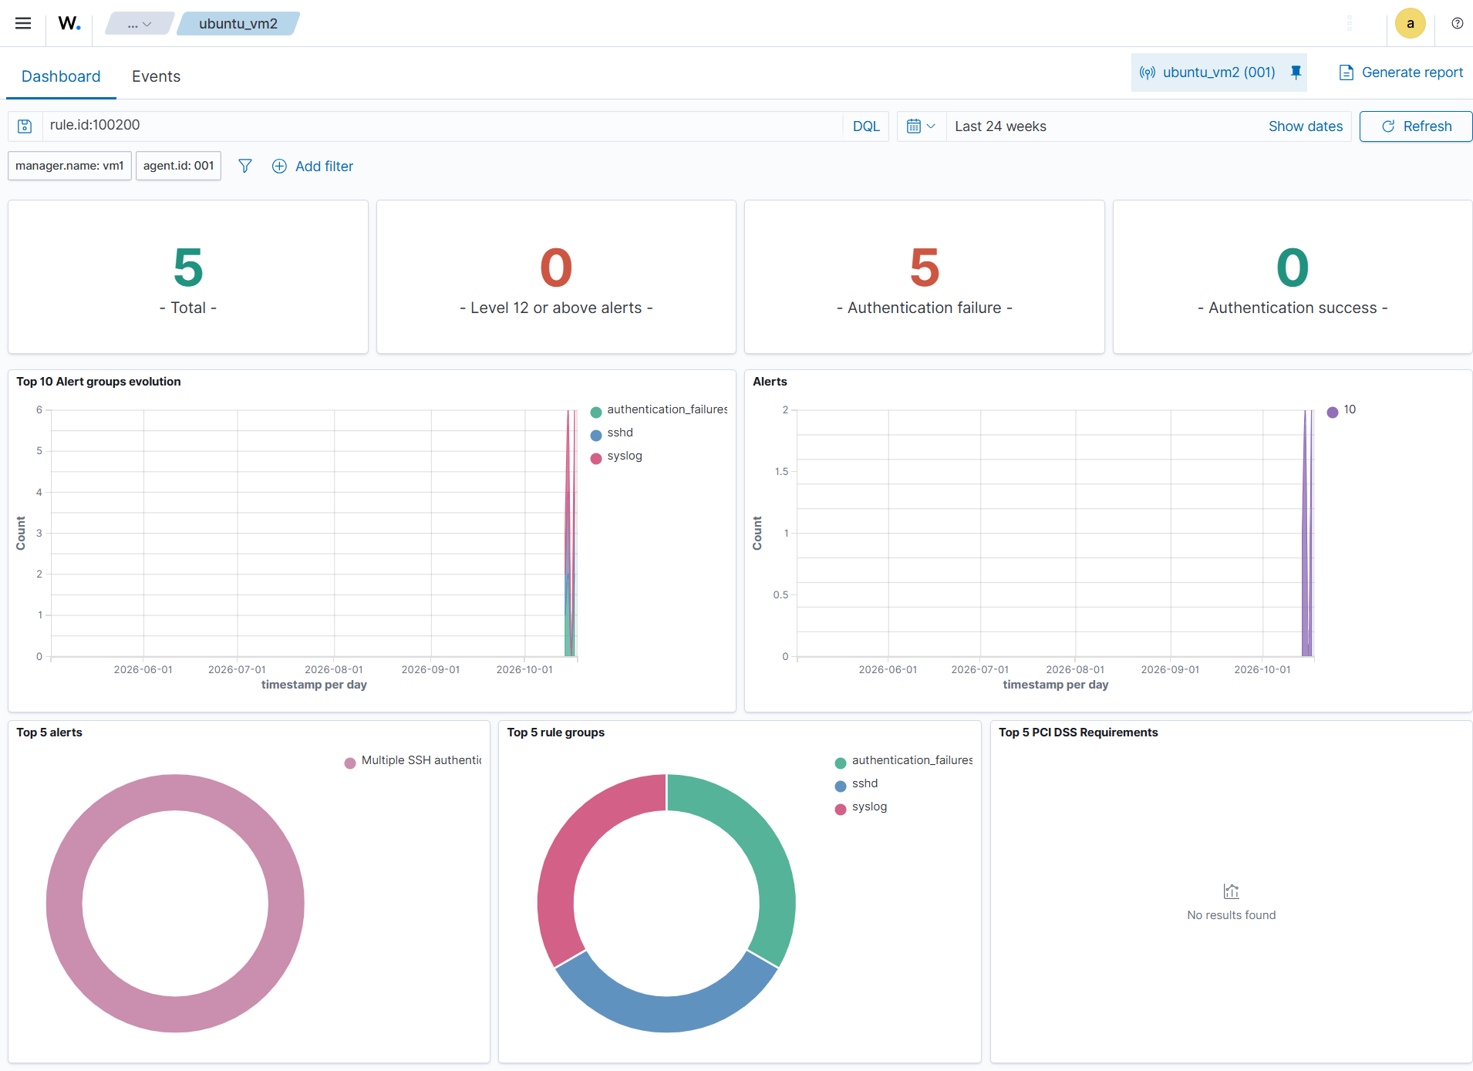

E02-alert-details.png
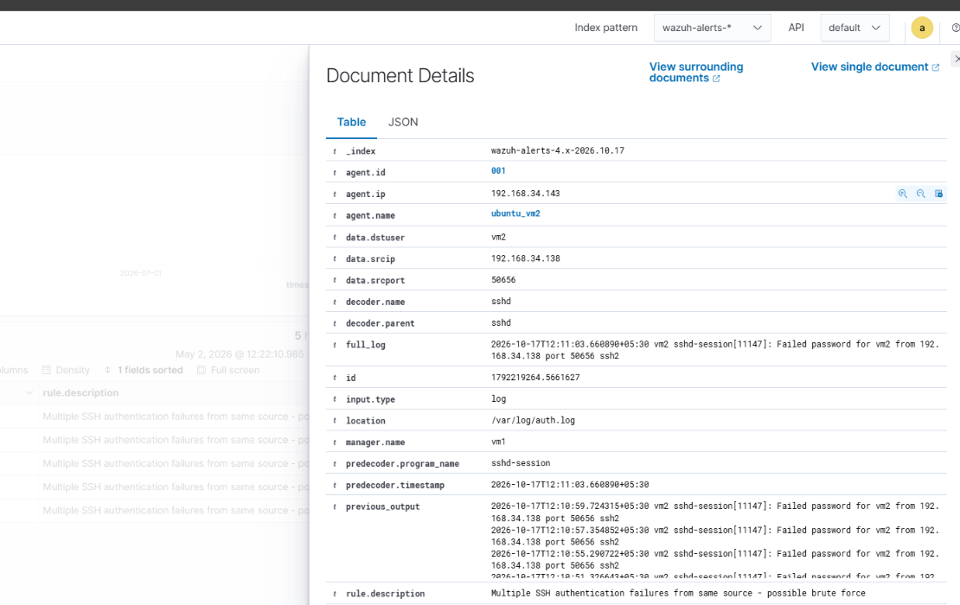

E03-alert-search-results.png
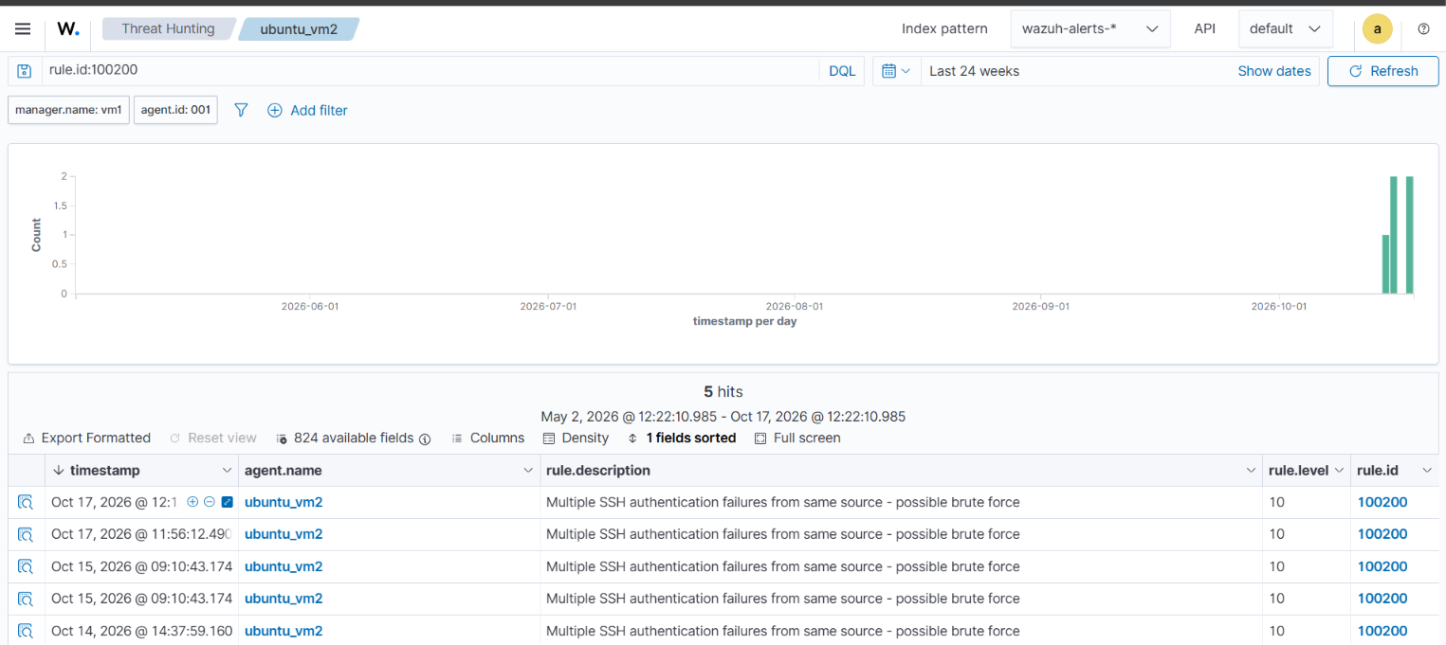

E04-successful-login-correlation.png
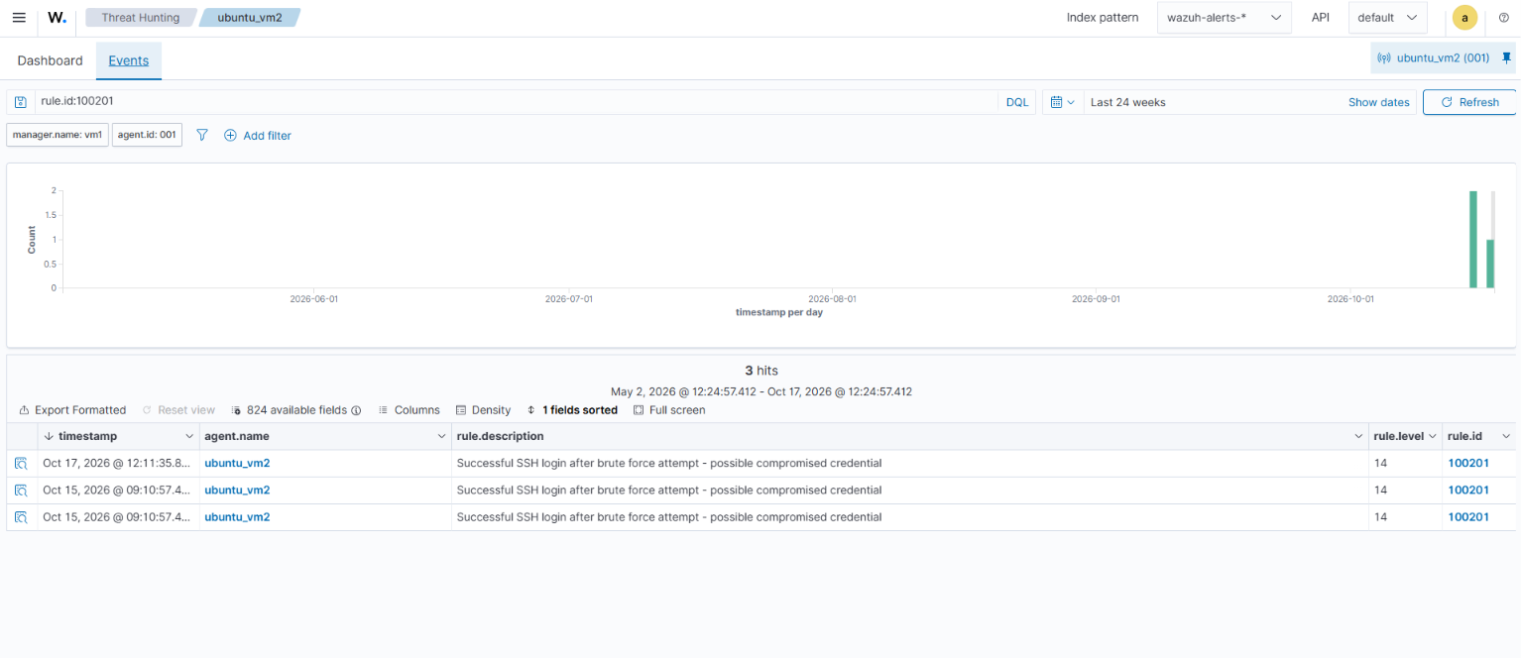

E05-custom-detection-rule.png
