CROSS-PLATFORM SOC DETECTION REPORT

Detection 007 — Persistence Monitoring
Wazuh • Linux Cron • Windows Scheduled Tasks
Status | Detection validated; review required
Verdict | Malicious persistence not confirmed
Linux endpoint | ubuntu_vm2 / 192.168.34.143
Windows endpoint | window10 / 192.168.34.148
Wazuh rules | 100530 / 100531 / 100532 / 100533
Dashboard result | 13 hits; 2 Level 12+
Date | 17 October 2026
Analyst | Vipin Kumar

1. Executive Summary
Wazuh query rule.id:(100530 OR 100531 OR 100532 OR 100533) returned 13 alert hits in the selected last-week range, including two alerts at Level 12 or above. Linux FIM detected cron-related file changes; Windows Security Event ID 4698 alerts recorded scheduled-task creation. Rule 100533 matched a task that launches PowerShell with the test command Write-Host persistence_test on a repeating one-minute trigger. This is consistent with lab validation. Malicious persistence or compromise is not confirmed.

2. Environment
Wazuh manager: vm1
Linux endpoint: ubuntu_vm2, agent 001, 192.168.34.143
Windows endpoint: window10, agent 002, 192.168.34.148
Linux telemetry: Wazuh FIM/syscheck
Windows telemetry: Security Event ID 4698
Date: 17 October 2026

3. Detection Rules
100530 — Linux cron-related file added/modified/deleted, Level 10, MITRE T1053.003.
100531 — Included in dashboard search, but no specific alert detail supplied.
100532 — Windows scheduled task created, Level 10, MITRE T1053.005.
100533 — Scheduled task runs a scripting engine with command visible, Level 12, MITRE T1053.005 and T1059.
Custom rule XML was not supplied, so only observed alert behavior is documented.

4. Linux Cron Finding
Wazuh FIM detected /etc/cron.d/test_persist added at about 14:50:20.836, /etc/cron.d/test_persist1 added at about 14:52:14.167 and modified at about 14:53:46.524. The latter file increased from 74 to 143 bytes and its SHA-256 changed from 2da5023deafd4da57132d2d8c52332b0063e4eb658f837b84e0d92be126a99df to 0912ef515f64685158cba92fbd028a9942928dfab90e587ef1bae1b5af76d1b2. The actual cron command text was not provided.

5. Linux Crontab Spool Activity
Around 14:53:56, FIM recorded a temporary file /var/spool/cron/crontabs/tmp.96btvJ added and deleted, and /var/spool/cron/crontabs/vm2 added. These events may arise during a crontab update workflow, but the job contents and originating action should be confirmed.

6. Windows Scheduled Task — OneDrive-named Task
Rule 100532, Level 10, recorded creation of a task named OneDrive Standalone Update Task-S-1-5-21-...-1001 by vipin. Windows Security Event ID 4698, event record 45525, has event time 07:34:34.094 UTC (13:04:34.094 UTC+05:30). The task action points to %localappdata%\Microsoft\OneDrive\OneDriveStandaloneUpdater.exe and is configured with a daily trigger and least privilege. Validate the executable path and signature; the name alone does not prove legitimacy or maliciousness.

7. Windows Scheduled Task — TestPersist1
Rule 100533, Level 12, fired for task \TestPersist1. Event ID 4698, record 46761, occurred at 09:29:05.198 UTC (14:59:05.198 UTC+05:30). The task is enabled, configured with a one-minute repeating trigger, and executes powershell.exe with arguments -command Write-Host persistence_test. The principal is DESKTOP-0P32A1N\vipin with RunLevel LeastPrivilege. This is clear test-like content and demonstrates the intended detection.

8. Windows Scheduled Task — TestPersist2
The dashboard shows rule 100532, Level 10, for task \TestPersist2 created by vipin at about 14:59:15 local time. The supplied summary confirms task creation, but the complete action content is not available here, so its behavior should not be inferred.

9. Dashboard Summary
Search: rule.id:(100530 OR 100531 OR 100532 OR 100533). Selected range: last week, 10–17 October 2026. Displayed total: 13 hits; alerts at Level 12 or above: 2. Visible categories include Cron, Scheduled Task, and Command and Scripting Interpreter. Counts refer to alert documents and may include related events.

10. MITRE ATT&CK
T1053.003 — Scheduled Task/Job: Cron.
T1053.005 — Scheduled Task/Job: Scheduled Task.
T1059 — Command and Scripting Interpreter.
These mappings describe behavior categories, not proof of malicious intent.

11. Findings and Verdict
Confirmed: Linux cron-related files changed and Wazuh FIM generated alerts; Windows Security Event ID 4698 recorded task creation; TestPersist1 contains a PowerShell test command. Not confirmed: successful execution of cron jobs/tasks, malicious intent, or system compromise. Verdict: persistence detections validated; lab test behavior observed; malicious persistence not confirmed.

12. Recommended Response
1. Confirm the cron files and test tasks were intentionally created.
2. Preserve and inspect full cron file contents and the user crontab.
3. Validate the OneDrive updater binary path, signer, and software baseline.
4. Correlate task creation with PowerShell/process events and task execution history.
5. Review permissions, trigger intervals, run-as identities, and task actions.
6. Validate rule 100531 with its XML or a sample alert.
7. Remove test artifacts only after preserving evidence and confirming they are no longer needed.

13. Limitations and Conclusion
The custom rule XML and actual cron contents were not supplied. Event ID 4698 confirms task creation, not successful execution. The task TestPersist1's content is test-oriented, and the OneDrive-named task requires endpoint-baseline validation. The data supports a cross-platform persistence detection lab, not a confirmed intrusion.

Appendix A — Evidence Screenshots

E01-persistence-alert-results.png
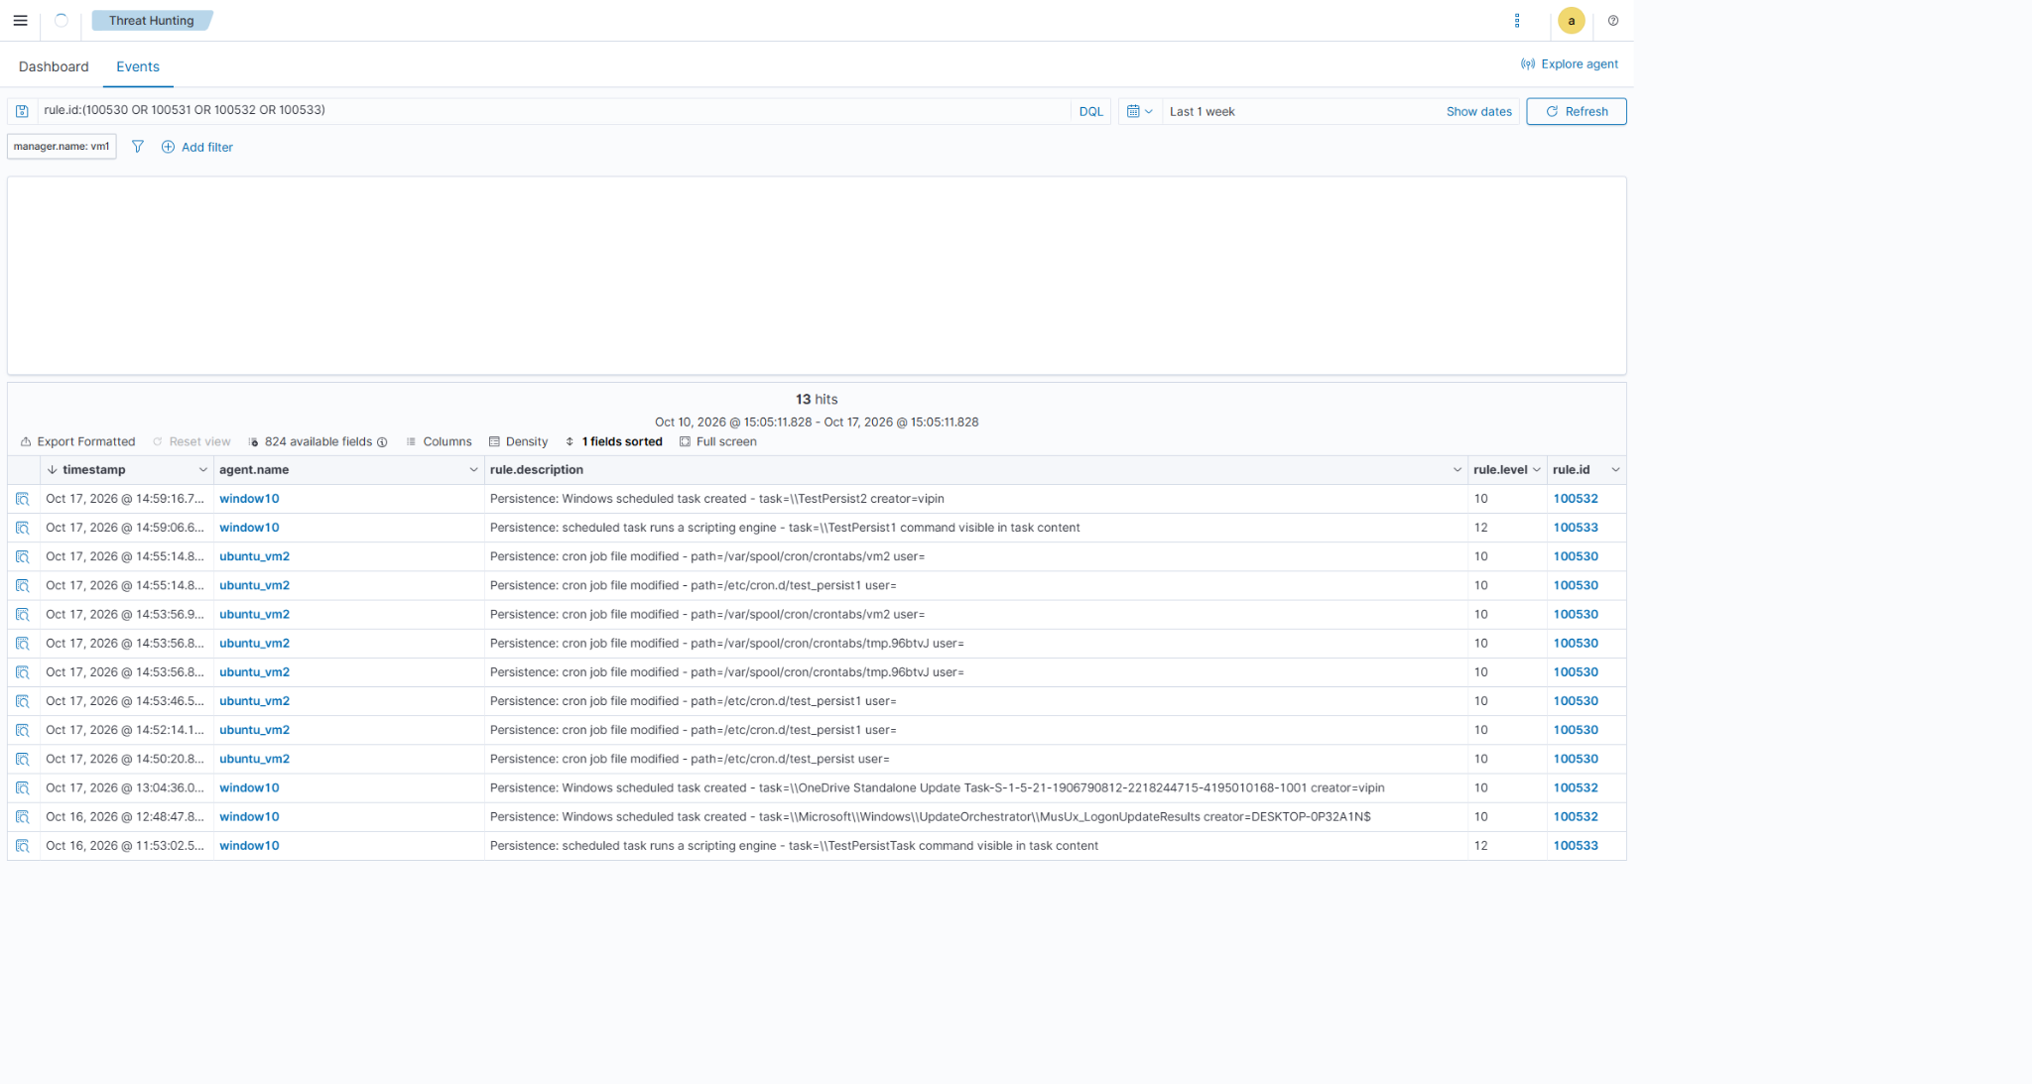

E02-persistence-dashboard.png
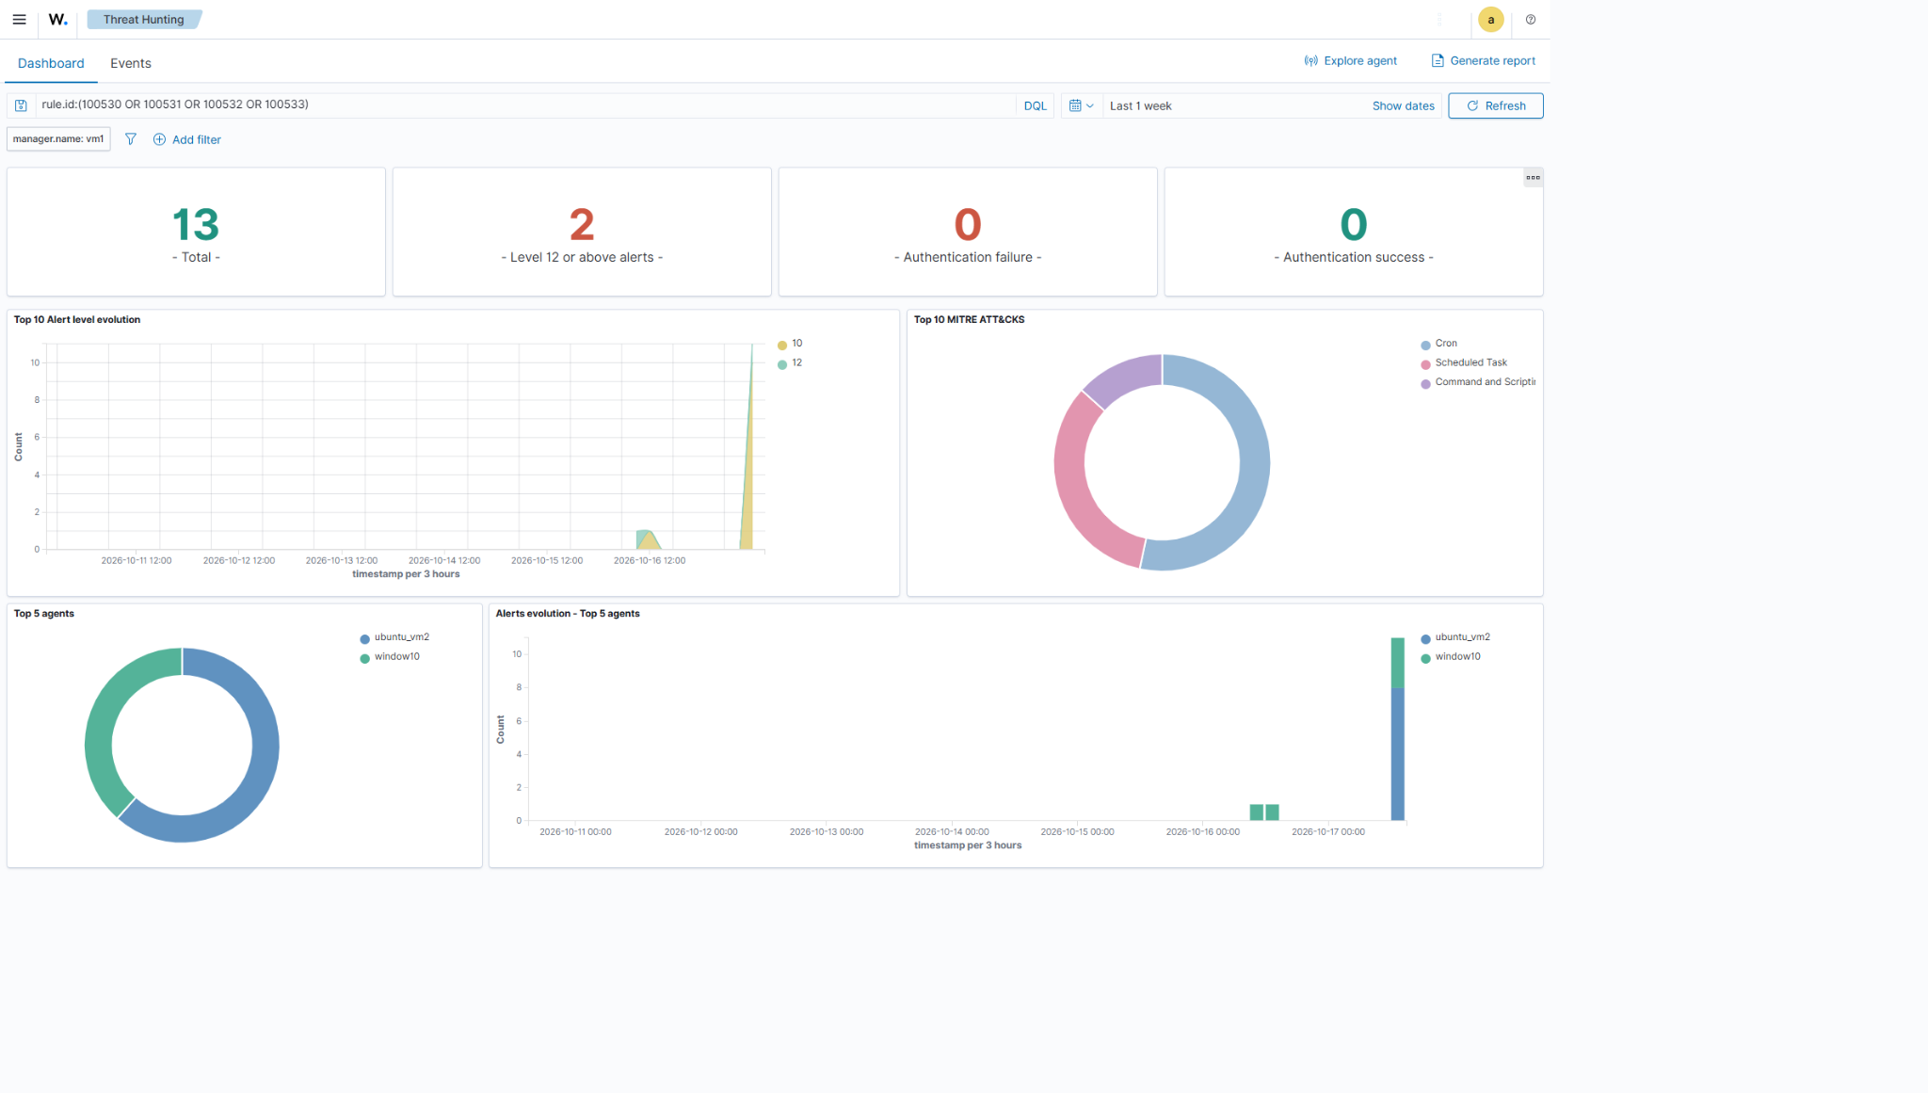

E03-linux-cron-file-alert-details.png
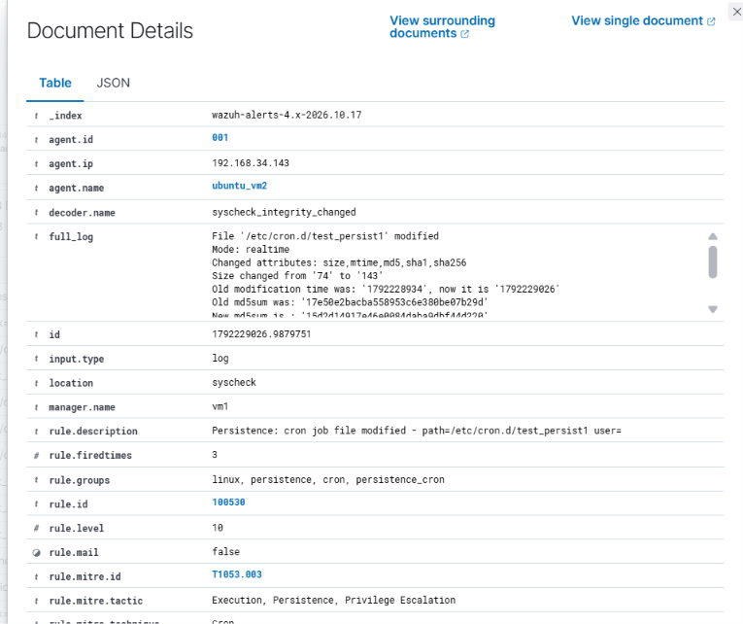

E04-windows-scheduled-task-alert-details.png
