WINDOWS SOC THREAT-HUNTING REPORT

Detection 008 — DNS & Network Connection Hunting
Wazuh • Sysmon • DNS telemetry • Network events
Status | Detection validated; contextual review required
Verdict | Suspicious DNS indicators; C2 not confirmed
Endpoint | window10 / agent 002
IPs shown | 192.168.34.148 and 192.168.34.152
Rules | 100400, 100600, 100604 plus query IDs
Dashboard result | 395 hits; 0 Level 12+
Investigation date | 17 October 2026
Analyst | Vipin Kumar

1. Executive Summary
The Wazuh dashboard query for DNS and network telemetry displayed 395 alert hits in the selected last-week range, with zero alerts at Level 12 or above. Two custom Level 10 alerts from rule 100604 flagged DNS queries to suspicious-test-domain.xyz and another-test.top. The samples associate both queries with powershell.exe (PID 1696) running as DESKTOP-0P32A1N\vipin. Detection is confirmed; command-and-control activity or compromise is not.

2. Environment
Wazuh manager: vm1
Endpoint: window10, agent 002
IP addresses shown: 192.168.34.148 and 192.168.34.152
Telemetry: Microsoft-Windows-Sysmon/Operational, Event ID 22 (DNS query) and network events
Date: 17 October 2026

3. Detection Rules
100400 — Sysmon network connection event, Level 3.
100600 — Sysmon DNS query event, Level 3.
100604 — DNS query to a low-reputation TLD commonly used for C2, Level 10, MITRE T1568.
100601–100603, 100605, 100610–100613 — included in the search, but no rule descriptions/sample alerts were supplied for independent documentation.

4. Finding A — suspicious-test-domain.xyz
Rule 100604, Level 10, ATT&CK T1568. Indexed timestamp: 12:45:31.312 UTC (18:15:31.312 UTC+05:30). Agent IP: 192.168.34.152. Process: C:\Windows\System32\WindowsPowerShell\v1.0\powershell.exe, PID 1696, user DESKTOP-0P32A1N\vipin. Sysmon embedded time: 08:40:40.186; queryStatus 9003; query results show ns0.centralnic.net. The alert proves a DNS query and rule match, not a C2 session.

5. Finding B — another-test.top
Rule 100604, Level 10, ATT&CK T1568. Indexed timestamp: 12:45:31.354 UTC (18:15:31.354 UTC+05:30). Agent IP: 192.168.34.152. Process: powershell.exe, PID 1696, user vipin. Sysmon embedded time: 08:40:40.321; queryStatus 9003; query results show a.zdnscloud.com. Correlate process command line and network events before judging maliciousness.

6. Baseline DNS & Network Activity
Other records show DNS queries for my.microsoftpersonalcontent.com, api.onedrive.com, onedriveclucproddm20048.blob.core.windows.net, microsoft.com, example.com, wpad, localdomain, and DESKTOP-0P32A1N. OneDrive.exe generated Microsoft/OneDrive domain lookups; Copilot and Edge generated wpad queries; Windows services queried local names. These entries demonstrate telemetry coverage and are not inherently malicious.

7. Dashboard Summary
Query includes 100600–100605, 100610–100613, and 100400. The selected last-week range showed 395 hits and zero Level 12+ alerts. Most visible records are Level 3 DNS/network telemetry; the two custom suspicious-domain alerts are Level 10. Counts are alert documents, not unique incidents.

8. Timeline
Approx. 14:56–14:57 local: DNS/network telemetry for OneDrive/Microsoft and local names. 18:15:31.312 local indexed time: suspicious-test-domain.xyz queried by PowerShell. 18:15:31.354 local indexed time: another-test.top queried by PowerShell. 18:16:44.727 local indexed time: example.com query by PowerShell. 18:17:39 local indexed time: microsoft.com DNS event. NOTE: embedded Sysmon UtcTime fields differ from systemTime/Wazuh timestamp; verify clock and parsing before treating this as definitive chronology.

9. MITRE ATT&CK
Rule 100604 maps to T1568 — Dynamic Resolution. This classification indicates a behavior category for investigation; it does not establish C2.

10. Analyst Verdict
DNS/network monitoring detection validated; possible suspicious DNS activity requires contextual review; C2 not confirmed. Rule 100604 fired on two selected test-domain lookups from PowerShell. The supplied logs do not establish a successful connection to either domain, payload delivery, or compromise.

11. Recommended Investigation
1. Confirm these two lookups were intentional lab tests.
2. Retrieve Sysmon Event ID 1 for process PID 1696, including command line and parent process.
3. Correlate with Sysmon Event ID 3 network-connection events and firewall/proxy logs.
4. Check raw DNS records and query status; do not assume a successful resolution.
5. Validate domains against trusted threat-intelligence sources.
6. Resolve endpoint IP difference (.148 vs .152).
7. Reconcile Sysmon UtcTime, systemTime, and Wazuh timestamp fields.
8. Review rule 100604 XML and obtain definitions/examples for query IDs without details.

12. Limitations and Conclusion
Custom rule XML was not supplied; details for IDs 100601–100603, 100605, 100610–100613 were not demonstrated. DNS queries alone do not prove network sessions. IP and timestamp inconsistencies need validation. The lab proves DNS/network event collection and custom detection behavior, not confirmed command and control.

Appendix A — Evidence Screenshots

E01-network-dns-dashboard.png
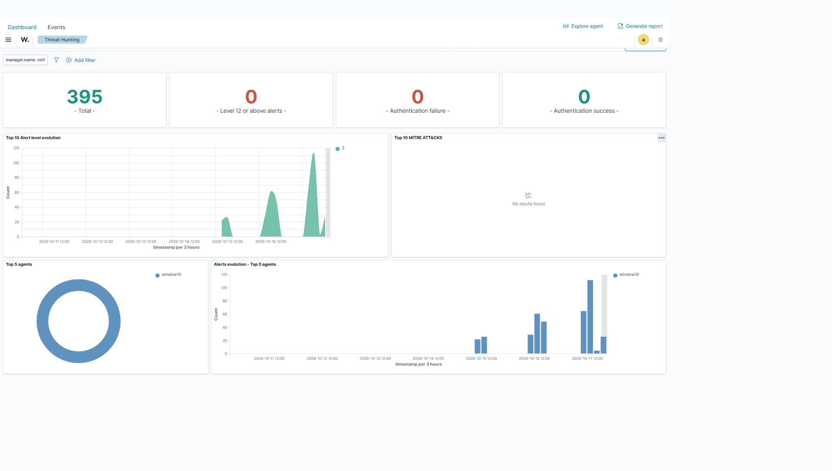

E02-network-dns-alert-results.png
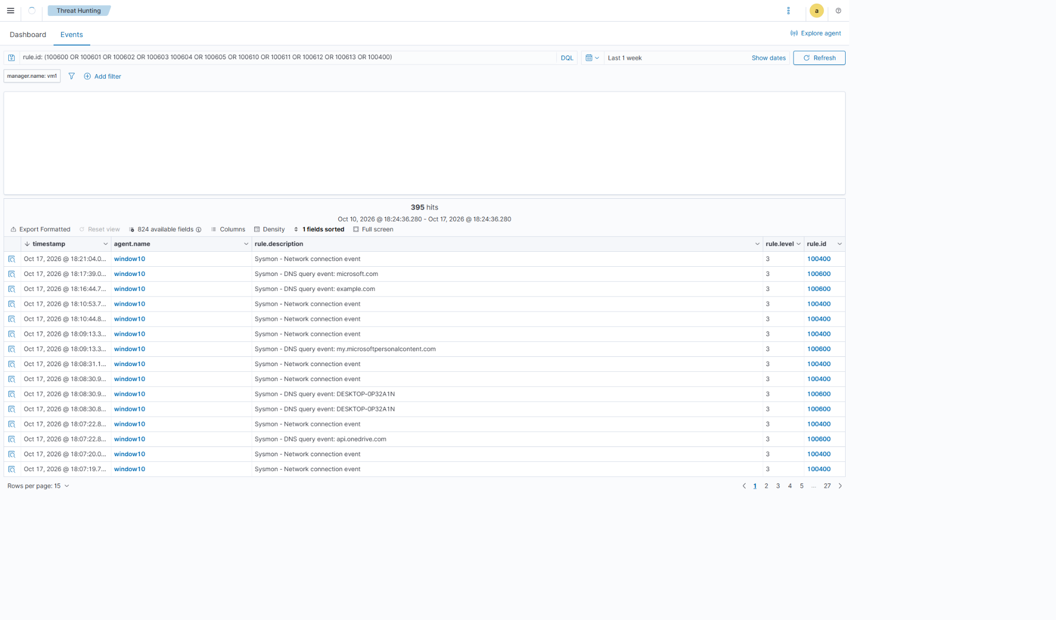

E03-example-com-dns-event-details.png
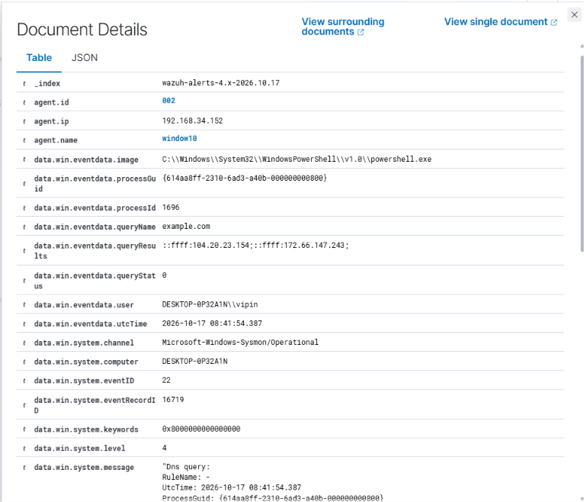

E04-system-dns-event-details.png
