INCIDENT INVESTIGATION REPORT
SSH Brute-Force
Detection & Review
Splunk Enterprise analysis of SSH authentication events
ASSESSMENT STATUS
Suspicious authentication patterns were identified in the lab dataset. The available evidence is not sufficient to confirm a successful compromise or attribute malicious intent to any source IP.

DATASET  ssh_logs_new.json | EVENTS REVIEWED  1,200
SPLUNK INDEX  ssh | HOST VALUE  ssh_vipin
SOURCE TYPE  _json | ACTIVITY DATE  24 April 2025
Prepared for: SOC Analyst Portfolio
Report date: 30 October 2026 | Environment: Windows workstation, Splunk Enterprise

1. Executive summary
I reviewed the 1,200 SSH event records in ssh_logs_new.json after they were uploaded into the Splunk index named ssh. The searches show a broad spread of failed authentication activity across 50 source IPs and 12 destination servers. Once the auth_attempts field is summed, the 608 failed-authentication records represent 2,102 failed attempts.
The clearest individual source / destination / account pattern is 164.89.50.183 targeting 123.158.160.191 as svc_ssh, with 33 failed attempts across five event records. The same searches returned seven successful-login events that had at least ten earlier failed attempts for the same source, target and username in the sorted dataset. These are useful investigation leads, not proof that an attacker gained access.
1,200  events reviewed | 2,102  failed attempts
59  source/target/account groups ≥10 | 7  success-after-failure matches

What the review establishes
- The uploaded file contains 1,200 separate JSON events. Splunk extracted fields such as ts, event_type, auth_success, auth_attempts, username and the dotted IP fields.
- All records use TCP with destination port 22, matching the SSH activity being reviewed.
- There are 608 failed-authentication records: 305 single-failure records and 303 multiple-failure records.
- The 10-attempt threshold flags 59 unique source IP / destination IP / username combinations. Three of those combinations have 20 or more failed attempts.
- The supplied sequence search returned seven successful-login events after at least ten accumulated failures for the same source, destination and account.
IMPORTANT LIMITATION
The event timestamps run from 10:20:09.508780 UTC to 10:20:09.522008 UTC on 24 April 2025 — a span of 13.228 milliseconds. This file cannot validate a five-minute brute-force rate or show how the activity unfolded over a normal operational period.

2. Scope and data handling
This is a review of the uploaded lab dataset and the Splunk searches shown in the supplied screenshots. It is not a review of a live production host, and no endpoint containment or blocking action was performed as part of this analysis.
Item | Observed configuration / value
Input file | ssh_logs_new.json (JSON Lines: one JSON object per line)
Splunk platform | Splunk Enterprise running on Windows
Index used in searches | ssh
Host value shown in upload settings | ssh_vipin
Source type shown in preview | _json
Time picker used in searches | All time
Event time range (UTC) | 2025-04-24 10:20:09.508780 to 10:20:09.522008
Timestamp span | 13.228 milliseconds

Authentication event mix
Event type | Records | How it was treated
Successful SSH Login | 306 | Successful-login events; reviewed separately from failure totals.
Failed SSH Login | 305 | Counted as failed authentication attempts using auth_attempts.
Multiple Failed Authentication Attempts | 303 | Counted using the value in auth_attempts, not one per record.
Connection Without Authentication | 286 | Kept out of failed-login totals because auth_attempts is zero and auth_success is null.
TOTAL | 1,200 | All events in the uploaded file.

The distinction between records and attempts matters here. The 303 “Multiple Failed Authentication Attempts” records add up to 1,797 failed attempts. Counting event rows alone would materially understate the activity. The failed-attempt total in this report is calculated from the two failure event types only.

3. Where the failures were coming from
The source ranking below is based on the sum of auth_attempts across failed-authentication events. An IP at the top of this list generated more failed attempts in the sample; that fact alone does not establish that the address is malicious.
Source IP | Failed attempts | Failure records | Servers targeted
25.47.52.197 | 88 | 19 | 10
83.195.24.226 | 87 | 22 | 12
191.47.156.160 | 72 | 14 | 8
110.177.195.150 | 68 | 20 | 9
52.173.49.103 | 67 | 20 | 10
168.154.125.86 | 63 | 17 | 8
170.86.212.161 | 63 | 13 | 9
110.16.7.177 | 61 | 16 | 9
74.165.131.224 | 60 | 19 | 9
173.53.0.82 | 56 | 14 | 9

Most targeted SSH servers
Destination server | Failed attempts | Unique source IPs
170.170.25.84 | 218 | 33
164.254.24.82 | 210 | 33
200.6.78.129 | 198 | 35
91.14.145.242 | 198 | 29
123.158.160.191 | 193 | 31
204.226.108.67 | 176 | 32
187.104.79.154 | 172 | 34
133.183.125.94 | 164 | 28
164.186.59.85 | 151 | 30
173.96.169.78 | 145 | 31
84.85.166.230 | 139 | 33
80.101.200.117 | 138 | 31

The highest-volume destination is 170.170.25.84, with 218 failed attempts from 33 distinct source IPs. The next is 164.254.24.82, with 210 attempts from 33 sources. The distribution across all 12 destinations suggests broad scanning or distributed login activity in the sample, but the dataset does not provide enough context to determine the intent.

4. Accounts receiving the most failures
Username | Failed attempts | Failure records
admin | 191 | 51
alice | 168 | 46
sysadmin | 155 | 38
backup | 154 | 47
svc_ssh | 144 | 34
test | 136 | 41
john.doe | 136 | 40
root | 135 | 44
service | 135 | 39
support | 129 | 34
webmaster | 117 | 37
ubuntu | 114 | 34
svc_user | 107 | 35
oracle | 106 | 30
dbadmin | 99 | 33
deploy | 76 | 25

The admin account is the most frequently targeted in this dataset (191 failed attempts), followed by alice (168) and sysadmin (155). Repeated guesses against privileged or service accounts deserve attention, but the account names alone do not tell us whether the accounts exist on the destination systems.

5. Incident candidates from the Splunk detection search
The supplied SPL groups failures by source IP, destination IP and username, then returns combinations with at least 10 failed attempts. The query returned 59 combinations: three were labelled High (20 or more attempts) and 56 Medium (10–19 attempts). Those labels are the thresholds used in this lab search, not an externally validated severity rating.
Ref. | Source IP | Target IP | Username | Attempts | Records | Triage
IR-01 | 164.89.50.183 | 123.158.160.191 | svc_ssh | 33 | 5 | High
IR-02 | 74.165.131.224 | 91.14.145.242 | webmaster | 21 | 5 | High
IR-03 | 191.33.181.155 | 170.170.25.84 | dbadmin | 20 | 4 | High

Initial analyst notes
- IR-01: 164.89.50.183 → 123.158.160.191, account svc_ssh. This is the largest individual combination: 33 failed attempts over five failure records. Check whether svc_ssh is an expected service account and review the destination host authentication log.
- IR-02: 74.165.131.224 → 91.14.145.242, account webmaster. The combination totals 21 failed attempts over five records. Confirm whether the account and source are expected for this server.
- IR-03: 191.33.181.155 → 170.170.25.84, account dbadmin. The combination totals 20 failed attempts over four records. Review alongside any successful authentication and subsequent database or shell activity.

6. Failed attempts followed by successful logins
The sequence search in the screenshots sorts events by ts and accumulates failed attempts for each source / destination / username combination. It returned seven successful-login events where the accumulated failure count had reached at least 10. Two of the seven events belong to the same source / destination / account combination, so there are six distinct combinations to review.
UTC time | Source IP | Target IP | Username | Prior failed attempts
10:20:09.518132 | 113.173.136.4 | 173.96.169.78 | dbadmin | 11
10:20:09.518521 | 113.173.136.4 | 173.96.169.78 | dbadmin | 11
10:20:09.518853 | 173.53.0.82 | 164.254.24.82 | root | 15
10:20:09.519658 | 31.184.137.182 | 91.14.145.242 | admin | 10
10:20:09.519877 | 168.154.125.86 | 187.104.79.154 | sysadmin | 12
10:20:09.521067 | 125.123.103.182 | 187.104.79.154 | backup | 10
10:20:09.521550 | 135.55.210.223 | 84.85.166.230 | support | 12

HOW TO READ THIS RESULT
These are correlation leads from the supplied search. They show successful-login records after earlier failed-attempt records for the same tuple in the sorted file. They do not prove that the successful login was unauthorized, that the same actor controlled both events, or that a five-minute attack window was met.

Recommended follow-up
- For the six combinations, confirm whether the usernames are valid and whether the source IPs are expected to authenticate to the target servers.
- On the target systems, review sshd / authentication logs for the exact account, source address, accepted-login time and authentication method.
- For any accepted login that cannot be explained, check the account’s subsequent shell activity, process execution, privilege changes and outbound connections.
- Ask the system owner whether the service accounts (for example svc_ssh) have approved automation or scheduled jobs that could explain repeated authentication.
- Preserve the original events and search results before making any containment decision. Do not block an address based only on this dataset.

7. Assessment, limitations and next steps

Assessment
The dataset contains multiple repeated-failure patterns that are consistent with brute-force-style SSH activity. The strongest individual pattern is the 33-attempt svc_ssh combination described in IR-01. The sequence search also surfaced seven successful-login events after at least ten accumulated failures. These findings justify a closer review of the relevant target hosts and accounts, but the available file does not establish a confirmed compromise.

Evidence limitations
- The full event-time span is only 13.228 milliseconds. A five-minute rate-based detection cannot be validated from this sample.
- The source data contains event summaries and connection metadata, not the full operating-system authentication log, source geolocation, threat-intelligence context, or post-login process activity.
- The source IPs are ranked by observed failed attempts only. They have not been checked against reputation services and should not be described as known malicious IPs.
- The correlation search uses cumulative failures within each source / target / username group across the selected dataset. It is not a bounded five-minute correlation.
- The dataset’s timestamps are in UTC (Z suffix). Splunk may display them in the workstation’s local timezone; use UTC when comparing with original records.

Recommended improvements before using this as a live detection
- Collect real SSH authentication logs over a representative period, with event timestamps recorded at their original precision.
- For a live rule, group failures by source IP, destination IP and username within a rolling five-minute window; sum auth_attempts rather than counting only rows.
- Tune thresholds against normal service-account activity and document approved source systems to reduce false positives.
- Create a separate alert for successful authentication after repeated failures, then enrich it with host and account context.
- Retain the raw event, time range, SPL used, result table and analyst notes for each escalated case.
FINAL DISPOSITION
Suspicious SSH authentication activity identified. Further host-level validation is recommended. No confirmed compromise, attribution or containment action can be concluded from this dataset alone.

Prepared as a hands-on Splunk Enterprise lab report. The findings and screenshots in the appendix reflect the uploaded dataset and the searches shown in the supplied Splunk captures.

Appendix A. Splunk evidence
The following captures were supplied with the project. They are included to show the upload configuration, field extraction and searches used for the findings in this report.
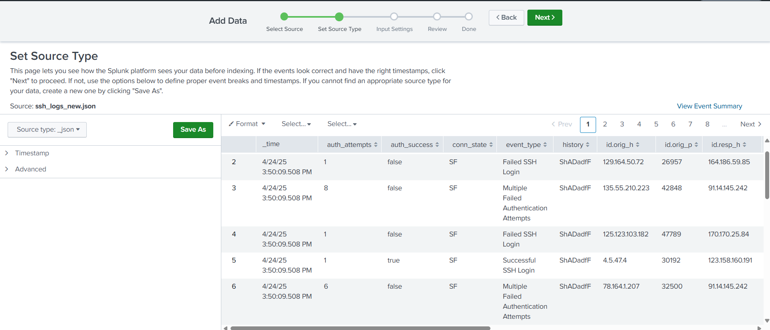
Figure A1. Splunk source-type preview. The uploaded file is recognized as JSON (_json), and the preview shows the authentication fields being extracted.
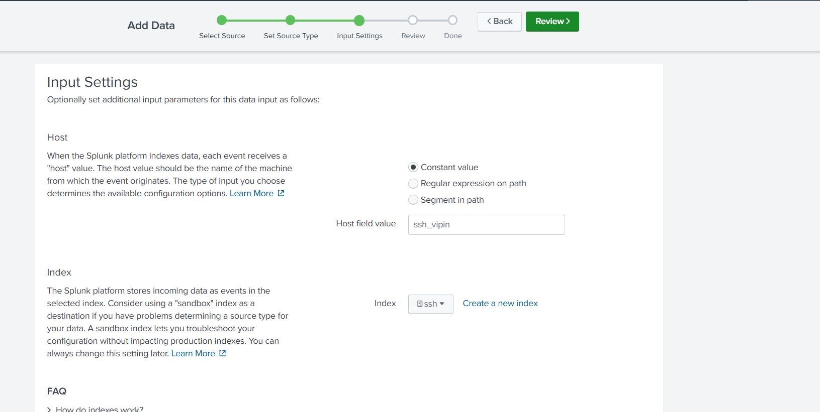
Figure A2. Input settings showing host value ssh_vipin and index ssh.

Appendix A. Splunk evidence (continued)
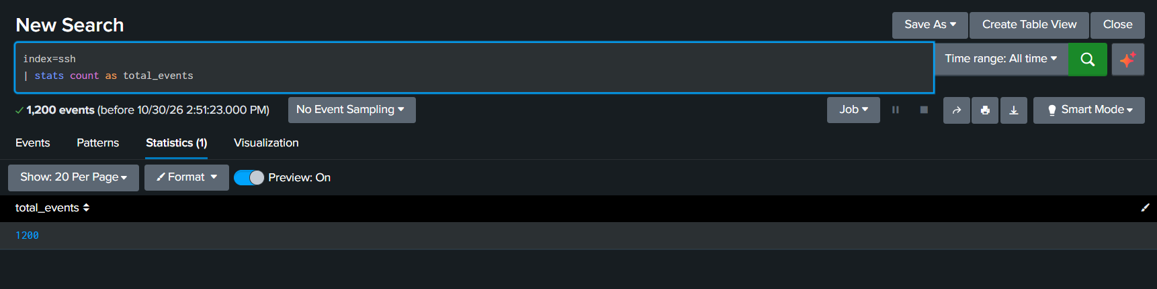
Figure A3. Initial search returning 1,200 events from the ssh index.
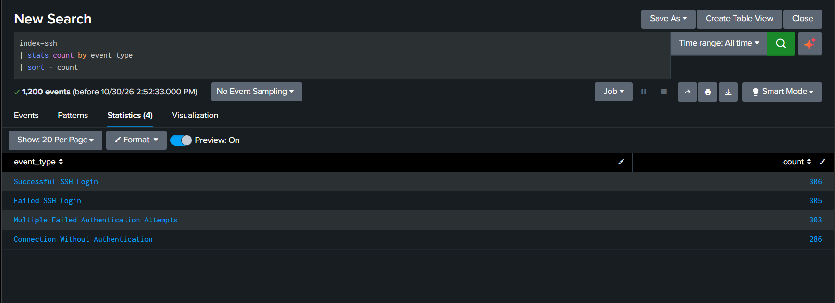
Figure A4. Event-type counts: successful login, failed login, multiple failures and connections without authentication.

Appendix A. Splunk evidence (continued)
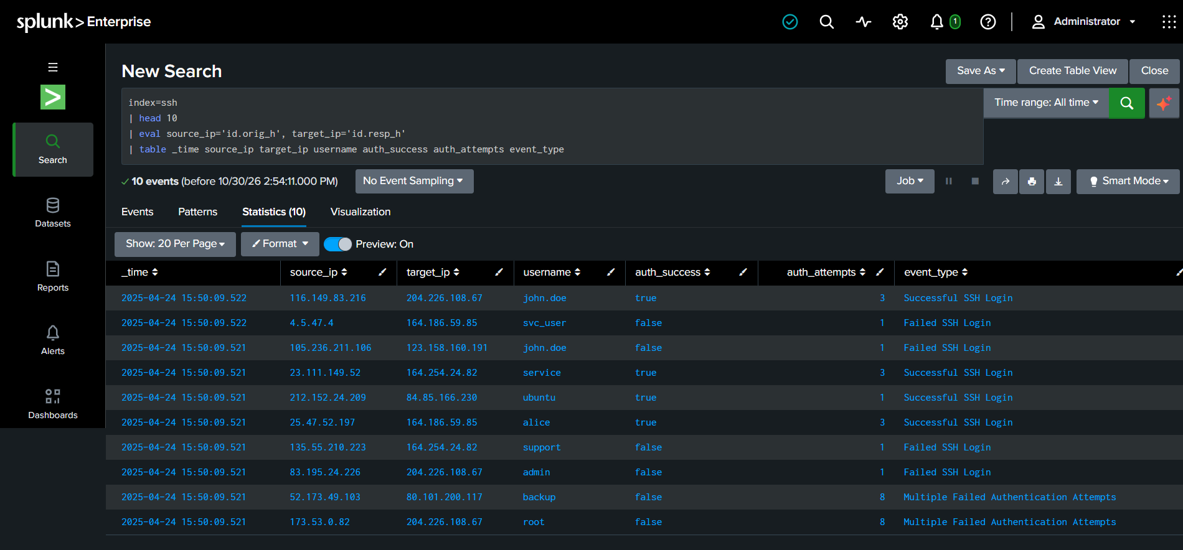
Figure A5. Sample event fields shown in the Splunk statistics table.
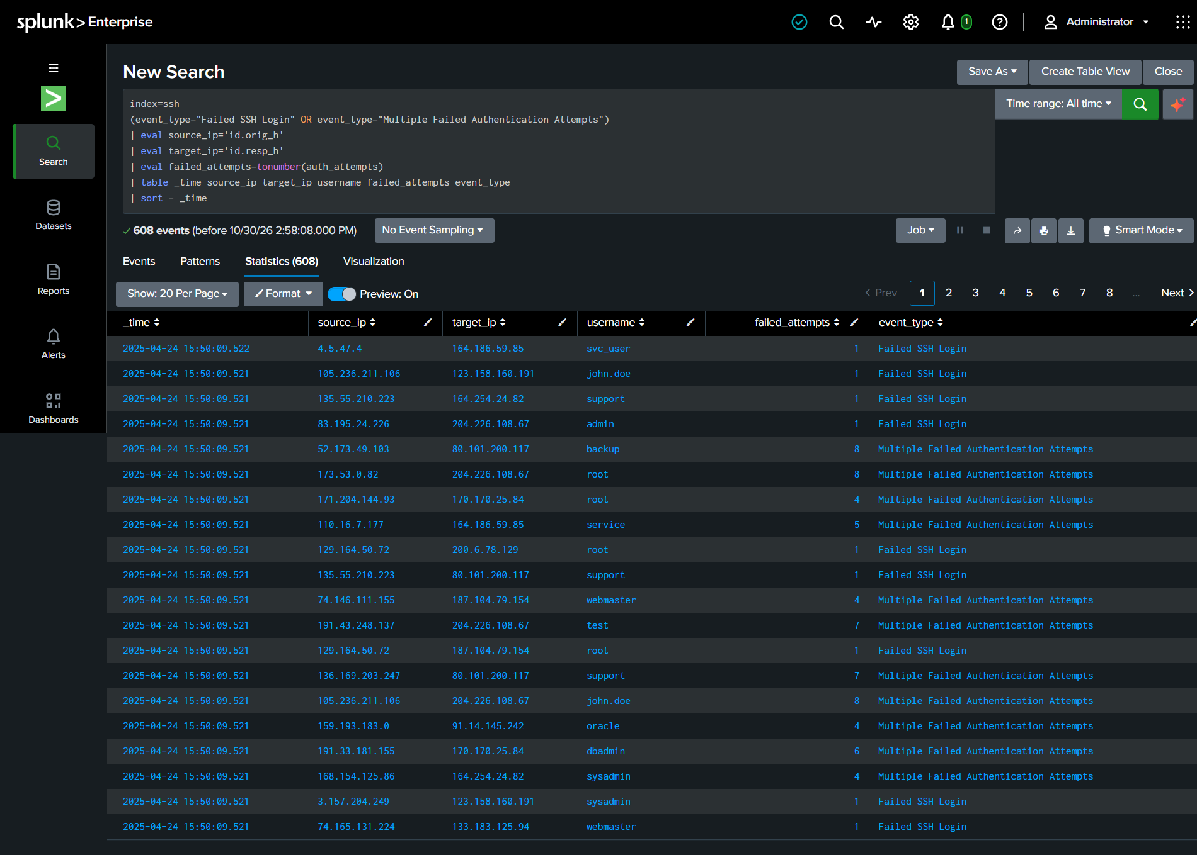
Figure A6. Failed-authentication event records with source, target, username and auth_attempts.

Appendix A. Splunk evidence (continued)
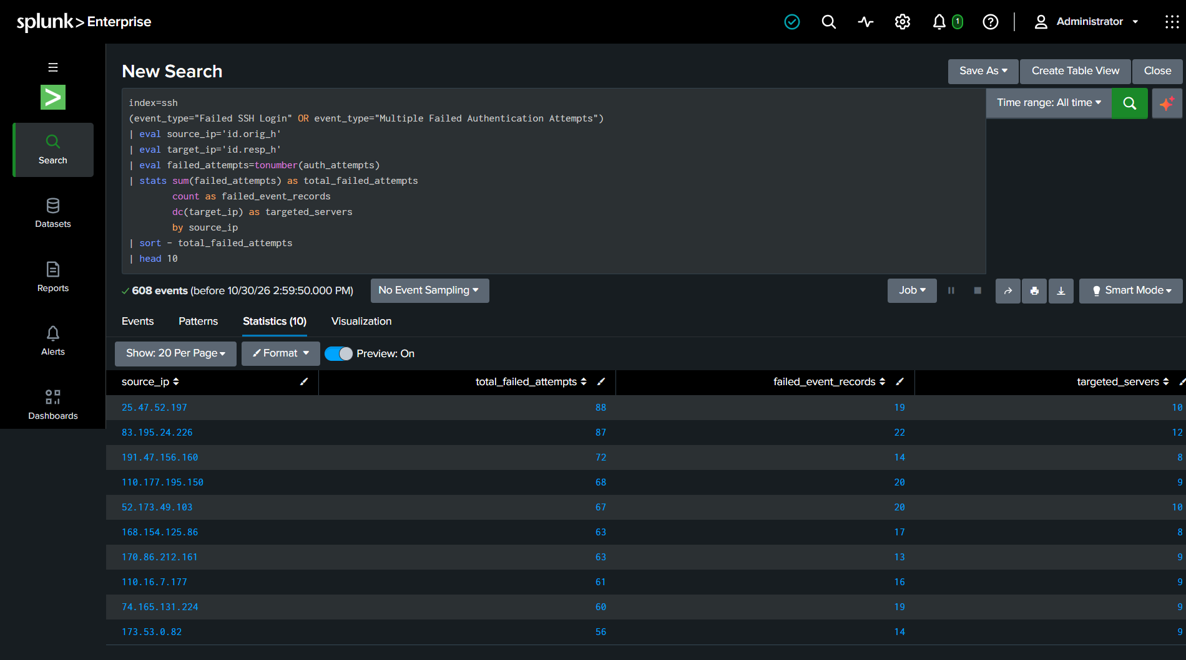
Figure A7. Source-IP ranking by summed failed attempts.
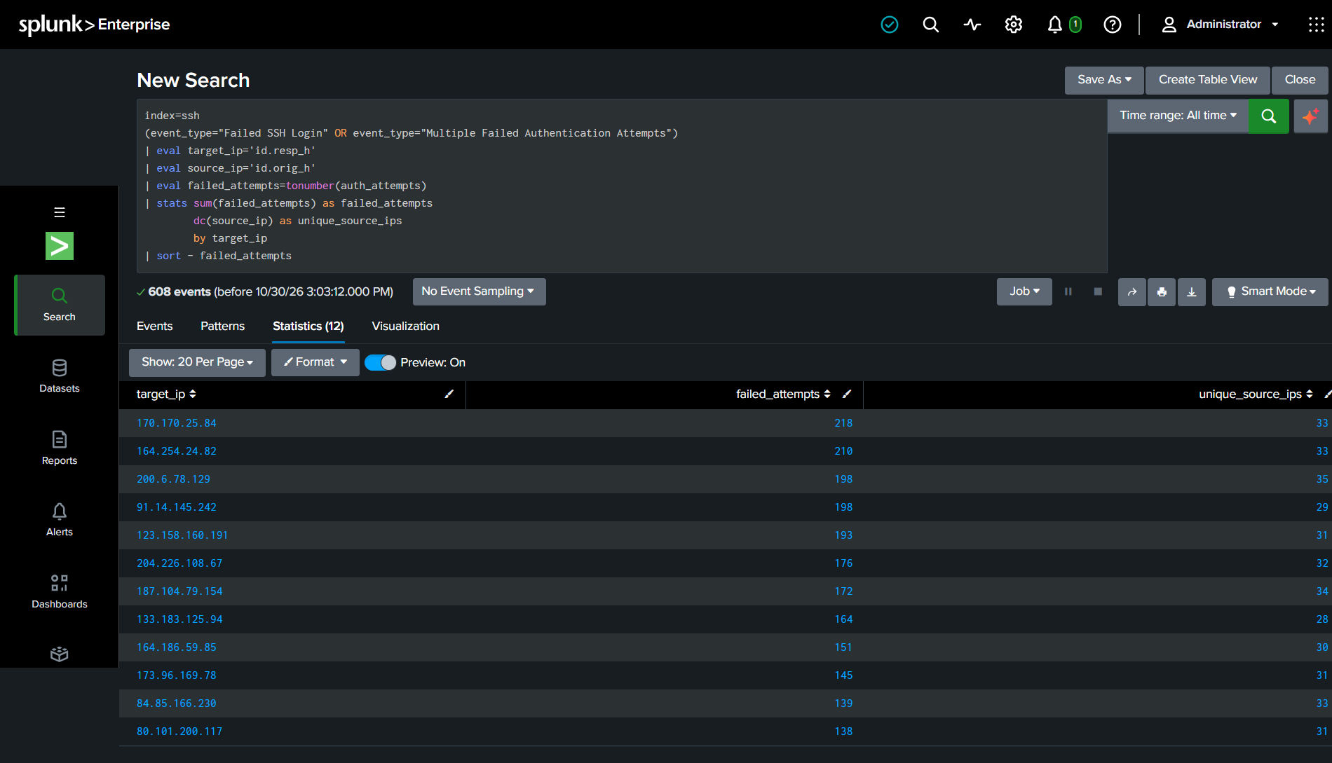
Figure A8. Destination-server ranking and number of distinct source IPs.

Appendix A. Splunk evidence (continued)
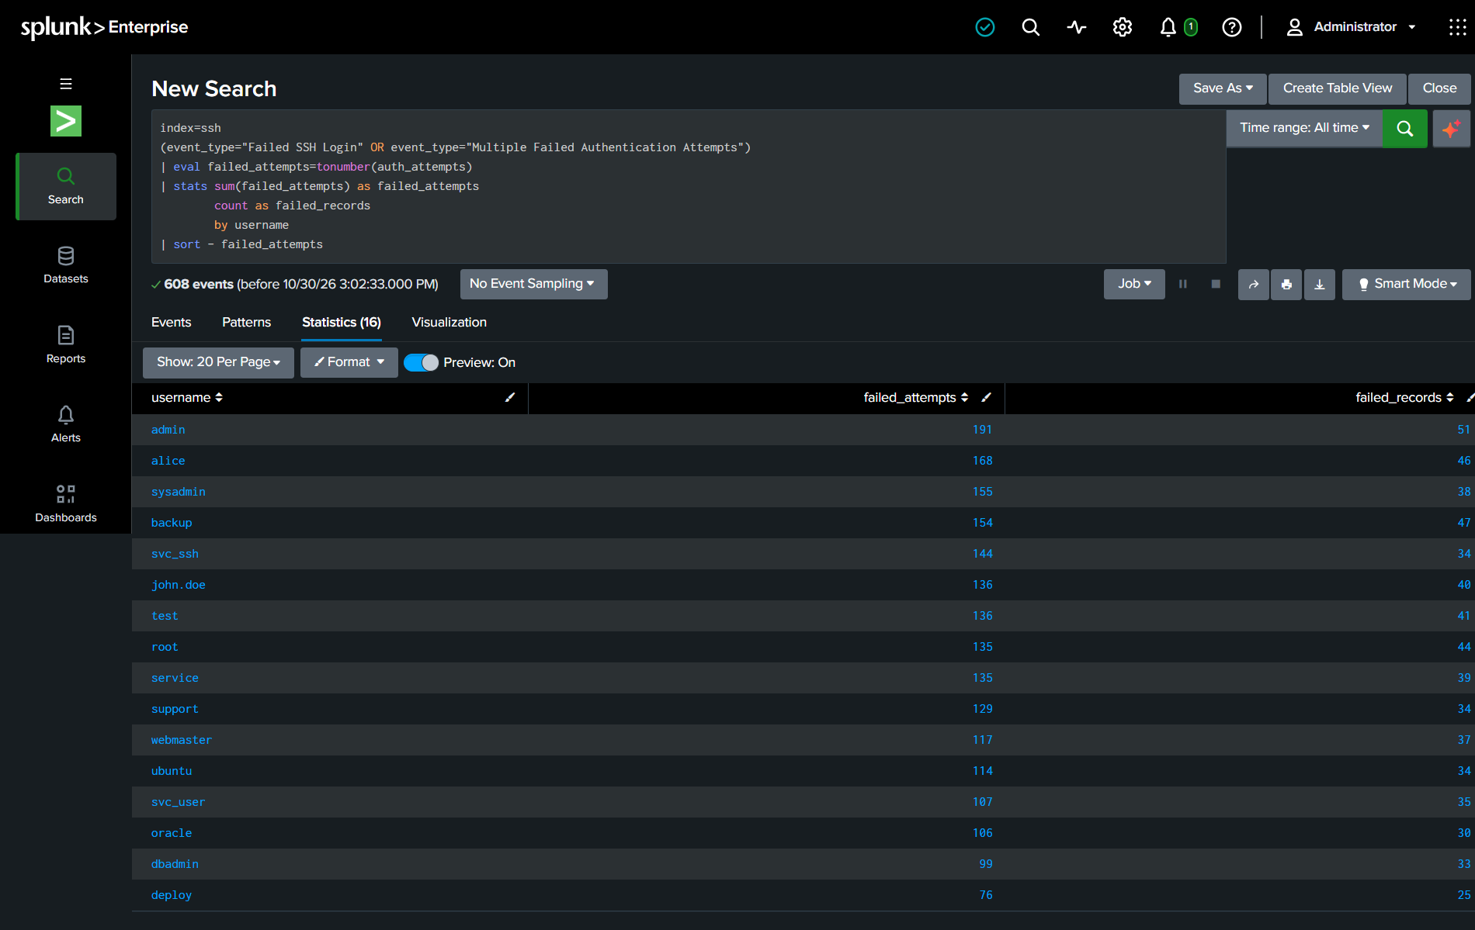
Figure A9. Username ranking by total failed attempts.
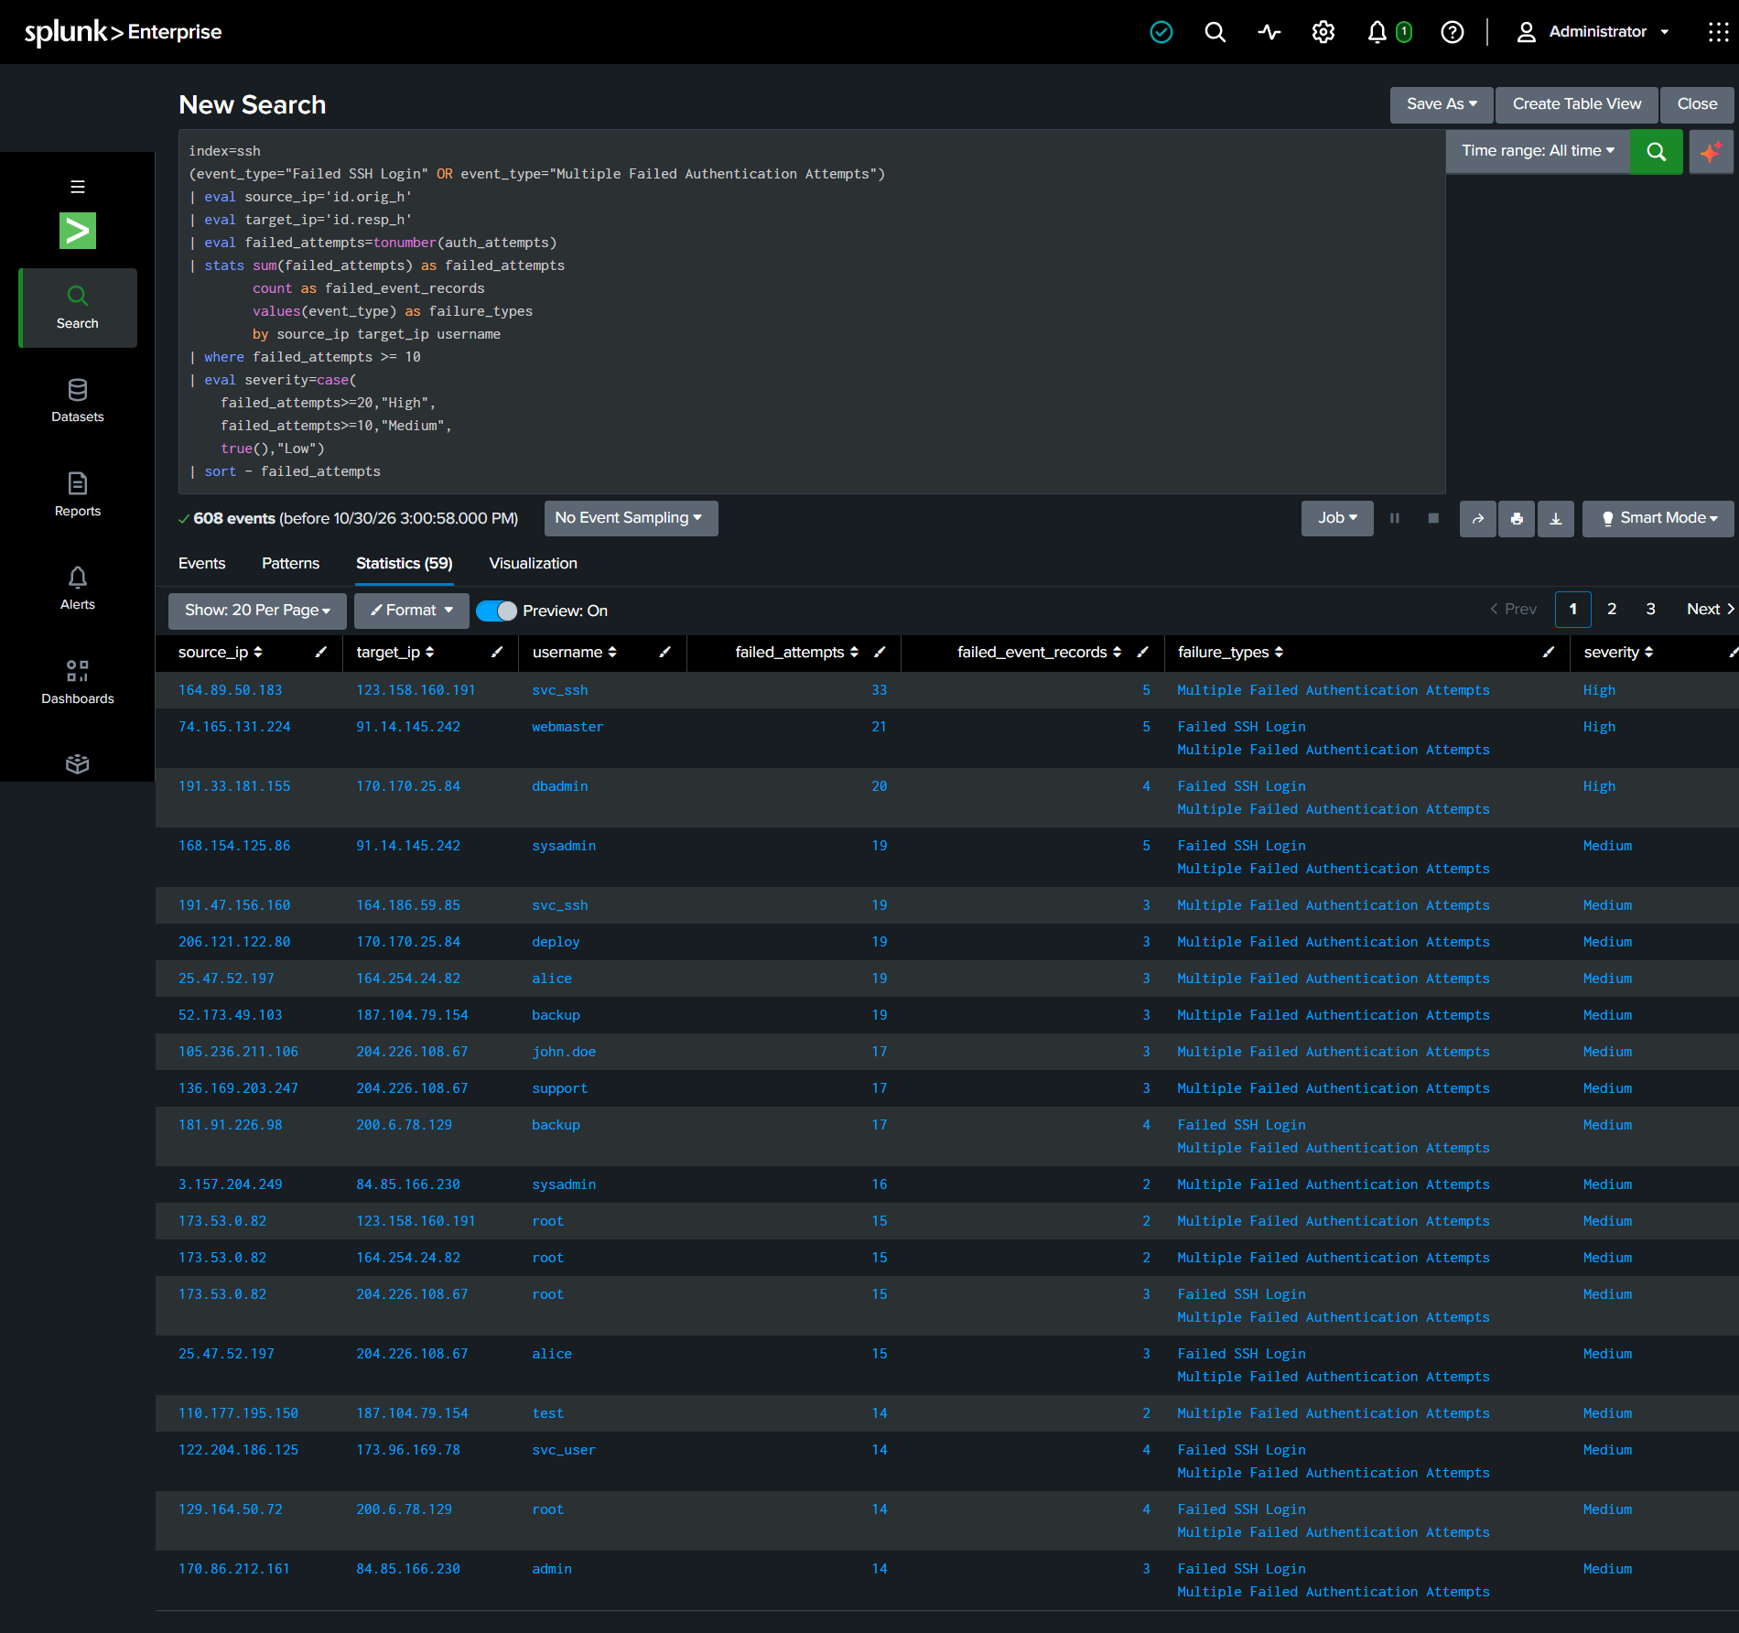
Figure A10. Source / target / username combinations meeting the 10-attempt threshold.

Appendix A. Splunk evidence (continued)
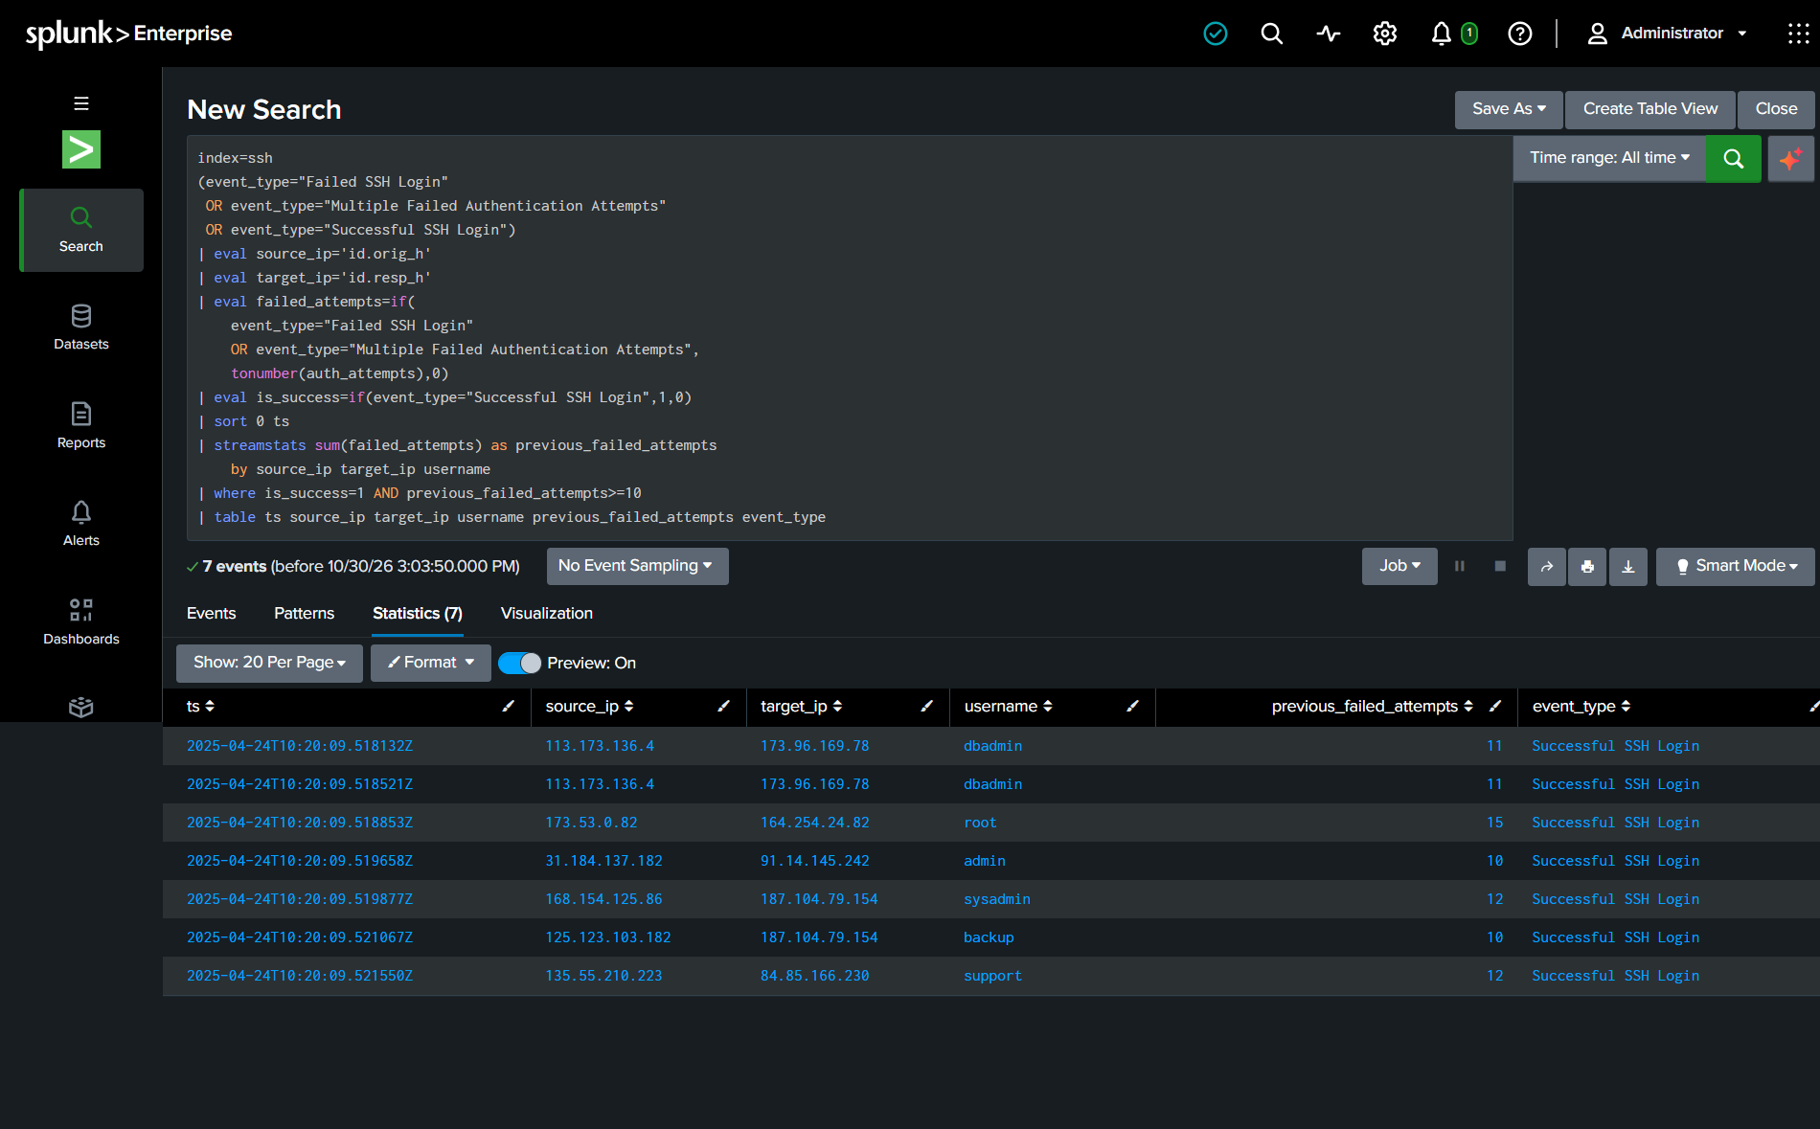
Figure A11. Sequence-correlation results showing successful logins after earlier failures.

