Resume Screener High Level Design
Architecture and operating model | Version 1.0 | 29 September 2026

Architecture decision
Use a React TypeScript frontend, a FastAPI modular backend, one lightweight worker process, and Supabase for authentication, Postgres and private object storage. Keep the worker in the same backend codebase and deployment host. PostgreSQL stores durable tasks, so the POC does not need Redis, a message broker or microservices.
Use React with Vite rather than Next.js for this authenticated application because the POC does not need server rendering or public-page SEO. This is an intentional simplification of the earlier plan. Python remains responsible for parsing, AI integration, scoring and PDF reports.

Component responsibilities
Component | Responsibility
React application | Forms, dashboard, report, evidence drawer, decision workflow
FastAPI | JWT validation, authorization, upload checks, API contracts and task submission
Worker | Extraction, redaction, LLM requests, validation, scoring and cleanup
Supabase Auth | Invite-only recruiter identity and sessions
Postgres | Workspace data, versions, evidence, decisions, tasks and usage ledger
Private object storage | Uploaded files with opaque workspace-scoped paths
LLM adapter | JD extraction and evidence classification through structured JSON

System relationships
The browser authenticates with Supabase Auth and calls FastAPI with its access token. FastAPI reads and writes user-facing data through Supabase with the same user JWT, preserving row-level security. It enqueues authorized work through narrowly scoped database functions. The worker reads private tasks and writes analysis results. Only the worker sends redacted job-related text to the configured AI provider.
Files flow from the browser through bounded upload validation into private storage. Source previews and PDF downloads pass through authenticated backend endpoints. The browser never receives a privileged Supabase key or the LLM key. No third-party analytics receives document text.

Architecture view
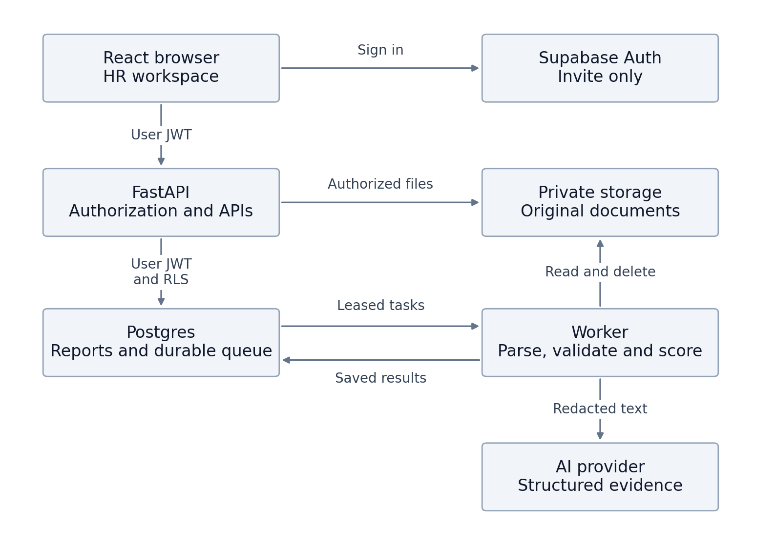
The user JWT follows ordinary API data requests into Supabase so database policies apply. Private queue operations are available only through authorized functions and the worker. Arrows show logical calls and data access; return traffic is omitted for readability.

Deployment boundaries
The application boundary contains the static frontend, API and worker. Supabase provides managed identity, database and object storage. The external AI provider receives only the reviewed redacted text and confirmed requirements needed for a request. Original documents stay in private storage.
The API handles user requests quickly and delegates slow parsing and model work to durable tasks. A frontend refresh cannot cancel or erase an analysis. Keeping API and worker in one codebase avoids duplicate business logic while allowing separate process restarts.

Data flow and version boundaries

Job preparation
- Create a draft job and upload or paste its JD.
- A durable task extracts text, builds stable source segments and asks the model for structured requirements.
- Validate JD quotes and display the draft requirements to HR.
- HR corrects, removes or adds criteria and confirms the version. The confirmed snapshot is immutable.

Candidate analysis
- Create the candidate and document records; store the original file privately.
- Extract stable text segments, evaluate readability and produce a redacted preview.
- HR reviews extraction and redaction warnings, then submits analysis against one confirmed job version.
- Reuse the extracted document and structured JD; request requirement-level findings and references.
- Validate JSON, allowed requirement IDs, exact quotes and source locations. Reject fabricated evidence.
- Calculate score, coverage and ATS readiness in application code. Save the report atomically and expose Ready.
- HR inspects evidence and saves a decision. A PDF renders the same saved snapshot without another model call.

Immutable history
Document versions, confirmed job versions and analysis reports are immutable. Replacing a resume creates a new document and report. Analysis stores parser, prompt, redaction, model, schema and scoring versions. Decisions identify the analysis they were made against. HR corrections produce a new snapshot instead of rewriting the historical record.

Trust boundaries
Uploaded documents are untrusted data. Instructions embedded in resumes or JDs are ignored and never executed. The provider has no tools, no database access and no outbound browsing in this workflow. Its response is untrusted until the application validates it.
Server authorization derives workspace membership from the authenticated user, never solely from an organization ID in a request. The worker's privileged credential can bypass row-level security, so worker code must validate task ownership and use workspace-scoped database operations. Tests must exercise this boundary separately.

Scoring and AI responsibilities
The model identifies job-related evidence and produces one finding for each confirmed criterion. It does not produce hiring recommendations, numeric scores or probabilities of success. The application computes Job Match and ATS Readiness separately using the LLD rules.
Missing evidence receives zero documented-match credit but remains a distinct status. Display evidence coverage beside Job Match and flag coverage below 60 percent. The UI does not label a candidate good or bad solely from the numeric score. A recruiter can select any decision, with a reason, regardless of score.
For relevant experience, duration comes from grounded dates and a server-calculated union of relevant intervals, not summed overlapping jobs. Ambiguous intervals are excluded from established duration and generate verification questions. Do not infer a skill's duration from total employment tenure.

Privacy and access model
Provision users outside the app for the POC and assign owner or recruiter membership. All workspace tables and stored objects are private. Authenticate each preview and export request, return Cache-Control no-store, and use attachment disposition for downloads. Keep raw documents out of browser local storage and remove preview URLs on navigation.
Remove direct identifiers before provider calls and give HR a redaction preview. This reduces exposure but is not guaranteed anonymization: job histories and employers can still identify someone. Identity-hidden mode hides direct identifiers from UI and exports; original-file access is owner-only and audited in that mode. Scoring always excludes protected characteristics whether the display mode is on or off.
Default retention is 30 days with a 7 to 90 day owner setting. Deletion first denies access and cancels queued work, then a retried cleanup job removes objects and related rows. Operational audit entries may retain only non-content event metadata and opaque deleted-resource IDs. Disclose that provider retention and backups follow their own configured policies; application deletion is not proof of immediate erasure from backups.

Provider choice
Use a replaceable adapter for an available low-cost Gemini Flash-class model with structured JSON output. Select and pin a supported model ID during implementation; do not build around an assumed future model name. Structured output constrains shape but does not establish truth, so evidence validation remains mandatory. [S1]
Use a paid provider configuration with data terms approved by the customer for real resumes. Google documents different treatment of unpaid and paid service data; confirm the applicable terms and region before the pilot. Synthetic fixtures may be used for zero-cost demonstrations. [S2]

Deployment and cost model
For the lowest incremental hosting cost, run the built frontend, FastAPI and worker on an existing compatible VPS, if one is available and has capacity. Use a reverse proxy with HTTPS and separate supervised API and worker processes. Supabase remains managed. Do not assume a prior VPS subscription is active or that it has free capacity.
If no suitable server exists, use a static frontend host and a small always-on backend host that supports a worker. Choose actual plans at deployment; commercial terms, idle suspension, limits and prices must be checked then. No mandatory paid Redis, vector database, monitoring suite or orchestration service is introduced.
Supabase's free tier may suit synthetic testing, but low-activity projects can pause. A customer pilot requiring continuous availability should budget for an appropriate plan. This design does not promise permanent free hosting. [S3]

Variable cost calculation
Estimated provider cost is input tokens divided by one million times the configured input rate, plus billed output tokens divided by one million times the configured output rate. Add any separately billed token categories according to the selected model. Record actual provider usage where available and mark missing usage as unknown.
Illustrative arithmetic only: assume input at USD 0.30 per million tokens and output at USD 2.50 per million. A 6,000-input and 1,500-output token screening costs USD 0.00555. At 500 screenings this is USD 2.775, before JD extraction, retries, taxes, hosting and storage. These are hypothetical rates, not a vendor quote.
Set a default application budget of USD 10 per workspace per calendar month, UTC, configurable by the owner. Atomically reserve the maximum estimated cost before dispatch and reconcile after completion. Stop new calls when the remaining budget is insufficient. Provider billing alerts and limits provide a second layer. Do not label this an exact invoice cap when provider prices or usage are unknown.

Cost controls
- Extract and confirm each JD version once; cache the structured requirements within that workspace.
- Cache completed analysis only for identical document, job and configuration versions.
- Bound input length, output tokens, concurrency and provider attempts.
- Poll report state instead of maintaining a costly realtime stack.
- Generate PDF exports from saved data with no AI call.
- Keep original files only for the configured retention period.

Reliability and capacity
Start with two concurrent worker tasks and one provider request per task. Queue records include attempts, next-run time, lease owner and expiry. A worker heartbeat extends the lease. Expired tasks are reclaimed after a restart; writes require the current lease token, preventing a stale worker from committing over a newer attempt.
Use a 60-second provider timeout, up to three total provider attempts per task and bounded exponential backoff with jitter. A malformed-response repair counts toward the same limit. A provider may have completed a timed-out call, so billing can duplicate even when stored reports do not. Account for that in usage and budget handling.
The 90-second p95 target applies to the supported warm two-concurrent workload without queue wait. Measure extraction, provider, validation and export latency separately. Return a visible failure with a retry action for exhausted transient errors; block unsupported documents without repeatedly paying for analysis.

Operational signals and recovery
Track queue depth, oldest task age, task failures by code, provider attempts, tokens, estimated cost, validation failures and warm latency. Log request IDs and opaque resource IDs only. Health endpoints distinguish process liveness from dependency readiness.
Take backups according to the chosen platform plan. Before the live pilot, demonstrate restoration of a synthetic job and report and verify restored data does not re-expose deleted candidates. Maintain a deletion ledger for reapplication after restores. The customer sets recovery objectives after the POC; no production SLA is assumed.

Extension points
Later versions can add OCR as a parser adapter, bulk import as multiple queued tasks, and HRMS integrations as authorized outbound services. Keep job versions and evidence contracts stable. Move the worker to a separate host only when measured workload requires it.

Reference sources
Official documentation checked on 29 September 2026. Vendor terms, limits and SDK APIs should be rechecked during implementation.
[S1] Google AI for Developers, Structured outputs: https://ai.google.dev/gemini-api/docs/structured-output
[S2] Google AI for Developers, Gemini API terms and pricing: https://ai.google.dev/gemini-api/terms and https://ai.google.dev/gemini-api/docs/pricing
[S3] Supabase, Free project pausing: https://supabase.com/docs/guides/platform/free-project-pausing
[S4] Supabase, Row Level Security: https://supabase.com/docs/guides/database/postgres/row-level-security
[S5] pypdf, Extract text: https://pypdf.readthedocs.io/en/6.7.1/user/extract-text.html
Supabase privileged service credentials bypass RLS and must never reach a browser. [S4] pypdf does not OCR image-only pages; this is why scans are excluded from the POC. [S5]

