Super Admin Login
1. In the shopping center, change that user name to the shopping center name.
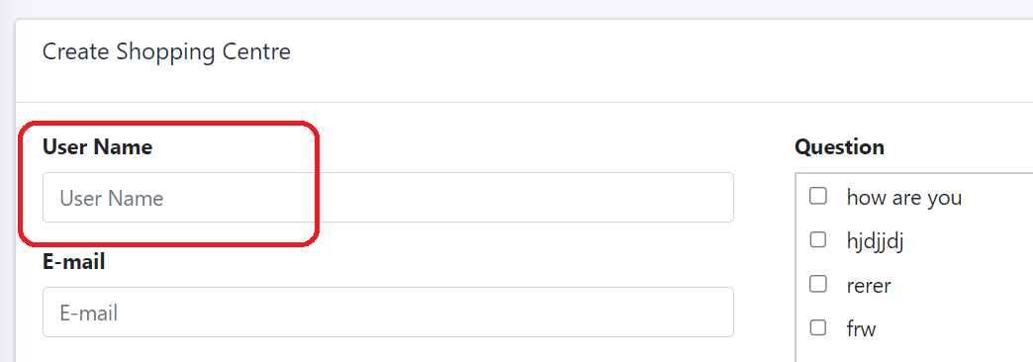

2. The cleaner login QR code is not valid. Please check it.
3. In the issue report, give some space for Super Admin Login, Admin Login and Shopping center login.
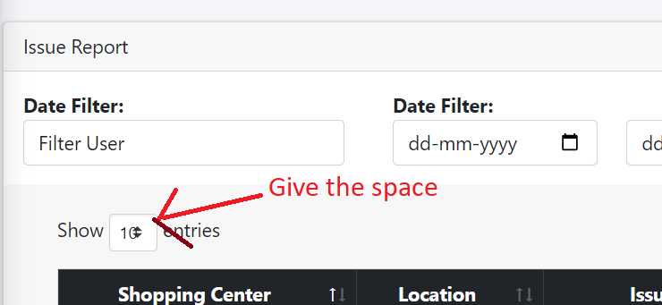

Admin Login
1. The cleaner login QR code is not valid. Please check it.
2. If shopping center is In-Active then it should hide in location.
3. For the first location, we only need one question, but for the second location, we need both questions. How can we select? Because we can not give same question to the all location - Need to discuss with prasad Sir.
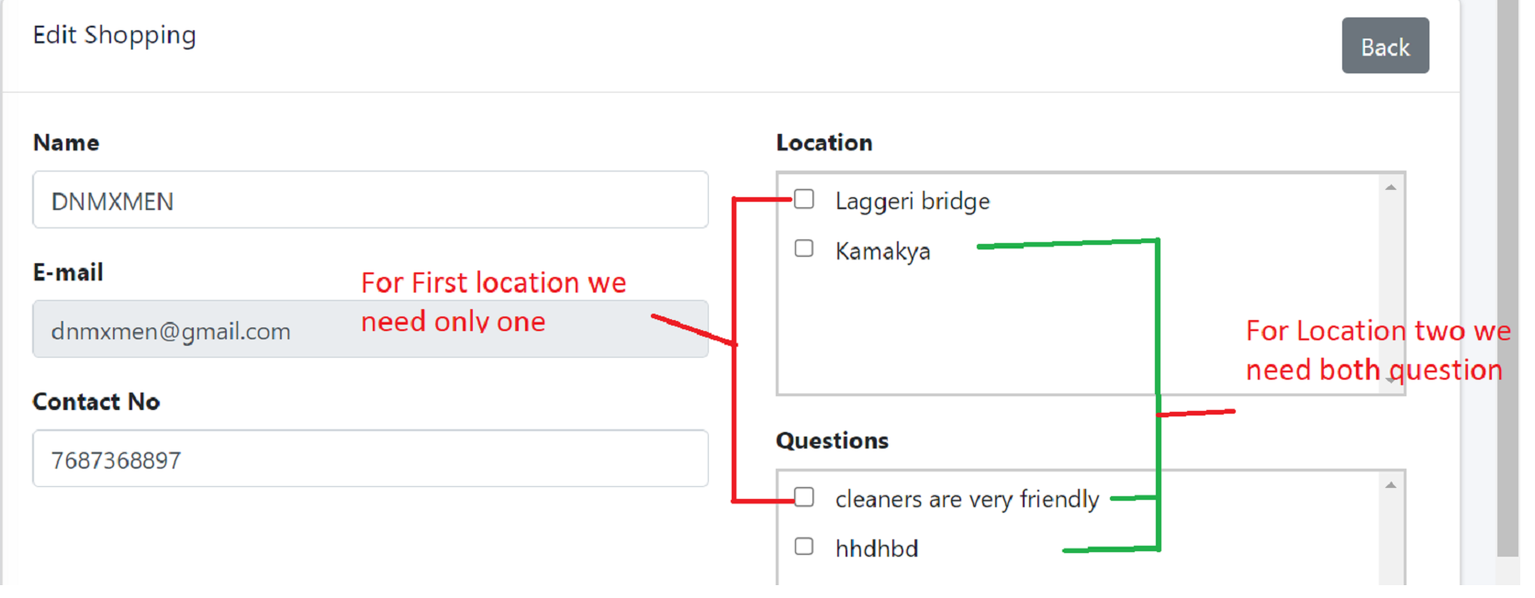

4. The edited location is not saved; it is showing an error.
5. Remove 'e' in Edit Location.
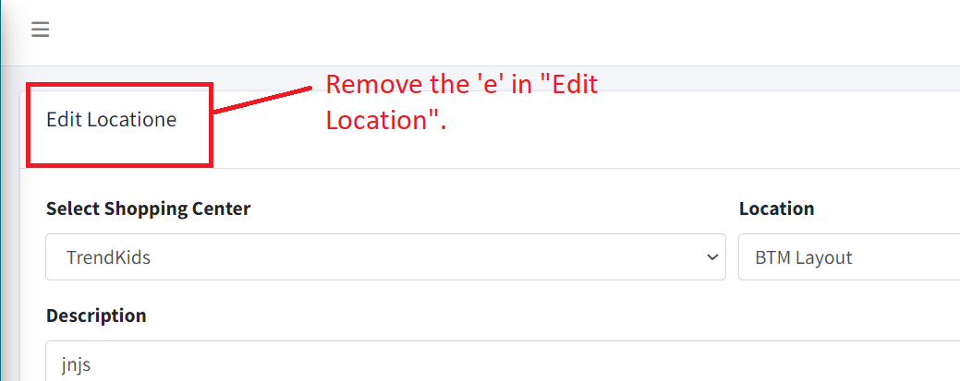

Shopping Center Login
1. The edited location is not saved; it is showing an error.

API
1. If a cleaner logs in to the shopping center, the issue reports should be displayed..
2. Notification is not working.
3. We are trying to log out with a different QR code, and it should not accept that one. However, currently, it is accepting it.
4. The cleaner is already logged in, and when they try to log in again, it should display "You are already logged in." However, it is currently displaying "First, you need to log out."
5. If we scan an invalid QR code or any other QR code, it should display the message "Invalid QR code. Please scan a valid QR code."

