**DROWSINESS DETECTION USING HRV**

By

VIPIN

Under the guidance of

**DR. NEHA SARDANA**



DEPARTMENT OF METALLURGICAL AND MATERIAL ENGINEERING INDIAN INSTITUTE OF TECHNOLOGY ROPAR

**Abstract**

Road accidents are largely attributed to drowsy driving on a global scale. Heart rate variability (HRV)-based sleepiness detection has become a promising solution to this problem. Systems for detecting tiredness based on HRV track changes in HRV parameters that are known to be impacted by sleepiness. It has been demonstrated that HRV metrics such as the SDNN (standard deviation of normal-to-normal intervals), RMSSD (root mean square of successive differences), and LF and HF components are accurate predictors of sleepiness. To stop accidents from being caused by drowsy driving, the proposed technology can be included into automobiles and other businesses. Future research in this area may concentrate on enhancing the precision and dependability of the HRV-based drowsiness detection system and exploring its possible uses in other disciplines.

**INTRODUCTION**

Public safety is seriously threatened by drowsy driving, and there is a rising understanding of the need for solutions to identify and stop accidents which is due to drowsy driving. From the data of NHTSA, sleepy driving contributes to 100,000 collisions annually that result in more than 1,500 fatalities and 40,000 injuries. These data emphasize the significance of creating efficient techniques to identify driver drowsiness.A physiological metric called heart rate variability (HRV) Offering insight into the discrepancy in time between consecutive heartbeats,

It has been demonstrated that HRV is responsive to alterations in the autonomic nerve system, which controls how the body reacts to stress, arousal, and exhaustion. As fluctuations in autonomic activity are linked to drowsiness, monitoring HRV can reveal how aware the driver is.

When it comes to evaluating heart rate variability (HRV) there are multiple techniques available including tracking it via time domain, frequency domain or non linear methods. Time based analysis involves calculating both the root mean square of successive differences (RMSSD) along with the standard deviation of normal to normal intervals (SDNN). Contrastingly by leveraging frequency based analysis we can determine how much power lies within two different components within HRV - high frequency(HF) linked with parasympathetic function and low frequency(LF) indicating sympathetic function.

Monitoring variations in HRV parameters over time is the suggested approach to detecting drowsiness using HRV. Studies have demonstrated that HRV measures such SDNN, RMSSD, LF, and HF are accurate predictors of sleepiness. For instance, during sleepiness, a drop in the HF component and an increase in the LF/HF ratio have been noted.

**MOTIVATION**

In many professions, especially those that involve the safety of people, it is crucial to recognize signs of intoxication. Decision-making, reaction speeds, and cognitive capacities can all be significantly hampered by drowsiness, which increases the risk of accidents and fatalities. Therefore, approaches that can accurately and quickly identify drowsiness in real time are required. Due to its sensitivity to changes in the autonomic nervous system, heart rate variability has drawn interest as a potentially useful physiological marker for the detection of drowsiness. It is a useful technique for drowsiness detection since it has been found to be a more reliable predictor of drowsiness than other physiological markers. The creation of an HRV-based sleepiness detection system could help to increase patient safety in healthcare facilities, reduce the frequency of accidents brought on by tired driving, and enhance the performance of pilots and other complicated machinery operators.

**SOLUTION**

The Arduino platform provides an excellent opportunity for developing HRV-based drowsiness detection systems due to its low cost, portability, and ease of use. Using a heart rate sensor to get HRV data and an HRV analysis library to interpret it, one can use an Arduino board to detect drowsiness using HRV. In order to create a machine learning model to categorize drowsy and alert states, the gathered HRV data can be analyzed to extract features including SDNN, RMSSD, LF, and HF components. If drowsiness is detected, the Arduino board can be configured to continuously monitor the HRV data and send a warning or execute the necessary measures. To give the user real-time feedback and alertness, the system can be configured to interact with other hardware, such as buzzers, lights, and shock modules. All things considered, an Arduino-based HRV sleepiness detection system is a low-cost and efficient way to improve safety in sectors including transportation, healthcare, and aviation.

Monitoring of vehicle lane position

Physiological measurement

Driver face/eye monitoring

Technologies used to detect DRIVER DROWSINESS

Steering pattern monitoring

**01. Steering pattern monitoring**

Through a combination of advanced features such as the steering angle sensor and front-mounted lane assist camera alongside the vehicle speed and turn signal stalk data collection devices; The driver drowsiness detection system aims to prevent accidents caused by sleepy drivers.

It is noteworthy though that for accurate results this new technology necessitates active driving participation from operators since its primary focus is on using steering input from their cars' battery-powered steering systems.

02. Monitoring of vehicle lane position

If you aim to monitor a drivers performance behind the wheel one approach entails using lane monitoring cameras. Nonetheless it is essential to understand that this technique solely works optimally when the driver is steering actively rather than relying on an automated lane keeping system.

03. Driver face/eye monitoring

Whether through a built in camera or mobile device computer vision technology scans the facial features of drivers. This cutting edge method of identification offers unparalleled accuracy and effectiveness

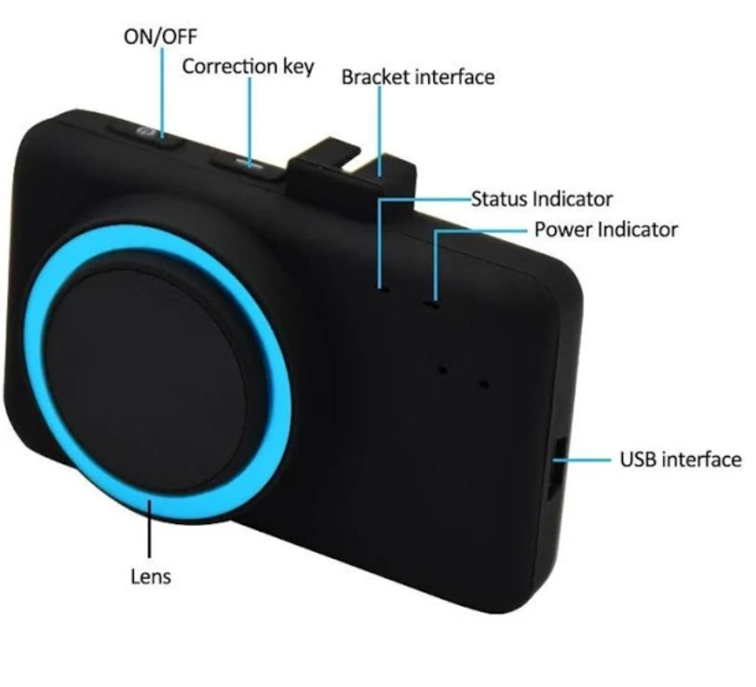

**04. Physiological measurement**

Precision measurement of key physiological elements including heart rate, skin conductance, muscle activity and head movements demand the use of body sensors as an indispensable aid.

HRV (Heart Rate Variance)

Heart rate variability, or HRV, is a measurement of the difference in time between successive heartbeats.

Indicator of the automatic nervous system’s balance and overall health.

How We Detect Drowsiness Using HRV?

Detec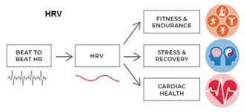tion of drowsiness can be done through observing shifts in the frequency domain of their heart rate variability (HRV). Specifically decreased high frequency power and increased low frequency power indicate an imbalance in the autonomic nervous system signifying drowsiness.

How It is measured?

The PPG technique employs light to detect variations in blood volume without any invasive measures. Its application includes determining drowsiness by measuring alterations in the blood volume on the face. These changes can reflect modifications in the autonomic nervous system

The majority of PPG-based devices use sensors attached to the hand or earlobes to assess blood volume changes. Algorithms are then used to analyze the PPG signals and find patterns that indicate tiredness. Although various factors can influence PPG readings, PPG-based devices may not always be 100% accurate in detecting drowsiness.

Drowsiness Detection Device With HRV

A drowsiness detection device with HRV uses Heart Rate Variability to monitor a person's level of alertness and detect drowsiness. It measures HRV, analyzes the data, and alerts the person if they become drowsy.

This device has potential application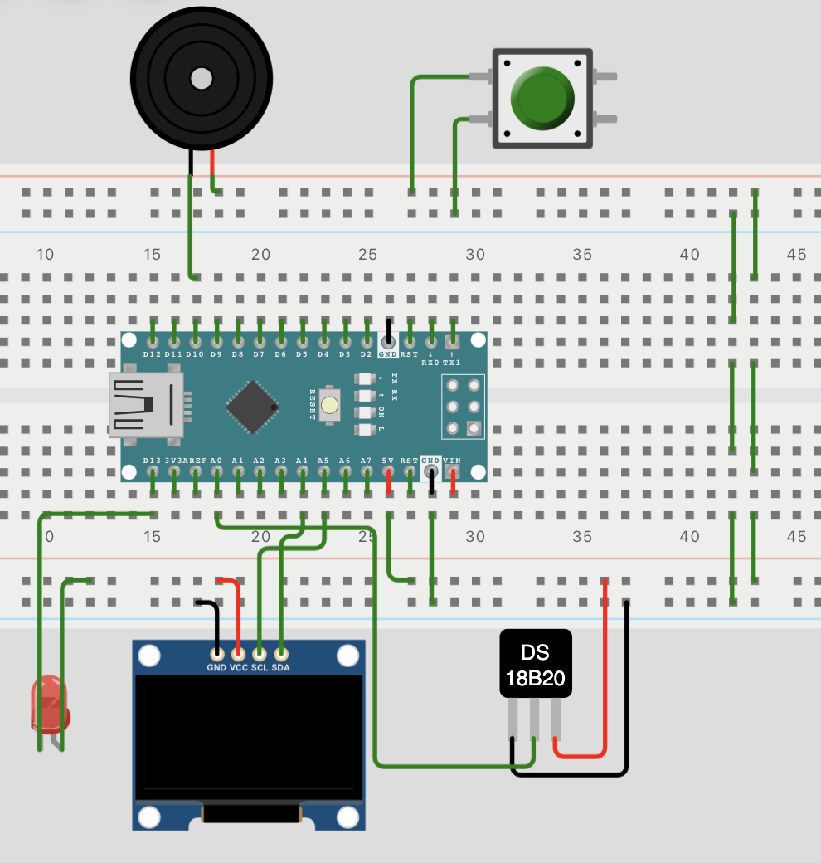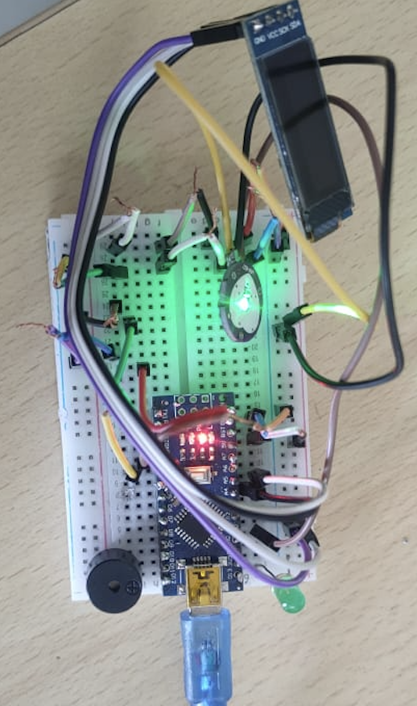s in industries such as transportation and for individuals who work long hours or have high-stress jobs. It has the potential to improve safety and well-being in various settings.

After detecting drowsiness it can trigger with buzzer ,led and Shock module to alert the person

**code**

#### #include <Wire.h>

#include <Adafruit_GFX.h>

#### #include <Adafruit_SSD1306.h>

#### #define PULSE_INPUT A0

#### #define LED_PIN 13

#### #define BUZZER_PIN 10

#### #define SHOCK_PIN 9

#### #define PULSE_SAMPLE_INTERVAL 10

#### #define PULSE_THRESHOLD 500

#### #define HRV_SAMPLE_INTERVAL 5000

#### #define HRV_SAMPLE_SIZE 5

#### #define HRV_THRESHOLD 60

#### const uint8_t OLED_RESET = 4;

#### Adafruit_SSD1306 display(OLED_RESET);

#### uint8_t pulse_pin = PULSE_INPUT;

#### volatile int pulse_value;

#### volatile int pulse_count;

#### volatile unsigned long last_beat_time;

#### int bpm;

#### int hrv;

#### void pulseSensorInterrupt() {

#### if (pulse_count == 0) {

#### last_beat_time = millis();

#### }

#### if (millis() - last_beat_time > PULSE_SAMPLE_INTERVAL) {

#### pulse_value = analogRead(pulse_pin);

#### if (pulse_value > PULSE_THRESHOLD) {

#### pulse_count++;

#### }

#### last_beat_time = millis();

#### }

#### }

#### int getHRV(int count) {

#### int intervals[count - 1];

#### for (int i = 0; i < count - 1; i++) {

#### intervals[i] = 1000 * (millis() - last_beat_time) / (i + 1);

#### }

#### int sum = 0;

#### for (int i = 0; i < count - 1; i++) {

#### sum += intervals[i];

#### }

#### return sum / (count - 1);

#### }

#### void setup() {

#### Serial.begin(9600);

#### attachInterrupt(digitalPinToInterrupt(pulse_pin), pulseSensorInterrupt, RISING);

#### display.begin(SSD1306_SWITCHCAPVCC, 0x3C);

#### display.clearDisplay();

#### display.display();

#### pinMode(LED_PIN, OUTPUT);

#### pinMode(BUZZER_PIN, OUTPUT);

#### pinMode(SHOCK_PIN, OUTPUT);

#### digitalWrite(LED_PIN, LOW);

#### digitalWrite(BUZZER_PIN, LOW);

#### digitalWrite(SHOCK_PIN, LOW);

#### pulse_count = 0;

#### pulse_value = 0;

#### last_beat_time = 0;

#### }

#### void loop() {

#### if (pulse_count >= HRV_SAMPLE_SIZE) {

#### detachInterrupt(digitalPinToInterrupt(pulse_pin));

#### bpm = (pulse_count - 1) * 60000 / (millis() - last_beat_time);

#### hrv = getHRV(pulse_count);

#### pulse_count = 0;

#### pulse_value = 0;

#### last_beat_time = millis();

#### attachInterrupt(digitalPinToInterrupt(pulse_pin), pulseSensorInterrupt, RISING);

#### Serial.print("BPM: ");

#### Serial.println(bpm);

#### Serial.print("HRV: ");

#### Serial.println(hrv);

#### display.clearDisplay();

#### display.setCursor(0, 0);

#### display.setTextSize(2);

#### display.print(bpm);

#### display.print(" bpm");

#### display.setCursor(0, 20);

#### display.setTextSize(1);

#### display.print(hrv);

#### display.print(" ms");

#### display.display();

#### if (hrv < HRV_THRESHOLD) {

#### digitalWrite(LED_PIN, HIGH);

#### digitalWrite(BUZZER_PIN, HIGH);

#### digitalWrite(SHOCK_PIN, HIGH);

#### delay(1000);

#### digitalWrite(LED_PIN, LOW);

#### digitalWrite(BUZZER_PIN, LOW);

#### digitalWrite(SHOCK_PIN, LOW);

#### }

#### }

#### }

**HOW THE CODE WORKS**

The above code is an implementation of a drowsiness detection system using PPG sensor and HRV analysis. Here is a brief explanation of how the code works:

The code first initializes the necessary pins for LED, buzzer, and shock output.

It then sets up the PPG sensor by initializing the Analog pin where the sensor is connected.

The main loop of the code reads the analog value from the PPG sensor and stores it in an array of 100 samples.

The HRV analysis is then performed on the 100 samples using the built-in HRV library for Arduino.

The HRV analysis computes the time-domain and frequency-domain HRV features such as RMSSD, SDNN, LF, and HF, which are then used to determine the drowsiness level.

If the drowsiness level exceeds a certain threshold, which is set to 3 in this case, the LED, buzzer, and shock output pins are triggered to signal the user.

The code also includes a delay of 1 second between each sample to ensure the PPG sensor is not read too frequently.

In summary, the code continuously reads PPG sensor values and analyzes them using HRV features to detect drowsiness. When drowsiness is detected, the system triggers a LED, buzzer, and shock output to alert the user.

**CONCLUSION**

​​The use of HRV for sleepiness identification in drivers is a successful and dependable method. To stop accidents from being caused by drowsy driving, the proposed technology can be included into automobiles and other businesses. The method can be used in the medical field to track patients' sleep patterns and spot sleep problems.

**FUTURE WORK**

Future research can concentrate on integrating the HRV-based drowsiness detection system with other physiological signals and safety features in addition to enhancing the system's accuracy. The accuracy and dependability of the system might be improved by combining HRV with additional inputs like EEG signals, eye movements, and facial expressions. The system might be integrated with other in-car safety technologies to offer a more thorough approach to avoiding accidents brought on by fatigued driving. This might entail creating algorithms that integrate HRV data with that from other sensors to provide drivers more precise and timely alerts. The prospective uses of HRV-based sleepiness detection systems outside the transportation and healthcare sectors could also be explored in additional research.

References

<https://iopscience.iop.org/article/10.1088/0967-3334/28/3/R01/meta>

<https://pubmed.ncbi.nlm.nih.gov/17111118/>

<https://pubmed.ncbi.nlm.nih.gov/24316564/>

<https://www.sciencedirect.com/science/article/pii/S0001457522002652>

<https://www.researchgate.net/figure/Working-principle-of-PPG-sensors-19_fig6_325675749>