🛒 Leegality - Frontend Engineer Assessment

Product Listing & Detail Page (Amazon-style)

📌 Objective
Build a simple e-commerce Product Listing Application using the public API:
👉 https://dummyjson.com/docs/products
The goal is to evaluate your ability to:
- Work with APIs
- Build reusable UI components
- Manage state
- Implement filtering logic
- Handle routing
- Structure clean, maintainable frontend code

🖥️ Application Requirements
The application should have two main screens:
- Product Listing Page
- Product Detail Page

🖼️ 1️⃣ Product Listing Page
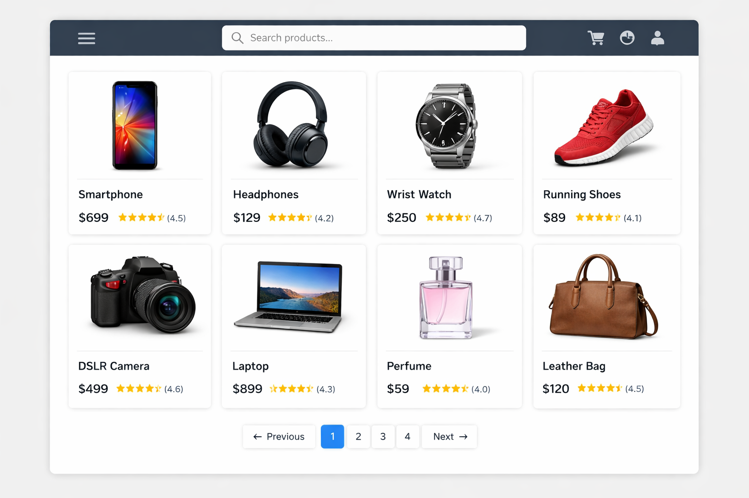

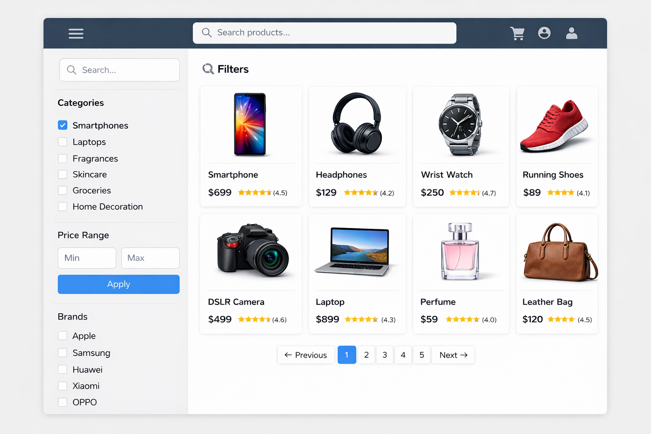

📌 Layout
- Left Side → Filters
- Right Side → Product Grid (cards)
- Pagination at bottom (or API-based limit/skip)

📦 Product Card Should Display:
- Product Image
- Product Name (Title)
- Price
- Rating
Clicking on a product card should navigate to the Product Detail Page.

🔎 Filters (Mandatory)
Use the DummyJSON API endpoints:
- GET /products
- GET /products/categories
- GET /products/category/{category}
- GET /products/{id}

Required Filters
- Category
  - Fetch dynamically from /products/categories
  - Selecting a category updates product list
- Price Range
  - Min Price input
  - Max Price input
  - Filter products accordingly
- Brand
  - Extract unique brands from fetched products
  - Allow selection (single or multi-select)

Filter Behavior Rules
- Filters should work together (combined filtering)
- Changing a filter should update the product list immediately
- Pagination should reset when filters change
- Proper loading state must be shown
- Proper error handling must be implemented

🖼️ 2️⃣ Product Detail Page
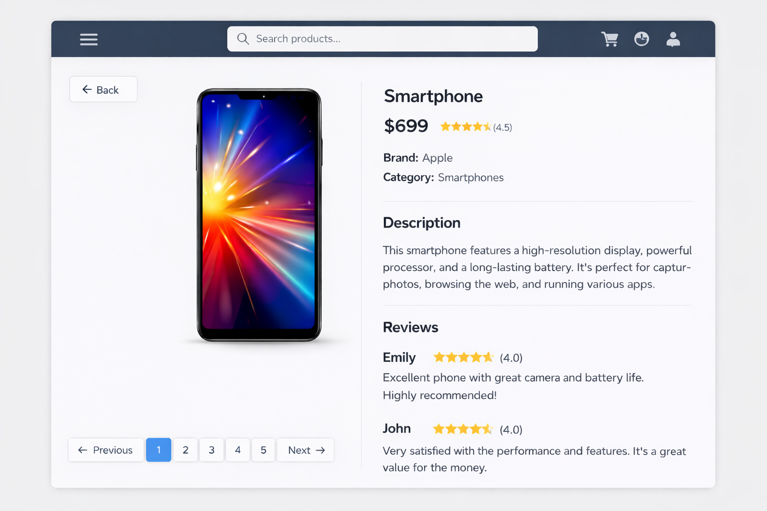

📦 Detail Page Should Display:
- Product Image
- Product Name
- Price
- Rating
- Description
- Brand
- Category

🔙 Navigation
- Clicking a product card navigates to /product/:id
- A Back button should return to the Listing Page
- Previously selected filters should remain applied when navigating back

⚙️ Technical Requirements
You may use:
- React (Functional Components preferred)
- React Router
- Hooks (useState, useEffect, etc.)
- CSS / Tailwind / Basic styling
Avoid using heavy UI libraries unless necessary.

📊 API Usage Requirements
Products must be fetched from:
- https://dummyjson.com/products
- https://dummyjson.com/products/categories
- https://dummyjson.com/products/{id}
You may:
- Use pagination via limit and skip
- Implement client-side filtering where required

📝 Submission Guidelines
Please submit:
- GitHub repository link
- Demo Link
- README file containing:
  - Setup instructions
  - Assumptions made
  - Architectural decisions
  - Improvements if given more time

