Project Management Requirements Specification

Scope

Overview
The component provides project management functionalities. A project will be associated with category and status. Application can use the component to create, update and search projects. The project persistence logic is pluggable.

Logic Requirements

Project Entity
A project will be associated with a category, a status, as well as some extended properties. Please refer to 2.1.2 for details.

Project Operations
Despite manipulation of the project structure defined above, this component will support the following operations.

Create Project
A new project can be created. The identifier will be provided with ID Generator. Project should be validated according to the defined rules.

The operator needs to be provided for auditing purpose.

Update Project
An existing project can be updated. Project should be validated according to the defined rules.

The operator needs to be provided for auditing purpose. An extra explanation should be provided.

Get Project
A project can be retrieved by specified identifier.

Search Projects
An array of projects can be retrieved by specified search criteria.

Project Search Criteria
At minimum, the criteria should be capable of specifying any combination of project type, project category, project status and extended properties.

User Projects
There should be a way to return all the active projects associated with a user external ID.

All Categories
There should be a way to retrieve all project categories in the system.

All Statuses
There should be a way to retrieve all project statuses in the system.

Search Builder Usage
Search Builder should be used with the searching functionality. Only the identifiers of the entities should return from the Search Builder. Convenient methods should be provided to create the applicable filters.

Persistence
Persistence needs to be pluggable. For this release an Informix plug-in will be developed. The SQL scripts will be provided.

Persistence Implementation
The persistence implementation needs to be designed in this component, but will be separated into a second development project. Please put all persistence implementation related information into a separate sub-package and clearly mark the responsibilities of the two development projects.

Required Algorithms
No specific algorithms are required.

Example of the Software Usage
A project management application can use the component as a model layer. Customer specific information can be stored as extended properties.

Future Component Direction
None.

Interface Requirements

Graphical User Interface Requirements
None.

External Interfaces
Design must adhere to the interface diagram definition. Designer can choose to add more methods to the classes/interfaces, but must keep the ones defined on the diagram as a minimum. Source files can be found in the distribution.

Project Category
A project will be associated with a project category. A project category consists of
ID a numeric identifier
Name name of the project category for display purpose
Project Type a project category further belongs to a project type
A project type consists of
ID a numeric identifier
Name name of the project type for display purpose

Project Status
A project will be associated with a project status. A project status consists of
ID a numeric identifier
Name name of the project status for display purpose
There will be a few built statuses for this release, including Active, Inactive and Deleted. More status may be added in the future.

Project
A project consists of
ID a numeric identifier
Status each project will have a status
Category each project will belong to a category
Extended Properties each project will maintain a set of unordered extended properties

Auditing Fields
Project must also include auditing fields of creation/modification operator and timestamp. These fields will not be provided by component users.
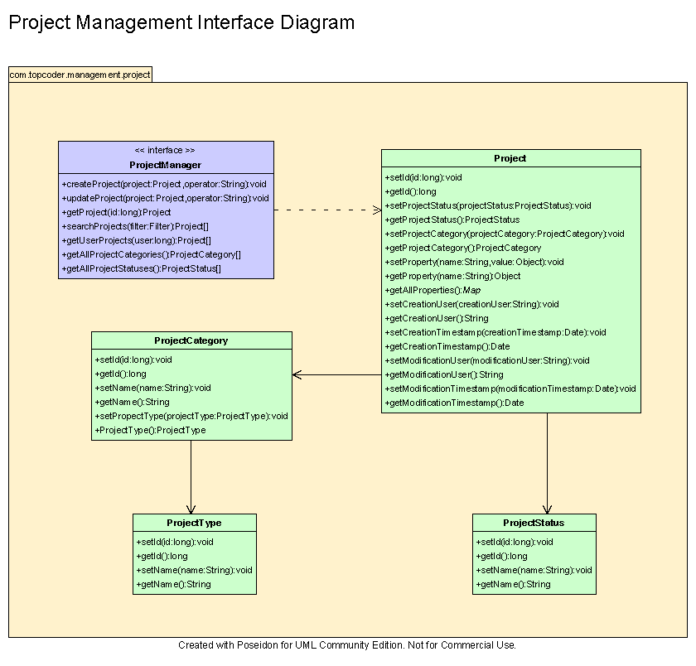

Environment Requirements
- Development language: Java1.4
- Compile target: Java1.4

Package Structure
com.topcoder.management.project

Software Requirements

Administration Requirements

What elements of the application need to be configurable?
- Database connection

Technical Constraints

Are there particular frameworks or standards that are required?
JDBC

TopCoder Software Component Dependencies:
- Configuration Manager
- DB Connection Factory
- ID Generator
- Search Builder

**Please review the TopCoder Software component catalog for existing components that can be used in the design.

Third Party Component, Library, or Product Dependencies:
None.

QA Environment:
- Solaris 7
- RedHat Linux 7.1
- Windows 2000
- Windows 2003
- Informix 10.0

Design Constraints
The component design and development solutions must adhere to the guidelines as outlined in the TopCoder Software Component Guidelines.

Database Connections
Database connections must not be cached within the component. Connections should be created for each operation and closed afterwards.

Component Scalability
The component needs to be scalable. Running multiple instances in the same JVM or in multiple JVM’s concurrently should not cause any problem.

Required Documentation

Design Documentation
- Use-Case Diagram
- Class Diagram
- Sequence Diagram
- Component Specification

Help / User Documentation
- Design documents must clearly define intended component usage in the ‘Documentation’ tab of Poseidon.

