Resource Management v1.1 Requirements Specification

Scope

Overview
The component provides resource management functionalities. A resource can be optionally associated with a project, phase and submission. Each resource will have a role which identifies the resource’s responsibilities for the associated scope. A set of resources can be created, updated or searched for a project. Also notifications can be assigned and unassigned to users. The resource persistence logic is pluggable.

The main purpose of upgrading this component is to allow Resources to have more than one submission. Note that the Changes to the 1.0 version are noted in RED for new functionality.

Logic Requirements

Resource Entity
A resource will be associated with a role, optionally a project, a phase, a list of submissions, as well as some extended properties. Please refer to 2.1.2 for details.

Resource Operations
Despite manipulation of the resource structure defined above, this component will support the following operations.

Update Resource
An existing resource can be updated. Resource should be validated according to the defined rules.

The operator needs to be provided for auditing purpose.

Update Project Resources
An array of resources can be updated for a specified project. The identifiers of any new resources will be provided with ID Generator. Existing resource should continue to use the original identifiers. Other resources for the project not specified in the array should be deleted. Resources should be validated according to the defined rules.

The operator needs to be provided for auditing purpose.

Get Resource
A resource can be retrieved by specified identifier.

Search Resources
An array of resources can be retrieved by specified search criteria.

Resource Search Criteria
At minimum, the criteria should be capable of specifying any combination of project, phase, submissions, resource role and extended properties. There should be ways to specify resource with no project assignment, no phase assignment or no submission assignment.

All Resource Roles
There should be a way to retrieve all resource roles in the system.

Add Notifications
A notification entry will associate a user external ID with a project and notification type. The operation should be able to add multiple external ID’s to the same project and notification type.

The operator needs to be provided for auditing purpose.

Remove Notifications
The operation should be able to remove multiple external ID’s from the same project and notification type.

The operator needs to be provided for auditing purpose.

Get Notifications
The operation should be able to retrieve all external ID’s associated with a project and notification type.

All Notification Types
There should be a way to retrieve all notification types in the system.

Search Builder Usage
Search Builder should be used with the searching functionality. Only the identifiers of the entities should return from the Search Builder. Convenient methods should be provided to create the applicable filters.

Persistence
Persistence needs to be pluggable. For this release an Informix plug-in will be developed. The SQL scripts will be provided.

Persistence Implementation
The persistence implementation needs to be designed in this component, but will be separated into a second development project. Please put all persistence implementation related information into a separate sub-package and clearly mark the responsibilities of the two development projects.

Required Algorithms
No specific algorithms are required.

Example of the Software Usage
A project management application can use the component as a model layer. Customer specific information can be stored as extended properties.

Future Component Direction
None.

Interface Requirements

Graphical User Interface Requirements
None.

External Interfaces
Design must adhere to the interface diagram definition. Designer can choose to add more methods to the classes/interfaces, but must keep the ones defined on the diagram as a minimum. Source files can be found in the distribution.

Resource Role
A resource will be associated with a resource role. A resource role consists of
ID a numeric identifier
Name name of the scorecard type for display purpose
Phase Type a resource role could be optionally confined to a phase type. For
instance, an approver only applies to a certain approval phase. This
could be represented as a numeric identifier.

Resource
A resource consists of
ID a numeric identifier
Role each resource will have a resource role
Project a resource could be optionally associated with a project. This could be
represented as a numeric identifier.
Phase a resource should be associated with a phase if the corresponding
resource role is associated with a phase type. This could be represented
as a numeric identifier.
Submissions a resource could be optionally associated with a submission list. This
could be represented as a list of numeric identifiers.
Extended Properties each resource will maintain a set of unordered extended properties

Auditing Fields
Resource must also include auditing fields of creation/modification operator and timestamp. These fields will not be provided by component users.
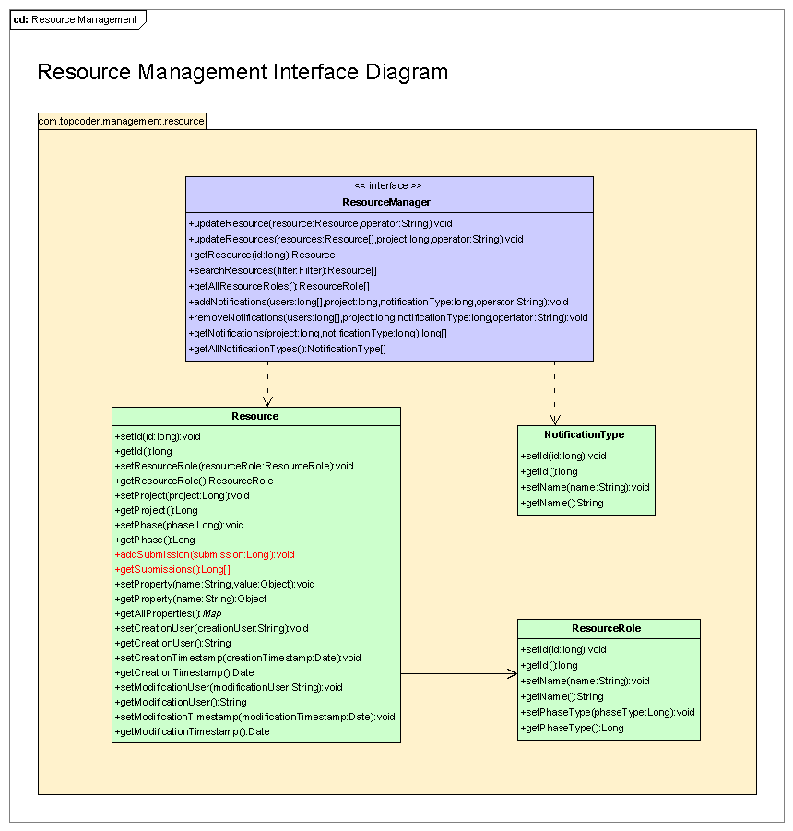

Environment Requirements
- Development language: Java 1.4
- Compile target: Java 1.4

Package Structure
com.topcoder.management.resource

Software Requirements

Administration Requirements

What elements of the application need to be configurable?
- Database connection

Technical Constraints

Are there particular frameworks or standards that are required?
JDBC

TopCoder Software Component Dependencies:
- Configuration Manager
- DB Connection Factory
- ID Generator
- Search Builder

**Please review the TopCoder Software component catalog for existing components that can be used in the design.

Third Party Component, Library, or Product Dependencies:
None.

QA Environment:
- Solaris 7
- RedHat Linux 7.1
- Windows 2000
- Windows 2003
- Informix 10.0

Design Constraints
The component design and development solutions must adhere to the guidelines as outlined in the TopCoder Software Component Guidelines.

Database Connections
Database connections must not be cached within the component. Connections should be created for each operation and closed afterwards.

Component Scalability
The component needs to be scalable. Running multiple instances in the same JVM or in multiple JVM’s concurrently should not cause any problem.

Required Documentation

Design Documentation
- Use-Case Diagram
- Class Diagram
- Sequence Diagram
- Component Specification

Help / User Documentation
- Design documents must clearly define intended component usage in the ‘Documentation’ tab of Poseidon.

