

Communications & System
Integration

Operational Analyst

Cradle to Grave Report Offering

Author

Viplav Fauzdar
Principal Consultant
Avaya CSI
678-421-5214 (V/F)
fauzdar@avaya.com

Table of Contents

Cradle to Grave Report 3
Report Input 3
Report Output 5
Call Data 5
Call Detail 5
Revision Log 8

Figure 1: Report Input 3
Figure 2: Report Input 4
Figure 3: Report Output 5
Figure 4: Report Output 6
Figure 5: Report Output 7

Cradle to Grave Report
The purpose of this document is to outline a Cradle to Grave Report for an implementation of Interaction Center and Operational Analyst with IR customizations. The report will contain certain input parameters and the output will display call detail data including the external call history data from the Call Management System, along with relevant IC repository data and the custom IR data being gathered by IC and stored in the custom fields in the repository database. The detailed description of the data elements is included in the design as follows. The aforementioned cradle to grave reporting was developed using the OA Basic Reporting Tool and will be available to run via the OA Basic Reporting Website. Please refer to the screen shots below for the report appearance and the data elements.

Report Input
The report input page allows the user to input for a number of search parameters as shown in the screen shots below. The input parameter for the report would generally consist of the following and can be modified depending on specific requirements.

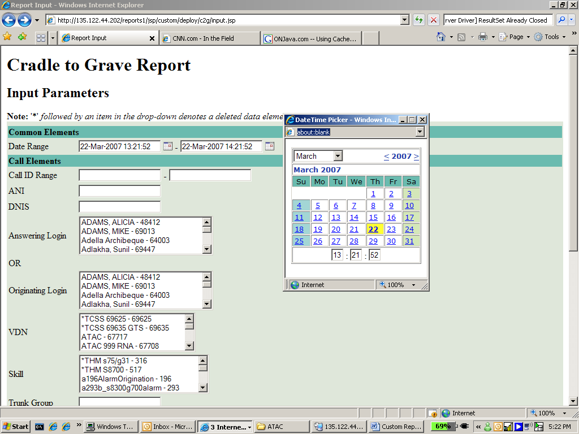
Figure 1: Report Input

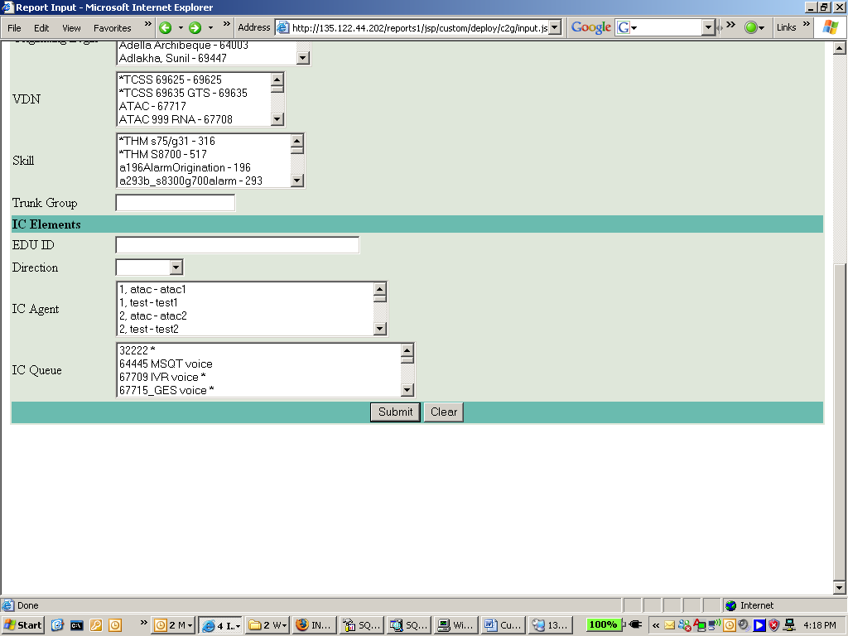
Figure 2: Report Input

Report Output
Based on the combination of the input parameters selected above the report output would be generated. The report output would comprise of four groups of data elements, along with displaying the input parameters selected on the input page. The screen shot below shows what the report output would look like and the actual report might vary in the look and feel and actual data elements.

Call Data
This group would show the first segment of all the calls retrieved from the database based on the input criteria. It would allow the user to see a summary of all the call records pulled from the database based on the input criteria. The call id would be a hyper link clicking on which, will pop up a new window with actual cradle to grave call details. The call data elements would consist of the following basic data elements.

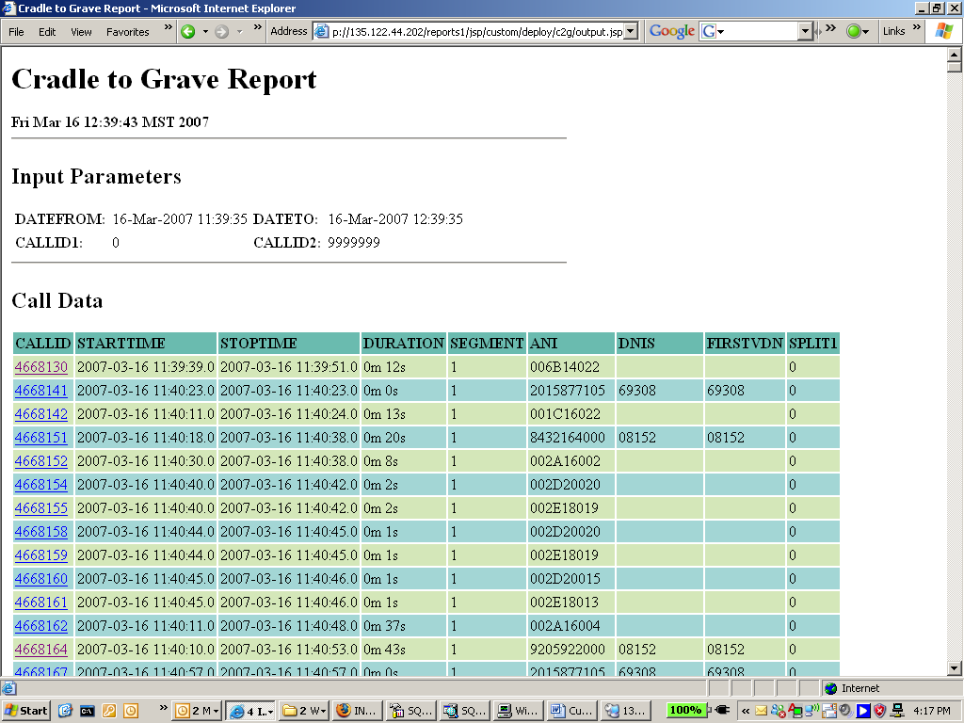
Figure 3: Report Output

Call Detail
The call detail would comprise of the cradle to grave call detail and would be broken down into the segment data as obtained from OA and thus the CMS and the IR and IC data as obtained from IC repository.

Segment Data
This group would consist of all the segments of the call displayed as columns of data. The data elements displayed for the segment would be as follows.

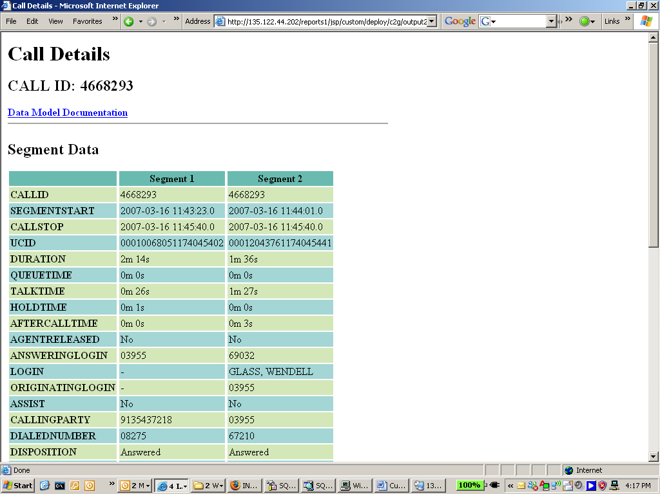
Figure 4: Report Output

IC Data
This section would consist of the IC data for this call with all its segments displayed as columns of data. The data elements would comprise of the following.

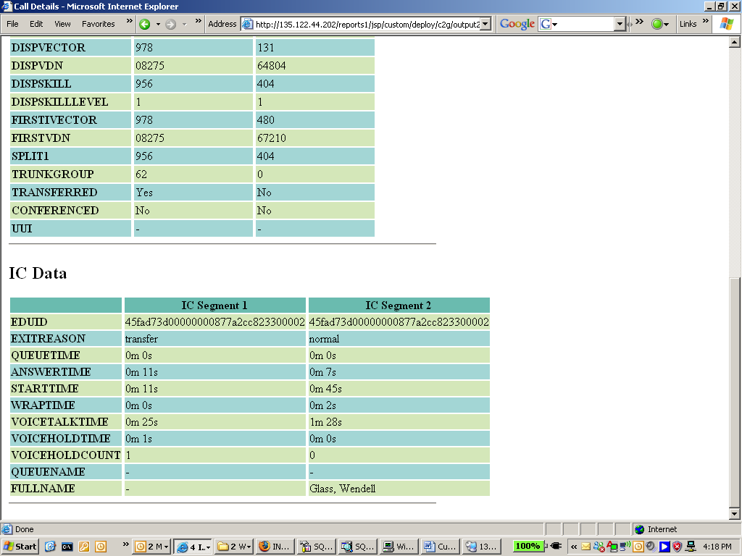
Figure 5: Report Output

Revision Log
ID | Date | Author | Comments
1 | 07/28/2008 | Viplav Fauzdar

