**Team Name** : Code of Duty

**Team Members** :

Kavila Sushant : RA2011003010480

Bhaskar: RA2011003010490

Viplav Sharma : RA2011003010647

Sourabh Nahar : RA2011003010675

Topic : Ethereum Blockchain Smart Contract

We have created a website based on web3 and blockchain which enables us to store digital assets and also enables us to perform transactions using it.

In creating this project we have used various tools such as :

Solidity, Hardhat, Metamask, Tailwind CSS, Next.js

We have created and implemented two smart contracts in our code:

One is to create the asset and the other is to list the object for sale and do other transactions based on the assets.

While creating this we have thought of various points that should be taken care of such as :

1. A token id will be generated on every transaction that will represent the authenticity of the transaction.
2. A major important point that is taken car of is that the person who will enlist the asset should not be able to buy its asset as it would lead to malpractices.
3. We require metamask authentication for the user to login into its account.
4. One of the cool features of our web app is that a user can see all the history of transactions that he/she has performed.

Considering the time crunch we have implemented as much as features as we were able to.

The website was deployed on localhost:3000.

The images of the website are as follows:

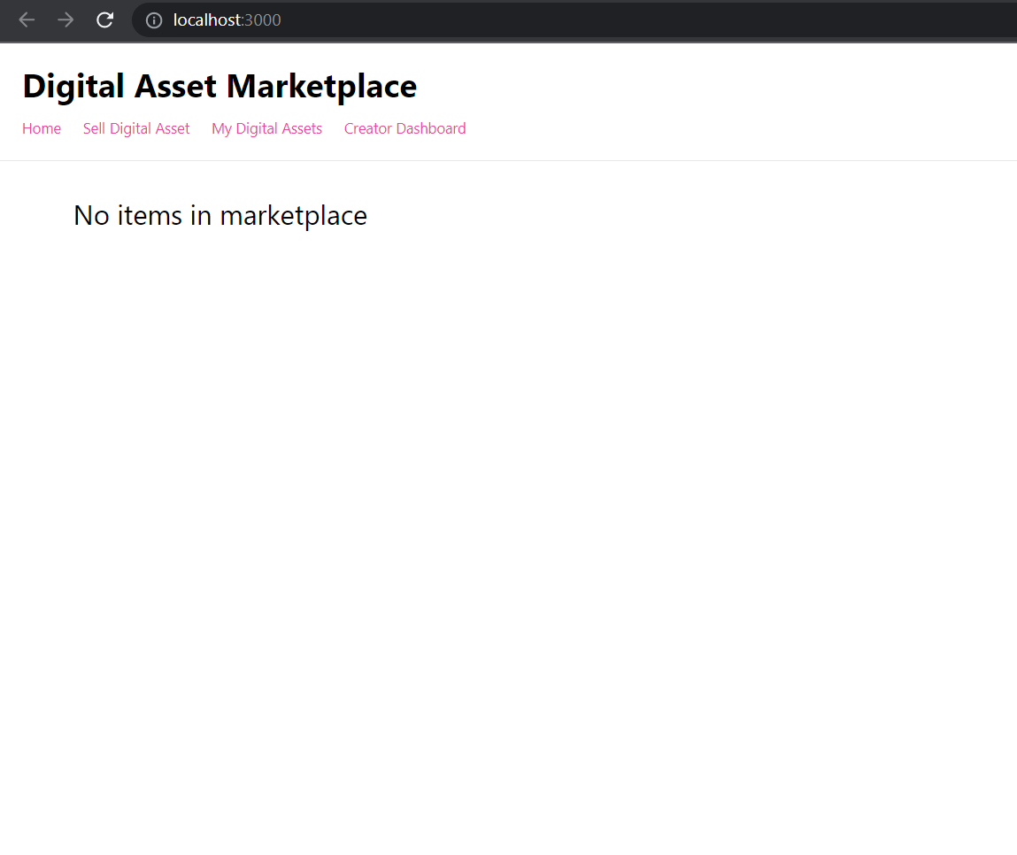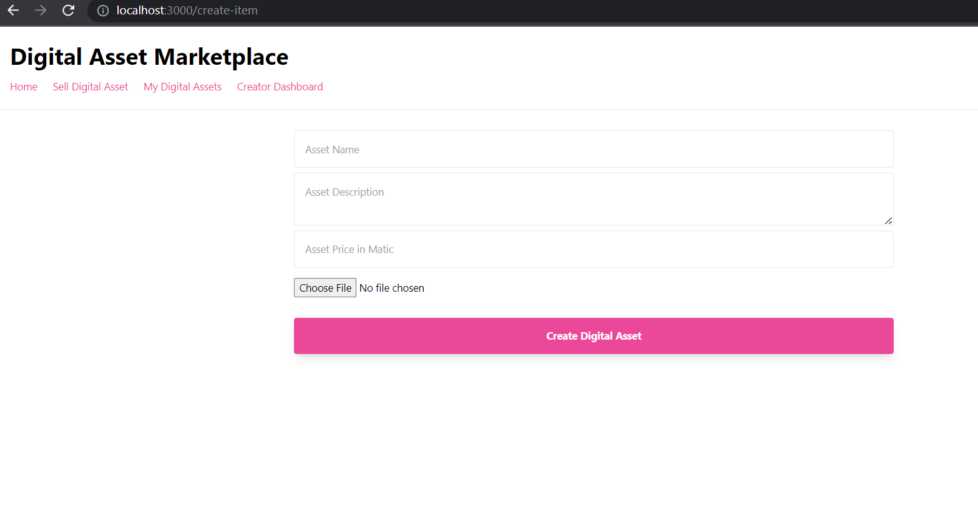

This is the page to upload the assets and create a selling price for it.

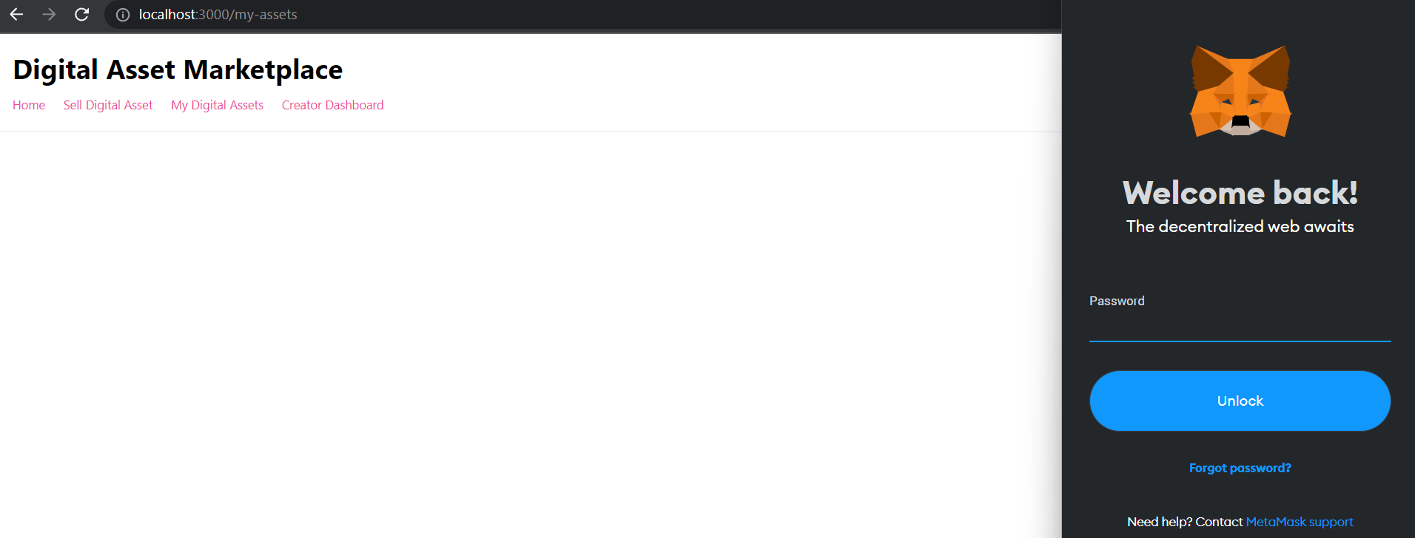

This page is connected with the metamask wallet to show the digital assets owned by the user.

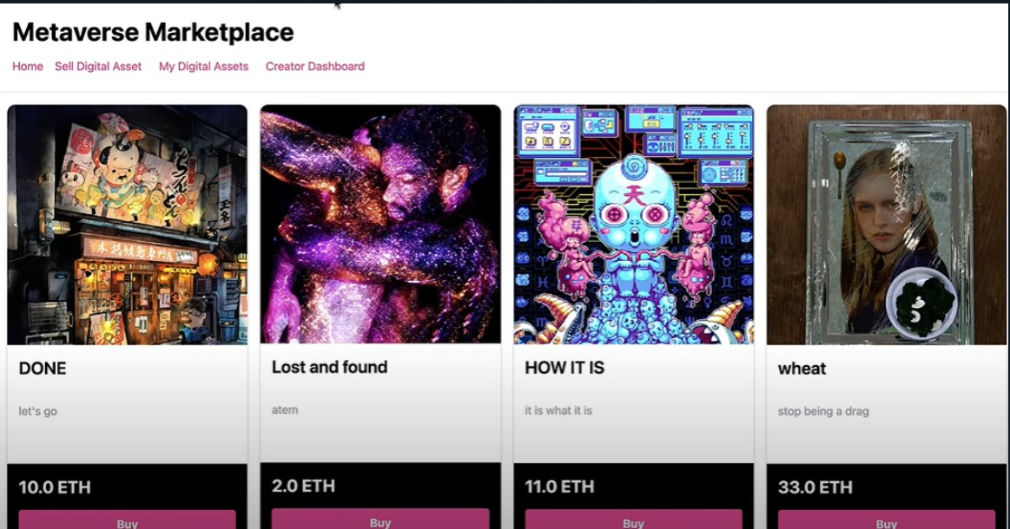

This is the final image of the website after uploading of the digital assets.

We have also tried to implement the dark mode in our user interface :

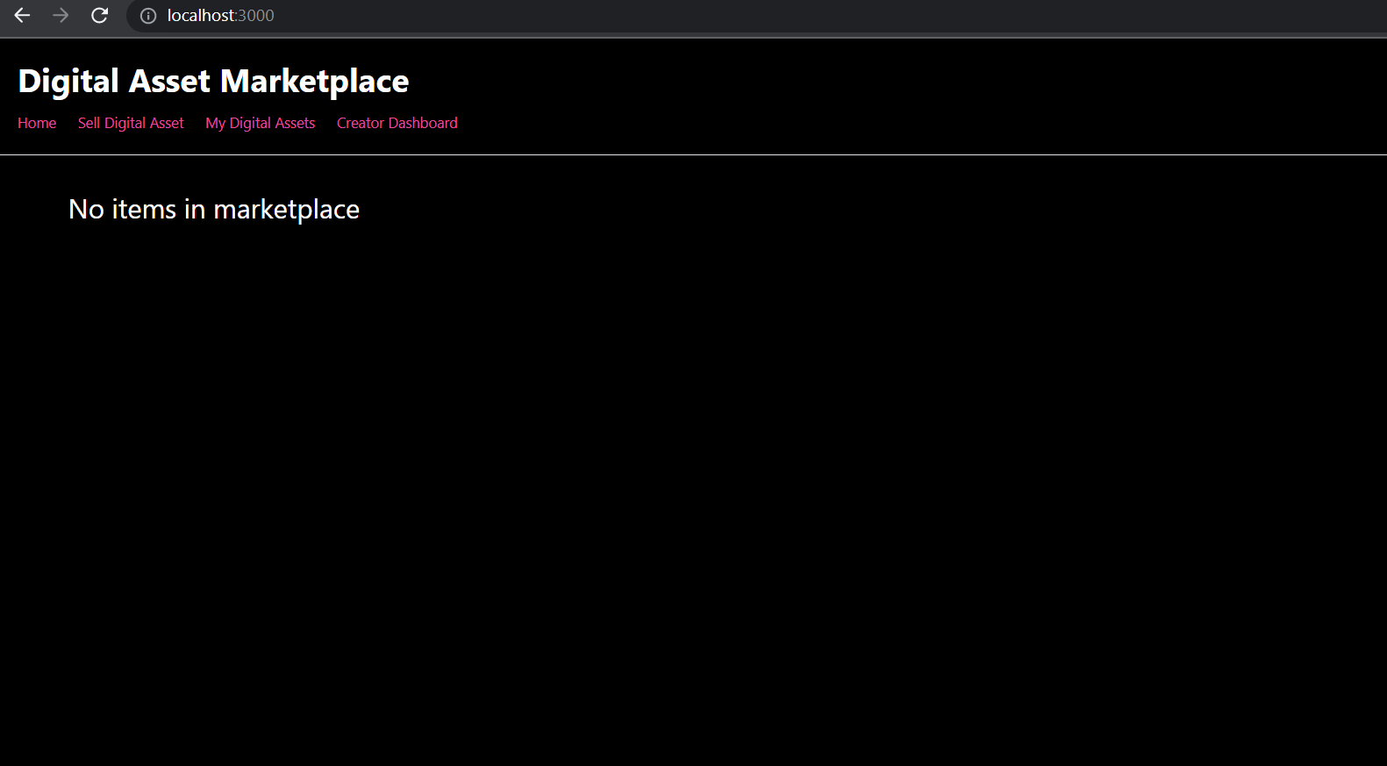

Thank You