Computer Vision Assignment

Ground and Noise Filtering

Task Description

Ground and noise filtering is one of the most important task in ADAS system.

Your task is given a point cloud data, remove the ground and noise points.

There are a wide range of methods to achieve this varying from using simple filters sequentially to many deep learning methods. We are sharing a bag file that contains 176 messages of point cloud data. Write a code that subscribes to the point cloud topic and publishes the filtered point cloud data.

Here is how the input point cloud looks like

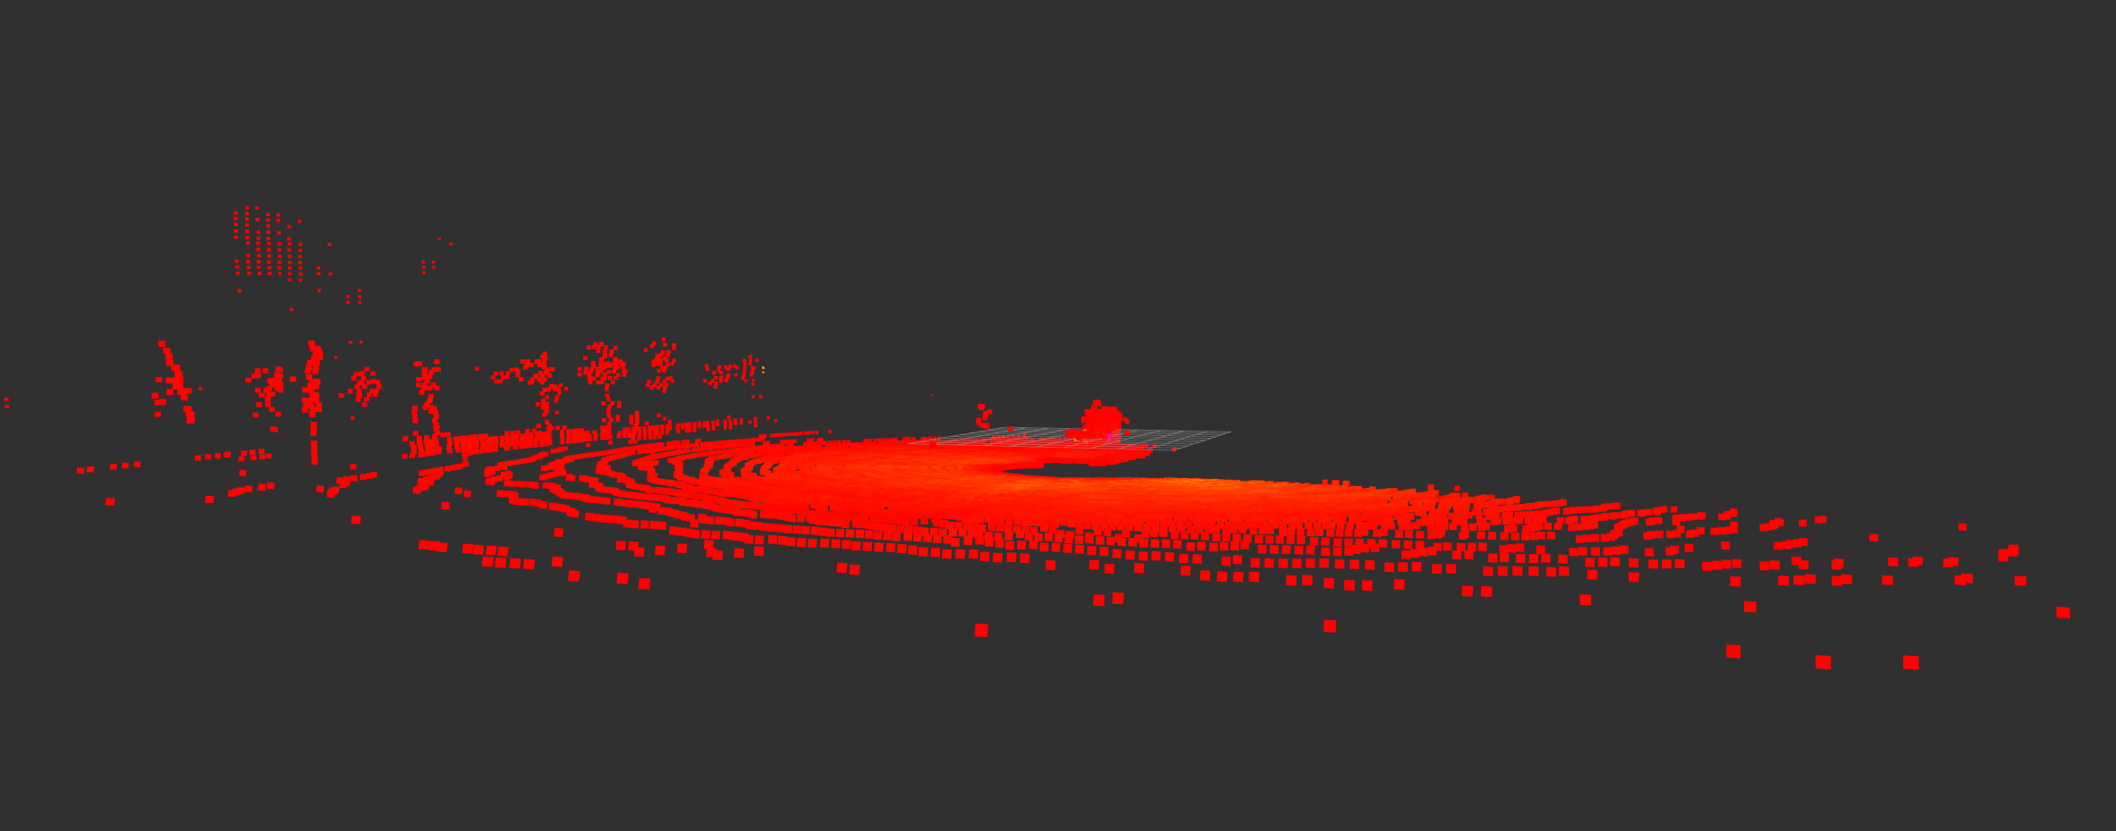

Other than the ground you need to even filter the noise in the point cloud data that looks something like this

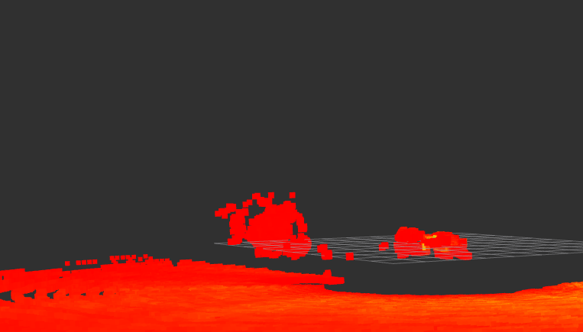

But make sure the point cloud data of the trees and building are not removed.

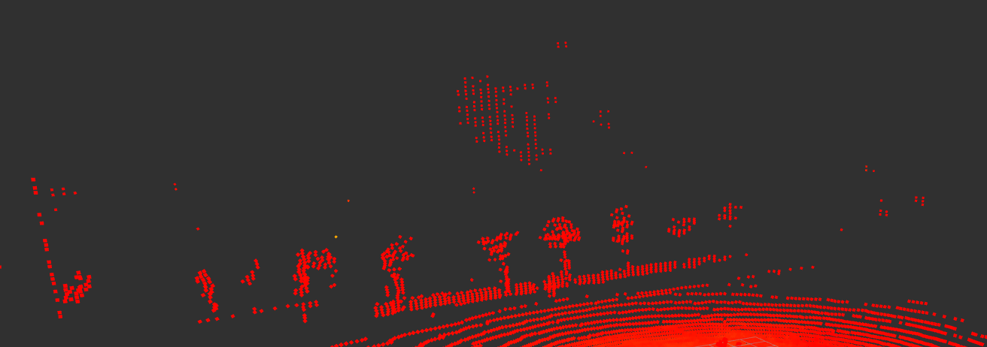

This data should not be filtered.

The Bag file can be found here : [LINK](https://tiiuae-my.sharepoint.com/:u:/g/personal/sai_avula_tii_ae/EdlcX5-f9WNAjy7ahwvrtgUBhgtemGnp6OMPV0KxtSw_YQ?e=v1L7mC)

Extra Info

Libraries like PCL, OPEN3D, OPENMMLAB and many others can be used.

Languages and Frameworks recommended

C++ or Python.

ROS framework.

You are free to use any libraries for this.

Notes

* We highly appreciate the results analyzed and provide us with the analysis report.
* The **accuracy of the result is not the most important part**, but the reasoning and decisions taken to implement the methodology are.
* Even if the implementation is not done, the strategy and methodology is welcome.

## If you have any questions/concerns, please do not hesitate to reach out to us. All the best!!