|  |  |
| --- | --- |
| **4COSC006C: Software Development I – Retake Coursework specification (2024/25)** | |
| Module leader | Guhanathan Poravi |
| Weighting: | 50% |
| Qualifying mark: | 30% |
| Description: | Coursework |
| Learning Outcomes Covered in this Assignment: | The coursework rationale is:  **LO1** Analyse specific problems and design their solutions by applying appropriate algorithmic techniques;  **LO2** Apply programming concepts to implement solutions in the taught programming language;  **LO3** Implement and manipulate simple data structures;  **LO4** Use an integrated development environment to create programs to satisfy a simple specification. |
| Handed Out: | Monday 25th Aug 2025 |
| Due Date: | **Coursework Deadline**: Monday 8th Sep 2025 **BEFORE** 1:00 pm |
| Expected deliverables: | a) Submit your Python program code  **Important: Submit a single python code file to run in IDLE** **shell** using the name convention: “student_id.py”, e.g. w1234567.py **- DO NOT** submit your code as a word, notepad or PDF document. **-**You **do not** need to submit the **graphics.py** module or any CSV files |
| Method of Submission: | Submitted online via Blackboard |
| Type of Feedback and Due Date: | Written feedback and marks 15 working days (3 weeks) after the submission deadline. All marks will remain provisional until formally agreed by an Assessment Board. |

**Assessment regulations**

Refer to the following for clarification on what constitutes plagiarism, collusion and penalties for late submissions.

This is an individual coursework. You should not share your coursework or parts of your coursework with another student as this can cause you both to receive an allegation of collusion: https://www.westminster.ac.uk/current-students/guides-and-policies/academic-matters/academic misconduct/collusion Clarification on what constitutes plagiarism: https://www.westminster.ac.uk/current-students/guides-andpolicies/academic-matters/academic misconduct/plagiarism

**Penalty for Late Submission**

If you submit your coursework late but within 24 hours or one working day of the specified deadline, 10 marks will be deducted from the final mark, as a penalty for late submission, except for work which obtains a mark in the range 40 – 49%, in which case the mark will be capped at the pass mark (40%). If you submit your coursework more than 24 hours or more than one working day after the specified deadline you will be given a mark of zero for the work in question unless a claim of Mitigating Circumstances has been submitted and accepted as valid.

It is recognised that on occasion, illness or a personal crisis can mean that you fail to submit a piece of work on time. In such cases you must inform the Campus Office in writing on a mitigating circumstances form, giving the reason for your late or non-submission. You must provide relevant documentary evidence with the form. This information will be reported to the relevant Assessment Board that will decide whether the mark of zero shall stand. For more detailed information regarding University Assessment Regulations, please refer to the following website[: **http://www.westminster.ac.uk/study/current-students/resources/academic-regulation**](http://www.westminster.ac.uk/study/current-students/resources/academic-regulation)

This document contains:

* Coursework Brief and Description
* Important Notes on Your Submission
* CW Specification Tasks A to E
* Example of a successful code run
* Mark Scheme.

**1. Coursework Brief and Description:**

A European Airports Survey has collected a number of datasets detailing air traffic departures from a number of European airports for the same single twelve-hour period over the last 25 years.

The data has been tabulated and saved as *.CSV* files (**test CSV files** are supplied – each one for a particular 12-hour period at a single Airport in a particular year).

You have been tasked with writing a program which analyses the data and returns selected information to allow the council to make informed decisions on European Air traffic.

Your program should allow the user to select and load **any** single CSV file (not just those supplied) as long as it has the correct structure and naming convention (Airport Code and year). It should *validate* the users file selection input as being in the correct format. **(Task A).** It should analyse the data and summarise the specific outcomes required **(Task B).** It should also save the outcome results as a text file **(Task C)** and use the ‘graphics.py’ module to display the results of some specific analysis in graphical form **(Task D: Histogram).**

# The CSV files

The data structure of the csv files is shown below with *each row* representing *one aircraft* departing the selected airport at a specific time over a 12hr period in the selected year (**below is just the first two rows as an example, see the supplied CSV files for full data list**).

|  |  |  |  |  |  |  |  |  |  |
| --- | --- | --- | --- | --- | --- | --- | --- | --- | --- |
| **Table1 – example of CSV data structure (two rows only)** | | | | |  |  |  |  |  |
| **Airport Code** | **Flight**  **Num** | **Scheduled Departure** | **Actual**  **Departure** | **Destination** | **Distance miles** | **Scheduled**  **Arrival** | **Actual Arrival** | **Runway Num** | **Weather Conditions** |
| **CDG** | AY929 | 00:32 | 00:32 | BCN | 713 | 02:42 | 02:42 | 1 | 18°C light rain |
| **CDG** | FR235 | 00:37 | 00:43 | CDG | 216 | 01:57 | 01:59 | 2 | 18°C light rain |

**Meaning of the Elements in Each Row (all are *string* data types)**

1. **AirportCode:** The selected departure airport’s three letter code (this is the same for all rows).
2. **FlightNum:** The flight Number of the departing aircraft, the *first tw*o characters are the *airline code* (see table 3).
3. **ScheduledDeparture:** Scheduled time of departure of this aircraft.
4. **ActualDeparture:** Actual departure time of the aircraft (same as Scheduled departure if aircraft departed on time)
5. **Destination**: The three-letter airport code of the destination airport (see table 2)
6. **Distance miles:** The distance in miles from the current airport to the destination airport.
7. **ScheduledArrival:** Scheduled arrival time of the aircraft.
8. **ActualArrival:** Actual arrival time of the aircraft (same as Scheduled Arrival if the aircraft arrived on time).
9. **RunwayNum:** Departing runway number.
10. **WeatherConditions:** Temperature and weather for the hour of departure.

You are provided with a template python file (“cw_template.py”) which *already loads* one of the supplied CSV files and converts the full dataset to a nested python list.

**You should start with this template,** rename and edit it to create your solution.

You are also provided with CSV files to use for testing purposes (these may not be the ones used to test your solution).

**For any CSV files to be imported by your python file, they must be saved in the same directory (folder) as your python file.**

# Important Notes on Your Submission

**The code to load a CSV file and add it to a python list is already included and is executed by the template. You should gather and process the data from *this* list in your solution (the list is called ‘data_list’ in the template). You do not need to access any elements directly from the CSV file again once it has been loaded into data_list (until you load an entire new file).**

**Your submitted python file must run stand alone in the Idle Shell window when downloaded to a folder containing the appropriate CSV files and the graphics.py module (please check this before submission).**

* Use user-defined functions in your solution as appropriate (use docstring to add function description comments).
* Use descriptive names for your variables and functions.
* Comment your code extensively with descriptive comments explaining the code usage and structure.
* Reference within your code any code adapted from external or other sources.
* Use only the **“graphics.py”** module to render the histogram.
* You should not use any libraries or modules not already included in the template to complete your solution.
* The documentation for the graphics.py module is included in the brief folder.

The **only** **airports** for which data has been collected, are shown in the table below

|  |  |
| --- | --- |
| **Table 2 – All airport codes used in the survey** | |
| **Airport Code** | **Full Airport Name** |
| LHR | London Heathrow |
| MAD | Madrid Adolfo Suárez-Barajas |
| CDG | Charles De Gaulle International |
| IST | Istanbul Airport International |
| AMS | Amsterdam Schiphol |
| LIS | Lisbon Portela |
| FRA | Frankfurt Main |
| FCO | Rome Fiumicino |
| MUC | Munich International |
| BCN | Barcelona International |

The **only** **airlines** for which data has been collected, are shown in the table below

|  |  |
| --- | --- |
| **Table 3 - all airline IATA codes used in the survey** | |
| **IATA Code** | **Full Airline Name** |
| BA | British Airways |
| AF | Air France |
| AY | Finnair |
| KL | KLM |
| SK | Scandinavian Airlines |
| TP | TAP Air Portugal |
| TK | Turkish Airlines |
| W6 | Wizz Air |
| U2 | easyJet |
| FR | Ryanair |
| A3 | Aegean Airlines |
| SN | Brussels Airlines |
| EK | Emirates |
| QR | Qatar Airways |
| IB | Iberia |
| LH | Lufthansa |

# The Project Tasks

## Task A. Input Validation (15 marks)

The template uses a string variable called ‘**selected_data_file’** set to a fixed, hard coded CSV file name (which is one of the supplied files - “CDG2021.csv”. This CSV contains a deliberately short dataset for ease of testing).

The first task is to adapt and re-write this code such that the user may input **any** valid three letter departure *city code* followed by *any* valid *year* integer value and the application will load anyappropriate CSV file in the same folder that has the correct naming format and data structure.

**Note: Your code does not need to check whether or not a selected csv file exists in the folder.**

This should be achieved using two prompts (validating the input each time). So, for example, if the user enters BCN to the first prompt and 2023) to the second, the program should load the file *BCN2023.csv* (the CSV with the data for Barcelona airport from 2023).

* For the city code prompt: The program should display “**Wrong code length - please enter a three-letter city code**” if the input is not three characters long.
* The program should display “**Unavailable city code - please enter a valid city code**” if the input is not

one of the city codes in table 2.

* For the year prompt: the program should display “**Wrong data type - please enter a four-digit year value**” if the input is not a four-digit value (for example letters instead of integers).
* The program should display “**Out of range - please enter a value from 2000 to 2025**” if the input falls before 2000 or later than 2025.

### Other validation

* For task D (histogram) the program should validate the *airline code* input by checking that the entry is one of the airlines included in the data (see table 3) and ask the user to re-enter the code if it is not.
* For Task E (loop code task) the program should validate “Y” to load new dataset or “N” to quit.

Your solution should be able to accept and process valid city and airline codes even if they are input as lower case. **You should Include code to catch and convert lower case le2er input.**

Your program should then show the selected file name *Full* airport name and year before returning the Task 2 ‘outcomes’ data (see example run below).

**An Example of the Program Valida>on Task Running with User Input (shown in bold):**

#### INPUT prompts

Please enter the three-letter code for the departure city required:**BCNE**

Wrong code length - please enter a three-letter city code:**XCH**

Unavailable city code - please enter a valid city code:**bcn <-**allow for lowercase entry

Please enter the year required in the format YYYY:**March**

Wrong data type - please enter a four-digit year value:**1997**  Out of range - please enter a value from 2000 to 2025:**2024**

#### OUTPUT

********************************************************************

File BCN2024.csv selected - Planes departing Barcelona airport 2024.

********************************************************************

The variable “selected_data_file” should now be set to BCN2024.csv

## Task B. Outcomes (25 marks)

The program should now process the data from the list ‘data_list’ calculate the results outcomes below and show them clearly to the shell window.

### The specific information required to be extracted from the selected CSV

1. **The total number of departure flights recorded in the 12-hour period.**
2. **The total number of flights taking off from runway 1.**
3. **The total number of departures of flights that are over 500 miles.**
4. **The *total number* of departure flights by British Airways aircraft.**
5. **The total number of flights departing in rain.**
6. **The average number of departures per hour (rounded to two decimal places).**
7. **The *percentage* of total departures that are Air France aircraft (rounded to two decimal places).**
8. **The *percentage* of flights with delayed departures (rounded to two decimal places).**
9. **The total number of hours of rain in the twelve hours (rain values are recorded once every hour).**
10. **The long name of the *most* common destination (or names if more than one).**

### Format for Task B results

The output to the shell window for task B should be formatted as below

*********************************************************************************

File CDG2022.csv selected - Planes departing Charles De Gaulle International 2022

*********************************************************************************

The total number of flights from this airport was 31

The total number of flights departing Runway one was 22

The total number of departures of flights over 500 miles was 22

There were 4 British Airways flights from this airport

There were 13 flights from this airport departing in rain

There was an average of 2.58 flights per hour from this airport

Air France planes made up 19.35% of all departures

25.81% of all departures were delayed There were 5 hours in which rain fell

The most common destinations are ['Amsterdam Schiphol', 'Lisbon Portela']

## Task C. Save Results as a Text File (10 Marks)

The program should collect The Selected airport name, year and all of the “outcomes” (part B) results.

It should then save them to a text file with the filename “results.txt” in the format shown below.

When task E (Loop the program, load process a new CSV file) is implemented, the new results should be *added* to the existing results.txt file *without* overwriting the previously saved data.

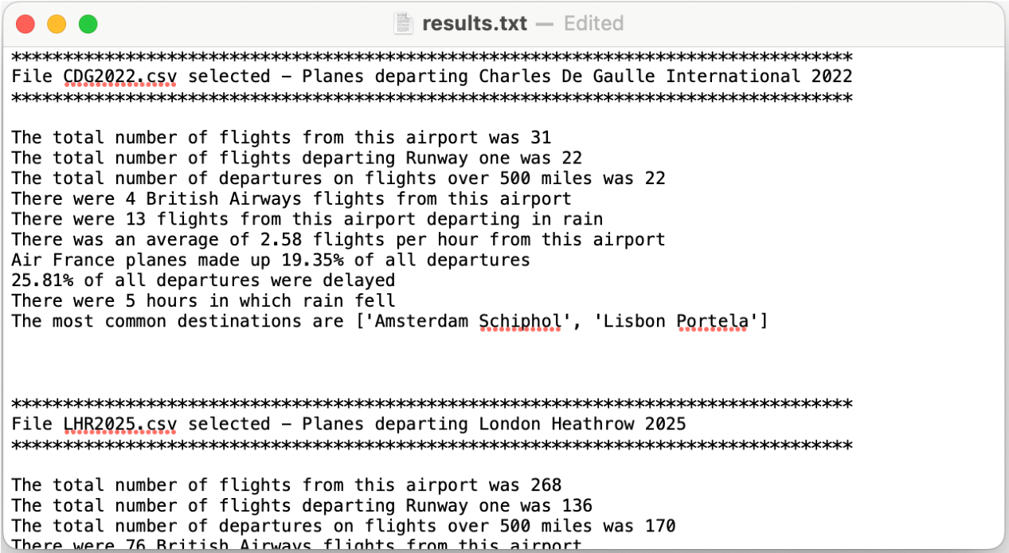

## Task D) Histogram (25 marks)

The program should now prompt:

Enter a two-character Airline code to plot a histogram:

The program should verify that the airline code entered is one of the valid airlines (those in table 3). If not, it should return.

Unavailable Airline code please try again.

Enter the two-character Airline code to plot a histogram:

When a valid code is entered, use the **“graphics.py”** module to pop up a window with a full histogram of the data.

The histogram should show the **total** **number of departing flights for the *selected* airline, for each hour of the twelve-hour survey** including numerical values for the number of flights each hour

The histogram should also include a title with the *full* selected **airline** name, the *full* departure airport name and the year of the CSV (see image below - results shown are illustrative only)

It should scale depending on the highest number of flights in a single hour so that it can accommodate any number of flights. It should make good use of colour and be clear and legible.

It *must* use the **graphics.py** module ***(do not use any other graphing module for this task)***.

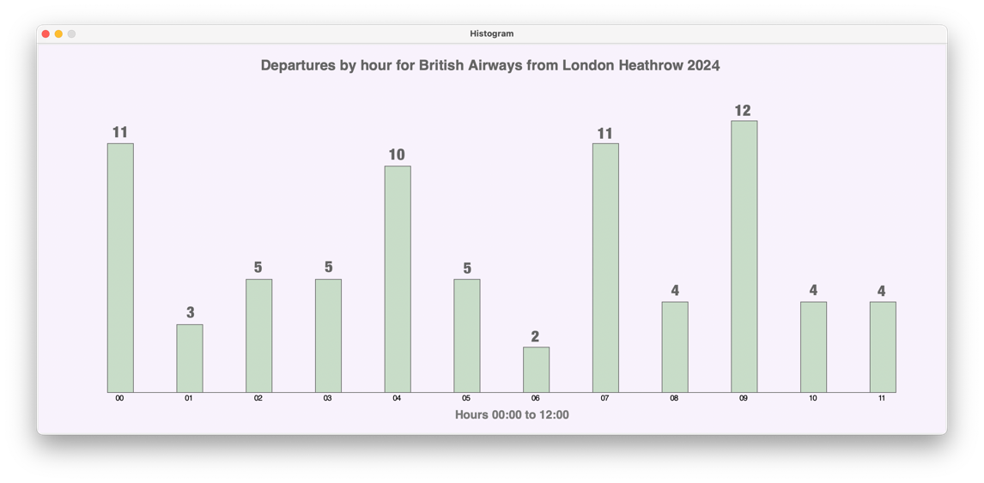

## Task E) Program Loops on Request and Loads a New CSV file (10 Marks)

The program should then allow the user to select a **new** data set (CSV) for a different city code and year input and run a new analysis. A>er the first run has completed, it should ask…

Do you want to select a new data file? Y/N:

If the user inputs **“Y”**, The program should clear all data from the previous run (and clear data-list) and re-run to import and process the data from a new CSV file selected by the user. It should then output the new results (updaGng the text file). The program should loop and process any loaded CSV files unGl the user enters **‘N’** to the quesGon “Do you want to select a new data file? Y/N”.

**You should Include code to catch lower case le2er input.**

# Example of a Single Full Code Run (user inputs shown in bold)

## INPUT prompts

Please enter the three-letter code for the departure city required:**BCNE**

Wrong code length - please enter a three-letter city code:**XCH**

Unavailable city code - please enter a valid city code:**LHR**

Please enter the year required in the format YYYY:**March**

Wrong data type - please enter a four-digit year value:**1997**

Out of range - please enter a value from 2000 to 2025:**2024**

## OUTPUT

********************************************************************** File LHR2024.csv selected - Planes departing London Heathrow 2024.

**********************************************************************

The total number of flights from this airport was 268.

The total number of flights departing Runway one was 136.

The total number of departures on flights over 500 miles was 170

There were 76 British Airways flights from this airport.

There were 120 flights from this airport departing in rain There was an average of 22.33 flights per hour from this airport.

Air France planes made up 16.79% of all departures.

29.48% of all departures were delayed.

There were 5 hours in which rain fell

The most common destination is ['Frankfurt Main']

<-save outcomes to a text file now

## INPUT prompt

Enter a two-character Airline code to plot a histogram:**QU**

Unavailable Airline code please try again:**BA**

## OUTPUT (pop up window)

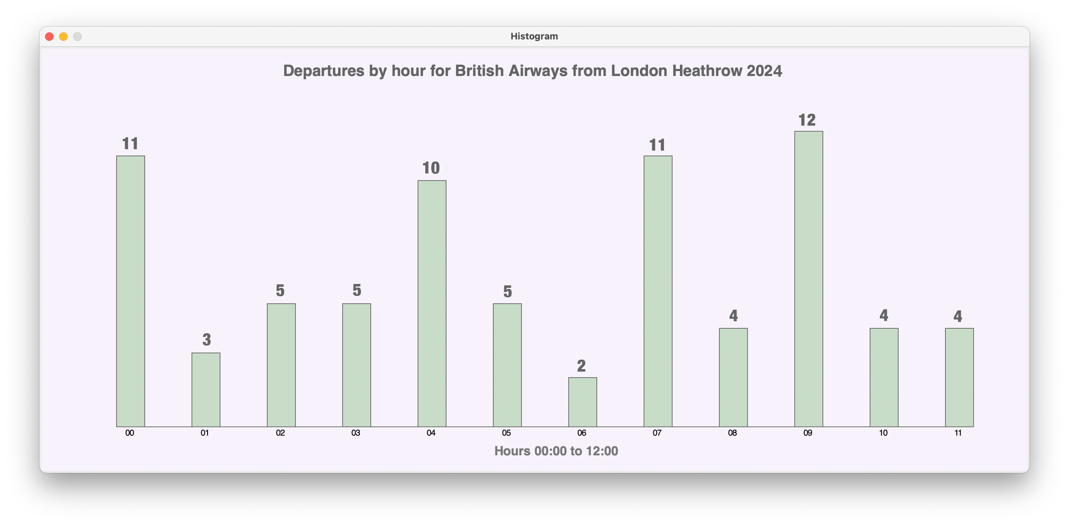

**INPUT prompt**

Do you want to select a new data file? Y/N:**N**

## OUTPUT

Thank you. End of run

# Mark Scheme

## ****Task A: Validation (15 Marks)****

**A1 – Airport Code Validation (3 marks)**

1. Detects wrong code length (not 3 chars) → **1 mark**
2. Detects invalid code not in Table 2 → **1 mark**
3. Displays clear error message & re-prompts → **1 mark**

**A2 – Year Validation (3 marks)**  
4. Detects wrong data type (non-integer) → **1 mark**  
5. Detects year out of range (not 2000–2025) → **1 mark**  
6. Displays clear error message & re-prompts → **1 mark**

**A3 – File Loading (4 marks)**  
7. Correctly concatenates airport + year into filename → **1 mark**  
8. Successfully loads CSV into program → **1 mark**  
9. Stores dataset in correct structure (data_list) → **1 mark**  
10. Displays confirmation (airport full name + year) → **1 mark**

**A4 – Airline Code Validation (3 marks)**  
11. Detects invalid airline code (not in Table 3) → **1 mark**  
12. Displays error message & re-prompts → **1 mark**  
13. Accepts lowercase and converts to uppercase → **1 mark**

**A5 – Loop Input Validation (2 marks)**  
14. Accepts Y and reruns program → **1 mark**  
15. Accepts N and ends program (case-insensitive) → **1 mark**

## ****Task B: Output Outcomes (25 Marks)****

**B1 – Correct Outcomes (20 marks, 2 marks each)**  
16. Total number of flights calculated correctly → **2 marks**  
17. Flights departing Runway 1 calculated correctly → **2 marks**  
18. Flights over 500 miles calculated correctly → **2 marks**  
19. British Airways flights counted correctly → **2 marks**  
20. Flights departing in rain counted correctly → **2 marks**  
21. Average departures per hour (2dp) → **2 marks**  
22. % Air France flights (2dp) → **2 marks**  
23. % delayed flights (2dp) → **2 marks**  
24. Total hours of rain → **2 marks**  
25. Most common destination(s) with full name(s) → **2 marks**

**B2 – Output Formatting (5 marks)**  
26. Outputs displayed with explanatory text → **1 mark**  
27. Results formatted consistently (matches example) → **1 mark**  
28. Clear separation between results and inputs → **1 mark**  
29. Headings/titles used for clarity → **1 mark**  
30. Layout easy to read and interpret → **1 mark**

## ****Task C: Saving Results (10 Marks)****

**C1 – Save Results (6 marks)**  
31. Creates results.txt → **1 mark**  
32. Includes selected airport name → **1 mark**  
33. Includes selected year → **1 mark**  
34. Includes all calculated outcomes → **2 marks**  
35. Results formatted clearly in file → **1 mark**

**C2 – Append Functionality (4 marks)**  
36. Appends new results instead of overwriting → **2 marks**  
37. Results from multiple runs saved sequentially → **2 marks**

## ****Task D: Histogram (25 Marks)****

**D1 – Input Handling (2 marks)**  
38. Prompts for 2-char airline code → **1 mark**  
39. Correctly stores and uses airline input → **1 mark**

**D2 – Title & Labels (6 marks)**  
40. Title includes airline full name → **2 marks**  
41. Title includes airport full name → **2 marks**  
42. Title includes year → **1 mark**  
43. Title displayed clearly in window → **1 mark**

**D3 – X-axis Label (2 marks)**  
44. X-axis label present → **1 mark**  
45. Axis formatted correctly (hours shown) → **1 mark**

**D4 – Bar Accuracy (7 marks)**  
46. Bars for each of 12 hours present → **2 marks**  
47. Bar heights reflect correct counts → **2 marks**  
48. Numerical values displayed on bars → **2 marks**  
49. No missing/misplaced bars → **1 mark**

**D5 – Scaling (4 marks)**  
50. Bars auto-scale to fit window → **2 marks**  
51. Bars remain visible and proportional → **2 marks**

**D6 – User Experience (4 marks)**  
52. Colours used effectively → **1 mark**  
53. Bars visually distinct → **1 mark**  
54. Text/labels clearly legible → **1 mark**  
55. Overall histogram easy to interpret → **1 mark**

## ****Task E: Program Loop (10 Marks)****

**E1 – Loop Control (2 marks)**  
56. Accepts Y to load new file → **1 mark**  
57. Accepts N to quit program gracefully → **1 mark**

**E2 – New Run Handling (8 marks)**  
58. Clears previous data before rerun → **2 marks**  
59. Loads new CSV file correctly → **2 marks**  
60. Produces new outputs accurately → **2 marks**  
61. Appends new run results to results.txt → **2 marks**

## ****Good Programming Practice (15 Marks)****

**P1 – Naming & Comments (5 marks)**  
62. Variables named descriptively → **1 mark**  
63. Functions named descriptively → **1 mark**  
64. Docstrings included → **1 mark**  
65. Code commented meaningfully → **1 mark**  
66. Comments explain why, not just what → **1 mark**

**P2 – Structure & Style (10 marks)**  
67. Uses functions for modularity → **2 marks**  
68. Functions avoid excessive repetition → **2 marks**  
69. Loops used effectively → **2 marks**  
70. Conditionals structured clearly → **2 marks**  
71. Program runs without errors/crashes → **2 marks**