Name: Vipparthi Navadeep
Roll No: 2520030019
1. Basic Webpage Design
Problem Statement:
Design a simple HTML webpage that displays your name, a brief introduction, and uses different heading levels, paragraph tags, and text formatting tags such as bold, italic, and underline.
<!DOCTYPE html>
<html>
<head>
<title>My Simple Webpage</title>
</head>
<body>
<h1>Introduction</h1>
<h2>About Me</h2>

<p>
Hello! My name is <b>Navadeep</b>. I am a student who is interested in
<i>web development</i> and learning new technologies.
</p>

<h3>My Interests</h3>

<p>
I enjoy <b>coding</b>, <i>problem solving</i>, and exploring
<u>new ideas</u> in technology.
</p>

<h4>Goal</h4>

<p>
My goal is to become a <b><i>skilled developer</i></b> and build
useful applications for people.
</p>

</body>
</html>

Output:
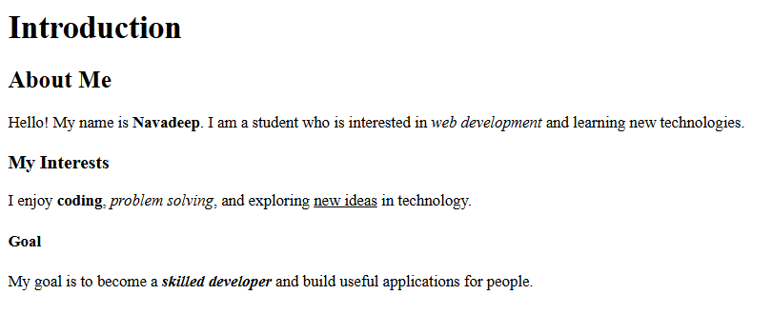

2. Time Table Creation
Problem Statement:
Create an HTML webpage to display a weekly class timetable using a table. Use appropriate table attributes including rowspan and colspan to structure the schedule properly.
<!DOCTYPE html>
<html>
<head>
<title>TimeTable</title>
<style>
th {
background: grey;
}
table {
margin: 30px auto;
border-collapse: collapse;
width: 80%;
}
h1 {
text-align: center;
}
th, td {
text-align: center;
border: 2px solid #333;
padding: 10px;
}
.break {
background: lightcoral;
font-weight: bold;
}
</style>
</head>
<body>

<h1>My TimeTable</h1>

<table>
<tr>
<th>Day</th>
<th>1</th>
<th>2</th>
<th>3</th>
<th>4</th>
<th class="break">Break</th>
<th>5</th>
<th>6</th>
<th>7</th>
<th>8</th>
</tr>

<tr>
<th>Monday</th>
<td colspan="2">DSA</td>
<td colspan="2">Java</td>
<td class="break" rowspan="6">Break</td>
<td colspan="2">Sports</td>
<td colspan="2">FEDF</td>
</tr>

<tr>
<th>Tuesday</th>
<td colspan="2">Java</td>
<td colspan="2">DSA</td>
<td colspan="2">Library</td>
<td colspan="2">CFAI</td>
</tr>

<tr>
<th>Wednesday</th>
<td colspan="2">CFAI</td>
<td colspan="2">Sports</td>
<td colspan="2">DSA</td>
<td colspan="2">Coding</td>
</tr>

<tr>
<th>Thursday</th>
<td colspan="2">Coding</td>
<td colspan="2">DSA</td>
<td colspan="2">Library</td>
<td colspan="2">CFAI</td>
</tr>

<tr>
<th>Friday</th>
<td colspan="2">DSA</td>
<td colspan="2">Coding</td>
<td colspan="2">Library</td>
<td colspan="2">CFAI</td>
</tr>

<tr>
<th>Saturday</th>
<td colspan="2">FEDF</td>
<td colspan="2">DSA</td>
<td colspan="2">Coding</td>
<td colspan="2">Library</td>
</tr>

</table>

</body>
</html>

Output:
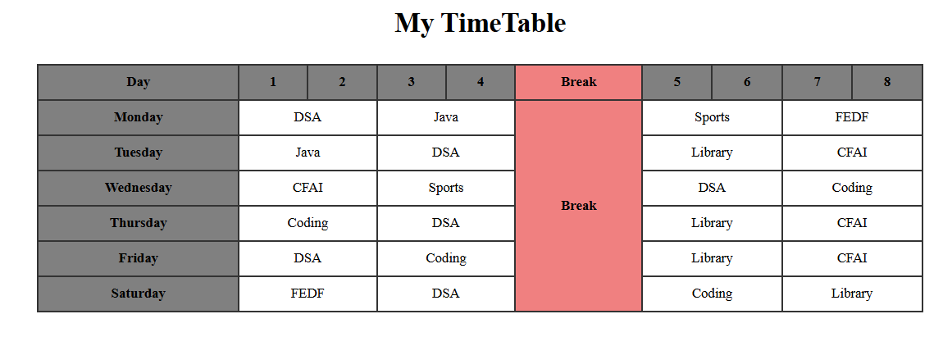

3. Resume Page
Problem Statement:
Develop a personal resume webpage using HTML that includes sections such as career objective, educational qualifications, technical skills, and hobbies.
<!DOCTYPE html>
<html>
<head>
<title>Resume</title>
<style>
body {
font-family: Arial;
margin: 30px;
background-color: #f2f2f2;
}

h1 {
text-align: center;
color: darkblue;
}

h2 {
color: #333;
border-bottom: 1px solid gray;
}

p, li {
font-size: 16px;
}
</style>
</head>

<body>

<h1>My Resume</h1>
<h1>Vipparthi Navadeep</h1>
<h2>Career Objective</h2>
<p>To get a good job and improve my skills.</p>

<h2>Educational Qualifications</h2>
<ul>
<li>10th - Kennedy High - The Magnet School</li>
<li>Intermediate - Narayana JR College</li>
<li>B-Tech - KLH Bachuppaly</li>
</ul>

<h2>Technical Skills</h2>
<ul>
<li>HTML</li>
<li>Basic CSS</li>
<li>Java Basics</li>
<li>C Language</li>
</ul>

<h2>Hobbies</h2>
<ul>
<li>Reading</li>
<li>Playing Games</li>
<li>Listening to Music</li>
</ul>

</body>
</html>

Output:


4. Hyperlink Navigation
Problem Statement:
Create multiple HTML pages and implement navigation between them using hyperlinks. Include both internal links (within the website) and external links (to other websites).
<!DOCTYPE html>
<html>
<head>
<title>About</title>
</head>
<body>

<h1>About Me</h1>

<a href="index.html">Home</a> |
<a href="about.html">About</a> |
<a href="contact.html">Contact</a>

<hr>
<p>
Hello! My name is <b>Navadeep</b>. I am a student who is interested in
<i>web development</i> and learning new technologies.
</p>

<p>This page contains information about me.</p>

</body>
</html>

<!DOCTYPE html>
<html>
<head>
<title>Home</title>
</head>
<body>

<h1>Welcome to My Website</h1>

<a href="index.html">Home</a> |
<a href="about.html">About</a> |
<a href="contact.html">Contact</a>

<hr>

<p>This is the home page.</p>

<h3>External Links</h3>
<a href="https://www.google.com" target="_blank">Visit Google</a><br>
<a href="https://www.wikipedia.org" target="_blank">Visit Wikipedia</a>

</body>
</html>
<!DOCTYPE html>
<html>
<head>
<title>Contact</title>
</head>
<body>

<h1>Contact Me</h1>

<a href="index.html">Home</a> |
<a href="about.html">About</a> |
<a href="contact.html">Contact</a>

<hr>

<p>Email: Student@gmail.com</p>

</body>
</html>

Output:
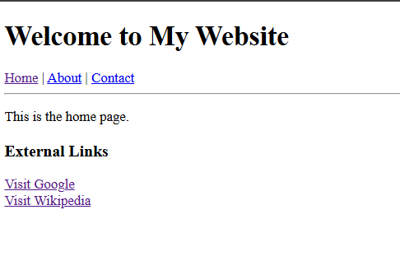
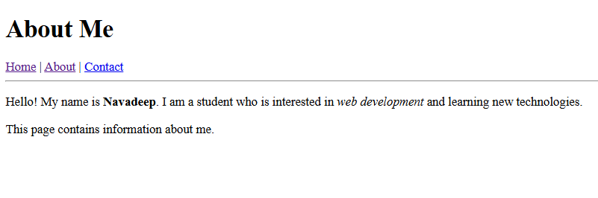
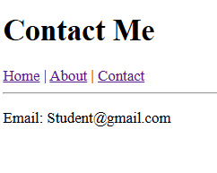

5. Image Gallery
Problem Statement:
Design an image gallery webpage that displays at least five images with captions. Arrange them neatly using basic HTML elements.
<!DOCTYPE html>
<html lang="en">
<head>
<meta charset="UTF-8">
<title>Nature Photography Gallery</title>
<style>
body {
font-family: 'Segoe UI', Tahoma, Geneva, Verdana, sans-serif;
background-color: #f4f4f4;
display: flex;
flex-direction: column;
align-items: center;
padding: 20px;
}

.gallery-container {
display: grid;
grid-template-columns: repeat(auto-fit, minmax(250px, 1fr));
gap: 20px;
max-width: 1200px;
width: 100%;
}

figure {
background: white;
margin: 0;
padding: 10px;
border-radius: 8px;
box-shadow: 0 4px 6px rgba(0,0,0,0.1);
transition: transform 0.2s;
}

figure:hover {
transform: translateY(-5px);
}

img {
width: 100%;
height: 200px;
object-fit: cover;
border-radius: 4px;
}

figcaption {
margin-top: 10px;
text-align: center;
font-weight: bold;
color: #333;
}
</style>
</head>
<body>

<h1>Global Landscapes</h1>
<hr style="width: 50%; margin-bottom: 30px;">

<div class="gallery-container">
<figure>
<img src="https://images.unsplash.com/photo-1464822759023-fed622ff2c3b?auto=format&fit=crop&w=400&q=80" alt="Mountain range">
<figcaption>The Misty Peaks</figcaption>
</figure>

<figure>
<img src="https://images.unsplash.com/photo-1507525428034-b723cf961d3e?auto=format&fit=crop&w=400&q=80" alt="Tropical beach">
<figcaption>Azure Shorelines</figcaption>
</figure>

<figure>
<img src="https://images.unsplash.com/photo-1441974231531-c6227db76b6e?auto=format&fit=crop&w=400&q=80" alt="Deep forest">
<figcaption>Emerald Woodlands</figcaption>
</figure>

<figure>
<img src="https://images.unsplash.com/photo-1501785888041-af3ef285b470?auto=format&fit=crop&w=400&q=80" alt="Alpine lake">
<figcaption>Crystal Waters</figcaption>
</figure>

<figure>
<img src="https://images.unsplash.com/photo-1470071459604-3b5ec3a7fe05?auto=format&fit=crop&w=400&q=80" alt="Foggy field">
<figcaption>Morning Dew</figcaption>
</figure>
</div>

</body>
</html>
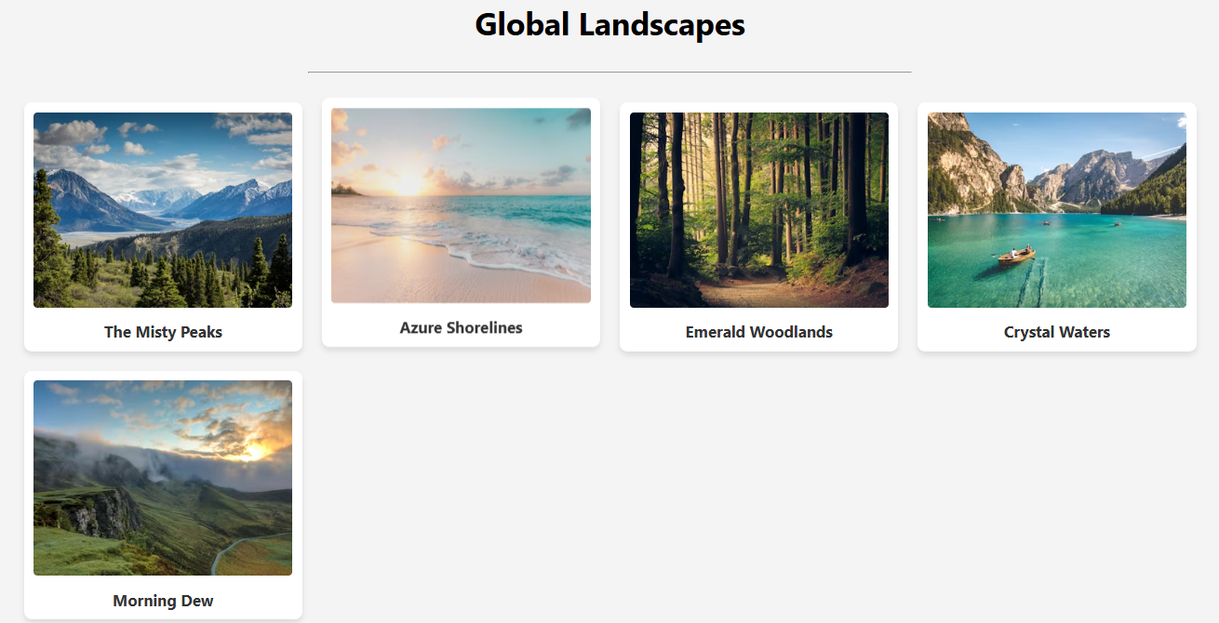
6. Lists Demonstration
Problem Statement:
Create a webpage demonstrating ordered lists, unordered lists, and nested lists to represent structured information.
<!DOCTYPE html>
<html>
<head>
<title>Lists Example</title>
</head>

<body>

<h1>HTML Lists Demonstration</h1>

<!-- Ordered List -->
<h2>Steps to Make Tea (Ordered List)</h2>
<ol>
<li>Boil water</li>
<li>Add tea powder</li>
<li>Add milk</li>
<li>Add sugar</li>
<li>Serve hot</li>
</ol>

<!-- Unordered List -->
<h2>Fruits (Unordered List)</h2>
<ul>
<li>Apple</li>
<li>Banana</li>
<li>Mango</li>
<li>Orange</li>
</ul>

<!-- Nested List -->
<h2>Subjects and Topics (Nested List)</h2>
<ul>
<li>Maths
<ul>
<li>Algebra</li>
<li>Geometry</li>
</ul>
</li>

<li>Science
<ul>
<li>Physics</li>
<li>Chemistry</li>
</ul>
</li>

<li>Computer
<ul>
<li>HTML</li>
<li>Programming</li>
</ul>
</li>
</ul>

</body>
</html>

Output:
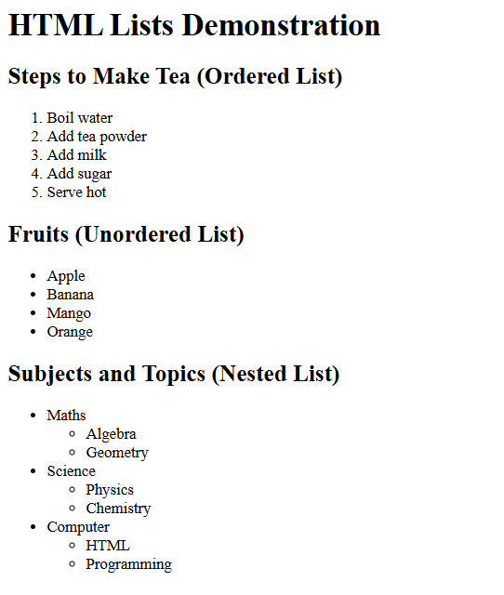

7. Student Registration Form
Problem Statement:
Design an HTML form for student registration that includes input fields such as name, email, gender, course selection, hobbies, and submit/reset buttons.
<!DOCTYPE html>
<html>
<head>
<title>Student Registration</title>
</head>
<body>

<h2>Student Registration Form</h2>

<form>
Name: <br>
<input type="text"><br><br>

Email: <br>
<input type="email"><br><br>

Gender: <br>
<input type="radio" name="gender"> Male
<input type="radio" name="gender"> Female<br><br>

Course: <br>
<select>
<option>B.Tech</option>
<option>B.Sc</option>
<option>B.Com</option>
</select><br><br>

Hobbies: <br>
<input type="checkbox"> Reading
<input type="checkbox"> Sports
<input type="checkbox"> Music<br><br>

<input type="submit" value="Submit">
<input type="reset" value="Reset">
</form>

</body>
</html>
Output:
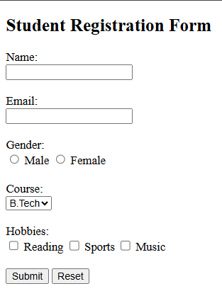

8. Webpage Styling
Problem Statement:
Apply CSS styles to an HTML page to enhance its appearance by modifying text colors, font styles, background colors, and alignment.
<!DOCTYPE html>
<html>
<head>
<title>Styled Page</title>
<style>
body {
background-color: #f0f8ff;
font-family: Arial, sans-serif;
text-align: center;
}

h1 {
color: darkblue;
}

p {
color: #333;
font-size: 18px;
}

.box {
background-color: white;
width: 300px;
margin: 20px auto;
padding: 15px;
border: 2px solid #ccc;
border-radius: 10px;
}

button {
background-color: green;
color: white;
padding: 10px;
border: none;
}
</style>
</head>
<body>

<h1>Welcome</h1>

<div class="box">
<p>This is a simple styled webpage using CSS.</p>
<button>Click Me</button>
</div>

</body>
</html>
Output:
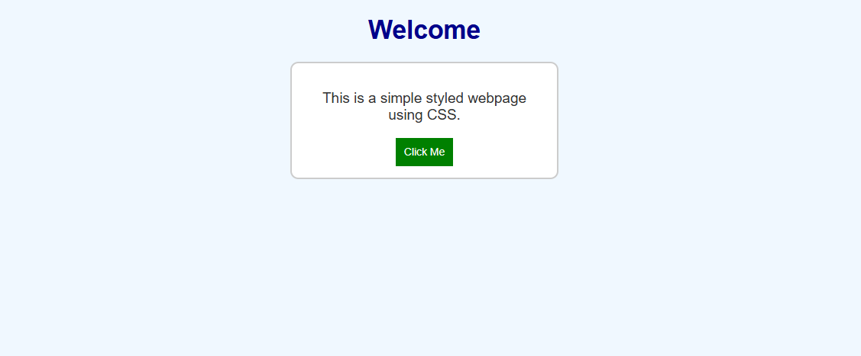

9. Box Model Demonstration
Problem Statement:
Create a webpage to demonstrate the CSS box model by applying margin, padding, and borders to different elements and explaining their visual effect.
<!DOCTYPE html>
<html>
<head>
<title>CSS Box Model Demo</title>
<style>
body {
font-family: Arial;
text-align: center;
}

.box {
width: 250px;
background-color: lightblue;

/* Box Model Properties */
border: 5px solid blue;
padding: 20px;
margin: 30px auto;
}

.margin {
background-color: lightgreen;
margin: 40px;
padding: 10px;
border: 2px solid green;
}

.padding {
background-color: lightcoral;
padding: 30px;
border: 2px solid red;
}
</style>
</head>
<body>

<h2>CSS Box Model Demonstration</h2>

<div class="box">
This is the main box.<br>
Border, padding, and margin are applied.
</div>

<div class="margin">
Margin creates space outside the element.
</div>

<div class="padding">
Padding creates space inside the element.
</div>

</body>
</html>
Output:
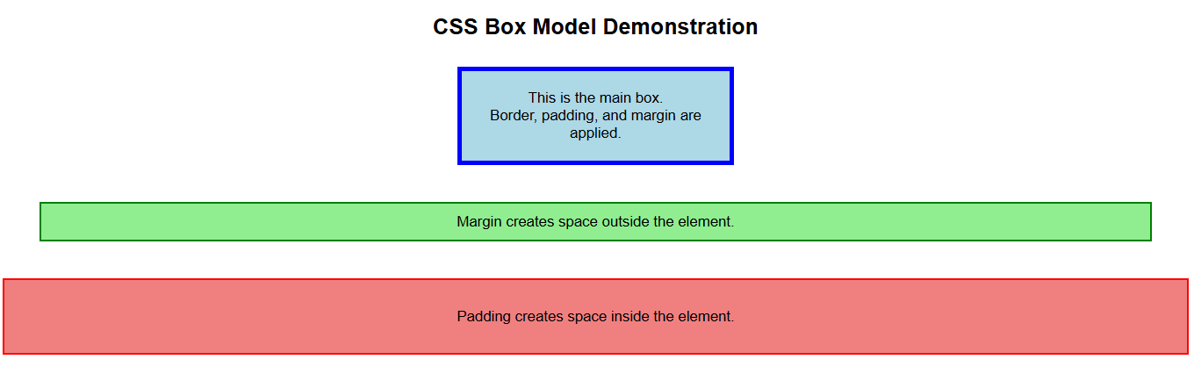
10. Navigation Bar Design
Problem Statement:
Design a horizontal navigation bar using CSS with hover effects. Include at least five menu items.
<!DOCTYPE html>
<html>
<head>
<title>Navigation Bar</title>
<style>
body {
font-family: Arial;
}

ul {
list-style-type: none;
margin: 0;
padding: 0;
background-color: #333;
overflow: hidden;
}

li {
float: left;
}

li a {
display: block;
color: white;
padding: 14px 20px;
text-decoration: none;
}

/* Hover effect */
li a:hover {
background-color: #4CAF50;
}
</style>
</head>
<body>

<ul>
<li><a href="#">Home</a></li>
<li><a href="#">About</a></li>
<li><a href="#">Courses</a></li>
<li><a href="#">Gallery</a></li>
<li><a href="#">Contact</a></li>
</ul>

</body>
</html>
Output:
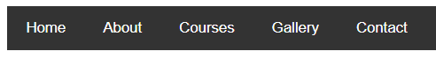
11. Responsive Layout
Problem Statement:
Develop a responsive webpage layout using CSS Flexbox or Grid that adjusts properly for desktop and mobile screen sizes.
<!DOCTYPE html>
<html>
<head>
<title>Responsive Layout</title>
<style>
body {
margin: 0;
font-family: Arial;
}

header {
background: #333;
color: white;
text-align: center;
padding: 15px;
}

.container {
display: flex;
}

.sidebar {
background: #f4f4f4;
width: 25%;
padding: 15px;
}

.content {
background: #ddd;
width: 75%;
padding: 15px;
}

footer {
background: #333;
color: white;
text-align: center;
padding: 10px;
}

/* Responsive for mobile */
@media (max-width: 600px) {
.container {
flex-direction: column;
}

.sidebar, .content {
width: 100%;
}
}
</style>
</head>
<body>

<header>
<h2>My Website</h2>
</header>

<div class="container">
<div class="sidebar">
<h3>Sidebar</h3>
<p>Links or menu here</p>
</div>

<div class="content">
<h3>Main Content</h3>
<p>This layout adjusts for mobile screens.</p>
</div>
</div>

<footer>
<p>Footer</p>
</footer>

</body>
</html>
Output:
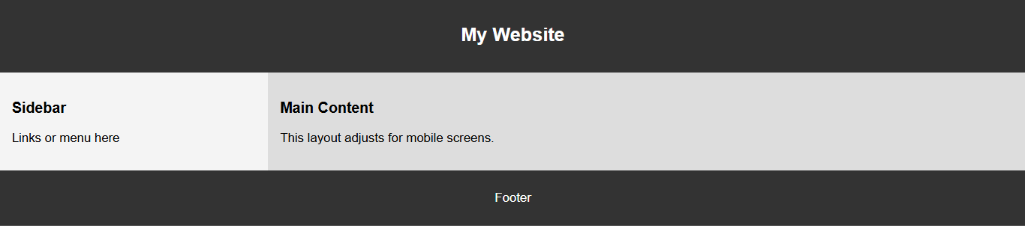
12. Card Layout Design
Problem Statement:
Create a card-based layout to display user profiles or products using CSS properties such as shadows, borders, and spacing.
<!DOCTYPE html>
<html>
<head>
<title>Card Layout</title>
<style>
body {
font-family: Arial;
background-color: #f2f2f2;
text-align: center;
}

.container {
display: flex;
justify-content: center;
flex-wrap: wrap;
}

.card {
background: white;
width: 200px;
margin: 15px;
padding: 15px;
border: 1px solid #ccc;
border-radius: 10px;
box-shadow: 2px 2px 10px rgba(0,0,0,0.2);
}

.card img {
width: 100%;
border-radius: 10px;
}

.card h3 {
margin: 10px 0;
}

.card p {
font-size: 14px;
}

.btn {
background: #4CAF50;
color: white;
padding: 8px;
border: none;
margin-top: 10px;
}
</style>
</head>
<body>

<h2>Product Cards</h2>

<div class="container">

<div class="card">
<img src="https://via.placeholder.com/200" alt="Product">
<h3>Product 1</h3>
<p>Nice product description.</p>
<button class="btn">Buy</button>
</div>

<div class="card">
<img src="https://via.placeholder.com/200" alt="Product">
<h3>Product 2</h3>
<p>Nice product description.</p>
<button class="btn">Buy</button>
</div>

<div class="card">
<img src="https://via.placeholder.com/200" alt="Product">
<h3>Product 3</h3>
<p>Nice product description.</p>
<button class="btn">Buy</button>
</div>

</div>

</body>
</html>
Output:
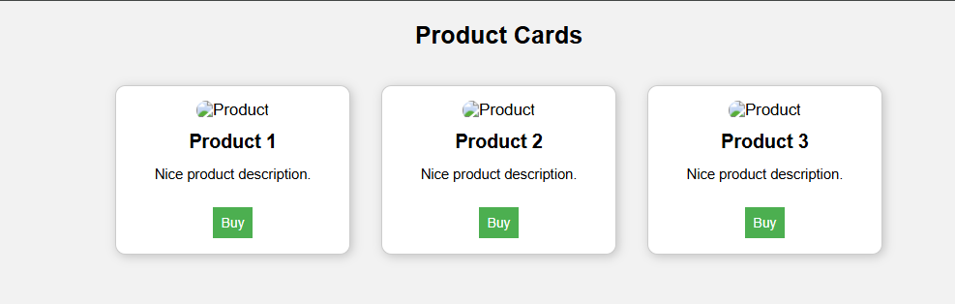
🔴
13. Simple Calculator
Problem Statement:
Develop a calculator using HTML, CSS, and JavaScript that performs basic arithmetic operations such as addition, subtraction, multiplication, and division.
<!DOCTYPE html>
<html>
<head>
<title>Calculator</title>
</head>
<body>

<h2>Simple Calculator</h2>

<input type="text" id="result"><br><br>

<button onclick="add()">+</button>
<button onclick="sub()">-</button>
<button onclick="mul()">*</button>
<button onclick="div()">/</button>

<script>
function add() {
var a = prompt("Enter first number");
var b = prompt("Enter second number");
document.getElementById("result").value = Number(a) + Number(b);
}

function sub() {
var a = prompt("Enter first number");
var b = prompt("Enter second number");
document.getElementById("result").value = a - b;
}

function mul() {
var a = prompt("Enter first number");
var b = prompt("Enter second number");
document.getElementById("result").value = a * b;
}

function div() {
var a = prompt("Enter first number");
var b = prompt("Enter second number");
document.getElementById("result").value = a / b;
}
</script>

</body>
</html>
Output:
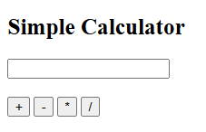

14. Form Validation
Problem Statement:
Implement client-side form validation using JavaScript to ensure that all required fields are filled correctly, including email format and password constraints.
<!DOCTYPE html>
<html>
<head>
<title>Form Validation</title>
</head>
<body>

<h2>Registration Form</h2>

<form onsubmit="return validateForm()">

Name: <br>
<input type="text" id="name"><br><br>

Email: <br>
<input type="text" id="email"><br><br>

Password: <br>
<input type="password" id="password"><br><br>

<input type="submit" value="Submit">

</form>

<script>
function validateForm() {
var name = document.getElementById("name").value;
var email = document.getElementById("email").value;
var password = document.getElementById("password").value;

// Check empty fields
if (name == "" || email == "" || password == "") {
alert("All fields are required!");
return false;
}

// Email format check
var emailPattern = /^[^ ]+@[^ ]+\.[a-z]{2,3}$/;
if (!email.match(emailPattern)) {
alert("Enter a valid email!");
return false;
}

// Password check (min 6 characters)
if (password.length < 6) {
alert("Password must be at least 6 characters!");
return false;
}

alert("Form submitted successfully!");
return true;
}
</script>

</body>
</html>
Output:
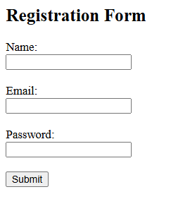

15. To-Do List Application
Problem Statement:
Create a To-Do list application where users can add, delete, and mark tasks as completed dynamically.
<!DOCTYPE html>
<html>
<head>
<title>To-Do List</title>
<style>
body {
font-family: Arial;
text-align: center;
}

input {
padding: 8px;
width: 200px;
}

button {
padding: 8px;
}

li {
margin: 10px;
list-style: none;
}

.done {
text-decoration: line-through;
color: gray;
}
</style>
</head>
<body>

<h2>To-Do List</h2>

<input type="text" id="task" placeholder="Enter task">
<button onclick="addTask()">Add</button>

<ul id="list"></ul>

<script>
function addTask() {
var taskInput = document.getElementById("task");
var taskText = taskInput.value;

if (taskText === "") {
alert("Enter a task");
return;
}

var li = document.createElement("li");

// Task text
li.innerHTML = taskText;

// Click to mark complete
li.onclick = function() {
li.classList.toggle("done");
};

// Delete button
var delBtn = document.createElement("button");
delBtn.innerHTML = "Delete";
delBtn.onclick = function() {
li.remove();
};

li.appendChild(delBtn);

document.getElementById("list").appendChild(li);

taskInput.value = "";
}
</script>

</body>
</html>
Output:
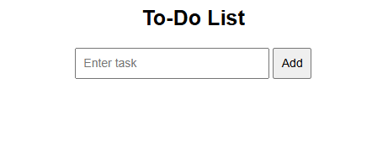
16. Digital Clock
Problem Statement:
Develop a digital clock using JavaScript that displays the current time and updates every second.
<!DOCTYPE html>
<html>
<head>
<title>Digital Clock</title>
<style>
body {
text-align: center;
font-family: Arial;
}

#clock {
font-size: 40px;
margin-top: 50px;
}
</style>
</head>
<body>

<h2>Digital Clock</h2>

<div id="clock"></div>

<script>
function showTime() {
var date = new Date();

var h = date.getHours();
var m = date.getMinutes();
var s = date.getSeconds();

// Add 0 if less than 10
if (h < 10) h = "0" + h;
if (m < 10) m = "0" + m;
if (s < 10) s = "0" + s;

document.getElementById("clock").innerHTML = h + ":" + m + ":" + s;
}

// Update every second
setInterval(showTime, 1000);

// Run once immediately
showTime();
</script>

</body>
</html>
Output:
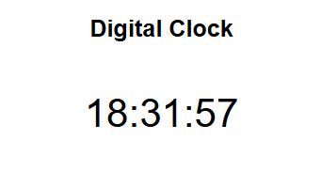
17. Image Slider
Problem Statement:
Design an image slider that allows users to navigate through images using next and previous buttons, with optional automatic sliding functionality.
<!DOCTYPE html>
<html>
<head>
<title>Image Slider</title>
<style>
body {
text-align: center;
font-family: Arial;
}

.slider {
width: 300px;
margin: 50px auto;
}

img {
width: 100%;
height: 200px;
border-radius: 10px;
}

button {
margin: 10px;
padding: 8px 15px;
}
</style>
</head>
<body>

<h2>Image Slider</h2>

<div class="slider">
<img id="slide" src="https://via.placeholder.com/300x200?text=Image+1">

<br>
<button onclick="prev()">Previous</button>
<button onclick="next()">Next</button>
</div>

<script>
var images = [
"https://via.placeholder.com/300x200?text=Image+1",
"https://via.placeholder.com/300x200?text=Image+2",
"https://via.placeholder.com/300x200?text=Image+3",
"https://via.placeholder.com/300x200?text=Image+4"
];

var index = 0;

function showImage() {
document.getElementById("slide").src = images[index];
}

function next() {
index = (index + 1) % images.length;
showImage();
}

function prev() {
index = (index - 1 + images.length) % images.length;
showImage();
}

// Auto slide every 3 seconds
setInterval(next, 3000);
</script>

</body>
</html>
Output:
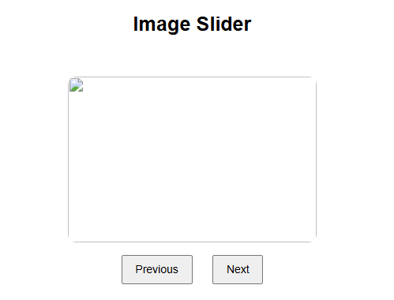
18. Student Marks Calculator
Problem Statement:
Create a program that accepts marks of multiple subjects, calculates total and average, and displays the corresponding grade.
<!DOCTYPE html>
<html>
<head>
<title>Marks Calculator</title>
</head>
<body>

<h2>Marks Calculator</h2>

Enter Marks:<br><br>

Subject 1: <input type="number" id="m1"><br><br>
Subject 2: <input type="number" id="m2"><br><br>
Subject 3: <input type="number" id="m3"><br><br>
Subject 4: <input type="number" id="m4"><br><br>
Subject 5: <input type="number" id="m5"><br><br>

<button onclick="calculate()">Calculate</button>

<h3 id="result"></h3>

<script>
function calculate() {
var m1 = Number(document.getElementById("m1").value);
var m2 = Number(document.getElementById("m2").value);
var m3 = Number(document.getElementById("m3").value);
var m4 = Number(document.getElementById("m4").value);
var m5 = Number(document.getElementById("m5").value);

var total = m1 + m2 + m3 + m4 + m5;
var avg = total / 5;

var grade;

if (avg >= 90) grade = "A";
else if (avg >= 75) grade = "B";
else if (avg >= 60) grade = "C";
else if (avg >= 40) grade = "D";
else grade = "Fail";

document.getElementById("result").innerHTML =
"Total = " + total + "<br>Average = " + avg + "<br>Grade = " + grade;
}
</script>

</body>
</html>
Output:
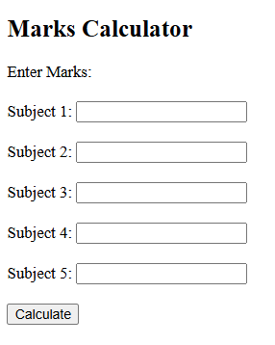

19. Quiz Application
Problem Statement:
Develop a quiz application that presents multiple-choice questions, evaluates user answers, and displays the final score.
<!DOCTYPE html>
<html>
<head>
<title>Quiz App</title>
</head>
<body>

<h2>Simple Quiz</h2>

<form id="quizForm">

<p>1. What is 2 + 2?</p>
<input type="radio" name="q1" value="3"> 3<br>
<input type="radio" name="q1" value="4"> 4<br>
<input type="radio" name="q1" value="5"> 5<br>

<p>2. Capital of India?</p>
<input type="radio" name="q2" value="Mumbai"> Mumbai<br>
<input type="radio" name="q2" value="Delhi"> Delhi<br>
<input type="radio" name="q2" value="Chennai"> Chennai<br>

<p>3. HTML stands for?</p>
<input type="radio" name="q3" value="Hyper Text Markup Language"> Hyper Text Markup Language<br>
<input type="radio" name="q3" value="High Text Machine Language"> High Text Machine Language<br>
<input type="radio" name="q3" value="Hyper Tool Multi Language"> Hyper Tool Multi Language<br>

<br>
<button type="button" onclick="checkAnswers()">Submit</button>

</form>

<h3 id="result"></h3>

<script>
function checkAnswers() {
var score = 0;

var q1 = document.querySelector('input[name="q1"]:checked');
var q2 = document.querySelector('input[name="q2"]:checked');
var q3 = document.querySelector('input[name="q3"]:checked');

if (q1 && q1.value == "4") score++;
if (q2 && q2.value == "Delhi") score++;
if (q3 && q3.value == "Hyper Text Markup Language") score++;

document.getElementById("result").innerHTML =
"Your Score: " + score + "/3";
}
</script>

</body>
</html>

Output:
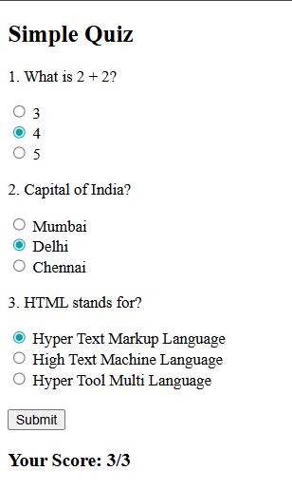

20. Popup Modal
Problem Statement:
Design a popup modal window that appears when a button is clicked and can be closed by the user.
<!DOCTYPE html>
<html>
<head>
<title>Popup Modal</title>
<style>
body {
font-family: Arial;
text-align: center;
}

/* Modal background */
.modal {
display: none;
position: fixed;
top: 0;
left: 0;
width: 100%;
height: 100%;
background: rgba(0,0,0,0.5);
}

/* Modal box */
.modal-content {
background: white;
width: 300px;
margin: 100px auto;
padding: 20px;
border-radius: 10px;
}

.close {
float: right;
cursor: pointer;
font-size: 18px;
}
</style>
</head>
<body>

<h2>Popup Modal Example</h2>

<button onclick="openModal()">Open Popup</button>

<div id="myModal" class="modal">
<div class="modal-content">
<span class="close" onclick="closeModal()">×</span>
<h3>Hello!</h3>
<p>This is a popup modal window.</p>
</div>
</div>

<script>
function openModal() {
document.getElementById("myModal").style.display = "block";
}

function closeModal() {
document.getElementById("myModal").style.display = "none";
}
</script>

</body>
</html>
Output:
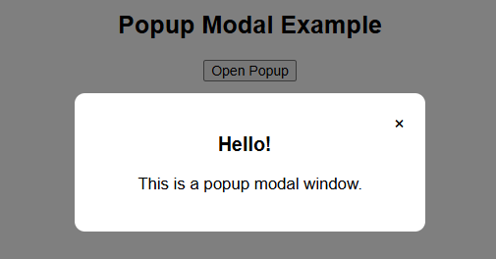

21. Student Data Management System
Problem Statement:
Develop a web application to add, display, and delete student records dynamically using HTML, CSS, and JavaScript.
<!DOCTYPE html>
<html>
<head>
<title>Student Records</title>
<style>
body {
font-family: Arial;
text-align: center;
}

input {
padding: 8px;
margin: 5px;
}

button {
padding: 8px;
}

table {
margin: 20px auto;
border-collapse: collapse;
width: 60%;
}

th, td {
border: 1px solid #333;
padding: 10px;
}

th {
background: #ddd;
}
</style>
</head>
<body>

<h2>Student Record System</h2>

<input type="text" id="name" placeholder="Name">
<input type="text" id="roll" placeholder="Roll No">
<button onclick="addStudent()">Add</button>

<table>
<thead>
<tr>
<th>Name</th>
<th>Roll No</th>
<th>Action</th>
</tr>
</thead>
<tbody id="tableBody"></tbody>
</table>

<script>
function addStudent() {
var name = document.getElementById("name").value;
var roll = document.getElementById("roll").value;

if (name === "" || roll === "") {
alert("Enter all details");
return;
}

var table = document.getElementById("tableBody");
var row = table.insertRow();

var cell1 = row.insertCell(0);
var cell2 = row.insertCell(1);
var cell3 = row.insertCell(2);

cell1.innerHTML = name;
cell2.innerHTML = roll;

// Delete button
var delBtn = document.createElement("button");
delBtn.innerHTML = "Delete";
delBtn.onclick = function() {
table.deleteRow(row.rowIndex - 1);
};

cell3.appendChild(delBtn);

// Clear inputs
document.getElementById("name").value = "";
document.getElementById("roll").value = "";
}
</script>

</body>
</html>

Output:
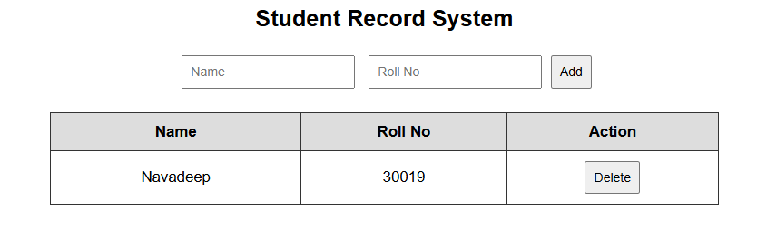
22. Login Validation Page
Problem Statement:
Design a login page that validates user credentials on the client side and displays appropriate success or error messages.
<!DOCTYPE html>
<html>
<head>
<title>Login Page</title>
<style>
body {
font-family: Arial;
text-align: center;
}

.box {
width: 300px;
margin: 50px auto;
padding: 20px;
border: 1px solid #ccc;
}

input {
width: 90%;
padding: 8px;
margin: 10px 0;
}

button {
padding: 8px 15px;
}

#message {
margin-top: 10px;
font-weight: bold;
}
</style>
</head>
<body>

<h2>Login</h2>

<div class="box">
<input type="text" id="username" placeholder="Username"><br>
<input type="password" id="password" placeholder="Password"><br>
<button onclick="login()">Login</button>

<div id="message"></div>
</div>

<script>
function login() {
var user = document.getElementById("username").value;
var pass = document.getElementById("password").value;
var msg = document.getElementById("message");

// Check empty
if (user === "" || pass === "") {
msg.style.color = "red";
msg.innerHTML = "Please fill all fields!";
return;
}

// Sample credentials
if (user === "admin" && pass === "1234") {
msg.style.color = "green";
msg.innerHTML = "Login Successful!";
} else {
msg.style.color = "red";
msg.innerHTML = "Invalid Username or Password!";
}
}
</script>

</body>
</html>

Output:
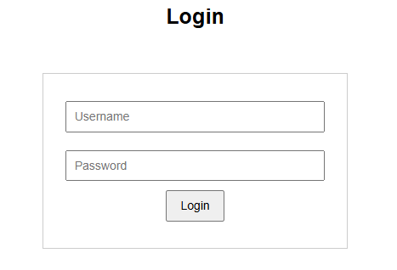
23. Expense Tracker
Problem Statement:
Create an expense tracker application that allows users to record income and expenses and displays the current balance.
<!DOCTYPE html>
<html>
<head>
<title>Expense Tracker</title>
<style>
body {
font-family: Arial;
text-align: center;
}

input, select {
padding: 8px;
margin: 5px;
}

button {
padding: 8px;
}

table {
margin: 20px auto;
border-collapse: collapse;
width: 60%;
}

th, td {
border: 1px solid #333;
padding: 10px;
}

th {
background: #ddd;
}

.income {
color: green;
}

.expense {
color: red;
}
</style>
</head>
<body>

<h2>Expense Tracker</h2>

<input type="text" id="desc" placeholder="Description">
<input type="number" id="amount" placeholder="Amount">

<select id="type">
<option value="income">Income</option>
<option value="expense">Expense</option>
</select>

<button onclick="addRecord()">Add</button>

<h3 id="balance">Balance: 0</h3>

<table>
<thead>
<tr>
<th>Description</th>
<th>Amount</th>
<th>Type</th>
<th>Action</th>
</tr>
</thead>
<tbody id="records"></tbody>
</table>

<script>
var balance = 0;

function addRecord() {
var desc = document.getElementById("desc").value;
var amount = Number(document.getElementById("amount").value);
var type = document.getElementById("type").value;

if (desc === "" || amount === 0) {
alert("Enter valid details");
return;
}

var table = document.getElementById("records");
var row = table.insertRow();

var c1 = row.insertCell(0);
var c2 = row.insertCell(1);
var c3 = row.insertCell(2);
var c4 = row.insertCell(3);

c1.innerHTML = desc;
c2.innerHTML = amount;
c3.innerHTML = type;

if (type === "income") {
balance += amount;
c2.className = "income";
} else {
balance -= amount;
c2.className = "expense";
}

document.getElementById("balance").innerHTML = "Balance: " + balance;

// Delete button
var btn = document.createElement("button");
btn.innerHTML = "Delete";
btn.onclick = function() {
if (type === "income") balance -= amount;
else balance += amount;

document.getElementById("balance").innerHTML = "Balance: " + balance;
table.deleteRow(row.rowIndex - 1);
};

c4.appendChild(btn);

// Clear inputs
document.getElementById("desc").value = "";
document.getElementById("amount").value = "";
}
</script>

</body>
</html>
Output:
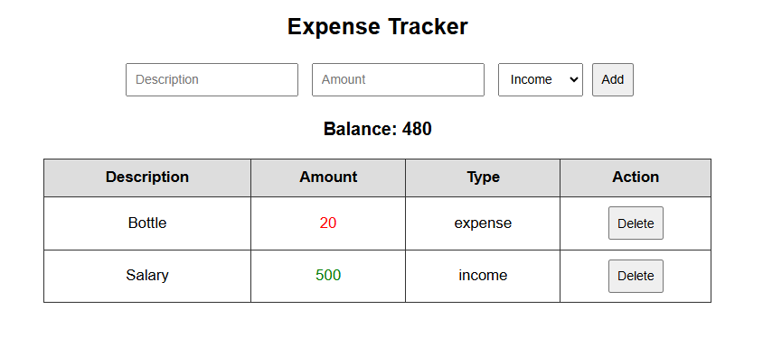
24. Weather Application
Problem Statement:
Develop a weather application that takes a city name as input and displays weather details using an API or predefined data.
<!DOCTYPE html>
<html>
<head>
<title>Weather App</title>
</head>
<body>

<h2>Weather App</h2>

<input type="text" id="city" placeholder="Enter city name">
<button onclick="getWeather()">Check</button>

<h3 id="result"></h3>

<script>
function getWeather() {
var city = document.getElementById("city").value.toLowerCase();
var result = document.getElementById("result");

// Predefined data
if (city === "hyderabad") {
result.innerHTML = "City: Hyderabad<br>Temp: 32°C<br>Condition: Sunny";
}
else if (city === "delhi") {
result.innerHTML = "City: Delhi<br>Temp: 28°C<br>Condition: Cloudy";
}
else if (city === "mumbai") {
result.innerHTML = "City: Mumbai<br>Temp: 30°C<br>Condition: Humid";
}
else {
result.innerHTML = "City not found!";
}
}
</script>

</body>
</html>
Output:
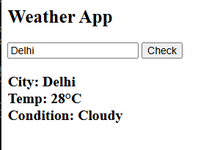
25. Mini E-Commerce Page
Problem Statement:
Design a basic e-commerce webpage displaying products with options to add items to a cart and update quantities.
<!DOCTYPE html>
<html>
<head>
<title>E-Commerce</title>
<style>
body {
font-family: Arial;
text-align: center;
}

.products {
display: flex;
justify-content: center;
gap: 20px;
}

.product {
border: 1px solid #ccc;
padding: 10px;
width: 150px;
}

table {
margin: 20px auto;
border-collapse: collapse;
width: 50%;
}

th, td {
border: 1px solid #333;
padding: 8px;
}
</style>
</head>
<body>

<h2>Simple E-Commerce</h2>

<div class="products">
<div class="product">
<p>Product 1</p>
<p>₹100</p>
<button onclick="addToCart('Product 1', 100)">Add</button>
</div>

<div class="product">
<p>Product 2</p>
<p>₹200</p>
<button onclick="addToCart('Product 2', 200)">Add</button>
</div>

<div class="product">
<p>Product 3</p>
<p>₹300</p>
<button onclick="addToCart('Product 3', 300)">Add</button>
</div>
</div>

<h3>Cart</h3>

<table>
<thead>
<tr>
<th>Product</th>
<th>Price</th>
<th>Qty</th>
<th>Total</th>
</tr>
</thead>
<tbody id="cart"></tbody>
</table>

<h3 id="grandTotal">Total: ₹0</h3>

<script>
var cart = {};

function addToCart(name, price) {
if (cart[name]) {
cart[name].qty++;
} else {
cart[name] = {price: price, qty: 1};
}
displayCart();
}

function displayCart() {
var table = document.getElementById("cart");
table.innerHTML = "";
var total = 0;

for (var item in cart) {
var row = table.insertRow();

var c1 = row.insertCell(0);
var c2 = row.insertCell(1);
var c3 = row.insertCell(2);
var c4 = row.insertCell(3);

c1.innerHTML = item;
c2.innerHTML = cart[item].price;

// Quantity input
c3.innerHTML = `<input type="number" value="${cart[item].qty}" min="1"
onchange="updateQty('${item}', this.value)">`;

var itemTotal = cart[item].price * cart[item].qty;
c4.innerHTML = itemTotal;

total += itemTotal;
}

document.getElementById("grandTotal").innerHTML = "Total: ₹" + total;
}

function updateQty(name, qty) {
cart[name].qty = Number(qty);
displayCart();
}
</script>

</body>
</html>

Output:


