**Jaypee Institute of Information Technology**



**DATA STRUCTURES LAB PROJECT**

**SUBMITTED TO: MRS. VARSHA GARG**

**SUBMITTED BY –**

TAHA ZUBERI- (9922103059)

VIPLOVE TYAGI- (9922103060)

ANGEL- (9922103062)

MANAN GARG-(9922103081)

SARTHAK SINGH-(9921103235)

**Index**

1.Problem statement

2.Methodology to solve problem/Solution Approach: Explanation along with flowchart

3. Data Structures Used and Why?

4. Implementation and Results

5.Working of project with snapshots. Code not required in report

6. Utility of your project and Complexity Analysis

7. References

**1.Problem statement**

Instant messaging and connecting with friends is the most widespread form of communication nowadays.

Through WeChat we are trying to create a miniature social media application where users can predominantly add other users to their friend circle and share short messages to be viewed by their network.

The program will provide user with various other user friendly functions to perform.

**2.Methodology to solve problem/Solution Approach: Explanation along with flowchart**

The problem is solved by maintaining certain data structures.

Users are considered to be the nodes of a graph and links between nodes indicate friendship.

Integrity of an account is established by using hash functions to encrypt unique username and passwords.

View your profile details/Delete your account

Add a friend/remove a friend/view current friends/view friend’s status

Edit password/edit status

Go back

**3.Data Structures Used and Why?**

* Hashmap-
* An user is uniquely identified by encrypting the username using a hash function. Then encrypted username is mapped to encrypted password in the map named “hashtable”.
* The encrypted username is mapped to the name of the user in another map named “names”.
* Vectors-
* Vectors are used to maintain the list of status messages for each user in string format.

Used to maintain no. of visited nodes and levels while calculating distinct user count.

* Graph-
* Vector of vectors used to represent the friendship graph.

**4.Implementation and Results**

The users are offered with-

* sign up/log in/exit options
* upon successfully signing up/logging in users can-

1. View Current Friends- displays list of all friends.

2. Add A Friend-pushes the friend’s encrypted username if exists into the vector associated with the graph.

3. Remove A Friend-deletes the friend from the vector associated with the graph.

4. Distinct user count- uses breadth first search concept to find the no. of users that lie b/w the two entered users.

5. Delete Your Account – removes the user from hashtable , names, status and the graph.

6. Your Profile Details- displays the details associated with a user.

7. Edit Status-status of the current user can be modified

8. Edit Password-new password is inserted into the hashtable.

9. View Friend's status-status of the selected friend is displayed

10. Go Back -returns to the main window.

**5.Working of project with snapshots**

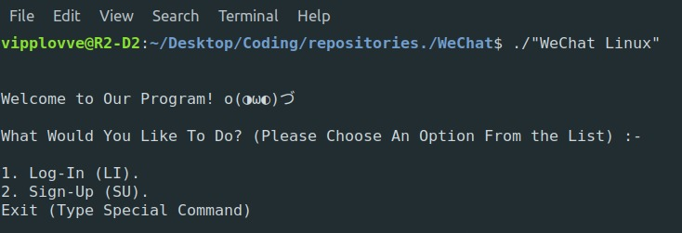

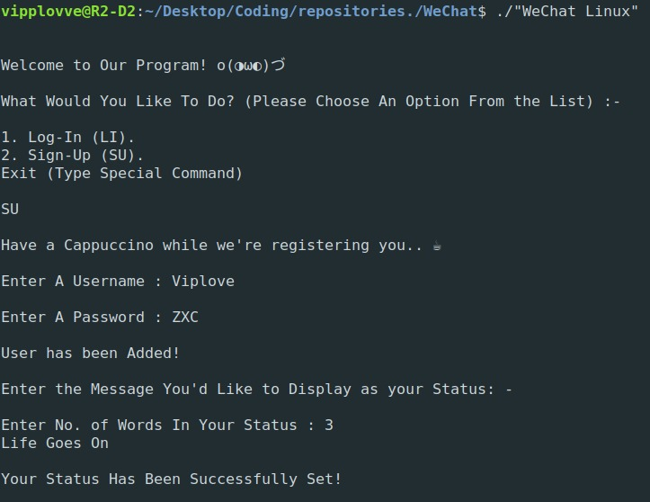

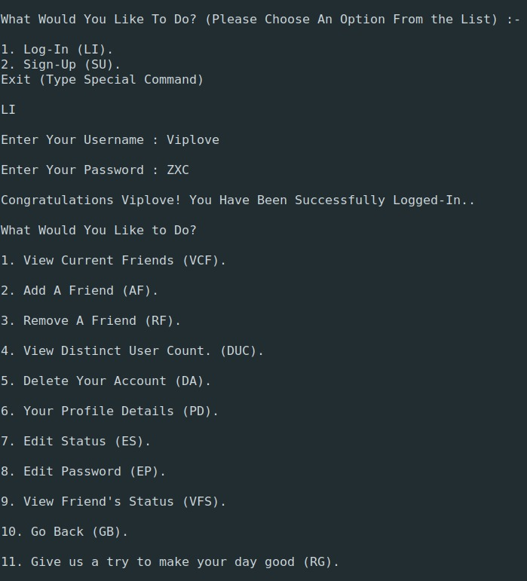

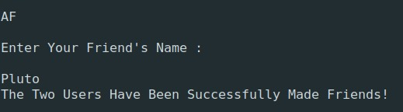

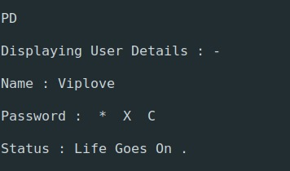

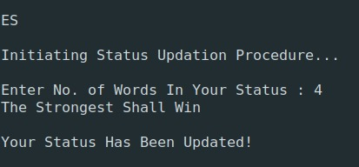

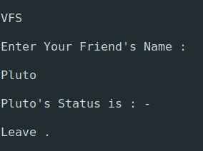

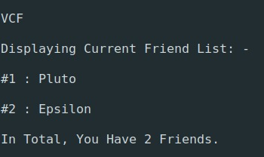

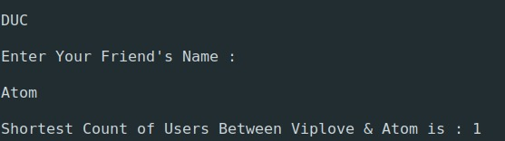

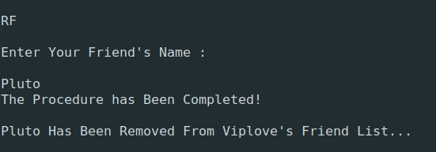

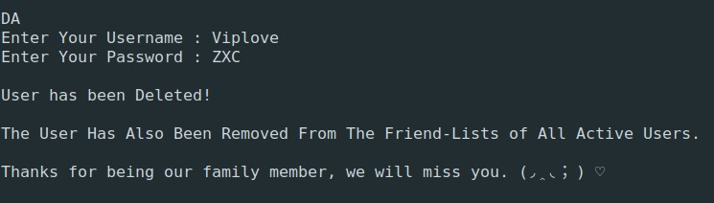

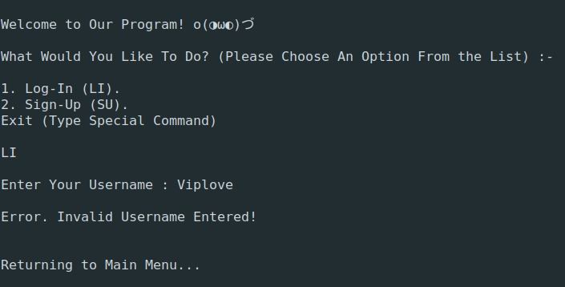

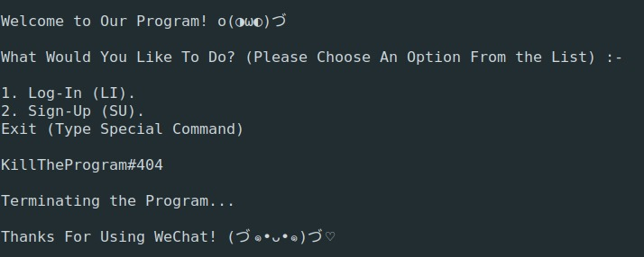

**6.Utility of your project and Complexity Analysis**

This idea is along the lines of the ever-increasing demand, usage and craze of other such social media platforms among the youth of today.

Such platforms are also largely used for knowing about the interests of others and also for various commercial purposes like advertisements, promotions and running online stores.

Ours is a lighter version which is mainly for communicating amongst the network.

But more features can be added further to include sharing multimedia and even connection beyond one’s private network.

Public spaces visible to all the users can also be created for commercial purposes.

The complexity would be directly measured by the no. of users since the graph has to be traversed for few functions.

**7.References**

1.R.B. Patel, Expert Data Structures with C++, Khanna Book Publishing

2. Yashwant Kanetkar, Data Structures Through C, BPB