Game Design Document

Fill up the following document

1. Write the title of your project.

Hunt of the bird

1. What is the goal of the game?

To make the highest score

1. Write a brief story of your game.

There is a bird who is hunting for the pigs and is encountered by

Some bots who harm the bird.the bird is provides with shields on its

way which protect it from the bots.before it dies it should kill as many

pigs as possible

1. Which are the playing characters of this game?

* Playing characters are the ones who respond to the user based on the input from the user.
* Cars, monkeys, dinos, wizards, etc., are the playing characters in the game.

|  |  |  |
| --- | --- | --- |
| Number | Character Name | What can this character do? |
| 1 | Bird | It can kill the pigs and get points |
| 2 |  |  |
| 3 |  |  |
| 4 |  |  |
| 5 |  |  |
| 6 |  |  |
| 7 |  |  |
| 8 |  |  |

1. Which are the Non-Playing Characters of this game?

* Non-Playing characters are the ones that don't have an action or behavior when the user interacts with the game.
* Hurdles, stones, bananas, coins, etc., are non-playing characters in the game.

|  |  |  |
| --- | --- | --- |
| Number | Character Name | What can this character do? |
| 1 | pigs | Pigs are the enemy of the bird and spawn randomly.They give the bird points |
| 2 | bot | Bots are the flying robots created by the pigs which also spawn randomly and when the bots attack the score is reduced |
| 3 | shield | These are the protective layers thet spawn randomly when the bird collects them the bots no longer can reduce the score and the speed of the bird is increased |
| 4 |  |  |
| 5 |  |  |
| 6 |  |  |
| 7 |  |  |
| 8 |  |  |

Draw your imagination of this game. What does this game look like?

* Draw the game either on your computer or on paper.
* Add images of the game scenes to show each of the playing and non-playing characters at least once.

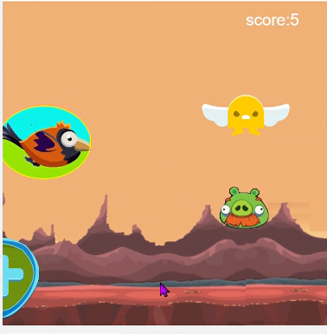

How do you plan to make your game engaging?

The players dont get bored because the game is endless and the spawning of all the NPC is random which makes it even more interresting