|  |
| --- |
| VA-Copcrash |
| Assignment 01 |
| **[2d Arcade Game** |
| Version #XX  All work Copyright © 2012 by XX Games.  All rights reserved. |
| **Vipul Arora** |
|  |

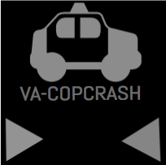

|  |
| --- |
| May 16th 2012 |

**Table of Contents**

[Your Table of Contents should go here. Make sure that your document’s sections are hyperlinked to their corresponding pages.]

**Version History**

This is my github link

<https://github.com/vips95?tab=repositories>

My version history is basically my commits which I made when I was making my assignment.

Here is the screen shot of my commits

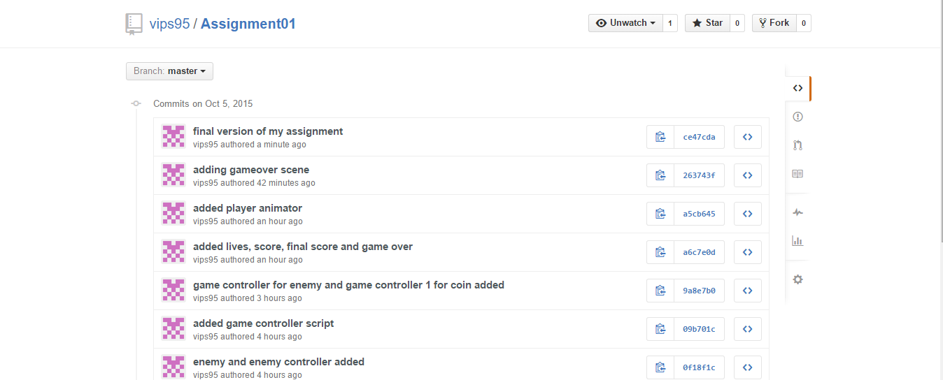

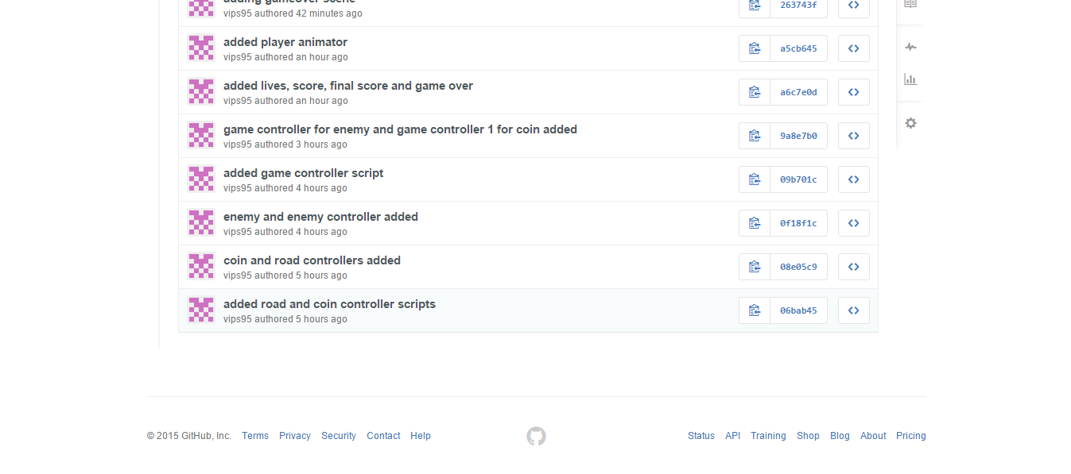

[This is the body of your video game design document. You should add and delete sections as they pertain to your game’s design.]

1. **Game Overview**

*This game is on a car travelling and there is a landslide. The car which the player has to survive through the rocks falling off. To score points you have to collect coins while dodging the rocks*

*If the rock hit you 3 times, the game ends*

1. **Controls**

*The controls are W and S or upper and lower key*

1. **Saving and Loading**

*No my games doesn’t include that*

1. **Interface Sketch**

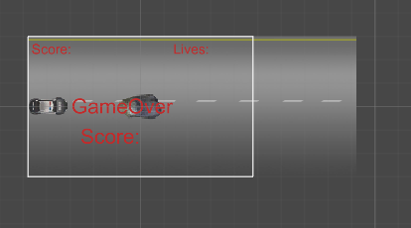

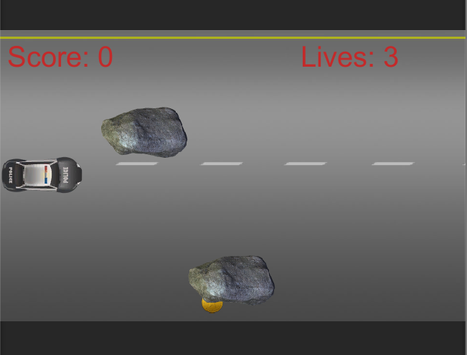

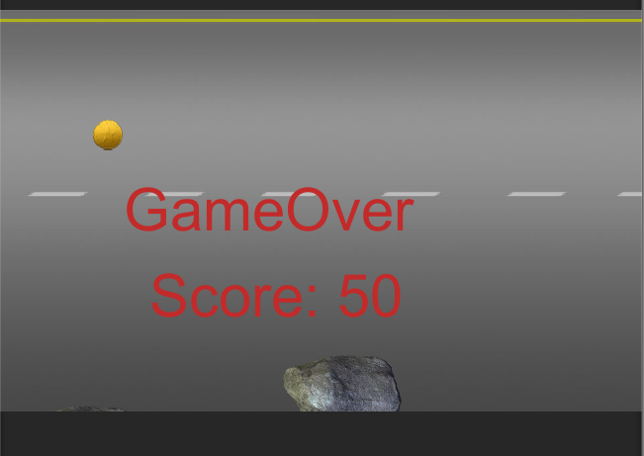

1. **Characters**

*Player is the main avatar who has to dodge the enemy avator which is rocks and collect coins*

1. **Enemies**

*Enemies in this project is rocks*

1. **Scoring**

The player can score in game through collecting coins while dodging the rocks. Each coins is worth 50 points. The more you collect, the more is the score.

1. **Sound Index**

*Police car siren*

*Collision*

*coins*