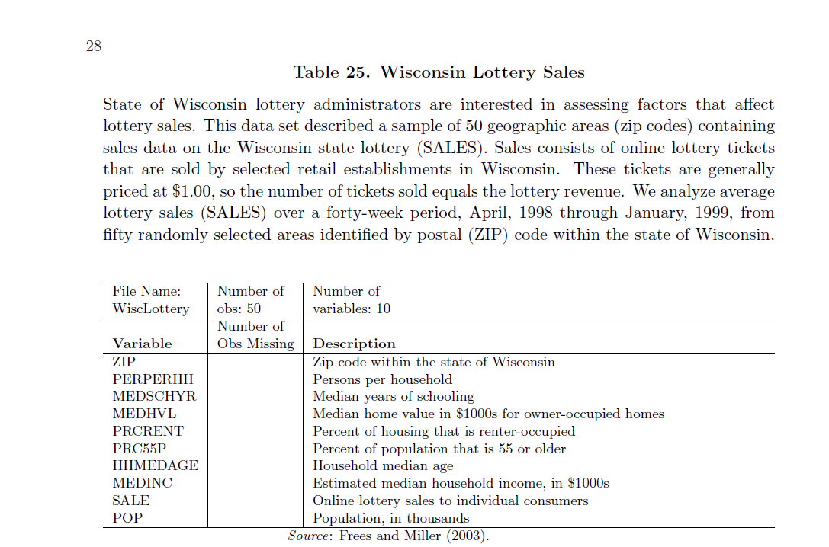

Problem

There is a dataset called "WiscLottery"  and its description on LMS in the folder "Assignment1".

**Dependent variable:**Sales (Online Lottery Sales to Individual Consumers)

**Independent Variables:**

PERPERHH , MEDSCHYR , MEDHVL , PRCRENT , PRC55P , HHMEDAGE ,MEDINC, POP

Fit a Regression model and apply the concepts that you have learnt so far.

**(Like Initial Model,Correlation Matrix , Partial Correlation Matrix,Normal QQ Plot, Residual Vs Fitted Plot,Added Variable Plots , Deletion Diagnostics and so on.)**

**The deadline for submitting the**[**assignment 1**](http://mandrillapp.com/track/click/30014752/isb1.linkstreet.in?p=eyJzIjoiNlRKZ3Q0ZGlkT2pkMmpLSkUtZmk0MDgxem9BIiwidiI6MSwicCI6IntcInVcIjozMDAxNDc1MixcInZcIjoxLFwidXJsXCI6XCJodHRwOlxcXC9cXFwvaXNiMS5saW5rc3RyZWV0LmluXFxcL21vZFxcXC9mb2xkZXJcXFwvdmlldy5waHA_aWQ9NjMxXCIsXCJpZFwiOlwiMzg1MDQ0NTBjYzIyNGVjMmE4ODVlMTg4OGY3YWQ3NzNcIixcInVybF9pZHNcIjpbXCJhYTFlYjk3N2RjYmM2ODc0YTNlMGZmYTg5OWE0MjQ1YTQxMjY0NmZlXCJdfSJ9)**is 11:55 PM February 21st,2015.**

Solution:

summary(Data)

ZIP PERPERHH MEDSCHYR MEDHVL PRCRENT

Min. :53003 Min. :2.200 Min. :12.20 Min. : 34.50 Min. : 6.00

1st Qu.:53549 1st Qu.:2.600 1st Qu.:12.50 1st Qu.: 43.77 1st Qu.:19.25

Median :54188 Median :2.700 Median :12.60 Median : 53.90 Median :24.00

Mean :54023 Mean :2.706 Mean :12.70 Mean : 57.09 Mean :24.68

3rd Qu.:54518 3rd Qu.:2.800 3rd Qu.:12.78 3rd Qu.: 66.47 3rd Qu.:27.00

Max. :54956 Max. :3.200 Max. :15.90 Max. :120.00 Max. :62.00

PRC55P HHMEDAGE MEDINC SALES POP

Min. :25.0 Min. :41.00 Min. :27.90 Min. : 189.0 Min. : 280

1st Qu.:35.0 1st Qu.:46.00 1st Qu.:38.17 1st Qu.: 821.3 1st Qu.: 1964

Median :40.0 Median :48.00 Median :43.10 Median : 2426.4 Median : 4406

Mean :39.7 Mean :48.76 Mean :45.12 Mean : 6494.8 Mean : 9311

3rd Qu.:44.0 3rd Qu.:51.00 3rd Qu.:53.62 3rd Qu.:10016.5 3rd Qu.:15446

Max. :56.0 Max. :59.00 Max. :70.70 Max. :33181.4 Max. :39098

cor(Data)

ZIP PERPERHH MEDSCHYR MEDHVL PRCRENT PRC55P

ZIP 1.00000000 -0.25043757 -0.1840536 -0.55502196 -0.1881527 0.3568658

PERPERHH -0.25043757 1.00000000 -0.1889199 0.06791617 -0.3683181 -0.5178883

MEDSCHYR -0.18405361 -0.18891986 1.0000000 0.70780357 0.6422949 -0.4792305

MEDHVL -0.55502196 0.06791617 0.7078036 1.00000000 0.3726068 -0.6213228

PRCRENT -0.18815274 -0.36831807 0.6422949 0.37260677 1.0000000 -0.3096679

PRC55P 0.35686577 -0.51788827 -0.4792305 -0.62132281 -0.3096679 1.0000000

HHMEDAGE 0.30556073 -0.47822064 -0.4810156 -0.54337571 -0.3695101 0.9636132

MEDINC -0.50253198 0.33397632 0.5222065 0.84133554 0.2001336 -0.7762837

SALES -0.21661170 -0.13625569 0.4674995 0.57150508 0.4964811 -0.3857442

POP -0.09552086 -0.18038028 0.5895641 0.52577941 0.6433933 -0.4035664

HHMEDAGE MEDINC SALES POP

ZIP 0.3055607 -0.5025320 -0.2166117 -0.09552086

PERPERHH -0.4782206 0.3339763 -0.1362557 -0.18038028

MEDSCHYR -0.4810156 0.5222065 0.4674995 0.58956409

MEDHVL -0.5433757 0.8413355 0.5715051 0.52577941

PRCRENT -0.3695101 0.2001336 0.4964811 0.64339330

PRC55P 0.9636132 -0.7762837 -0.3857442 -0.40356640

HHMEDAGE 1.0000000 -0.6809147 -0.3648614 -0.41572416

MEDINC -0.6809147 1.0000000 0.4687388 0.43299180

SALES -0.3648614 0.4687388 1.0000000 0.88628266

POP -0.4157242 0.4329918 0.8862827 1.00000000